Camp 43 - Harcourt Hill Camp, North Hinksey, Oxfordshire

Included in the 1945 ICRC camp list – Labour Camp. 43. Harcourt Hill Camp, North Hinksey, Oxford.

1947 Camp List
43(G.W.C.) | Harcourt Hill Camp, North Hinksey, Oxford | S. | Priswar, Oxford | Oxford 4891 | Oxford | Lt.Col.C.Gentry-Birch, M.C. | v/1453/2

Prisoner of War Camps (1939 – 1948) - Project report by Roger J.C. Thomas - English Heritage 2003
OS NGR | Sheet | No. | Name & Location | County | Cond’n | Type 1945 | Comments
SP 488 044 | 164 | 43 | Harcourt Hill Camp, North Hinksey | Oxfordshire | 4 | German Working Camp | STANDARD type

Location: Camp shown on map marked as Hostel (private) in 1959. About 2.5 km SW from Oxford.  Before the camp: Farmland. The original proposed site for Camp 43 in December 1941 was at Wheatley, Oxon, with an Italian pow construction company from Camp 33 Bicester, allocated to build the new camp. |  | 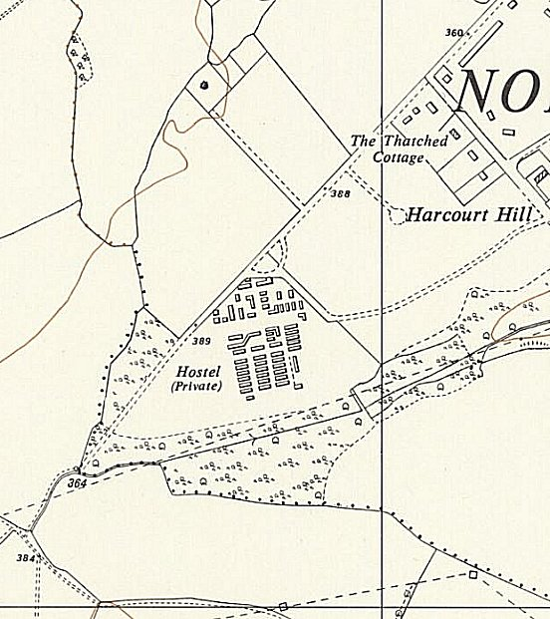
POW Camp:  1942 - Estimated opening in local report. Listed as Italian working camp / labour battalion to 1944 / 45, then German pows + other nationalities, (record of 1 Yugoslavian staying on after the war).  1943 – Italian hostel listed at Milton-under-Wychwood, (see Shipton).  May and November 1944 - The camp was listed as an Italian Labour Battalion under the Southern Command area, (WO 32/10737). The Italians were recorded as co-operators.  One later account from a guard stated; “600-700 pows in the camp, with 500 in another section: 1100 altogether. It was a mixed camp, with very few Italians, and both officers and men.” ‘500 in another section’ could mean a separate compound or a satellite camp. White and grey classified pows. (Prisoners of England – Miriam Kochan).  Oversight and development of re-education activities and English teaching for German pows was carried out by PID (Political Intelligence | 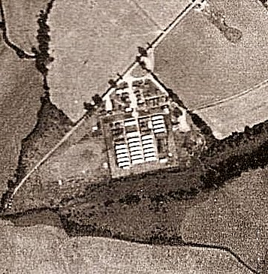
 | Aerial photo 1947 | Ordnance Survey 1959
Department of the Foreign Office) / COGA (Control Office for Germany and Austria – UK). Visits and reports were made. The standard of the reports varied greatly. The visitors took little interest, if any, in activities other than re-education. They rarely mentioned welfare, sports, games, pastimes, crafts, etc of the pows.

11 June 1945 – Designated as a German labour camp with 850 German pows – more arrived soon after. Italians moved to hostels or billets.

17 July 1945 – political screening took place. 120 Grade C pows were removed and replaced by A and B grades. [Political grades – A white (Non-Nazi)/ B grey / C black (Nazi).]

21-23 August 1945 – A very early camp report on political gradings and re-education by three members of PID.

The report mentions a hostel at ‘Shipton’, 22 miles away. This was Shipton-under-Wychwood, referred to in an earlier record as Milton-under-Wychwood

Commandant: Lt Col Worth Camp leader: St.Fwb Karl Kruke (A)
2nd i/c: Major Marsh Deputy C/L: Hwm. Wilhelm Hengst (A)
Interpreter: Lt Lees. [New] German M.O.: Dr Albrecht

Camp leader – minor civil servant, stated that he joined the [Nazi] party under pressure in 1934. Called up 1941. He did not encourage political discussion as he believed it would lead to trouble.

Deputy – Professional soldier since 1935. “Although brought up in the spirit of Vaterlanspartei, of which his father was a staunch member, he professes to be a convinced anti-Nazi. A colourless but honest man.” His political attitude was already under review. The Vaterlanspartei was a direct predecessor of the Nazi Party and it was believed he must have been brought up, “in that way of thinking.” Despite stating he was anti-Nazi, he was re-graded as (B-).

M.O. – Austrian, Social democrat. He had been imprisoned for four months in a concentration camp because of his political activities. Spoke English well. “Useful and intelligent but disillusioned.” Not interested in politics.

2 German interpreters were referred to as they were both originally graded C. It was believed they were adjusting their political views and could be left in place.

“…this grey/white camp is being run by German staff on military but not Nazi lines.” The visitors put their own interpretation to the political complexion of the camp:

“5% at least virulent Anti-Nazi / 25% Anti-Nazi now / 65% Sheep / 5% Still Nazi.”

Morale was regarded as ‘fair’ as they had settled down and work was usually available. Negative aspects were lack of mail, news and activities. The visitors stated that the pows needed stimulation to rouse them from political apathy. There were few signs of communist activity. One unpleasant situation was recorded; on VJ Day, though this had been celebrated by the pows, a group of people in Oxford threw stones and water at them when they were on their way to work. It was stated that the pows were bewildered and disapponted by this.

Youth pows (under-25) were regarded as a special problem – “They are utterly bewildered.”

Re-education activities had not started and various recommendations were made. ‘Wochenpost’ and ‘Ausblick’ were eagerly read. It was stated that 400 to 500 pows wanted to learn English – this initial very high response was common in camps, but very quickly reduced.

Religion – Irregular visits from protestant and RC padres from Oxford. The camp chapel was also a dormitory due to lack of space.

September 1945 - Appendix to HQ Southern Command War Diary– Harcourt Hill, Oxford – German Labour camp – capacity 1100 – 105/938248
Italian hostels – Headington, Longworth, Wootton – total cap 570
German hostels – Milton Under Wychwood, Bessels Leigh – total cap 270

15 & 16 September 1945 – English Inspector’s Report. Strength given for German pows only: Main 1060 / Shipton 70 / Bessels Leigh 220 = 1350.

[There were two EIRs in January and March 1946 with very brief reports.]

13/14 October 1945 – A very well respected visiting lecturer, Harald von Waldheim, gave a report on his visit and impressions of the camp.

He stated that the camp leader was one of the best he had met, and unlike the PID report, regarded him as being anti-militaristic.

The lecturer reported on a disturbing aspect where an order was received that pows had to remove all family photos and other personal effects from their bedsides. A handwritten note on the report indicates that this was referred to Henry Faulk, the Chief Executive Field Officer of the Prisoner of War Division.

A RC British priest regularly gave Mass. The protestant situation was regarded as “scandalous;” - a Professor Kramm living in Oxford was supposed to visit, but had only done so once in six weeks.

1946 – Various lecturer’s reports. Lecturers were asked to write brief reports about their visits. During 1946 several commented on pows in Camp 43 who had previously been held in camps in the USA. They had been mistakenly informed in the States that they were to be returned to Germany, instead they ended up in the UK, consequently morale was low for many. Some were also a disruptive influence, this was mentioned in particular about a small minority of pows in some of the hostels.

8/10 May 1946 – General Survey. Strength; 1 officer, 1320 Other Ranks.

Commandant: Lt Col Gently-Birch MC Camp Leader: Fwbl Kruke (A)
Interpreter: Lt E A Adams Deputy C/L: W Hengst (B-)
M.O.: Dr H Albrecht (B+) (Austrian).

Only 50% of the pows had been politically screened. Morale was recorded as ‘good.’ Positive factors; strict, but benevolent and fair military discipline; re-education activities. An education class had been started for youth pows. A group of pows had attended the special training course at Wilton Park.

The standard list of re-education activities was given:

Wochenpost and Ausblick – 250 copies of Wochenpost received.

Newspapers – a range of English newspapers + some German and Swiss papers.

Library – 400/500 books. Did not state how many were German.

Lectures – regular.

Discussion groups – weekly political meeting of 30/50, and an arts discussion group with 20/30.

Films – fortnightly.

Wireless – in the Interpreter’s office, but controlled by German staff. Loudspeakers in dining hall and hospital.

Camp magazine – ‘Sprachrohr’ (Mouthpiece or megaphone). 200 copies, popular, also sent to hostels and billetees.

Press review – daily news bulletins posted on noticeboard, weekly oral review.

English instruction – 3 classes of about 40 pupils.

Other activities –

Religion – Protestant padre, Lolling (A) arrived January 1946; he did not participate in political activities. Congregation of about 100. RC padre from Oxford weekly.

Education – yes, but classes not listed.

Theatre – variety shows and plays – well produced.

Orchestra – 2 harmoniums, piano, 3 violins, cello, and a piano-accordion. 23 concerts of light music and operetta had been given in 6 months. Choir and orchestra also performed on Sundays.

18/19 May 1946 – A visiting lecturer commented on the pows in the main camp that had arrived from camps in the USA – he had been received with general hostility, and from 2 pows in particular. The IO was to investigate the incident.

20-22 July 1946 – Progress report. Strength; 1 officer, 2494 OR.

No changes to senior personnel. The I.O. Lt Adams, was very well regarded – he was also mentioned several times by visiting lecturers during his time at Camp 43.

The standard list of re-education activities was given. A wide range of activities were being held, many under the direction of the Wilton Park trained pows. Due to the increased strength, more printed material was required – newspapers, magazines, and books. Radio sets were available in all the hostels.

English instruction – 600 students with 15 teachers. More texts were needed.

An ‘Information Room’ had been set up at the main camp. It held exhibitions of materials sent by COGA and produced by the pows – the first title was; ‘The World Food Problem.’

24/25 August 1946 – Lecturer’s report. Many concerns were raised in discussions about repatriation. Pows who had been garrisoned on the Channel Islands complained about delayed repatriation. Comment – “we starved with 1300 calories to save the population and were praised by Churchill only to be kept as slaves.”

There were complaints expressed to visiting lecturers at this time, that the previous camp leader had been a member of the Nazi Party, and yet he had been repatriated while others who had been held in concentration camps were still being held captive.

25 August 1946 – English Inspector’s Report. Strength 2726.

New camp leader (Lagersprecher): ‘Hengst’ – previously deputy.

Main camp - 79 pupils in 4 classes. Class also held at Besselsleigh. Attendance at activities was affected by harvest – pows often returning to camp between 9 and 10 p.m.

Other classes were held for – French, Spanish, motor engineering, maths and shorthand.

25 November 1946 – English Inspector’s Report. Strength 2623.

Main camp – 48 pupils in 4 classes – steady decline in numbers. All hostels except Shipton, held classes.

31 January / 2 February 1947 – English Inspector’s Report. Strength 2350.

Main camp – 28 pupils in 3 classes.

A large theatre was being constructed – the stage was built to revolve and the concrete floor of the auditorium was sloped. English plays were translated and performed in the camp, the last one was Pygmalion). It was hoped that the old theatre would used for teaching as previous accommodation was often cold.

6 – 13 March 1947 – Re-education survey. Strength; 1 officer, 2167 OR.

One recent change to senior personnel – a new M.O. Dr Bertholdt. The deputy (started December 1946) was listed as Owm. G Michael (B+)

All pows had been screened, but figures not given. 478 pows repatriated to date.

As in many camps, the commandant had no interest in re-education, this was left to the Interpreter Officer who was stated to be efficient.

Camp leader, Wilhelm Hengst – salesman, then professional soldier 1935-44. “Pleasant, efficient type; interested in furthering re-education, particularly magazine.”

Deputy C/L, Gustav Michael – lawyer – “Intelligent, earnest, too busy to participate in re-education, but interested.”

German M.O., Hans Berthold – had been a Nazi Party member – “Lukewarm outlook on re-education.”

Morale was recorded as mixed. Pows were placed in ‘groups’ and so those in later groups for repatriation had a lower morale. Positive factors were increased privileges for walking out, and Headington pows were able to visit Oxford University students. Sport and entertainment facilities were good.

A group of 132 pows, recently transferred from Shotover House Camp 687, complained that on arrival at Camp 43 only regulation Army issue items were allowed to be kept.

Re-education activities had suffered as many were led by Category A pows, but they had been repatriated. The standard list was given – there was little difference to the previous report in May 1946. The request for more printed materials, texts, books, etc was repeated.

Religion – Weekly services in camp and hostels. Local churches could also be visited.

About 1/3 RC; Catholic priest, Herbert Kitzinger (B+) – no party record – “has a rather defeatist outlook on re-education.”

Evangelical parson, Paul Schoen (B) – no party record. Polish citizen up to 1939. “Earnest, intelligent, prepared to help with magazine.”

Education – no classes recorded, only private studies.

Entertainment – theatre and excellent orchestra.

21/22 May 1947 – Re-education Survey. Strength; 1 officer, 2497 OR.

Commandant: Lt Col W H Green Camp Leader: Ogefr W Hengst (B)
Interpreter: Capt E A Adams (was Lt) Deputy C/L: Maat A Schwarz (B)
M.O.: Oberarzt Dr Berthold (B)

Simplified political screening in use: A 1 / B 2497. 35 pows were appealing against their grades; the better the grade, the earlier repatriated, in theory. About 500 pows repatriated to date.

Morale was recorded as ‘fairly high.’ Positive factors were; local contacts, employment, repatriation. Negative factors were; bad news from home, a feeling that repatriation should be better managed. An example was given that letters were received from some repatriated pows who were homeless, whereas fathers of families with jobs to go to were still held prisoner. In some ways, this was a valid point, however, the complications of investigating who then should be released would have been extremely complicated. The basic priorities for repatriation were; 1. Poor health; 2. Compassionate grounds; 3. Political grading; 4. Men needed to work in the British-zone, then other zones.

A youth group had been started for pows under-25 – lectures and discussions.

The standard list of re-education activities was given:

Wochenpost and Ausblick – 325 / 214 copies respectively.

Newspapers – well supplied.

Library – 1495 books, mainly texts, only 500 reading books. More needed, as commented on before.

Lectures – regular and well attended.

Discussion groups – weekly with 30 -50 pows.

Films – regular

Wireless – satisfactory. Loudspeakers in all huts.

Camp magazine – fortnightly.

Information Displays – 2 in dining halls, 1 for youth education, exhibition of 9 boards in canteen and circulated to hostels.

Other activities –

Religion – no change.

Entertainment – Very successful theatre group. 14 member band.

15/16, 21 July 1947 – Re-education survey. Strength; 2 officers, 2472 OR.

No changes to senior personnel.

Little difference from the previous report. Trips to Oxford from the main camp had started, but there was only one formal contact established, with Toc-H – more were expected to develop. There were complaints about the lack of letter forms and cards that the pows had to use for mail. The band had given concerts to local citizens.

8/11 August 1947 – English Inspector’s Report. Strength; 2278. 45 pupils in 5 classes.

9-11 September 1947 - Re-education survey. Strength; 2 officers, 2117 OR.

No change to senior personnel. 760 Pows repatriated since January.

Little difference from the previous report. There were 2000 books in the library, up by 500. The camp magazine was temporarily suspended due to lack of ink.

Of all the factors that affected pows the most, it was outside contacts as fraternisation rules were relaxed. Most pows developed personal links with families and others that they worked with. Formal contacts were also being developed with local church groups, the WEA, and some Oxford colleges.

21-25 October 1947 - Re-education survey. Strength; 2 officers, 1923 OR.

Only change to senior personnel - a second doctor; O/Arzt Dr Dieter Mueller.

The pows voiced a grievance that PM Attlee had made a comment that pows were being kept here as a form of reparations. They also believed the UK was acting unfairly to those wishing to remain in this country. This arose as the French were allowing some of their pows to stay on in trades other than agriculture, and to bring their families to France. Within the UK the trades unions raised strong objections to pows working in a wide range of industries.

The standard list of re-education activities was given. The only noteworthy changes were the ending of discussion groups, mainly due to repatriations, and the camp magazine was back with adequate supplies of ink and paper.

29 October – 1 November 1947 – So soon after the last report; Re-education survey and Institutional Contacts. Strength; 2 officers, 1895 OR.

Commandant Lt Col W H Green was being replaced by Lt Col E C Prattley.

There was a new Deputy C/L; Wm Richard Rosse (B), aged 37, agricultural worker, “unintelligent and an incoherent speaker. He was appointed because nobody else wanted the job.”

Political screening: | B+ | B | B- | C | C+
 | 317 | 1353 | 225 | 1 | 1 escaped

1250 pows repatriated to date. It was believed that morale had improved due to further relaxations of regulations, e.g. the pows could use/save English money.

45% of the pows were ‘youth’. The youth group had stopped, but it was hoped to re-start. Many of these pows attended classes and courses in Oxford.

Newspapers – a wide range of English papers and magazines + 12 German and some Swiss papers. Copies of Hansard were also received.

Library – 2200 books, including 1000 fiction. Books circulated to the hostels.

Lectures – regular in main camp, less so at the hostels.

Discussion groups – lapsed, but many pows attended debates and discussions at the Oxford WEA.

Films – alternate weeks for YMCA and ‘Travelling Films.’

Wireless – 2 sets in main camp with 21 loudspeakers. Hostels had wireless sets, but those at Headington and Haseley were out of order.

Camp magazine – 250 copies fortnightly.

Press reviews – weekly typed commentary by the study leader

English instruction – see next report.

Information room – no particular room due to lack of space, exhibitions were held in part of one of the dining huts and other spaces. The hostels had their own information boards.

Entertainment – theatre group of 12 members. Orchestra of 14 members which also visited the hostels. Main recreations were; football, handball, table-tennis and chess.

Outside contacts – many contacts around Oxford with religious groups, colleges, schools.

7 November 1947 – English Inspector’s Report. Strength 1819. Main camp - 30 pupils in 3 classes.

14 November 1947 - Camp number included in an ‘Urgent Memorandum’ (FO 939/270) regarding inspection of food parcels.

10/13 December 1947 – Re-education survey and ‘Cultural Contacts.’ Strength; 2 officers, 1754 OR.

Commandant: Lt Col E C Prattley Camp Leader: Ogefr Wilhelm Hengst (B)
Interpreter: Capt E A Adams Deputy C/L: Wm Richard Rosse (B)
German M.O.’s: Oberarzt Dr Hans Berthold (B) / A/Arzt Dieter Mueller (B)

There were 2 C grade prisoners – both were recorded as ‘escaped.’ 1349 pows repatriated to date. Morale was high due to more freedom of movement and rising speed of repatriations.

Re-education activities continued to be strong, despite repatriations. Further outside contacts with local town councils were developed for pows to attend meetings.

24/27 January 1948 – Re-education survey, including new satellite camp. Strength; 2 officers, 2408 OR.

Only change to senior personnel at main camp – new Camp Leader; Gerhard Kretzschmar (B+).

The 2 C grade prisoners were still recorded as ‘escaped.’ 1469 pows repatriated to date. Morale ‘fairly high,’ but some pows unsettled as the camp was due to close.

Re-education activities and an extensive range of contacts continued, including pows putting on a Christmas party for 50 children and giving out toys.

Religion – a new Lutheran padre, Uffz Johannes Mueller, aged 46, previously with Camp 185 – “his outlook, is particularly a German one and he contrasts all thought and systems in relation to his Fatherland seeking the weaknesses rather than the good points of non-Germanic ideas.”

Late February / early March 1948 - the camp closed. The Bicester Satellite Camp, Besselsleigh and Over Norton hostels were transferred to Lodge Farm Camp 25.

Known camp commandants:
1945 – Lt Col Worth
1946 - Lt Col Cyril Gentry-Birch, M.C. From the Cheshire Regiment.
1947 - Lt Col William Howard Green M.C. from the King’s Own Royal Regiment. Previously at Hampton Lovatt Camp 54.
1947 – Lt Col E C Prattley [??? Eric Charles Prately, pow of the Japanese from the Royal Norfolk Regiment ???]

After the camp: Later reverted to farmland.  Further information:  National Archives –  FO 939/125 & 299 - 43 Working camp, Harcourt Hill Camp, North Hinksey, Oxfordshire. Dated 1945-1948. Used above. | 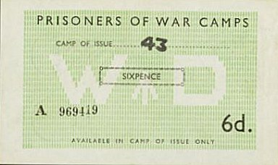 | 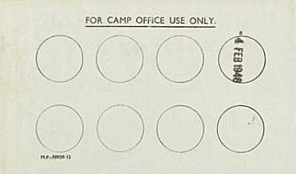
 | Camp ‘money’ could only be used in the camp marked. Stamped on the back after each use.

Camp and hostels + number of pows where known:

 | Not open |  | Unknown |  | Open |  | With another camp

 | 1942 | 1943 | 9/45 | 5/46 | 7/46 | 11/46 | 2/47 | 3/47 | 5/47 | 7/47 | 9/47 | 11/47 | 12/47 | 1/48
Main |  |  |  | 900 | 899 | 910 | 818 | 700 | 836 | 853 | 683 | 580 | 742 | 302
Shipton/Milton |  |  | G | 60 | 73 | 69 | 72 | 70 | 63 | 66 | 56 | 56 | 52 | 34
Headington |  |  | I |  | 160 | 187 | 164 | 131 | 230 | 163 | 64 | 57 | 60 | 37
Longworth |  |  | I
Wootton |  |  | I
Bessels Leigh |  |  | G | 60 | 289 | 252 | 220 | 264 | 298 | 263 | 270 | 200 | 175 | 233
Burford |  |  |  | 100 | See 2 hostels below *
Signet Hill * |  |  |  |  | 103 | 93 | 96 | 92 | 82 | 82 | 81 | 72
Bury Barns * |  |  |  |  | 115 | 219 | 189 | 170 | 190 | 212 | 189 | 166 | 149 | 60
Haseley Court |  |  |  |  | 197 | 189 | 149 | 134 | 165 | 196 | 174 | 152 | 118 | 78
Cokethorpe |  |  |  |  | 249 | 234 | 186 | 162 | 180 | 189 | 173 | 145 | 124
Greystones |  |  |  |  | 161 | 182 | 175 | 160 | 170 | 152 | 141 | 136 | 114 | 85
Bicester | Windmills Camp 33 |  |  |  |  |  |  |  |  |  |  |  |  | 1227
Over Norton |  |  | With C 31 then 185 |  |  |  |  |  |  |  |  |  |  | 107
Larkstoke |  |  |  |  |  |  |  |  |  |  |  |  |  | 101
Billets |  |  |  | 200 | 249 | 288 | 281⁽¹⁾ | 285 | 284 | 298 | 288 | 255 | 222 | 146
Total |  |  | Cap 1100 | 1321 | 2495 | 2623 | 2350 | 2168 | 2498 | 2474 | 2119 | 1819 | 1756 | 2410

(1) 281 billetees were spread around approx. 120 farms.

Satellite Camp

Bicester – was Windmill Camp 33

Attached as a satellite camp for a short time in early 1948, then finally attached to Lodge Farm Camp 25.

January 1948 – Commandant; Major Wilson. Camp leader; O/Fw Hans Bangert, (previously hostel leader at Headington).

The previous camp leader, Johannes Sonna, became the deputy – aged 40, an engineer. Pows who wished to re-start studies were transferred to the main camp.

6/9 February 1948 – Supplementary report on this satellite camp. Strength 1227. There were plans to change the hostel leader, but this does not seem to have occurred as Hans Bangert was still recorded when the camp was attached to C25. Arrangements were still being made to arrange for outside visits and pows to attend training courses.

 | 1942 | 1943 | 9/45 | 5/46 | 7/46 | 11/46 | 2/47 | 3/47 | 5/47 | 7/47 | 9/47 | 11/47 | 12/47 | 1/48
Bicester | Windmills Camp 33 |  |  |  |  |  |  |  |  |  |  |  |  | 1227

Hostels

Bessels Leigh or Besselsleigh. 4 miles from the main camp.  Location – “…go past the greyhound pub I lived there, there is a thatched cottage past there, the next entrance is where the pow camp was before the farm.” NGR SP 456 013  September 1945 – Hostel for Germans  23 March 1946 – a visiting lecturer believed that many of the young pows at this hostel had retained their Nazi beliefs.  May 1946 – Hostel leader; ‘Rehm.’ Many pows were from pow camps in the USA.  March 1947 – Hostel leader; St.Ofw Georg Eining (B) – sailor; “Efficient, helpful, interested in lectures and discussion.”  May 47 – Weekly discussion groups held. Small theatre group.  December 1947 – same leader.  January 1948 – Hostel leader; O/Jaeg Theo Niermann (B+)  March 1948 – listed as a hostel for Lodge Farm Camp 25 | 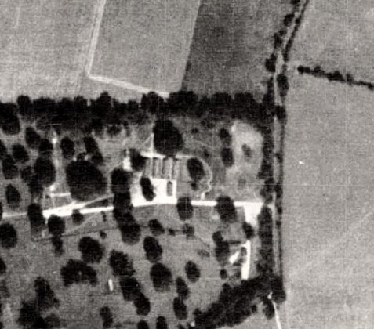
 | Aerial photograph 1947

 | 1942 | 1943 | 9/45 | 5/46 | 7/46 | 11/46 | 2/47 | 3/47 | 5/47 | 7/47 | 9/47 | 11/47 | 12/47 | 1/48
Bessels Leigh |  |  | G | 60 | 289 | 252 | 220 | 264 | 298 | 263 | 270 | 200 | 175 | 233

Burford. 18 miles from the main camp.

May 1946 – Hostel leader; Ledwig (C). Many pows were from pow camps in the USA.

The two Burford hostels below + Shipton Hostel were meant to share facilities such as lectures and films. However, Shipton often missed out due to lack of transport.

I think one of the two hostels - * - was the original ‘Burford’ and then another hostel was opened nearby – to avoid confusion two names then used.

 | 1942 | 1943 | 9/45 | 5/46 | 7/46 | 11/46 | 2/47 | 3/47 | 5/47 | 7/47 | 9/47 | 11/47 | 12/47 | 1/48
Burford |  |  |  | 100 | See 2 hostels below *
Signet Hill * |  |  |  |  | 103 | 93 | 96 | 92 | 82 | 82 | 81 | 72
Bury Barns * |  |  |  |  | 115 | 219 | 189 | 170 | 190 | 212 | 189 | 166 | 149 | 60

Burford – Bury Barns. 16 miles from the main camp. Bury Barns NGR SP 250 116.

March 1947 – Hostel leader; Fw G Engsberg (B+)

May 1947 – Hostel leader; Fw K Bauschke (B+). 16-20 pows attended local Wesleyan Church and 25 the Catholic Church.

July 1947 – same hostel leader. Pows gave a concert for local citizens.

September 1947 – Hostel leader; Fw Hugo Rulle (B) – “a very definite improvement on his predecessor.” Later comments – aged 33, a master bookmaker, “Independent character who can speak up for himself and comrades.”

There was a small theatre and orchestra.

December 1947 – It was commented that the local population at Burford took some time to accept the pows, but by this time relationships were improving.

January 1948 – same hostel leader.

 | 1942 | 1943 | 9/45 | 5/46 | 7/46 | 11/46 | 2/47 | 3/47 | 5/47 | 7/47 | 9/47 | 11/47 | 12/47 | 1/48
Bury Barns * |  |  |  |  | 115 | 219 | 189 | 170 | 190 | 212 | 189 | 166 | 149 | 60

Burford – Signet Hill. 16 miles from the main camp. Signet Hill NGR SP 239 109

March 1947 – Hostel leader; Wm Emil Westphal (B)

November 1947 – same leader. Pows went to Bury Barns to see films.

 | 1942 | 1943 | 9/45 | 5/46 | 7/46 | 11/46 | 2/47 | 3/47 | 5/47 | 7/47 | 9/47 | 11/47 | 12/47 | 1/48
Signet Hill * |  |  |  |  | 103 | 93 | 96 | 92 | 82 | 82 | 81 | 72

Cokethorpe. (nr Ducklington). 10 miles from the main camp. NGR for Cokethorpe Park NGR SP 371 062.

3 November 1946 – Lecturer’s Report. Commented that the hostel leader seemed to be, “a reasonable chap,” but there were strained relationships with the British Sergeant-in-charge. The lecturer also found the sergeant to be rude.

March 1947 – Hostel leader; Ofw.H.Bornholdt (A)

May 1947 – Hostel leader; Maat Bruno Speer (B)

November 1947 – same leader.

December 1947 – Hostel leader; Uffz Bernhard Torge (B), aged 42, master hairdresser, “humourless type from Berlin, seemingly indifferent to political regimes.” Some pows from Haseley Court were working on drainage in this hostel and caused unrest – the report did not say why.

 | 1942 | 1943 | 9/45 | 5/46 | 7/46 | 11/46 | 2/47 | 3/47 | 5/47 | 7/47 | 9/47 | 11/47 | 12/47 | 1/48
Cokethorpe |  |  |  |  | 249 | 234 | 186 | 162 | 180 | 189 | 173 | 145 | 124

Greystones. (Chipping Norton). 24 miles from the main camp. NGR SP 316 259  Probably linked to a different main camp before November 1946.  2 November 1946 – Lecturer’s Report. “Worst morale of all hostels. 160 present with a choir of ten men posted outside singing and yelling ‘We want to go home.’” The lecturer persisted and the ‘choir’ desisted. This disturbance arose from two misunderstandings. Firstly, the pows had assumed that visiting lecturers were government employees. Secondly, most of the pows had not been screened and so believed they would not be repatriated until 1948 / 49. Apart from this incident, discipline was recorded as being good, and no-one had been punished since the hostel opened.  March 1947 – Hostel leader; Fw H Blank (B)  April 1947 – Lecturer’s report. Comments that relationships between the sergeant and corporal in charge at the hostel, and the pows, were not good.  July 1947 – same hostel leader. Lectures with the WEA, trips to Stratford upon Avon, and a visit to the Bishop of Birmingham - were being arranged.  November 1947 – Hostel leader; Ofw Werner Hennig (B) |  | 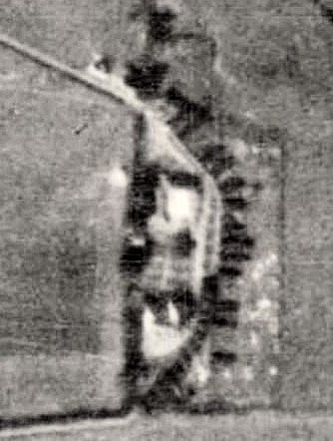 |  | 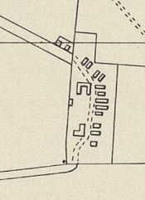
 |  | Aerial photo 1947 |  | OS Map 1955
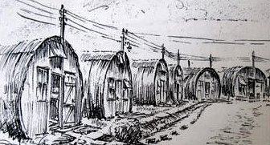 | December 1947 – Hostel leader; Uffz Heinz Boettger (B+)  January 1948 – same leader.  February 1948 – hostel closed.  < (1) Greystones hostel drawn by Conrad Gries, pow. The position that he would have been to make this sketch can be worked out from the map and photo above.  (2) Conrad Gries > |  | 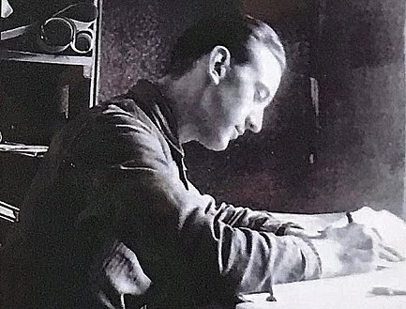

(1) https://www.history.ac.uk/sites/default/files/file-uploads/2022-09/Chipping%20Norton%20-%20Social%20History%20I%20%28Social%20and%20Political%20History%29.pdf

(2) Exert from the display at the Alderney Museum… “Conrad Gries, a German soldier, spent much of World War II stationed on Alderney. As a military draughtsman and surveyor, he made detailed drawings of the minefields. But, in his limited free time, Gries also drew and painted the Alderney landscape.

Before the liberation of Alderney, the Germans ordered the destruction of Alderney minefield plans. Gries had made a second set and these he hid, hoping the Allies would discover them. The plans survived and almost certainly saved lives.

Cries survived the was and was repatriated to Germany.” – after being a pow in England. https://jamescolmer.com/portfolio/reflections-occupation/

 | 1942 | 1943 | 9/45 | 5/46 | 7/46 | 11/46 | 2/47 | 3/47 | 5/47 | 7/47 | 9/47 | 11/47 | 12/47 | 1/48
Greystones |  |  |  |  | 161 | 182 | 175 | 160 | 170 | 152 | 141 | 136 | 114 | 85

Haseley Court. (Thame) 8 miles from the main camp. Listed as being huts – so probably in the grounds of Haseley Court NGR SP 644 005. Site recorded as being a Canadian field hospital during the war.

Probably administered by a different main camp before July 1946.

March 1947 – Hostel leader; St.Ofw Erich Grimm (B)

November 1947 – Comments on leader; aged 35, gardener, depressed because he was in a late repatriation group. General low morale due to length in captivity and bad news from home. Radio out of order. There was a small variety group.

January 1948 – same leader.

 | 1942 | 1943 | 9/45 | 5/46 | 7/46 | 11/46 | 2/47 | 3/47 | 5/47 | 7/47 | 9/47 | 11/47 | 12/47 | 1/48
Haseley Court |  |  |  |  | 197 | 189 | 149 | 134 | 165 | 196 | 174 | 152 | 118 | 78

Headington. 3 miles from the main camp.  Location – Field belonging to Wood Farm. NGR SP 552 063  1942 – possibly opened. Held Italian pows.  September 1945 – Hostel for Italians.  July 1946 – 160 German pows.  March 1947 – Hostel leader; Ofw Hans Bangert. (B)  May 1947 – Small theatre group.  November 1947 – Comments about leader; aged 31, professional soldier, “common type, little education.”  The hostel only received films from the YMCA, but pows were able to visit cinemas in Oxford (5 miles away). Radio out of order.  December 1947 – same leader. | 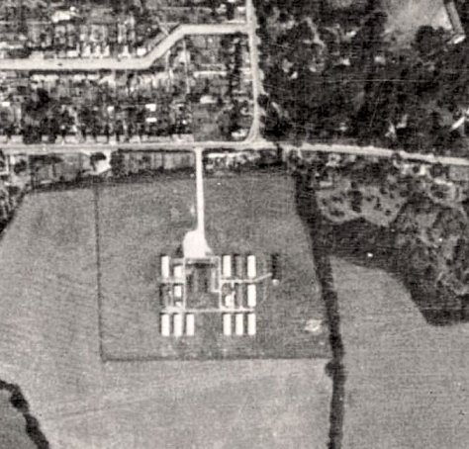 | 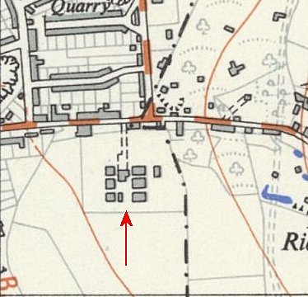
 | Aerial photo August 1947 | Ordnance Survey 1952

January 1948 – hostel closed

After the camp – huts used for emergency housing.

Further information:

Site includes local memories and more aerial pictures: https://www.headington.org.uk/history/misc/old_road_camp.html

 | 1942 | 1943 | 9/45 | 5/46 | 7/46 | 11/46 | 2/47 | 3/47 | 5/47 | 7/47 | 9/47 | 11/47 | 12/47 | 1/48
Headington |  |  | I |  | 160 | 187 | 164 | 131 | 230 | 163 | 64 | 57 | 60 | 37

Larkstoke. Location not certain – possibly ‘Larkstoke’ NGR SU 627 855. (There was also a US Army Larkstoke Camp during WW2).

Almost certainly attached to a different main camp before the single entry:

January 1948 – Hostel leader; Uscha Herbert Liebers (B)

 | 1942 | 1943 | 9/45 | 5/46 | 7/46 | 11/46 | 2/47 | 3/47 | 5/47 | 7/47 | 9/47 | 11/47 | 12/47 | 1/48
Larkstoke |  |  |  |  |  |  |  |  |  |  |  |  |  | 101

Longworth  Location not certain – local memories place it in the grounds of Southmoor House, NGR SU 402 981, this is in Southmoor which is just south of Longworth.  September 1945 – Hostel for Italians.  Probably attached to a different main camp after this.  1942 1943 9/45 5/46 7/46 11/46 2/47 3/47 5/47 7/47 9/47 11/47 12/47 1/48  Longworth I | 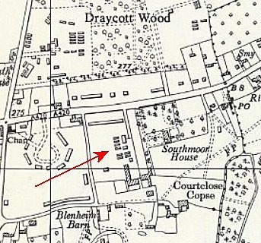
 | Ordnance Survey 1961

Over Norton

Previously listed as a hostel for Camp 31, then 185.

January 1948 – attached for a short time with Camp 43. Hostel leader; Uffz Joachim Rehm (B), previously hostel leader at Shipton.

March 1948 – listed as a hostel for Lodge Farm Camp 25

 |  | 1942 | 1943 | 9/45 | 5/46 | 7/46 | 11/46 | 2/47 | 3/47 | 5/47 | 7/47 |  | 9/47 | 11/47 | 12/47 | 1/48
Over Norton |  |  |  | With C 31 then 185 |  |  |  |  |  |  |  |  |  |  |  | 107
 | Shipton-under-Wychwood. (Listed in some reports as Milton-under-Wychwood). Location – NGR SP 268 181.  1943 – Hostel for Italians.  August 1945 – British staff – 1 Sgt, 1 Cpl, 1 L/Cpl.  Hostel leader: U/Offz Joachim Rihm, aged 32 “independent and intelligent.” He stated he had not been a Party member.  September 1945 – Hostel for Germans.  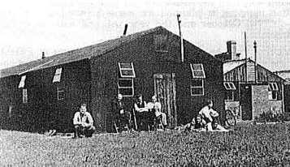  May 1946 – Hostel leader; Doring (B-).  March 1947 – Hostel leader; Uffz J Rehm (B) [Same as at Besselsleigh May 1946?]  November 1947 – Comments about leader – aged 34, window dresser, “amiable and suitable for a small hostel.”  Hostel only received films from the YMCA.  December 1947 – same leader.  January 1948 – pow hostel closed.  Picture shows huts in use for displaced persons until the 1960’s. https://www.thewychwood.co.uk/archives/Vol19No1/wychwoodhistory.pdf |  |  |  |  |  |  |  |  |  |  | 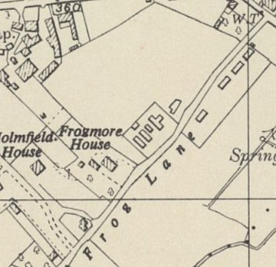
 |  |  |  |  |  |  |  |  |  |  |  | Ordnance Survey 1955

 | 1942 | 1943 | 9/45 | 5/46 | 7/46 | 11/46 | 2/47 | 3/47 | 5/47 | 7/47 | 9/47 | 11/47 | 12/47 | 1/48
Shipton/Milton |  |  | G | 60 | 73 | 69 | 72 | 70 | 63 | 66 | 56 | 56 | 52 | 34

Wootton. Location not known – possibly Wootton village about 3 km north of Woodstock and just 1½ km from Besselsleigh.

September 1945 – Hostel for Italians.

Probably attached to a different main camp after this.

 | 1942 | 1943 | 9/45 | 5/46 | 7/46 | 11/46 | 2/47 | 3/47 | 5/47 | 7/47 | 9/47 | 11/47 | 12/47 | 1/48
Wootton |  |  | I

