Camp 37 - Sudeley Castle Camp, Winchcombe, Gloucestershire

Included in the 1945 ICRC camp list – Labour Camp. 37. Sudeley Castle Camp, Winchcombe, Glos.

1947 Camp List
37(G.W.C.) | Sudeley Castle Camp, Winchcombe, Cheltenham/Glos | S. | Priswar,  Winchcombe | Winchcombe  118 | Winchcombe (G.W.R.) | Lt.Col.R.F.H.Browne | v/1453/2

Prisoner of War Camps (1939 – 1948) - Project report by Roger J.C. Thomas - English Heritage 2003
OS NGR | Sheet | No. | Name & Location | County | Cond’n | Type 1945 | Comments
SP 030 279 | 163 | 37 | Sudley Castle Camp, Winchcombe | Gloucestershire | 4 | German Working Camp | STANDARD type

Location: In the grounds of Sudeley Castle. Site on map shown as an Agricultural Hostel.  Before the camp: Part of Sudeley Castle estate. During the war, the castle was used to house a large part of the Tate Gallery’s picture collection.  Pow camp: Italian, then Austrian / German pows.  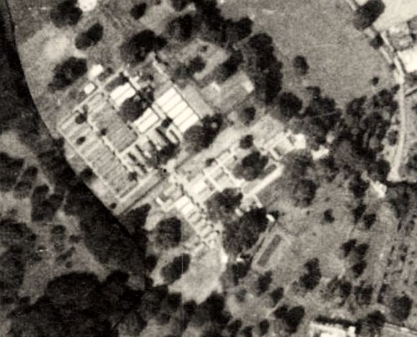  December 1941 - Listed with Italian pows, some of whom were formed as a construction crew to build Hampton Lovett Camp 54. Capacity 600. The Italian pows were in tents while they built the huts with the Pioneer Corps. Huts were mixed Nissen, reinforced concrete and Tarrant.  (1947 aerial photograph. The 1954 map shows buildings that were larger than those shown in the photograph, so parts may have been rebuilt).  23 July 1942 - ICRC visit; 553 Italian pows. Some were lodged in hostels and billets. They carried out mainly agricultural work. The camp was described as ‘excellent.’ | 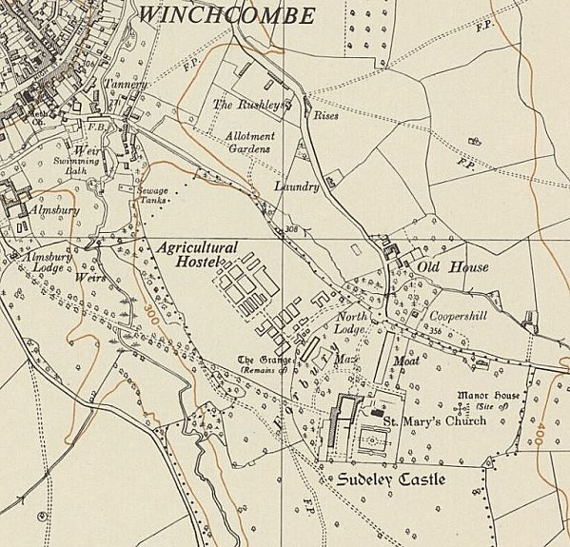
 | Ordnance Survey 1954
Increasingly during 1943 / 44 the Italians were allowed to live outside of the camp, mainly in billets on farms.

1943 – Hostels listed for Italian pows; North Leach (Northleach)/ Tewkesbury (Newtown) / Cheltenham (Swindon village).

May and November 1944 - The camp was listed as an Italian Labour Battalion under the Southern Command area, (as a Pioneer Corps Group) (WO 32/10737). Italians listed as co-operators.

3 December 1944 - Austrian pows started to arrive at the camp. Italian pows were placed in billets or other hostels until repatriation.

Oversight and development of re-education activities and English teaching for German pows was carried out by PID (Political Intelligence Department of the Foreign Office) / COGA (Control Office for Germany and Austria – UK). Visits and reports were made. The standard of the reports varied greatly. The visitors took little interest in activities other than re-education, they rarely mention welfare, sports, games, pastimes, crafts, etc of the pows.

15 May 1945 – Educational visit. This was early days for the development of re-education activities.

Camp Commandant – Major Harris was very eager to develop re-education. He commented; “I regard all the men under me as possible friends or possible foes of Britain. When they leave us, they will either like us or hate us. If 10,000 men pass through my hands, I want every one to be an ambassador for us.”

Interpreter Officer – Lt Landsell. Camp leader – Kohla. Austrian doctor unnamed.

There was a dramatic society hoping to perform plays in the near future. Films had not yet started to be sent to the camp. There were just 11 books in the library.

Various pieces of teaching equipment were required – blackboard, gramophone, texts.

28/29 June 1945 – English Education visit. The visitor was very pleased with progress being made.

20 July 1945 - The camp was visited by the ICRC again. Capacity had increased to 1025, with 1022 pows present + 60 in a hostel. All the pows were Austrian.

September 1945 - Appendix to HQ Southern Command War Diary; “Sudeley Castle, Winchcombe – German Labour camp – capacity 1000 – 93/480481” + Hostel at Alderton, capacity 70. Although listed as a German Labour Camp, it held Austrians.

2 October 1945 – Notes from a lecturer’s report. “There is a stage in this camp with cleverly painted Austrian scenery, and an orchestra whose performances were a morale uplift.” There were education courses for English and history. There was no padre and relationships with the RC priest from Winchcombe “do not appear to be ideal.”

21 February 1946 - A further ICRC visit.

12 May 1946 – Segregation Report, (mainly concerning political screening). The Austrians were due to be repatriated. 201 German pows were moved in to Moreton-in-Marsh hostel – see hostel details below.

19 May 1946 - The Austrian pows left, the camp then held German pows; 1025 arrived from Springhill Camp 185, and 50 from Bourton-on-the Hill Camp 157. Many of these pows had been previously held in camps in the United States and had expected to be returned to Germany; low morale was noted for them.

21 June 1946 – English inspector’s Report. German Working Camp. Total strength 1277.

Commandant: Major McCormac Lagersprecher: O/Gfr Kurt Marnette

4 classes with 76 pupils; beginners / intermediate. “The camp is remarkable for its display of flowers and vegetables.”

15 July 1946 – Re-education Report. Strength 2 officers; 1273 Other Ranks.

Commandant: Major McCormac Camp leader: S/O/Stue H Schneider (B)
Interpreter: Lieut Kemp Deputy C/L: Uffz Luchmann (B)
S/Sgt Marek German M.O.: S/Arzt Haessler (C)

Political screening: | A | B+ | B | B- | C | Unscreened
 | 0 | 1 | 21 | 46 | 131 | 276

Still regarded as a ‘black’ camp – but, the figures above only relate to Moreton-in-Marsh hostel and most pows had still not been screened.

The commandant had only been in place for a short time and was not expected to stay for long. He showed no interest in re-education.

Morale was regarded as fair. Improvement was noted with the start of repatriations, good welfare arrangements in camp, and better news from home.

The standard list of re-education activities was given. Very little was taking place, this was stated to be down to the commandant’s attitude + pows not yet settled down.

Newspapers – 11 British daily papers + three weekly papers. 10 German papers received fortnightly. Noted that many pows did not like what they were reading in the papers as it went against their political attitudes.

Library – 980 books, mainly fiction.

Lectures – None

Discussion group – None

Films – YMCA and ‘British Films’ fortnightly.

Wireless – In main and all hostels. Main camp had a loudspeaker system.

Camp Magazine – New edition of 300 copies, ‘Skizze der Zeit’ (Sketch of Time). Run by the S/sgt with pow assistance – hoped to be handed over entirely to pows when established.

Press review – none.

English Education – had taken a dip when the Austrians left, was restarting.

Other activities –

Religion – 60% Protestant / 40% Catholic. A padre from camp 185 visited. Not a lot of interest shown.

Education – classes of about 20 for mathematics, stenography, accountancy, geography and electrical engineering.

Theatre group – 16 members with one performance so far.

Orchestra – being formed with 13 members.

27/29 October 1946 – English Inspector’s Report. Total strength 1390.

New Commandant: Lt Col Hayward-Browne. 3 classes with 31 pupils.

25/26 January 1947 – English Inspector’s Report. Total strength 885

4 classes with 52 pupils – increased number of beginners. The visitor only visited the main camp as local roads were impassable with heavy snowfalls.

28/29 May 1947 – Re-education Report. Strength; 2 officers; 694 OR.

Commandant: Major F S Eaton Camp leader: Fw Anton Erdle (B+)
Interpreter: S/Sgt Marek Deputy C/L: O/Stm Hans Witt (B)
German M.O.: S/Arzt Georg Brehme (B+)

Simplified screening figures were given; A 6 / B 690. 40 appeals were pending over these grades – the better the grade, the sooner the repatriation, in theory. 350 pows repatriated to date.

Regarding re-education, it was noted that the British staff showed no interest, except for the interpreter. The S/Sgt interpreter was briefly described; “very self-assured young man who does not get on well with the British officers; he supports re-education where required but is too wrapped up in his personal affairs to be of much real use.”

The Camp leader started 3 weeks earlier, previously a hostel leader, aged 27 – “Good type… rather nervous about his new job. A quiet, decent individual with the right political outlook.”

Deputy, aged 31, professional soldier since 1934 – “deputy since December last and has made a good job of it. Not much political understanding and does little to help re-education.”

German M.O., aged 32, professional soldier since 1932 and studied medicine while in the navy – “Good type, cheerful and decent although slightly self-centred.” He was not involved in re-education.

Morale was recorded as “quite fair.” The camp was regarded as comfortable and pows were well treated by the British staff.

The standard list of re-education activities showed slight improvements:

Newspapers – As before – British and German papers received.

Library – 1480 books; 710 in German.

Lectures – regular, of mixed interest.

Discussion groups – Weekly with up to 80 pows.

Films – Travelling Films had visited once. YMCA and Gaumont British also showed films. Some films cost 6d to enter and this was considered too much by many pows.

Wireless – adequate in main camp.

Camp magazine – 300 copies fortnightly, “not of a very high standard.” Difficulties in obtaining supplies.

Press review – included in discussion groups.

Information Room – 3 exhibitions had been held – ‘Nobel Prize Winners,’ ‘Law Organization,’ and ‘British Parliament.’

Some formal contacts had been established. A small group attended a meeting of Cheltenham Town Council; 100 visited the Bath & West Agricultural Show. Other contacts were being considered if transport was available.

Other activities -

Religion – Interest very poor. Protestant (lay) Padre; Leutn Helmut Dietrich (B), aged 30, elementary school teacher. Had been a member of the Hitler Youth and NSStB (Nazi studentbund). “Not a very outstanding personality and has done little here as yet.” RC had a visiting local priest.

Education – None other than English classes.

Entertainment – Theatre and orchestra had disbanded due to repatriations.

28 May 1947 - The final visit by the ICRC. 628 German, 4 Czechoslovakian, and 24 Yugoslavian pows.

As the rate of repatriation accelerated during 1947, Sudeley was administered by Springhill Camp 185, and then became a satellite camp to Leckhampton Camp 263.

20 January 1948 - Sudeley camp/hostel closed.

Known Camp Commandants:
1945 Major A Harris – he moved to Leckhampton Camp 263.
21 June 1946 – ? Major McCormac (I think he was previously based at Royston Camp 29).
? - ? Major S G Graham
1946 - ? Lieutenant Colonel R F Hayward-Browne – (In one report listed as R F H Browne. I think he was from the Worcester Regiment).
1947 Major F S Eaton

After the camp: The site was used by the Land Army volunteers for a while. Now parkland within the estate.

Further information:

* ‘Inside The Wire’ – Ian M C Hollingsbee – 2014 – The History Press – whole chapter about Sudeley camp.

National Archives –
FO 939/119 37 Working Camp, Sudeley Castle Camp, Winchcombe, Gloucestershire. Dated 1945-47. Used above.
FO 939/337 same details. Dated 1946-47. Used above.

Camp and hostels + number of pows where known, (many figures were rounded):

 | Not open |  | Unknown |  | Open |  | With another camp

 | 7/42 (It) | 7/45 (Aus) | 9/45 (Aus) | 1/46 (Aus) | 5/46 (Ger >) | 6/46 | 7/46 | 10/46 | 5/47
Main |  | 1022 |  | 705 | 1075 | 717 | 705 | 833 | 524 | With C185/263
North Leach |  | With Camp 142
Newtown (Tewksbury) |  | With Camp 142 |  | 65 | 65 | 70 | 65 | 71
Swindon (Cheltenham)
Alderton |  |  | 70 | 52 | 70 cap | 53 | 52 | 8
Moreton-in-Marsh |  |  |  | 240 | 240? | 246 | 240 | 231
Sezincote |  | With Camp 142 |  | 51 | 60 | 56 | 51 | 58
Stanton |  | With Camp 142 |  | 51 | 60 | 68 | 65 | 76 | 61 | With C185
Billets / Other |  | 60 (1) |  | 97 | ? | 67 | 97 | 89+24 (2) | 111
Total | 553 | 1082 | ? | 1261 est. | 1320 est. | 1277 | 1275 | 1390 | 696

(1) Unnamed hostel, probably Alderton (2) 24 protected personnel.

Hostels

Alderton. 6 miles from the main camp. Huts.

July 1946 – Hostel leader O/Stm Witt (B)

 | 7/42 (It) | 7/45 (Aus) | 9/45 (Aus) | 1/46 (Aus) | 5/46 (Ger >) | 6/46 | 7/46 | 10/46 | 5/47
Alderton |  |  | 70 | 52 | 70 cap | 53 | 52 | 8

Moreton-in-Marsh. 15 miles from the main camp. Huts.  Hostel also known as ‘University Hostel,’ as it was located next to University Farm - located at NGR SP 205 325.  May 1946 – recorded as being newly opened with 201 German pows. 50 had been in US custody, either in Britain or the USA; 150 had been sent from BAOR Belgium camps. 1 pow had been sent from the special training camp at Wilton Park.  Hostel leader: S/Fw Karl Bruemann, (B-) aged 45. Post Office official, Nazi Party member since 1932. “Opportunist, poor character.” Recommended he be replaced.  German interpreter: S/Gefr Willy Elix, (B-) aged 33. Civil servant, spoke English. Member of the SA since 1933 and Nazi Party since 1937. Also recommended to be replaced.  German Police Chief: Fw Adolf Braun, (B) aged 31. Bookkeeper, non-political, Polish by birth. “Somewhat of an opportunist, but quite efficient.”  This was a high number of ‘black’ category C Nazis – most were ex- Waffen-SS. Many pows had been members of the Nazi Party. | 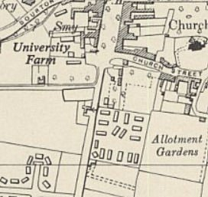
 | Ordnance Survey 1955

Political screening: | A+ | A | B+ | B | B- | C | C+
 | 0 | 0 | 1 | 21 | 46 | 131 | 2

45% of the pows were ‘youth’ (under 25) – and most were under 20. There is no mention of any special provision for these pows.

July 1946 – Hostel leader as before.

16 October 1946 - suicide of Ewald Issel, a German pow, recorded at the Moreton-in-Marsh hostel.

The hostel shows on 1947 aerial photographs.

 | 7/42 (It) | 7/45 (Aus) | 9/45 (Aus) | 1/46 (Aus) | 5/46 (Ger >) | 6/46 | 7/46 | 10/46 | 5/47
Moreton-in-Marsh |  |  |  | 240 | 240? | 246 | 240 | 231

Newtown (Tewksbury). 10 miles from the main camp. Huts.

Where the Canterbury Pub is on Ashchurch Road, GL20 8BT.

With Camp 142 prior to June 1946.

An account of the camp by Joachim Schulze, a German pow, was in the Tewkesbury Historical Society Bulletin 21 (2012) – brief notes:

He arrived February 1946, transferred from a camp on the US. Italian pows had been accommodated there just before this. Barbed wire fencing. Huts with 2 storey bunk beds, iron stove, some stools. Beds with straw ‘bags’ and army blankets. One hut served as kitchen, canteen and room for 2 British guards, a sergeant and a private. One hut with four rooms – washroom, latrine, coal store, spare room used by medic and barber. Radio with loudspeaker in the huts.

Details are given about the food, work, relations with guards, repatriation. See - https://tewkesburyhistory.org/Joachim-Schulze

June 1946 – No English classes, or teaching texts. Hostel had a radio and received English newspapers.

July 1946 – Hostel leader O/Fw Seidenschwanz (est B).

March 1947 - Hostel closed

 | 7/42 (It) | 7/45 (Aus) | 9/45 (Aus) | 1/46 (Aus) | 5/46 (Ger >) | 6/46 | 7/46 | 10/46 | 5/47
Newtown (Tewksbury) |  | With Camp 142 |  | 65 | 65 | 70 | 65 | 71

Northleach (North Leach)

“A few pows were housed in the old prison” [at Northleach] - Leckhampton Local History Society.

Transferred to Camp 142

 | 7/42 (It) | 7/45 (Aus) | 9/45 (Aus) | 1/46 (Aus) | 5/46 (Ger >) | 6/46 | 7/46 | 10/46 | 5/47
North Leach |  | With Camp 142

Sezincote. 10 miles from the main camp. Huts.

With Camp 142 prior to June 1946.

June 1946 – Short of all English language texts, but lessons due to start. Had a radio and received English newspapers twice weekly.

July 1946 – Hostel leader O/Bm Wiczarek (C)

 | 7/42 (It) | 7/45 (Aus) | 9/45 (Aus) | 1/46 (Aus) | 5/46 (Ger >) | 6/46 | 7/46 | 10/46 | 5/47
Sezincote |  | With Camp 142 |  | 51 | 60 | 56 | 51 | 58

Stanton. 4 miles from the main camp. Huts. Possibly located near to Stanton Court – SP 067 343

With Camp 142 prior to June 1946.

July 1946 – Hostel leader O/Fw Will (est C).

May 1947 – Hostel leader; S/Wm Willi Becker (A), aged 33, builder’s labourer then professional soldier. “Intelligent and keen with good personality. Runs re-education in the hostel himself.”

Wireless was battery with one accumulator, so could only be listened to on alternate weeks. This was being looked into. Weekly press reviews held.

November 1947 - Listed as a hostel with Springfield Camp 185.

 | 7/42 (It) | 7/45 (Aus) | 9/45 (Aus) | 1/46 (Aus) | 5/46 (Ger >) | 6/46 | 7/46 | 10/46 | 5/47
Stanton |  | With Camp 142 |  | 51 | 60 | 68 | 65 | 76 | 61 | With C185

Swindon (Cheltenham)

“…during World War II the Manor, Swindon Hall and the current playing field area were commandeered and used as an army camp and later as a camp for Italian Prisoners of War” – Swindon Village Conservation Area Character Appraisal & Management Plan, 2007. Manor – SO 934 249.

 | 7/42 (It) | 7/45 (Aus) | 9/45 (Aus) | 1/46 (Aus) | 5/46 (Ger >) | 6/46 | 7/46 | 10/46 | 5/47
Swindon (Cheltenham)

