Camp 37 (& 553) - Colley Lane, Bridgwater, Somerset

Included in the 1945 ICRC Camp list – Labour Camp. 553. Southern Ordnance Camp, Colley Lane, Bridgwater, Somerset.

Prisoner of War Camps (1939 – 1948) - Project report by Roger J.C. Thomas - English Heritage 2003
OS NGR | Sheet | No. | Name & Location | County | Cond’n | Type 1945 | Comments
ST 306 365 | 193 | 37 | Colley Lane, Bridgwater | Somerset | 5

Location: Just to the S of Bridgwater.  Before the camp: The 1930 OS map shows a saw mill and fields at the site. The building shown on the 1962 map is much bigger than the one from 1930 and is unlabelled, (probably newly built). The building just below is the GWR Carriage works.  POW Camp:  May 1944 - The camp was listed as an Italian Labour Battalion (553) under the Southern Command area, (WO 32/10737).  September 1945 - Appendix to HQ Southern Command War Diary; “553 Ordnance camp, Bridgewater – Italian working company – capacity 350 – 120/745579.”  Believed to have held German pows later.  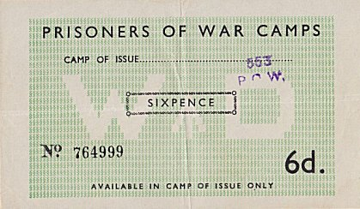  I can find no online reference to ‘Southern Ordnance Camp’ at Bridgwater. There was a ‘Royal Ordnance Factory, Bridgwater,’ but this was N of the town.  After the camp: residential and part industrial.  https://repatriatedlandscape.org/england/pow-sites-in-the-south-west/pow-camp-37-colley-lane/ | 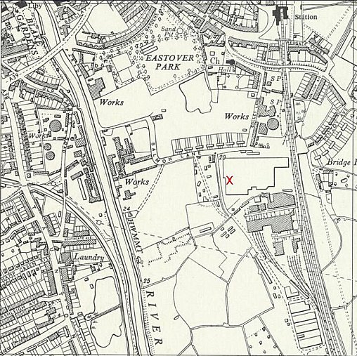
 | Ordnance Survey 1962

