Camp 36 - Walworth Castle, Walworth, County Durham

Prisoner of War Camps (1939 – 1948) - Project report by Roger J.C. Thomas - English Heritage 2003
OS NGR | Sheet | No. | Name & Location | County | Cond’n | Type 1945 | Comments
NZ 2316 1884 | 93 | 36 | Walworth Castle, Walworth | County Durham | 4 |  | Nissen huts dispersed under trees to east of castle

Location: About 7.5 km NW of Darlington.  Before the camp: Walworth Castle site dates from the 11th C – the castle was completed c.1600. Passed through various families.  POW Camp: The castle and grounds were used as a pow camp for 200 men including Italian and German officers. Some huts were found to the east of the castle building in woodland. Guards have been recorded as Durham Light Infantry and the Pioneer Corps.  In some similar places, pow officers were held in the main building, with guards in huts; or the huts were used to hold additional pows.  In an article referring to Commandant Major Holmes at Stadium Camp, there is a comment that there were 1000 pows – “with another 200 billeted under his overall command at Walworth Castle, near Darlington.” Possible therefore that Walworth Castle became a hostel for Camp 631.  Known Camp Commandant Major Rollin Holmes – very young. Transferred from Stadium Camp, Catterick, Camp 631. “Still just 27, he retired from military service at the end of 1946, the Germans clearly sorry to see him go and the top brass not very happy, either.  "I don't want to be boastful, but they sent a chap from the War Office to try to get me to change my mind but I wanted to be back in civilian life. I was married with a young son who I hadn't seen until he was three and bonding was quite difficult. He just thought I was this feller who'd come to spoil the cushy life he had with his mother." (Extracts from an article in The Northern Echo, 24 March 2005, by John North)  After the camp: Became a girls’ boarding school and then a hotel.  The site as it is now (2023) –  https://repatriatedlandscape.org/england/pow-sites-in-the-north-east/pow-camp-36-walworth-castle/ | 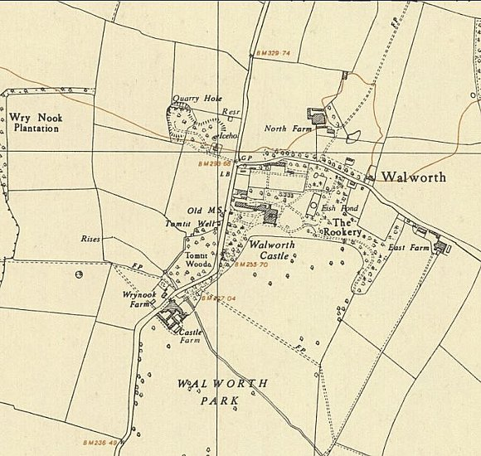
 | Ordnance Survey 1954

