Camp 3 (& 63) - Balhary Camp, Perthshire (aka Balhary Estate Camp)

Included in the 1945 ICRC List as – Labour Camp. 63. Balthary [sic] Est, Camp, c/o GPO Alyth, Perths.

1947 Camp List
63(G.W.C.) | Balbary [sic] Est. Camp, c/o G.P.O. Alyth, Perthshire | Sc. | Priswar, Alyth | Alyth 163/4 | Alyth Junc. (L.M.S.) | Lt.Col.D.M.Gall, M.C. | v/1453/2

Prisoner of War Camps (1939 – 1948) - Project report by Roger J.C. Thomas - English Heritage 2003
OS NGR | Sheet | No. | Name & Location | County | Cond’n | Type 1945 | Comments
 |  | 3 | Balhary Camp | Perthshire |  |  | Scotland
 |  | 63 | Balhary Estate Camp, Alyth |  |  | German Working Camp

Location: 3 Balhary / Rannaleroch NO 2504 4594  63 Balhary Estate NO 2665 4645  Correspondence with James Mackay, 2005, postal historian: Camp 3 (Balhary) and Camp 63 (Balhary Estate Camp) were about a mile apart. Camp 3 was actually located on a farm called Rannaleroch. After the war it became a Displaced Person’s camp renamed Leroch and even today (2005) is one of a dozen farm work camps in the UK employing East Europeans (mainly Poles). Camp 63 was in a huge field in front of Balhary House. All that remains of the Balhary Estate Camp is a massive three-storey watch tower.  2 miles south-east of Alyth, at the side of the A927  Information from RCAHMS (DE), October 2005 - “This prisoner-of-war camp is visible on vertical air photographs taken in 1949 (541A/477, 3173-3175, flown 19 June 1949) in area to the SE of Balhary House…The air photographs show the camp occupied an area of about 8.6 hectares with the main hutted section in the NE corner.  At least 35 huts can be identified on the photographs within what may be a fenced compound and a further 23 smaller huts, possibly for camp staff and guards on the S side of the main camp.  The buildings shown on the OS 1:10000 map (1977) do not follow the same alignment as those on the 1949 air photographs suggesting these are of a later date, the current OS digital 1:2500 scale map shows the field with no buildings.” | 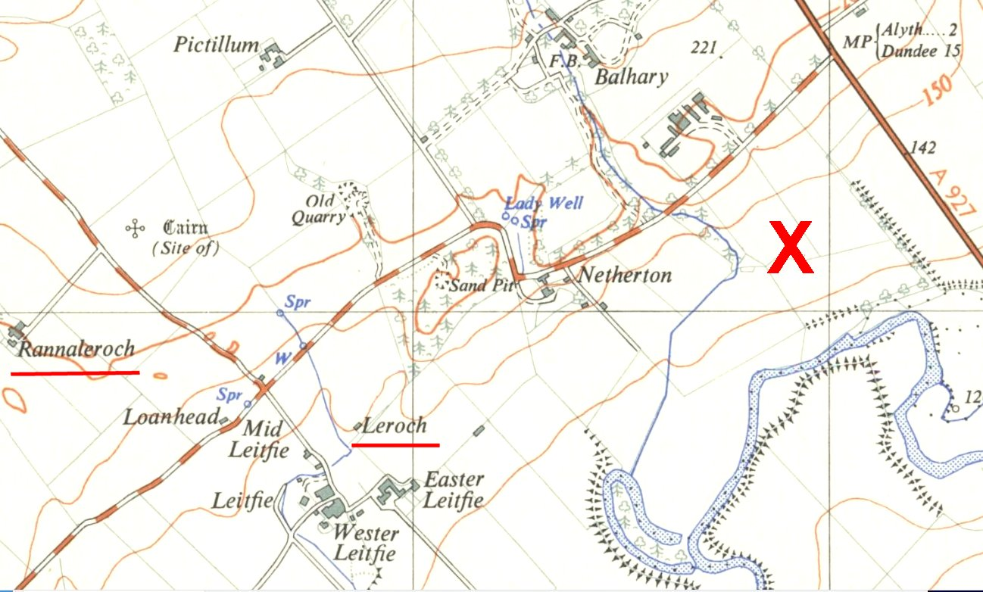
 | Ordnance Survey map 1959 - Map shows farm sites Rannaleroch and Leroch – the modern OS map only shows Leroch in the place where Rannaleroch was.

Pows worked at local farms, in woodland and in sawmills.
POW Camp:
12 November 1942 - International Red Cross inspection - Italian prisoners, capacity 800.

1943 / 1944 - A modern list of Italian camps recorded 4 hostels with Italian pows – Bankfoot / Friockheim / Pitroddie / Tannadice.

May 1944 and November 1944 - The camp was listed as an Italian Labour Battalion (Camp 63) under the Scottish Command area in, (WO 32/10737).

POW mail was censored and some of their comments were recorded to summarise Italian attitudes towards politics and to Britain. One pow at Balhary stated; ‘I no longer remember that I am an Italian. I have already been two and a half years in Scotland, which seems like my own country.’ (FO 371/49859/ZM 696, ‘Postal and Telegraph Censorship’).

Listed as an Italian working camp to at least 1945. English Heritage then records it as a German Working Camp.

2 October 1945 – Report of Mr J Grant’s visit for English Education. Recorded as Camp 63, Balhary Estate. Commandant Lt Col. Leshallas ( spelling ? ).

German pows. “This is a very pleasant camp where Commandant is interested in education and re-education. Unfortunately he [is] due to go very soon. Camp is hutted and gay with flower beds.”

There were three English teachers with 106 pow pupils of mixed abilities.

29 December 1945 – very brief note about James Grant’s English Education visit; “… a most friendly camp in every way.”

11 June 1946 – English Inspector’s Report by James Grant. Total strength 1755. 6 hostels.

Commandant: Lt Col D G Gall Lagersprecher: Wilhelm (Willi) Hildebrandt

It was stated that there was little contact between the main camp and the hostels. There had been several staff changes and an unsettled picture was given.

Many of the pows had been transferred from the US, their morale was low as they had expected to be returned to Germany due to false information given to them in the States.

29 / 31 July 1946 – W G W Aston carried out a Re-education Survey. Strength – 1 officer; 1894 OR. (14 over 50 years old).

Commandant: Lt.Col D M Gall, MC. Camp Leader: St.Fw Hildebrandt, Wilhelm (A)
Interpreter: Pte A G Gorbits (French nat, German born). Deputy CL: Fw Kast (A)
German M.O.: S/Arzt Dr Fiegenbaum, Adolf (B+)
German dentist: U/arzt Klein (A)

Only 831 of the pows had been politically screened: A+ - 3 / A – 60 / B – 590 / C – 178. About 1000 pows had arrived from the USA and Canada. Morale overall was fairly high with favourable factors being a lot of sport activities, re-education activities and good food.

The standard list of re-education activities was given:

Wochenpost and Ausblick – 390 / 80 copies received respectively.

Newspapers – a range of Scottish / English papers received. 8-10 German papers. Some Swiss papers received privately.

Library – 1074 books. Insufficient books for the hostels.

Lectures – regular, with increasing audiences.

Discussion Groups – various groups involving 250 to 300 pows.

Films – YMCA films every 3 weeks and BFC every 2 weeks. Films also shown at most hostels.

Wireless – BBC and Hamburg stations were the regular stations listened to.

Camp Magazine – ‘Der Huttenbote Campzeitung Des Kriegsgefangenenlagers No.63’ (The Hut messenger?). Fortnightly with 250 copies.

Press reviews – not carried out.

English Instruction – separate report.

Other activities:

Religion – services were held in the theatre. There was a protestant padre. RC pows attended mass every 3 weeks at Alyth RC Chapel. There were also bible study groups.

Education – in addition to English, there were small classes for; French, German literature, German history, maths, shorthand, calligraphy, English history, book keeping, motor mechanics and agriculture.

Theatre – 20 pows formed a variety group producing mainly comedies.

Orchestra – 13 pows played light classical pieces – there were some evening performances of music and poetry.

Choir – 30 members and an additional religious choir.

23 – 24 October 1946 - English Inspector’s Report by James Grant. Total strength 2250. 8 hostels.

3 classes, but insufficient teaching materials. Low attendance due to late nights working on gathering harvests.

11 November 1946 – Mr H A Morgenstern from the ‘Segregation Section’ (a section of COGA - Control Office for Germany and Austria (UK)) made a report on the camp. Strength – 2 officers; 2203 OR.

Commandant: Lt.Col D M Gall, MC. Camp Leader: St.Fw Hildebrandt, Wilhelm (A)
2nd I/C: Major I R L Fraser
Adjutant: Capt C MacKenzie
Interpreter: Lt P Kohl.

The main purpose of the visit was to carry out political screening. The grades for the whole camp were:

A+ | A | A- | B+ | B | B- | C | C+ | Not known
2 | 129 | 1 | 237 | 902 | 190 | 299 | 9 | 436

It was stated that the Commandant was; “furthering political re-education in his camp and is well acquainted with our aims and methods. He knows his prisoners well.”

The Interpreter Officer was new to this camp and had been promoted from S/Sgt – “Well informed of his duties, young and full of drive. He speaks faultless German…”

The Camp Speaker was a regular soldier from 1932, “…but was never a soldier at heart. He comes from a family of workers with T.U. and socialist background and had several clashes with the Nazi authorities… Good Camp Speaker who has organised his camp on democratic lines.” He had previously been graded as ‘B’ – this visitor regraded him as ‘A’.

The organiser of studies was Soldat Karl Norbert Teubert (A+), a Christian Democrat, journalist and former press photographer – he had a; “Clean record, intelligent and reliable.” He was also due for repatriation and it was expected that the camp dentist, Unterarzt Hans Rolf Eberhard Klein (A) would take on the responsibilities for organising studies. Described as “Intelligent man with firm convictions and a high sense of duty.”

In summary, the visitor reported that; “My visit has raised morale sky-high. PsW feel that they are not forgotten in Scotland and that promises of repatriation are being implemented.” He recommended the removal of all Grey and Black Camp Leaders, and the replacement of the two religious leaders.

Religion – There was a protestant padre, Obergefreiter Herbert Schaufler (B+) – a “decent young man, aged 24, but no strong personality.” There were about 700 protestant pows, but only 40 attended services. There was no RC padre, but RC spiritual welfare was administered by a lay-man, Unteroffizier Alois Oelschlaeger (A) – “a genuine anti-Nazi who does his best without great success.” 300 RC pows with about 100 attending services. Pows in hostels attended local churches.

Winter / Spring 1946 / 1947 – heavy snowfalls and then flooding in the area.

17 – 19 March 1947 – L H F Thornton visited the camp to survey re-education and screening. Strength - 2 officers; 2120 OR.

Political screening: A – 1 / B – 1673 / C – 277 / C+ - 2 / Rest unscreened. A number of pows were appealing against their grades - better grades meant earlier repatriation. 767 pows had been repatriated to date.

Commandant: Lt.Col D M Gall, MC. Camp Leader: Ernst Frank (B+)
Interpreter: 2nd Lt Kohl. Deputy C/L: Uffz Karl Schlautkoetter, Karl (B+)
German M.O.: S/Arzt Dr Fiegenbaum, Adolf (B+)
Asst. Arzt. Fuellkert (B-)

The Interpreter Officer had been at the camp since October, (previously at Camp 199) – “He speaks excellent German, has energy and seems on good terms with all in the camp.” Unfortunately, he was moved shortly after this report.

The Camp Leader was described as; “an old regular soldier and for the purpose of running the camp is excellent. Politically he is not much use though he does give the weight of his support and authority to the various camp activities.”

The study leader and dentist was Dr Klein. (A)

Morale was normally good, though the pows were remote, without outside contacts. Mail was good except for the East-Prussians, (Russian zone of occupation). Negative aspects included; Flooding, lack of money due to no work, poor food, poor tobacco and cigarettes, and conditions in Germany. The visitor thought there was steady progress in developing political awareness.

40% of the camp were youth (under-25), but were not seen as a problem.

Shortage of accommodation was a problem for developing activities. The standard list of re-education activities was given, (see below for a very similar list).

Religion – no great interest was shown in the camp. There was a Protestant minister (Schlaufler), but no RC padre. There was no designated meeting room for services. Pows were able to visit local churches as time allowed.

Education – only a few classes were being held.

Entertainment – a good orchestra, but lacking instruments. An active theatre group. Visits to hostels had not been possible due to bad weather. Sports had also been affected.

It was noted that a large number of hostels were due to close. [Note – a camp leader was listed for Tannadice hostel, but no pows were listed].

15 – 21 April 1947 – L Thornton visited the camp to look at political screening.

Summary figures were given: A – 5 / B – 1972 / C+ - 4. This may not have been the total strength as Mr Thornton did not visit some hostels. Three of the C+ pows “were newly arrived from Watten (Camp 165) and are self professed National Socialists. Apart from these bad spots I found that the average POW was well-disposed and conscious of his obligations and duties.”

40 pows were appealing against their B gradings.

15 / 17 May 1947 – English Inspector’s Report by James Grant. Strength 2559

Commandant: Lt.Col J H Stitt, MC. Camp Leader: Kirschke, Hermann

There were 3 small classes and some ‘private’ studies for English – only 97 students altogether.

22 - 26 July 1947 – S Denham-Jacobs carried out a Re-education Survey. Total strength 2 officers; 2037 OR.

General screening figures were given: A – 6 / B – 2033. 1123 pows had been repatriated to date.

Commandant: Lt.Col J H Stitt, MC. Camp Leader: de Buhr (B+)
Interpreter: Nil Deputy C/L: Uffz Schlautkoetter, Karl (B+)
German M.O.: S/Arzt Dr Fiegenbaum, Adolf (B+)

Commandant Stitt had been a pow in the Far east.

The Camp Leader was Christoph De Buhr, he had previously been leader at the Pitrodie hostel. Described as, “a good type of NCO although lacking inspiration and initiative.”

The MO was described by the visitor as; “pleasant, middle-aged individual, but has not the slightest interest in re-education. He is inclined to be cynical and superior.”

Morale was fairly good – a positive effect was noted to be the Commandant’s great interest in the pow’s well-being. Negative aspects included the remoteness of the camps with bigger towns being, “out of bounds”, conditions in Germany, and poor cigarettes. The German camp staff complained that they were paid less than those working on farms. There were difficulties with providing transport which caused problems with hostels being so wide-spread.

A large number of pows had recently been transferred from Watten Camp 165, many had been regraded from C to B. 40% of the pows were ‘youth’.

The German dentist, U/Arzt Dr Hans Klein, was responsible for developing re-education activities. Some activities were affected by long working hours at local farms – further disruption was expected with a large number of pows being transferred. The standard list of re-education activities was given:

Wochenpost and Ausblick - separate report.

Newspapers – adequate. Papers also received from the British and USA zones of Germany, but none from the French and Russian.

Library – 1170 volumes + 300 at Errol and 400 at Calvine. Pows complained that there was insufficient light reading.

Lectures – regular, but no great interest in general, an exception being when a lecturer had been female.

Discussion Groups – only active at main and Whitefield hostel.

Films – projector out of order for 8 weeks.

Wireless – adequate.

Camp Magazine - 300 copies printed.

Press reviews – fortnightly.

English instruction – separate appendix.

Information room – none.

Other activities:

Religion – no camp church, it was stated that the previous Commandant would not allow one, but no reasons were given. Interest was small.

Education – there were 16 different classes for a wide range of subjects.

Entertainment – there was an orchestra, but it was short of instruments. A theatre group performed, but stage facilities were poor.

Outside contacts – none. It was hoped that a canteen would be opened at Alyth.

6 – 10 October 1947 – Educational survey carried out by H McCarthy-Main. Strength 4 officers; 3856 OR. A very large increase in pow numbers.  There was a new interpreter: Capt H B Stadler – and a new German Camp Leader: Fw. Krebs, Werner (B)  500 pows were due to be repatriated within a fortnight.  The commandant was seen as ‘utilitarian’ and not furthering re-education within the camp.  The Camp Leader was, “age 32, is non-political, is administratively good but no educationalist.” The dentist, Unterarzt Hans Klein, continued to lead activities.  Morale was generally good – especially with the notice of repatriations. Dundee and Perth were considered to be “dangerous” towns and there was limited contact.  25% of pows were youth, but they were not seen as a particular problem.  Many pows were involved at local farms with the potato harvest. Re-education activities were developing following the harvest and major changes in the numbers of pows – see standard list in the November report.  24 / 29 October 1947 – English Inspector’s Report by A Robinson. Strength 3040.  Just 2 classes with 73 students for English in the main camp.  14 November 1947 - Camp number included in an ‘Urgent Memorandum’ (FO 939/270) regarding inspection of food parcels. | 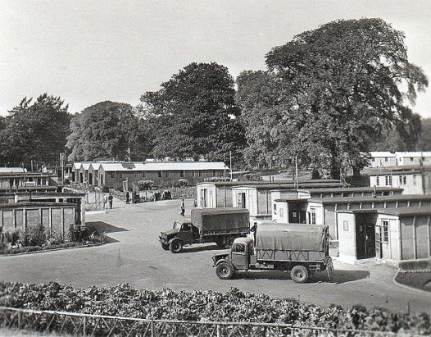
 | 1947 - Alyth Family History Project https://www.facebook.com/AlythFHP

17 – 20 November 1947 – A Re-education Survey carried out by H McCarthy-Main. Strength 3 officers; 2817 OR.

Commandant: Lt.Col I H Stitt, MC. Camp Leader: Uffz Hoffmann, Artur (B-)
Interpreter: Capt H B Stadler Deputy C/L: Uffz Schlautkoetter, Karl (B+)
German M.O.: S/Arzt Dr Fiegenbaum, Adolf (B+) S/Arzt Dr Wollmann, Siegfr. (B-)
A/Arzt Dr Hamm, Julius (B) U/Arzt Dr Klein, Hans (A) [Dentist]

The new Camp leader was described as; “Mittelschule, no political affinities, a plumber, efficient. Keeps good discipline and allows his education staff to develop.”

Good overall morale – “The good and fair treatment meted out by the British staff is largely responsible”. Increased repatriations also played a major part. Christmas was being looked forward to. Negative aspects included lack of transport and clothing, with a large group arriving from the south without winter clothing.

Youth – about 1/3 of the pows were youth. Some of these were politically graded as ‘black’ (C).

The standard list of re-education activities was given:

Newspapers: Adequate supply, distribution to hostels had been a problem. Some German newspapers received privately.

Library: 3600 books. Adequate.

Lectures: Poor attendances lately due to weekend timings when local cinemas offered a better attraction, Lack of transport for the hostels, inadequate arrangements.

Discussion groups: Many groups, mainly political discussions.

Films: Regular from YMCA and Travelling Films Ltd in the main camp. Some of the hostels had issues with generators and transport.

Wireless: Adequate.

Camp magazine: continued.

Press reviews: Regular in main camp and most hostels.

The visitor proposed that the camp should make contacts with the authorities in Perth and Dundee, but little seems to have developed.

Other activities:

Religion: Interest was “average to weak”. German padres visited and some pows attended local churches. Dr Fraser, a German scholar from Perth visited local hostels to conduct services.

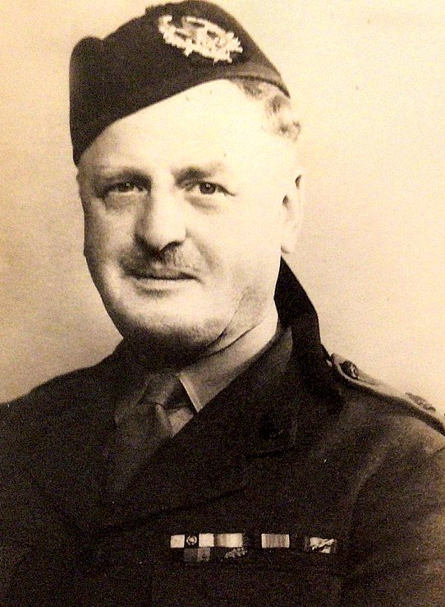 | Education: In addition to English language lessons, classes were held for carpentry, bee-keeping, French, German, World history, shorthand, mathematics, design, literature, horticulture and agriculture.  Entertainment: A band and a choir of 12 in the main camp – they visited other camps when transport was available. Football keenly pursued.  20/23 January 1948 – English Inspector’s Report by A Robinson. Strength 1879.  As the camp was wound down there were no classes for English teaching. The library was largely transferred to Errol Hostel.  February 1948 – Camp 63 took over the running of Annsmuir Camp 77 and four hostels – Balgowan; Dunino; Dunning and The Beeches. This was a short-lived arrangement as the newly acquired camps were closing down - only Dunino and Beeches were listed in March.  9 / 13 March 1948 – English Inspector’s Report by A Robinson. Strength 1006.  No English lessons at the main camp or at any hostel.  Known Commandants:  1945: Lt Col. Leshallas (Spelling?)  <<< 1946 / 1947: David Menmuir Gall, M.C. Entry in the Supplement to the London Gazette, 16 September 1947: “Cameronians, Capt. (War Subs. Maj.) D.M.GALL, M.C. (52051), having exceeded the age limit of liability to recall, relinquishes his commn., 13 Sept. 1947, and is granted the hon. Rank of Lt.Col.” Photograph kindly provided by granddaughter.  1947 Lt.Col J H Stitt, MC. From the Gordon Highlanders. – also recorded as commandant at Gosford Camp 16.  After the camp: Balhary Estate cleared, no remains. Balhary / Leroch became a farm work camp for displaced persons, the land around is now part golf course, part farming land. The huts were demolished in 1996.  The site as it is today - https://repatriatedlandscape.org/pow-sites-in-scotland/pow-camp-63-balhary-estate/
Camp numbers:

 | Open |  |  | With other camps |  |  | Unknown |  |  | Not listed / not open

 | 12/42 | 43/44⁺ | 6/46 | 7/46 | 10/46 | 11/46 | 3/47 | 7/47 | 5/47 | 10/47 (1) | 10/47 (2) | 11/47 | 1/48 | 3/48
Balhary | 800 cap | + | 902 | 862 | 936 | 967 | 653 | 596 | 697 | 758 | 698 | 730 | 157 | 104
Bankfoot |  | + | 72 | 77 | 80 | 73 | 65
Burrelton |  |  | 68 | 68 | 72 | 75 | 57 | 81 | 87 | 74 | 69
Friockheim |  | + | 74 | 71 | 61 | 66 | C275
Inchture |  |  | 72 | 79
Meikleour |  |  | 174 | 185
Tannadice |  | + | 72 | 75 | 69 | 68 | With Camp 75
Douglas Wood |  |  |  | 152 | 149 | 152 | 94 | 51 | 87 | 161 | 144 | 138 | 190
East Haven |  |  |  |  | 92 | 41
Tealing |  |  |  |  | 268 | 273 | 137 | 177 | 250 | 275 | 235 | 226
Whitefield |  |  |  |  | 161 | 162 | 70 | 139 | 155 | 147 | 134 | 131 | 94 | 11
Pitroddie |  | + |  |  |  |  | 65 | 76 | 85 | 76 | 75 | 72 | 71 | 399
Errol |  |  |  | Camp 274 |  |  | 99 | 186 | 376 | 1320 | 781 | 743 | 426
Calvine (Sat) |  |  |  | Camp 66 |  |  | 564 | 448 | 528 | 271
Black Isle |  |  |  |  |  |  |  |  |  |  | 265 | 271 | 287 | 140
Buddon |  |  |  |  |  |  |  |  |  | 495 | 361 | 234
Rosemount |  |  |  |  |  |  | With Camp 75 |  |  |  |  |  | 428 | 83
Dunino |  |  |  |  |  |  | With Camp 77 |  |  |  |  |  |  | 27
The Beeches |  |  |  |  |  |  | With Camp 77 |  |  |  |  |  |  | 87
Other |  |  |  |  |  |  |  |  |  |  |  | 9 hospital
Billetees |  |  | 313 | 326 | 345 | 328 | 312 | 285 | 294 | 283 | 278 | 266 | ? | 155
Total | 800 |  | 1755* | 1895 | 2250” | 2205 | 2122* | 2039 | 2559 | 3860 | 3040 | 2820 | 1879 | 1006

+ camp / hostels listed, numbers unknown. * totals do not tally with figures above.

Further information:

Historic Environment Scotland: Lists Camp 3, not 63

National Archive Reference: Lists Camp 63 – FO 939/144 - 63 Working Camp, Balhary Estate Camp, Alyth, Perthshire – dated 1945-48, (used above).

The Imperial War Museum has copies of the magazine dated Weihnachten-Neujahr 1946-1947 / May 1947. Ref LBY E.J. 369.

Hostels

Bankfoot – (Location – sited where Garry Place, Bankfoot is now – NGR NO 063 353).

1944 (possibly earlier) - Held Italian pows.

June 1946 - 5 huts recorded.

July 1946 – Camp Leader; Uffz Janke

November 1946 – Camp Leader; Unteroffizier Karl-Heinz Janke (B). He was a; “medical student. Good clerk and interpreter, but not the right man for a hostel where Nazi-influence is predominant through the presence of some young Nazi thugs of the Africa Corps”. 27 from 73 pows were classed a ‘C’. [It does not state this, but these pows were most likely held in Canada prior to this camp].

March 1947 – Camp Leader; Hans Jahn (C)

End March 1947 - Hostel disbanded and leader moved to Whitefield hostel.

(There were Polish troops stationed in Bankfoot – could be at a different site, or possibly guards, or at this site after March 1947?)

 | 12/42 | 43/44⁺ | 6/46 | 7/46 | 10/46 | 11/46 | 3/47 | 7/47 | 5/47 | 10/47 (1) | 10/47 (2) | 11/47 | 1/48 | 3/48
Bankfoot |  | + | 72 | 77 | 80 | 73 | 65

Black Isle (Blair Atholl) – 50 miles from main camp. Near Calvine. All references in the file FO 939/144 refer to ‘Black Isle’ – however, I believe this was Black Island, a strip of land between the railway and River Garry – NGR NN 853 655.  During WW2 the No.5 Company of the Canadian Forestry Corps were stationed here. A note in the CFC War Diary for 1943 showed that the CO went to visit the nearby pow camp – it does not name it, but presumably this was Calvine Camp 66, and I would expect that pows worked with the Canadian troops. The CFC forestry camp was described as being about 40 or so huts in use by the CFC up to August 1945. I am guessing that this may have been the site for the pow camp after this date.  Possibly attached to another camp before October 1947.  October 1947 - pows were transferred from the nearby Calvine satellite camp.  November 1947 – Camp Leader; Uffz Christoph, Alfred (B), - previously Camp Leader at Calvine. Age 41, “is among the best of camp personnel”. Good morale noted. Carpentry class. Generator problems led to lack of films and limited wireless reception. Band of 7 musicians. | 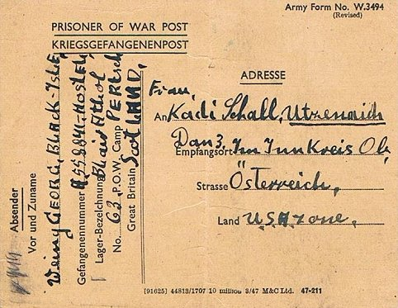
 | Camp 63 Black Isle – dated February 1948

 | 12/42 | 43/44⁺ | 6/46 | 7/46 | 10/46 | 11/46 | 3/47 | 7/47 | 5/47 | 10/47 (1) | 10/47 (2) | 11/47 | 1/48 | 3/48
Black Isle |  |  |  |  |  |  |  |  |  |  | 265 | 271 | 287 | 140

Buddon – 25 miles from main camp, near Carnoustie. Now the site of the Barry Buddon Army Training Camp. NGR NO 521 326  Possibly attached to another camp before October 1947.  October 1947 - “Very inadequate accommodation and conveniences.” Oil lamps were being used for lighting – so was there an electricity supply? Camp Leader; Uffz Rothermel, Hermann (B). He was; “educated but depressed at the state of Buddon, where little re-education is possible.”  November 1947 – Same camp leader. The site was in the process of closing down. Noted that some of the pows were politically ‘black’.  12/42 43/44⁺ 6/46 7/46 10/46 11/46 3/47 7/47 5/47 10/47 (1) 10/47 (2) 11/47 1/48 3/48  Buddon 495 361 234 | 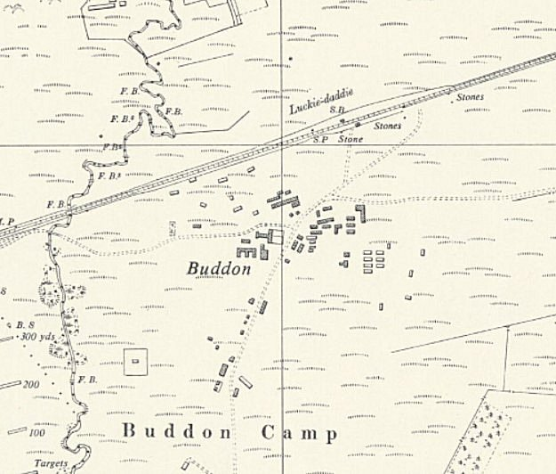
 | Ordnance Survey 1959

Burrelton – 13 miles from main camp. Burrelton Village. Local information gives probable site at what is now Hall Crescent, Burrelton, NGR NO 2020 3724.

Possibly attached to another camp before June 1946.

June 1946 – 8 huts

July 1946 – Camp Leader; W/m Koppe

November 1946 – Camp Leader; as above, Wachtmeister Paul Koppe (B). “32 years old, this man has travelled and shows understanding of the mentality of many peoples but is not interested in politics.”

12 of the 75 pows were graded C.

March and October 1947 – same Camp Leader, “quite satisfactory and easily controls the 57 men in this grey hostel”. There was little re-education activity at the hostel, but some pows went to nearby Whitefield hostel for activities such as visiting lecturers. A lot of sporting activities were recorded. “The hostel is in close contact with the civil population – being just off the village street.” “The Ps/W are content, morale is good, even though one man committed suicide on the night before my visit, and there were no complaints.” [I think this was a pow who jumped from the bridge onto the track near Burrelton Station in May 1947].

 | 12/42 | 43/44⁺ | 6/46 | 7/46 | 10/46 | 11/46 | 3/47 | 7/47 | 5/47 | 10/47 (1) | 10/47 (2) | 11/47 | 1/48 | 3/48
Burrelton |  |  | 68 | 68 | 72 | 75 | 57 | 81 | 87 | 74 | 69

Calvine Satellite Camp – Formerly Camp 66. 50 miles from the main camp.

March and April 1947 - Officer i/c Captain F Blackie R.A.C. – “seemed well liked and fair”. Camp leader; Hermann Kirschke (B+) – “able and intelligent P/W who can be trusted to do his job well.” A range of re-education activities were taking place. Morale was good.

July 1947 – Camp Leader; Uffz Christoph, Alfred (B). Many of the pows had arrived from the USA and Canada. The ex-US pows in particular had low morale as they had been mis-informed in the States that they were to return to Germany. Most of the pows from Canada had been prisoners for many years and many were seen as politically ‘black’ (C).

October 1947 - same Camp Leader. Pows being transferred to Black Isle.

 | 12/42 | 43/44⁺ | 6/46 | 7/46 | 10/46 | 11/46 | 3/47 | 7/47 | 5/47 | 10/47 (1) | 10/47 (2) | 11/47 | 1/48 | 3/48
Calvine (Sat) |  |  |  | Camp 66 |  |  | 564 | 448 | 528 | 271

Douglas Wood – 20 miles from main camp. Hutted. Ex RAF Camp and next to an RAF wireless post, one of the Chain Home air defence RDF stations. 3 parts to this base; centre marked on map at NGR NO 4877 4154 (X) – also accommodation site at NO 4954 4175 (Y).  July 1946 - Hostel opened. Camp leader; O/Fw Trudel.  Unlike the main camp, morale was seen to be low. All pows had newly arrived from the USA and Canada. The ex-US pows had particularly low morale as they had been mis-informed that they were to return to Germany. Many had not received news from their home and food was poor. |  | 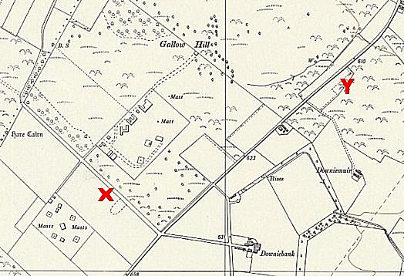  Ordnance Survey 1959
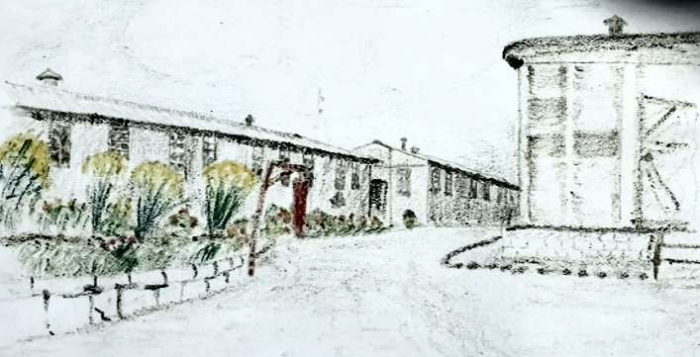  Enhanced image from a sketch of the camp.  www.douglashistory.co.uk/history/Places/douglas_wood.html | November 1946 – same Camp leader; Oberfeldwebel Max Trudel (B). “Opportunist, SPD 1924-1932 who joined the NSDAP in 1937 (under pressure as he says now). Realising that his party record will always be a handicap for him, he has become cynical and bitter and lost all faith in the future.” These negative remarks did not arise with other visitors after this. 11 out of 152 pows were graded ‘C’, most of these would have been the pows from Canada.
The main driving force for re-education in this hostel was seen to be Gefreiter Reginald Wildenhayn (A+) who had previously been held in the USA. Political discussion groups had started.

March to at least November 1947 - Hostel leader continued to be Max Trudel – “amusing, very likeable Hamburger,
does his job well and ably. A fine man.” Political complexion of the hostel was light grey – “Douglas Wood has the best spirit of all the hostels”.

 | 12/42 | 43/44⁺ | 6/46 | 7/46 | 10/46 | 11/46 | 3/47 | 7/47 | 5/47 | 10/47 (1) | 10/47 (2) | 11/47 | 1/48 | 3/48
Douglas Wood |  |  |  | 152 | 149 | 152 | 94 | 51 | 87 | 161 | 144 | 138 | 190

Dunino – previously with Annsmuir Camp 77

August 1948 - Taken over for administrative purposes as it was being closed down.

 | 12/42 | 43/44⁺ | 6/46 | 7/46 | 10/46 | 11/46 | 3/47 | 7/47 | 5/47 | 10/47 (1) | 10/47 (2) | 11/47 | 1/48 | 3/48
Dunino |  |  |  |  |  |  | With Camp 77 |  |  |  |  |  |  | 27

East Haven – 30 miles from main camp. Hutted

Possibly attached to another camp before October 1946.

November 1946 - CL Hauptfeldwebel Hans Heinrich Peter Gosch (B). “Ex-policeman, regular soldier since 1933. Politically uninspired but willing to learn.” 5 out of 41 pows were graded ‘C’. A strong religious presence was noted, with many pows attending local churches.

 | 12/42 | 43/44⁺ | 6/46 | 7/46 | 10/46 | 11/46 | 3/47 | 7/47 | 5/47 | 10/47 (1) | 10/47 (2) | 11/47 | 1/48 | 3/48
East Haven |  |  |  |  | 92 | 41

Errol – Formerly Camp 274

March and April 1947 - Part of a huge RAF M.U. with some pows attached to the Unit. Hostel Leader, Rolf Lueders, gave a good impression and was regraded from B+ to A.

July / October / November 1947 - same hostel leader - Wm. Luedders, Rolf Bodo (A), “age 33, no political affinities, Arbitur bank-clerk, is highly intelligent and has a flair for organisation.”

January 1948 - being used mainly as a transit camp prior to repatriation

 | 12/42 | 43/44⁺ | 6/46 | 7/46 | 10/46 | 11/46 | 3/47 | 7/47 | 5/47 | 10/47 (1) | 10/47 (2) | 11/47 | 1/48 | 3/48
Errol |  |  |  | Camp 274 |  |  | 99 | 186 | 376 | 1320 | 781 | 743 | 426 | 399*
* Combined number of pows with Pitrodie hostel.

Friockheim – 26 miles from main camp.

1943 / 1944 - listed as a hostel with Italian pows.

June 1946 - 6 huts

July 1946 – Hostel Leader; O/Wm Grimm (C)

November 1946 – Hostel leader; Obermaat Heinz Berger (C). “Very backward hostel. 50% US intake. The Nazi atmosphere already reported by Capt Drucker has not improved since the former Nazi Hostel Speaker Grimm has been replaced by another Nazi.” 21 out of 66 pows were graded ‘C’.

Became separate camp 275.

 | 12/42 | 43/44⁺ | 6/46 | 7/46 | 10/46 | 11/46 | 3/47 | 7/47 | 5/47 | 10/47 (1) | 10/47 (2) | 11/47 | 1/48 | 3/48
Friockheim |  | + | 74 | 71 | 61 | 66 | Camp 275

Inchture – 22 miles from main camp.

June 1946 – 5 huts

July 1946 – Hostel Leader; CL F/w de Buhr (B) – he later moved to Pitrodie

 | 12/42 | 43/44⁺ | 6/46 | 7/46 | 10/46 | 11/46 | 3/47 | 7/47 | 5/47 | 10/47 (1) | 10/47 (2) | 11/47 | 1/48 | 3/48
Inchture |  |  | 72 | 79

Meikleour – 10 miles from main camp.

Probably attached to another camp before June 1946.

June 1946 – 18 huts

July 1946 – Hostel leader; O/Fw Graefe (C)

 | 12/42 | 43/44⁺ | 6/46 | 7/46 | 10/46 | 11/46 | 3/47 | 7/47 | 5/47 | 10/47 (1) | 10/47 (2) | 11/47 | 1/48 | 3/48
Meikleour |  |  | 174 | 185

Pitroddie –

1943 / 1944 - Listed in modern Italian camp list, but then no further details until March 1947.

Local memories: ‘Golach’ - 17-Jan-07;

“I left Caithness in 1946, to settle on a small farm in the Carse of Gowrie in Perthshire, the Mains of Pitroddie, my father was a ploughman who worked with two of the nicest Clydesdales I ever met. 100 yards from our house, which in those days had no electricity, no running water inside the house, and a dry lavvie that my father moved around the garden)… was originally an Italian POW camp with barbed wire and all the trappings one would expect of a POW camp.
Shortly after the Germans arrived and it was all change, the barbed wire came down, the British soldiers no longer went around armed, and the POW were allowed out to work, and mix with the locals to a certain extent.
I, at nearly 7 years old was the only child for nearly a mile around the camp, so it did not take me long to become friends with the POW's and eventually I was spending as much time in the camp as I was at home. The Germans were nothing but kindness to me, I had some of the greatest toys you could ever imagine, I could count up to twenty in German. I ate and watched movies with my new found friends, (remember this is now 1947), I saw flushing toilets, showers, Electric lights and food that my parents could never hope to supply. Some of the POW's used to come to our house at night and play cards with my parents.
The POW's all wore square or diamond patches on their clothing, to identify them as POW's, one night they sewed a patch on the back of my jacket, my parents laughed their heads off, I was broken hearted as I thought I was going to be sent back to Germany.:( I was also the POW's football team mascot, with a strip but no football boots and travelled all over Perthshire with them playing football against other POW camps and British soldiers.” http://forum.caithness.org/archive/index.php/t-20294.html

March and April 1947 – “a beautifully laid out and well tended hostel, set in lovely surroundings.” About 70 pows – “of a good type”. Leader Christoph De Buhr (B+) – “satisfactory”. Though there was little re-education activity, the visitor had; “a good impression of the hostel and its inmates.”

July 1947 – Hostel leader; H/Fw Gosch, Peter (B); “with some youthful enthusiasm which seems to be taking effect.”

October and November 1947 - same leader; “age 35. Despite trying conditions this spokesman keeps his PsW morally and intellectually at a good level.” Good morale noted.

 | 12/42 | 43/44⁺ | 6/46 | 7/46 | 10/46 | 11/46 | 3/47 | 7/47 | 5/47 | 10/47 (1) | 10/47 (2) | 11/47 | 1/48 | 3/48
Pitroddie |  | + |  |  |  |  | 65 | 76 | 85 | 76 | 75 | 72 | 71 | 399*
* Joint number with Errol camp.

There is a small book – ‘Prisoners of war at Pitroddie during the Second World War’ by Donald Abbot - Invergowrie: 2000 – I have not yet tracked a copy down.

Rosemount (Hillside)

Previously with North Hill Camp 75 at Laurencekirk.

January 1948 - pows awaiting repatriation

 | 12/42 | 43/44⁺ | 6/46 | 7/46 | 10/46 | 11/46 | 3/47 | 7/47 | 5/47 | 10/47 (1) | 10/47 (2) | 11/47 | 1/48 | 3/48
Rosemount |  |  |  |  |  |  | With Camp 75 |  |  |  |  |  | 428 | 83

Tannadice – 16 miles from main camp. Close to Broom Farm, (aka ‘The Broom’ and previously as ‘Wester Balgillo’). Site NGR NO 4716 5863.  1943 / 1944 - Listed in modern Italian camp list. Local memories recall Italian pows.  June 1946 – 4 huts.  July 1946 – Hostel leader; F/w Janta (C). It was recommended that he be removed, but this did not happen. There were 23 new pows from the USA with low morale as they had been mis-informed that they were to be returned to Germany.  November 1946 – Hostel Leader; Feldwebel Horst Janta (C). “Harmless Nazi. Hostel atmosphere should improve under better leadership, as there is a high percentage of Whites who however have no influence on the Nazi Youth who keep apart, remain insolent and unteachable.” 13 out of the 68 pows were graded C.  August 1947 – recorded as a hostel with Northhill Camp 75  12/42 43/44⁺ 6/46 7/46 10/46 11/46 3/47 7/47 5/47 10/47 11/47 1/48 3/48  Tannadice + 72 75 69 68 | 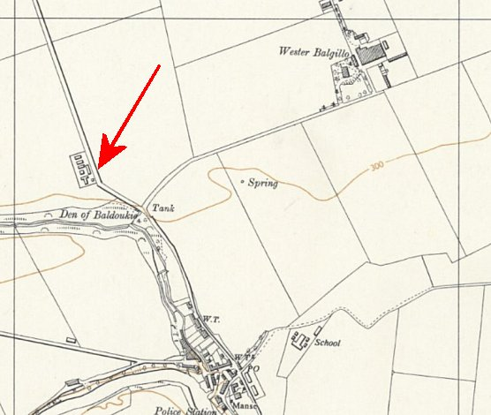
 | Ordnance Survey 1959

Tealing – 20 miles from the main camp. Hutted.

Located at Tealing Airfield. The airfield was placed on Care and Maintenance in June 1945. The accommodation site was used as a PoW camp probably from late 1945.

November 1946 – Hostel leader; Funk-Obergefreiter Hans Stephan (B+) “Young man with socialist background, intelligent and with positive outlook but without drive. Makes a sleepy impression.” 67 out of the 273 pows were graded ‘C’.

March and April 1947 – Hostel leader; Gerhard Gnerlisch (B+) – “satisfactory”. It is a rather lonely place. All pows worked on local farms and were “content”.

May 1947 – A comment in the English Inspector’s Report – “no teacher: Richard Christ escaped 11.3.47 and so far no trace beyond Newcastle has been found.” No further information.

July 1947 – Hostel leader; Ofw Schlegelsberg, Karl-Heinz (B), age 31, “is a worker”. Same leader in October 1947.

November 1947 – Hostel leader; Uffz Schleuter, Franz (B-), “age 34, clerk in metal works, has been spokesman just over one month. This PW is on the weak side but may develop.”

 | 12/42 | 43/44⁺ | 6/46 | 7/46 | 10/46 | 11/46 | 3/47 | 7/47 | 5/47 | 10/47 (1) | 10/47 (2) | 11/47 | 1/48 | 3/48
Tealing |  |  |  |  | 268 | 273 | 137 | 177 | 250 | 275 | 235 | 226

The Beeches – previously with Annsmuir Camp 77

February 1948 - Taken over for administrative purposes by Balhary as it was being closed down.

 | 12/42 | 43/44⁺ | 6/46 | 7/46 | 10/46 | 11/46 | 3/47 | 7/47 | 5/47 | 10/47 (1) | 10/47 (2) | 11/47 | 1/48 | 3/48
The Beeches |  |  |  |  |  |  | With Camp 77 |  |  |  |  |  |  | 87

Whitefield – 10 miles from main camp. Hutted. Near Kinrossie. NGR NO 172 347 for the nearby farmhouse.

Probably attached to another camp before October 1946.

November 1946 – Hostel leader; Feldwebel Ludwig Fischer (B). “A former head-teacher who gives French lessons in his hostel. Ex-party member, today very passive anti-Nazi”. 35 of the 162 pows were politically graded ‘C’ – “There are quite a number of A’s in this hostel, mostly older men and former Trade-Unionists, but they are outnumbered by young Nazis whom they cannot get under control.”

March 1947 – Hostel leader; Fritz Becker (B-)

April 1947 – Hostel leader; Hans Jahn (B-, previously C). He had been the leader at Bankfoot hostel. About 220 pows, all working at local farms. There was a hostel library, films were shown, newspapers supplied and a small discussion group – but little political interest was shown by the pows. Overall political complexion was grey, the camp was “quite happy”.

July 1947 - same leader, described as; “excellent in spite of his Party membership since 1933. He is frank and honest, though rather trenchant at times, and by his own example keeps interest alive in his hostel.” In October he was described as; Uffz. Jahn, Hans (B-), age 32, “is alert and keen but inclined to regiment his comrades.”

November 1947 – Hostel leader Uffz Anacker, Rudolf (B-)

January 1948 – called Whitefield; Meikleour – I think this should be ‘Meikle Whitefield’ which is a farm just 3km NNW of Kinrossie.

March 1948 - only pow maintenance staff left.

 | 12/42 | 43/44⁺ | 6/46 | 7/46 | 10/46 | 11/46 | 3/47 | 7/47 | 5/47 | 10/47 (1) | 10/47 (2) | 11/47 | 1/48 | 3/48
Whitefield |  |  |  |  | 161 | 162 | 70 | 139 | 155 | 147 | 134 | 131 | 94 | 11

