Camp 35 - Boughton Park Camp, Boughton, Northampton, Northamptonshire

Included in the 1945 ICRC camp list – Labour Camp. 35. Boughton Park Camp, Boughton, N’hants.

1947 Camp list
35(G.W.C.) | Boughton Park Camp, Boughton, Northampton | E. | Priswar, Northampton | Chapel Brampton 391 | Pitsford (L.M.S.) Brampton (L.M.S.) | (Blank) | v/1453/2

Prisoner of War Camps (1939 – 1948) - Project report by Roger J.C. Thomas - English Heritage 2003
OS NGR | Sheet | No. | Name & Location | County | Cond’n | Type 1945 | Comments
SP 749 664 | 152 | 35 | Boughton Park Camp, Boughton, Northampton | Northamptonshire | 4 | German Working Camp | STANDARD type Woodland. Camp newspaper 'Lager Zeitung'. See Camp no.259.

Note: there is also a Boughton Camp 633 in Nottinghamshire. + Camp 259 Weekley Camp at Boughton Park by Boughton House.

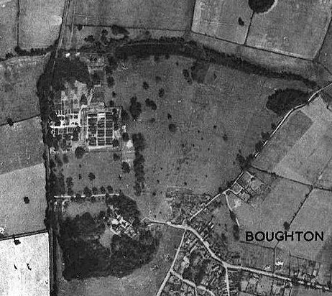  Location: The camp is still shown on the 1958 map, but in use as an agricultural hostel. Boughton village is about 6.5 km from Northampton.  POW Camp: The camp was listed in December 1941 as having Italian pows, some of whom were formed as a construction crew to build Harrington Camp 49.  Purpose built, standard type camp. Italian, then Austrian, and then mainly German pows.  1943 – hostels for Italian pows listed as; Barby; Greens Norton; Sherington.  5 January 1944 - There was an International Red Cross visit - Italian prisoners, capacity 870.  5 May 1944 – hostels for Italian pows listed (WO 32/10737) as: Grendon, Northamptonshire and Sherington, Bedfordshire. | 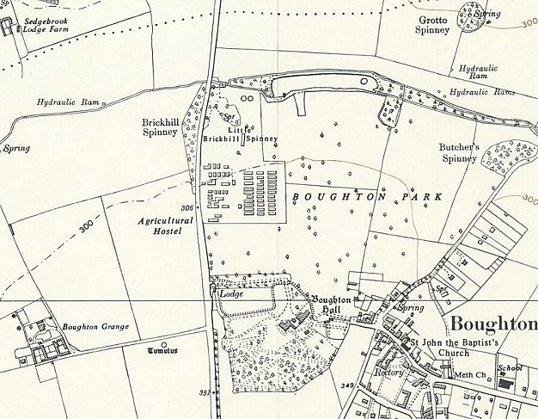
 | Ordnance Survey 1958
The camp was listed in records as an Italian Labour Battalion under the Eastern Command area in May 1944 and as an Italian POW Working Camp in November 1944, (WO 32/10737).

15 September 1945 - Hostels listed for pows from this camp, (WO 32/10737): Great Cransley, Kettering, Northampton; Haselbech, Kelmarsh, Northampton; and Lamport, Northampton.

1945 / 1946 - Italian pows were placed in the hostels and billets in order to move Austrians into the main camp. The War Establishment was increased and the rank of the Camp Commandant was raised from Major to Lieutenant Colonel.

21 May 1946 – The Austrians were moved from the main camp to another camp (not recorded which one).

End May / Early June 1946 - The first batch of 400 German pows arrived from the USA via BAOR (Belgium) and Camp 409 (Wolterton, Norfolk). Morale was low for these pows as they had expected to be sent to Germany, instead they arrived in the UK.

June 1946 – A further batch of 259 German pows arrived having been transferred from Canada. These pows had been held for several years, many were hard-core Nazis.

26-29 June 1946 – A Re-education Survey was carried out by O F Nash. Strength 1 Medical Officer; 962 OR.

Commandant: Lt Col Lambart Camp Leader: Heinrich Dekker SFWBL (est. B-)
Interpreters: S/Sgt Dr.K Rawack Deputy C/L: FBL Paul Ostermann (est B)
S/Sgt H Abrahamson German M.O.: Ass/Arzt Walter Hartmann (A+)

It was noted that the Commandant was “not helpful, though not openly obstructive” towards re-education.

The interpreter Rawack was said to be interested in his work, but Abrahamson was ‘insignificant’.

The Camp Leader had been selected by the Commandant on the basis of his rank, described as “politically insignificant, but is certainly keen to please.” He had been a soldier since 1934.

The MO was graded A+, but it was recorded that; “his influence is reduced by the highly nervous state in which he is at present.”

The overall political complexion of the camp was seen as ‘Grey / Black’. Morale was ‘reasonably high’. The disappointment of the pows from the USA was wearing off due to good housing and food. Receiving news from home was also a positive factor. Two pows had been selected to attend the special training camp at Wilton Park. Some of the ex-Canadian pows were seen as trouble-makers and needed careful handling. The ring-leader of the Nazis, Wulf, had recently been transferred from the camp.

About 25% of the pows were under-25 (‘youth’), but very few under 20 - no special arrangements had been made for these pows.

Re-education activities were just starting up. The standard list was given:

Wochenpost – 140 copies received

Ausblick – 0 so far.

Newspapers – 22 English papers purchased privately. Some Austrian papers had been received, but 0 German papers had been received so far.

Library – “few serious books or books of re-educational value”.

Lectures – 0 so far. A comment was made that lecturers would need to be carefully selected as; “There are still large numbers of PsW in this camp who believe the KZ film to be a fake.” The KZ film was about concentration camps which pows had been required to watch.

Discussion Groups – 0 so far, but expected to start soon under S/Sgt Rawack.

Films – YMCA and PID films were shown. The newsreels were often derided by the Canadian pows who saw them as “just propaganda”. [PID – Political Intelligence Department within the Foreign Office, overseeing re-education of POWs].

Wireless – a set in the camp leader’s office and 4 speakers in the dining huts. BBC German broadcasts and PW programmes regularly received.

Camp magazine – not started.

Press review – not started.

English teaching – 3 teachers with 180 pupils. More books required.

Other activities –

Religion – Protestants had services by a pow padre from Royston Heath Camp 29. No services for RC pows to date.

Education – “French, arithmetic, agriculture, etc”

Theatre and Orchestra – not started.

It was recommended that the “blackest elements” be removed from the camp as soon as possible.

11 July 1946 – English Inspector’s Report by Mr W Dadley Potter. Total strength 1661, (821 main and 840 hostels).

There were three English classes.

Some Italian pows were still held at this camp – they were accommodated in hostel buildings and billets.

July > November 1946 - the remaining Italians were moved to other locations.

7-9 November 1946 – E A P Helps carried out a ‘Routine Screening’ visit. Strength; 1 officer, 994 OR.

Commandant: Lt Col Lambart Camp Leader: Uffz. Hausberg
Interpreters: Nil Deputy C/L: Not listed
German M.O.: Nil

The Commandant was described as; “a martinet”, however the relationships between the German and British staff was regarded as excellent.

Political complexion – grey / dark grey. Morale was regarded as good.

There were about 100 ‘Roumanian’ pows held at Brixworth and a smaller number at Haselbech hostels. Their future was uncertain as many had received messages that their land had been taken and their female relatives removed by the Russians. With no home to return to, many expressed a wish to go to the USA.

Very little progress had been made at developing re-education activities. A camp magazine was due to start and it was hoped some pows would be able to attend Nottingham Town Council meetings.

A RC clergyman, Mr Taylor, was preaching in his church in German to a congregation from the camp.

November 1946 - Incidental information from a German theatre group journal held by the Deutsches Historisches Museum. The group toured pow camps around England during 1946. It recorded its visit to Boughton Park Camp, 35 as being in late November 1946 with 5 performances.

28 December 1946 – Major R L S Raffles provided an English Inspector’s Report. Strength 1183.

2 English classes were being held. The standards of the teachers were not considered to be high.

14 April 1947 – A Re-education Survey was carried out by F W Arrigoni. Strength; 1 officer, 880 OR.

Political screening. | A | B+ | B | B-
Number | 16 | 151 | 599 | 115

The category C pows previously commented on, had been removed and 100 were regraded during this visit. 160 pows had been repatriated to date.

Commandant: Major Tomkins Camp Leader: Fw Lausberg, Heinz (B+) [Previously Uffz. Hausberg – same person /diff spelling]
Interpreter: None Deputy C/L: Uffz. Morh Bernard (B+)
German M.O.: Dr Kretzberg, Friedrich (B-)

The rank of the new Commandant had been downgraded in the ‘War Establishment’ to reflect the smaller size of the camp.

Again, it was noted that there was no interest in re-education by the British staff. Interpretation was carried out by a German pow.

The Camp Leader had been in position for 6 months and was due for repatriation. His replacement was not to be the deputy, but Uffz Waldemar Kiemstedte, 38 years old with no party history, “intelligent, a good disciplinarian, and respected by the PsW.” It was hoped he would improve re-education in the camp.

Morale was seen to be ‘fair’; low morale amongst the C category pows had improved on being regraded, (a lower grading meant earlier repatriation). “There was no active Nazi element, there are a few who still try to defend a minor point of the system…”

250 youth pows, but they were not seen as a problem. 14 had been nominated for training at the ‘youth camp’, (Radwinter Camp 180).

Re-education activities –

Newspapers – English and foreign sufficient.

Library – 1000 books.

Lectures – started.

Discussion groups – None.

Films – adequate

Wireless – adequate (14 ‘extensions’)

Press review – A weekly summary of news was read out weekly over the radio.

English Instruction – “English For All” is popular.

Information Room – none.

Other activities –

Religion – 15% interest. Services adequate – served by visiting padres.

Education – lack of teachers due to repatriations.

Entertainments – An active theatre group produced light plays once a month – a good theatre in the camp set up by the pows. Orchestra members had been repatriated.

Outside contacts had been made and were regarded as constructive

Overall the visitor noted for the camp – “There are no factions or isolations in camp; the general tone is one of peace and hope in the future.”

30-31 July 1947 – English Inspector’s Report by Mr E F Peeler. Strength 861.

2 English classes were being held.

November 1947 – the camp became a satellite to Weekley Camp 259. None of the hostels associated with Camp 35 were listed for Camp 259.

Spring 1948 – Boughton Park POW Hostel closed.

Known Camp Commandants:
c.1944 Major J A McDonnell OBE (Camp war establishment v/1264/2)
c.1946 - 1946 Lt.Col D H C Lambert
c.1946 - ? Major Tomkins. (Tompkins?)

Camp numbers:

 | Open |  |  | With other camps |  |  | Unknown |  |  | Not listed / not open

 | 1941 | 1943 | 1/44 | 5/44 | 9/45 | 6/46 | 7/46 | 11/46 | 12/46 | 4/47 | 7/47 | >
Boughton Park |  |  |  |  |  |  | 821 | 676 | 658 | 634 | 477 | See Camp 259
Barby |  | C 35 | C? | C? | Hostel with Byfield Camp 87
Greens Norton |  | C 35 | C? | C? | Hostel with Byfield Camp 87
Grendon
Sherington |  |  |  |  | Hostel with Shalstone Camp 55
(Great) Cransley |  |  |  |  |  |  | 120 | 58 | 58 | 18 | 17
Haselbech |  |  |  |  |  |  | 400 | 58 | 58 | 50 | 44
Lamport
Brixworth |  | Probably linked to another main camp |  |  |  |  | 320 | 203 | 140 | 179 | 177
Billets * |  |  |  |  |  | 135 | ? | ? | 169 | ? | 146
Total | ? |  | 870 | ? | ? | 963 | 1661 | 995 | 1183 | 881 | 861 | -

* many entries did not separate those pows in billets from those in the main camp and hostels.

After the camp: Used for displaced persons, then an agricultural hostel.

The camp as it is today - https://repatriatedlandscape.org/england/pow-sites-in-the-east-midlands/pow-camp-35-boughton-park/

Further information:

National Archives – FO 939/117 35 Working Camp, Boughton Park camp, Boughton, Northampton. Dated 1946/47. (Used above).

A copy of the camp newspaper ‘Lager Zeitung’ is held at the Imperial War Museum – Catalogue LBY E.J. 385

Hostels

Barby, Warwickshire (Note this is NOT Barby Camp 1005 – that was a separate site).

1943 – Italian pows.

1945 - Recorded as being a hostel administered by Byfield Camp 87. Further details and map under Camp 87.

 | 1941 | 1943 | 1/44 | 5/44 | 9/45 | 6/46 | 7/46 | 11/46 | 12/46 | 4/47 | 7/47 | >
Barby |  | With C35 | C? | C? | Hostel with Camp 87

Brixworth. (Brixworth Hall was located at SP 747 709).

July 1946 - Italian pows. Listed as being – “huts and tents” – so probably in the grounds of Brixworth Hall.

November 1946 - German pows. Camp Leader: FW Erich Markworth (B)

December 1946 - Accommodation was described as being a ‘building’ rather than huts / and in a later report as ‘house’.

April 1947 - Same camp leader.

This hostel was no longer recorded when the main camp was taken over in November 1947.

 | 1941 | 1/44 | 5/44 | 9/45 | 6/46 | 7/46 | 11/46 | 12/46 | 4/47 | 7/47
Brixworth | Probably linked to another main camp |  |  |  |  | 320 | 203 | 140 | 179 | 177

Brixworth Hall was demolished in 1954.

(Great) Cransley. Hutted accommodation.

July 1946 - Italian pows.

November 1946 - German pows. Camp leader; Wm Arno Schulz (B)

April 1947 – Camp leader; Stock, Werner (B-). There were 43 Rumanian Waffen SS pows here - they had previously been listed for 2 other hostels. Their morale was very low with letters from home telling them NOT to return as the situation was ‘desperate and dangerous’. They were advised to defer repatriation for up to 6 months to see how the political situation developed.

This hostel was no longer recorded when the main camp was taken over in November 1947.

 | 1941 | 1/44 | 5/44 | 9/45 | 6/46 | 7/46 | 11/46 | 12/46 | 4/47 | 7/47
(Great) Cransley |  |  |  |  |  | 120 | 58 | 58 | 18 | 17

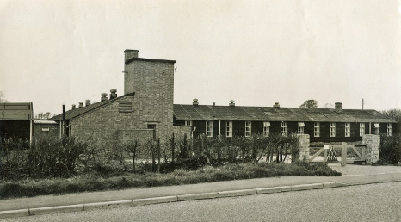  Greens Norton - NGR SP 671 501.  Built as a hostel for the Women’s Land Army. The building was mainly timber framed, with a brick-built ablution block.  1943 - Listed as a hostel for Camp 35 with about 35 Italian pows.  Later (by 1945) listed as a hostel for Byfield Camp 87 when it held German pows. (See C87 for further details).  The pow hostel closed in April 1948.  After the war it became a Youth Hostel – now Greens Norton Community Centre.  Background information from - https://gncommunitycentre.org/history (also has a picture of a group of Italian pows at the hostel). | 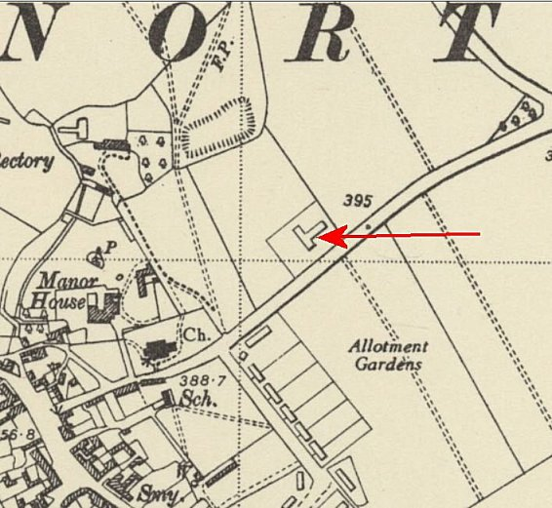
 | Ordnance Survey 1952

 | 1941 | 1943 | 1/44 | 5/44 | 9/45 | 6/46 | 7/46 | 11/46 | 12/46 | 4/47 | 7/47 | >
Greens Norton |  | c.35 |  |  | Hostel for Byfield Camp 87

The site today - https://repatriatedlandscape.org/england/pow-sites-in-the-east-midlands/pow-hostel-87-greens-norton/

Grendon, Northamptonshire –  Located at NGR SP 874 604  May have been associated with another camp before 1944  5 May 1944 - (WO 32/10737): Italian pows.  Not listed in visit reports for C35 from 1945. It was most likely linked to another main camp as Harrington Museum states the hostel was open until 1946.  1941 1/44 5/44 9/45 6/46 7/46 11/46 12/46 4/47 7/47  Grendon | 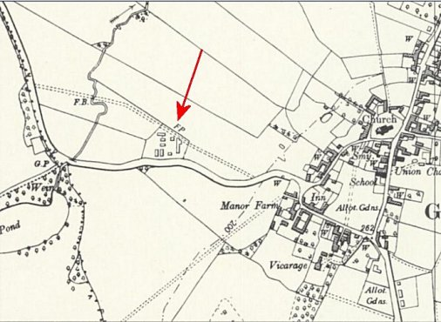
 | Ordnance Survey 1957

Haselbech –

Hutted accommodation in the grounds of Haselbech Hall, NGR SP 712 773.

July 1946 - Italian pows

November 1946 – German pows. Camp Leader FW. Willi Kahfeld (B)

April 1947 - same camp leader, but spelling Kaalfeld.

 | 1941 | 1/44 | 5/44 | 9/45 | 6/46 | 7/46 | 11/46 | 12/46 | 4/47 | 7/47
Haselbech |  |  |  |  |  | 400 | 58 | 58 | 50 | 44

Lamport

1945 - Listed for Italian pows. NGR SP 760 746

Not listed for C35 in reports after 1945 – may have been linked with another main camp.

 | 1941 | 1/44 | 5/44 | 9/45 | 6/46 | 7/46 | 11/46 | 12/46 | 4/47 | 7/47
Lamport

Sherington, Bedfordshire  Location NGR SP 895 465, just off Perry Lane, currently a cul-de-sac called Hillview.  1943 – Land transfer recorded by Newport Pagnell District Council for use by the Ministry of Agriculture (WAR-AG) to instal a pow camp. Italian pows working on local farms.  5 May 1944 - (WO 32/10737): Italian pows.  This hostel is not recorded with Camp 35 after 1944/45 – linked to Shalstone Camp 55.  1945/1946 – German pows. “…Fred Niebel, was captured at Caen a few days after D-Day. He came back to visit us in early 2004 and gave us an insight into the life of a POW in Sherington. He was a lorry driver and his duties were to deliver the men to various farms each morning and collect them at the end of the day. The POWs were paid a small wage for the work they did and were allowed freedom to attend the local cinema and village hall dances, etc. Not one of them ever absconded. At first these were all Italian men, but latterly, 1946 and after, it also housed German prisoners. ‘Prisoners’ is very loose term, as there was only one strand of wire around the camp perimeter. The camp also had its own monetary voucher system, so that the vouchers were stamped, much like the ration book system that the civilians were required to use, for items like toothpaste and soap. All their clothing was supplied, but with large round patches sewn on them, to make them easily distinguishable. The camp was under the supervision | 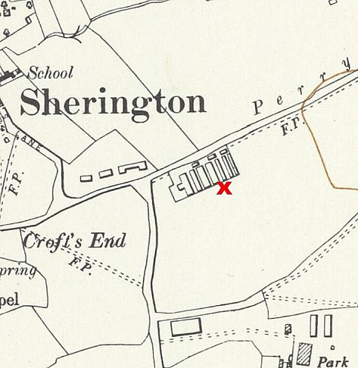
 | Ordnance Survey 1957
of Staff Sergeant Wilf Rollinson, who married Phyllis Middleweek. After Wilf was demobbed from the army he took charge of the camp as a WAR-AG executive.” *

 | 1941 | 1943 | 1/44 | 5/44 | 9/45 | 6/46 | 7/46 | 11/46 | 12/46 | 4/47 | 7/47 | >
Sherington |  |  |  |  | Hostel with Shalstone Camp 55

Further information –

* Sherington History Society has an archive file on the camp, “this includes copies of some of the memorabilia that our visitor brought to us. We have some photos and names of the men who lived here during the years 1943-1949, we also have some copies of the letters that the POWs have written to their friends in Sherington after they returned to their homes in foreign countries. https://www.mkheritage.org.uk/sherington/village-places/general/prisoner-of-war-camp/

