Camp 34 (& 1018) - Acksea Camp, Kinnerley, Oswestry, Shropshire

1947 Camp List
1018(G.Wkg.Coy) | W | Acksea Camp, Kinnerley, Oswestry, Shropshire | Shrewsbury 3602 Ext.216 | 23 | V/1270/4

Prisoner of War Camps (1939 – 1948) - Project report by Roger J.C. Thomas - English Heritage 2003
OS NGR | Sheet | No. | Name & Location | County | Cond’n | Type 1945 | Comments
SJ 3540 1938 | 126 | 34 | Acksea Camp, Kinnerley, Oswestry | Shropshire | 2 |  | Associated with an Ordnance Depot, now a military training area. See Camp no.34 / 1018
 |  | 1018 |  |  |  | German Working Company

Location: Acksea Farm is about 12 km SE of Oswestry. (Different spelling on the 1954 map).  Before the camp: Farmland. Area used by US army.  POW Camp: Nissen huts. Guards may have used the farmhouse. Listed as Italian working camp / labour battalion to 1944/45, then as a German Working Camp.  Italian pows and Pioneer Corps worked with Sir William McAlpine and Co to construct railway lines and sheds which were linked to military depots.  Camp magazine – Die Tage  Pow mail: July 1942 to Italy.  After the camp: Became part of the Nesscliffe military training area.  The site as it is now –  https://repatriatedlandscape.org/england/pow-sites-in-the-west-midlands/pow-camp-34-acksea/ | 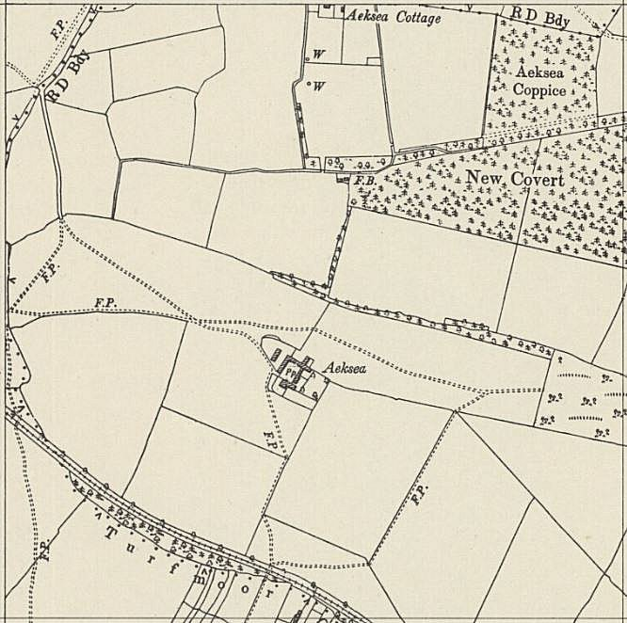
 | Ordnance Survey 1954

