Camp 33 (& 670a) - Shorncliffe Camp, St Martin’s Plain, Folkestone, Kent

Prisoner of War Camps (1939 – 1948) - Project report by Roger J.C. Thomas - English Heritage 2003
OS NGR | Sheet | No. | Name & Location | County | Cond’n | Type 1945 | Comments
TR 18 36 | 179 | 33 | St Martin's Plain, Shorncliffe Camp, Folkestone | Kent | 5 |  | Large pre-existing military camp. See Camp no.670a.  [670a – same details]

Location: The NGR above is a general location for St Martin’s Plain. St Martin’s Plain is part of Folkestone, an area used by the military with many barracks.  The Pow camp was reported (Hob Uid: 1590801) to have been south of Dibgate Camp (North Dibgate Camp is top left), so the actual point TR 18 36 may be accurate.  POW Camp: Probably Italian pows, replaced by Germans.  Memories, must be from later years with the removal of the fence – “Up at St Martins plain was a German prisoner of war camp. Not fenced off, and we used to wander up there to look at the krauts as we kids called them. But they seemed no different to us and we found the ones who spoke English very interesting.  The outside of their huts were a credit to them with lovely gardens and hand made ornaments adorned the area surrounding them.” (Contributed by John B Dray - Article ID: A2904680 – BBC WW2 People's War archive.”  Postal items: Camp 33 POW Letter-sheet, 23 February 1944 in Italian to Italy. | 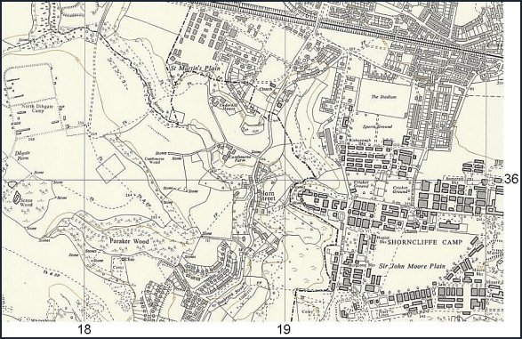
 | Ordnance Survey 1962

