Camp 33 (& 610, 632, 653) - Old Windmills Camp, Blackthorn, Arncot, Oxfordshire

Included in the 1945 ICRC Camp list – Labour Camp. 610. Address non communiqué

1947 Camp list
632(G.W.Coy) | S | Old Windmills Camp, Blackthorn, Bicester, Oxon | Bicester 260 Ext.174 | 52(W.O.) | V/1456/2
653(G.W.Coy)

Prisoner of War Camps (1939 – 1948) - Project report by Roger J.C. Thomas - English Heritage 2003
OS NGR | Sheet | No. | Name & Location | County | Cond’n | Type 1945 | Comments
SP 608 207 | 164 | 33 | Old Windmills Camp, Blackthorn, Arncot | Oxfordshire | 3 | German Working Camp | LARGE STANDARD. See Camp no.632 and 653

Location: The English Heritage report gives SP 608 207 (A) for Camp 33 and SP 609 206 (B) for Camps 632/653. The site is about 3 km SE of Bicester.  POW Camp:  Italian then German pows.  10 September 1941 – War Diary for Glanbranter Camp 6 recorded the transfer of Capt T E Hardcastle to this camp as commander.  December 1941 - The camp was listed as having Italian pow, some of whom were formed as a construction crew to build Camp 43. Guarded by the Pioneer Corps. Capacity stated as 1300 men.  1943 & 5 May 1944 - Hostel listed for Italian non-co-operator pows from this camp, (WO 32/10737): Duns Tew, Deddington, Oxon  May 1944 - Camp listed as an Italian Labour Battalion under the Southern Command area.  November 1944 - Camp listed as an Italian POW Pioneer Corps Group.  September 1945 – Entries in Appendix to HQ Southern Command War Diary:  632 Old Windmills camp, Bicester – German working company - capacity 900 – 94/015426  653 Old Windmills camp, Bicester – German working company – capacity 650 – same map ref. |  | 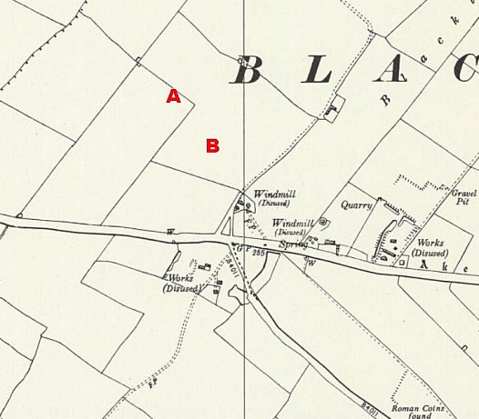
 |  | Ordnance Survey 1958
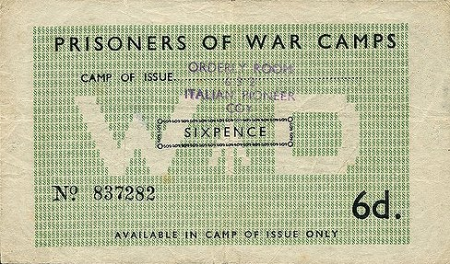 | < 6d token money for use in Camp 632 only. Stamped ‘ORDERLY ROOM / 632 / ITALIAN PIONEER COY’ issued by the War Department. The back would be stamped after each use.  2s6d token money for use in Camp 653 only. > |  | 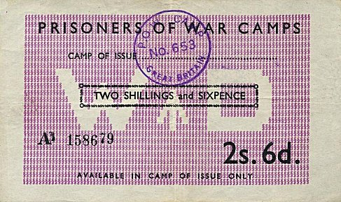

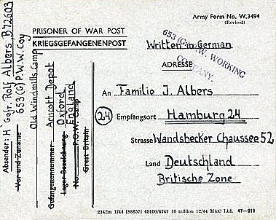
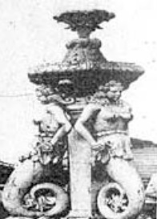
< A fountain remains on the site (now a scrapyard), reportedly completed by Italian pows.

The Pow Card is from 1946. It is stamped ‘653 (G) P.W. WORKING COMPANY’. The sender’s address is Old Windmills Camp, Arncott Depot…’ This is likely to be the Central Ordnance Depot at Arncott, about 3 km S of the camp.

There was a camp magazine 632 and 653 – Die Windműhle – (The Windmill).

The Bicester Local History Society record that the pows worked on farms, the local clay pits and the countryside clearing ditches and maintaining fences. They also record that there was another camp at the back of the Star Inn, Bucknell Road, Bicester – the pub is now closed, not sure if this was a hostel).

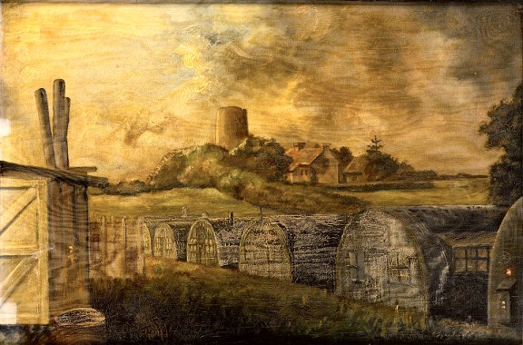 | The oil painting of the camp shows Nissen type huts and the old windmill in the background. It was painted by H Rúsiring c.1946 and was presented to the Camp Commandant Major N C Kerr on his retirement in 1946.  (Picture at the National Army Museum. Website states ‘Not NAM Copyright’. Accession number NAM.1998-11-81-1).  March 1948 – listed as a hostel for Lodge Farm camp 25.  After the camp: Now a scrap yard, caravan site and farm.  https://repatriatedlandscape.org/england/pow-sites-in-the-south-east/pow-camp-632-old-windmills/  There is a record of the disposal of the site at the National Archives – DEFE 51/13: Bicester, Oxon: disposal of Windmill Camp (former PoW camp) at Blackthorne Hill. Dated 1963-66.  Further information:  National Archives – WO 166/5981 – ‘Miscellaneous: Prisoners of War Camps: 1 Prisoner of War Camp at Tidworth (1939) – 101 Prisoner of War Camp at Southampton (1940): moved to Liverpool, 12 July 1940”. Dated 1939 Sept – 1940 July.  IWM have a copy of the magazine dated January 1947, Ref LBY E.J. 444. The German Federal Archives also has a copy, date unknown.

Hostel - Duns Tew, Deddington, Oxon. | 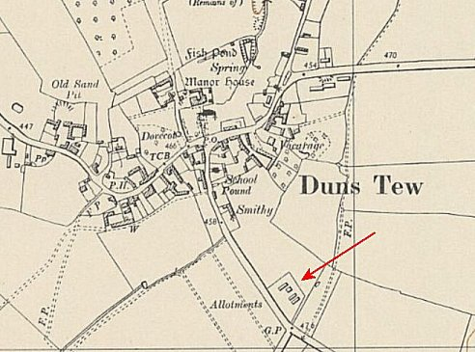
 | Ordnance Survey 1955

