Camp 32 - Plas Llwynon Camp, Anglesey (aka Glan Morfa)

Prisoner of War Camps (1939 – 1948) - Project report by Roger J.C. Thomas - English Heritage 2003
OS NGR | Sheet | No. | Name & Location | County | Cond’n | Type 1945 | Comments
 |  | 32 | Anglesey | Anglesey |  |  | Wales

Location: The site was also called Glan Morfa. There is a Glanmorfa Lodge located at SH 434 678. To the N, extensive irrigation / drainage work has been carried out on the rivers.  POW Camp:  August 1941 – War Diary for Glenbranter Camp 6 has entries related to the transfer of 2 lieutenants to Glanmorfa.  The camp was established in 1942 for Italian pows to carry out a drainage project on Anglesey under the Ministry of Agriculture. Pioneer corps Plas Llwynon Camp, Llanfair, PG Anglesey – 200 men.  Memories – “My father wasn't called up to fight in the war as he was a farmer and was needed at home to farm the land and make sure that there was plenty of food for those who stayed at home. We lived on Anglesey in a village called Llangritiolus. In Welsh - Anglesey is Ynys Mon and Ynys Mon is famously known in Wales as "Mon Mam Cymru" as it produced enough food to feed the whole of Wales. Work on the farm was hard in those days, no modern technology to save time - just hard work all day long.  Not far from Aberffraw there was a Prisoner of War camp where prisoners from Germany and other enemy countries were being held and with so much work to be done and much of that hard manual work, my parents could certainly do with the help - and help they received from an Italian Prisoner of War - I can't recall his name and unfortunately both my parents have passed away so I can't ask them.  He was a wonderful, hardworking man and grateful I was told for the opportunity to work. He became great friends with my father and they would have many long conversations. He would | 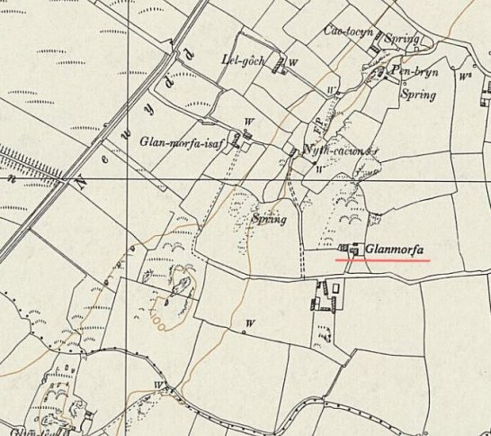
 | Ordnance Survey 1961
arrive early morning on a truck full of POW's who would each be allocated to a farm and picked up at the end of the day to be taken back to the camp.

I can't imagine what it must have been like for the Italian, who was at the end of the day - the enemy. But to find a friend, in a foreign country and to be treated with humanity when many weren't given hope of survival - must have been a huge relief for him. I can't really recall much more of my father’s story - just that it gives me hope during times of war - that both sides can find common ground in something so simple as working the land.” (From bbc.co.uk/ww2peopleswar – contributed by ‘WRVS Volunteer’ Article ID A4301029)

October 1944 the camp was listed as a hostel for Pabo Hall Camp 119.

