Camp 2 (& 168, 176) - Glen Mill, Wellyhole Street, Oldham, Lancashire

1947 Camp List
168(B.C.) | Glen Mill Camp, Oldham, Lancs | W. | Priscamp, Oldham | Oldham (Main) 3684 | Oldham | Lt.Col.W.S.Tanner O.B.E. T.D. | V/202/4

Prisoner of War Camps (1939 – 1948) - Project report by Roger J.C. Thomas - English Heritage 2003
OS NGR | Sheet | No. | Name & Location | County | Cond’n | Type 1945 | Comments
 |  | 2 | Glen Mill, Wellyhole Street, Oldham | Lancashire | 4 | Base Camp | Large cotton mill and associated weaving sheds etc. with additional huts See Camp no.176

Location: Grid reference SD 948 047. Leesbrook area of Oldham. The large, old mill was located between Wellyhole Street and the railway line, (now removed).  Previous use: A cotton spinning mill built in1903 and closed in 1938.  Pow Camp:  This was the first POW Camp opened for other ranks in 1939 – with officers held at Grizedale Camp 1. The large site held a main mill building with four floors and many other smaller buildings. Additional huts were built for guards, prisoners and storage. There was capacity for 5000 prisoners.  A general description, 1944; “…several stories high with but a single staircase and has several long spinning halls, some of which can hold a thousand men. The main windows are all permanently painted over because of the black-out. Every ten minutes an LMS train roars by on the embankment above the camp. Well over four thousand men are here at first and before wash-rooms are provided the conditions are appalling. There are only twelve lavatories and two taps, towards which a thick mass of men is forcing its way up and down the ‘martyrs’ stairs’ all the time, and often in vain as the taps don’t always run. There are extra delays because of the dozen Muslims [“Russen und Mongolen”] in the camp whose ritual ablutions are respected, ten of them forming a human barrier round the two who are washing. Time is passed carving objects from bits of wood, such as the cross-pieces of the American ‘lend-lease’ beds, blades being made from old iron hoops. But it is against the camp rules and for this and other misdemeanours culprits are locked in a big room. Food is sent in but the English ‘forget’ to empty the lavatory buckets, so that by the third and fourth day the conditions are unbearable… There are searches when everyone has to stand out in the open in the cold and wet and all sorts of things are filched…” (Described by German pow Father Josef Jassen in 1944).  24 September 1939 - Many of the first prisoners were captured from U-boats. The first crew was from U-39 which was sunk on 14 September, 1939. The U-39 had a crew of 44, but the four officers were sent to Grizedale. The pows at Glen Mill attracted a lot of local curiosity. Soon after their arrival, on 24 September, a Daily Mail reporter stated that he had; “joined the hundreds of people who climbed the slopes overlooking a disused mill in the hope of seeing 40 German prisoners of war”. | 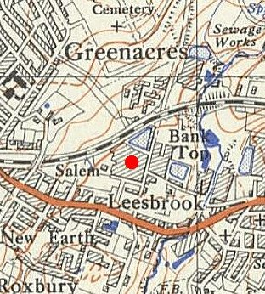
 | 1951 Ordnance Survey map showing location of main mill building.

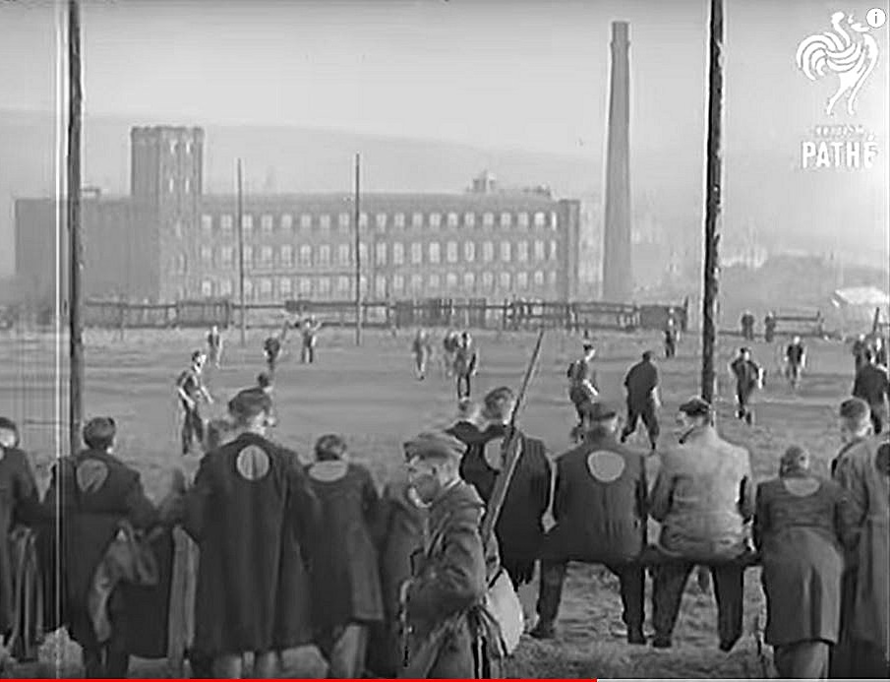 | They were soon followed by the crew of U-27, (sunk 20 September). Those from the U-35 arrived sometime in December 1939 after they had been interrogated at the Tower of London. There were also crew members from the Luftwaffe.  The first guards at the camp were from the 6th Battalion East Lancashire Regiment, a home defence battalion.  26 December 1939 – Commandant Lieutenant-Colonel Dennison commented that the pows were young men with, “little or no knowledge of any creed other than that of Nazi-ism of Hitler’s regime.” [Comments to Colonel Bernard Trench, Intelligence Section, Naval Staff – ADM/10069. Trench was later accused of being involved in the interrogation of POWs using drugs].  < 1939 Film by British Pathe Gazette shows Glen Mill Camp and area.  Entitled, ‘German Prisoners Of War In Camp (1939)’. The narration starts: “At one of the camps somewhere in Britain, ex-German sailors saved from sunken U-boats and ex-German airmen whose planes were brought down, are learning to start life afresh in more peaceful jobs. They are not forced to wear any prison uniform, but to avoid escape they have patches of contrasting material sewn into their trousers and into the backs of their jackets…” It is interesting to note the jaunty commentary and the attitude it displayed towards the German pows in the early part of the war. https://youtu.be/WkdhZxHKDbY  There were only two camps in 1939, so this must be Glen Mill. The barbed wire fencing and sentry boxes are shown along with pows at work, preparing food and playing football. I think the picture to the left shows nearby ‘Bank Top Mill’.
Most of the German prisoners arriving between 1939 to 1942 were shipped to Canada.  June 1940 – Pows were transported to Liverpool for shipment to Canada on the SS Duchess Of York. Other shipments followed as soon as there were sufficient numbers.  For one shipment there was a riot when pows heard they were to be sent to Canada as they believed the journey was too dangerous with U-boats sinking ships. The pows smashed windows and furniture. The riot was ended when a sergeant-major used physical force against some of the ring-leaders.  Pows marched under escort through Oldham to the station – 1940 >  March 1942 – International Red Cross (ICRC) inspection report. Capacity 1,500, but recorded only 229 nco’s and ORs. Commandant Lt Col Dennison.  Extracted details; “Rations were being adjusted to include more potatoes to meet the dietary preferences of the prisoners, but the supply of other foodstuffs such as meat, cheese and jam was being cut back in line with reductions in civilian rations. The men at Glen Mill had received a consignment of uniforms from Germany, ‘their best Christmas present’, but were continually unhappy about the time it took mail and parcels to reach them. Many of the latter seem never to have arrived at all. The mill contained its own infirmary, a library of 960 books and English classes were offered to inmates. There were even plans for the YMCA to provide film shows. Prisoners were employed maintaining the camp, and were soon to be deployed in |  | 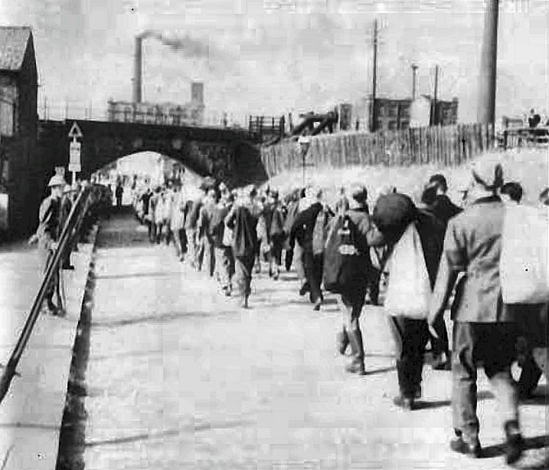

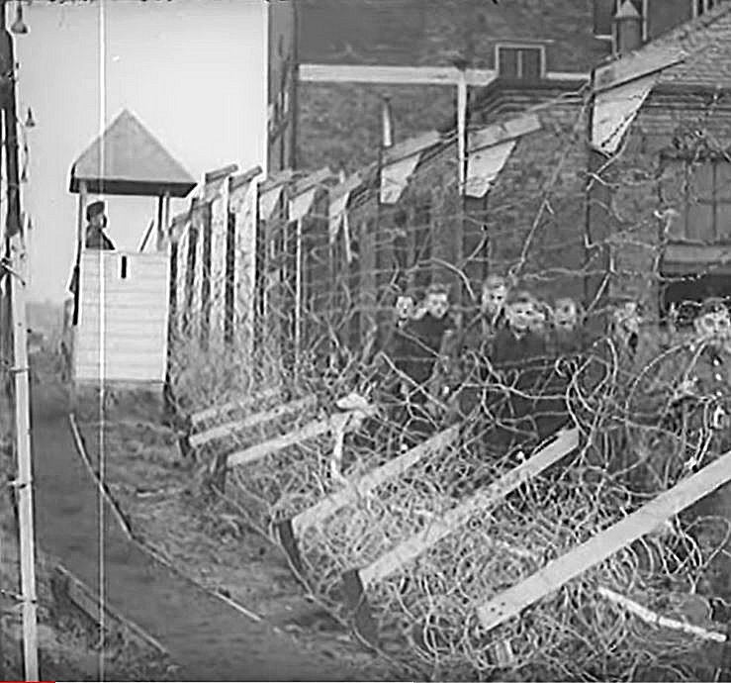 | cultivating a four-acre kitchen garden. Overall, the ICRC delegate reported his impression of the camp as excellent and the morale of the inmates as good.” [From an article by Bob Moore – ‘Glen Mill: The international History of a Local POW Camp During World War II’ - Manchester Region History Review, 10 (1996b), pp48–56].  Summer 1942 – after German pows had been shipped out, the camp was re-filled with 1,575 Italian pows captured during the northern Africa campaigns.  August 1942 – ICRC Report noted that conditions of transportation to the camp had been poor and that there were insufficient rations for new arrivals who were malnourished. The camp acted as a transit camp with most Italian pows being sent on to other camps or hostels within a few days. 44 pows formed a permanent staff as cooks, medical staff and administrators.  One Italian pow, Francisco Aceto, committed suicide by hanging.  c.1943/1944 - Became a camp for US captured pows in transit to the States - ETO PWE 3, (European Theater of Operations – Prisoner of War Enclosure) - one of 12 such camps in the UK. US troops as guards.  August 1943 – Leutnant Wolfgang Kleibomer and Oberleutnant Bernhard Schweers escaped. They were recaptured 15 miles away at Ripponden.
During 1944 – Trouble at Mill. The camp was returned to British control in September and became Base Camp 176.  A large number of Russians who had volunteered to serve with the Axis forces and had been captured in France were held here. They were accommodated separate from the Germans. Later they were sent to camps with other Russians and then transported back to the USSR – many were executed, and others imprisoned on returning home.  7 February 1945 - Erich Breuss, was one of 7 pows, (other names unknown) who escaped from the camp. He was an Austrian, wounded and captured in Normandy. Described in the local press as one of several fanatical young Nazis. The group split up; four were re-captured near Leeds, two near Wakefield and Erich Breuss at Castleton Railway Station. He was later sent to Wolterton, Camp 409 in Norfolk from where he was repatriated on 2 November 1946.  8 February 1945 - Paul Hartmann, a German pow was shot dead by a guard, Gunner J.A.Jaffray. The circumstances were disputed. The British described unrest in the camp with the pows trying to cover up an escape attempt, (see above) by being deliberately obstructive, singing Nazi songs, and refusing to obey orders during a roll call. When a crowd advanced towards the guards a warning was shouted, and when |  | 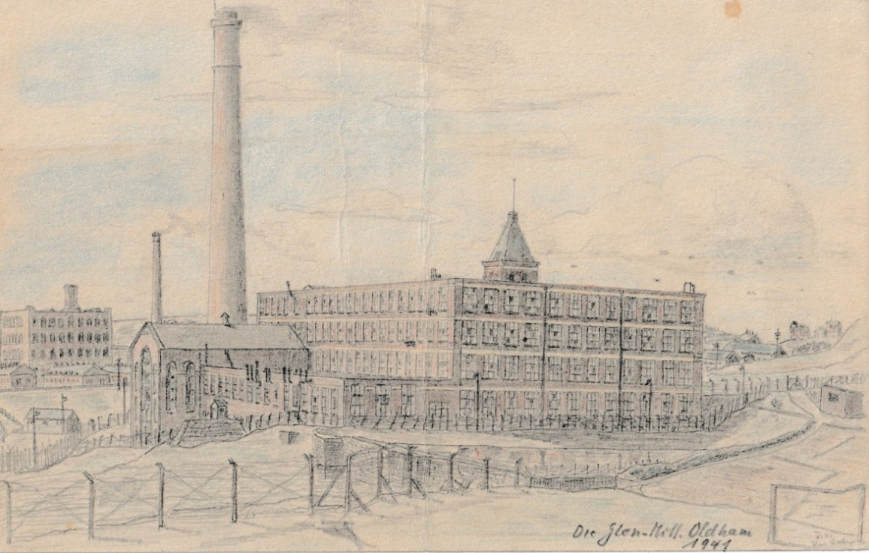
 |  | Glen Mill in a pow sketch dated 1941. Shown on the aircrashsites.co.uk website

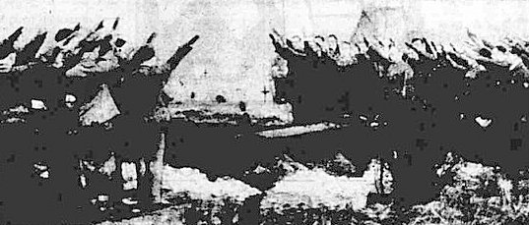 | this was ignored, shots were fired. Gunner Jaffray fired from the hip into the crowd, killing 18-year-old Paul Hartmann.  The brief War Office press release stated that four others were wounded, but other accounts do not mention any other injuries at all. The German side of the story is that they were singing love songs and were not being deliberately obstructive.  There were fears of German reprisals against British pows. Delegates from the Swiss protecting power and the Papal Legate were invited to the camp. A verdict of justifiable homicide was recorded at the inquest.  9 February 1945 - A press account in the Oldham Evening Chronicle reported that; “Recently the younger Nazi prisoners in the Oldham camp have adopted a hostile attitude and there have been several attempts to escape.”
14 February 1945 – The Daily Herald showed a picture (above) of German pows using the Nazi salute at Paul Hartmann’s funeral at the adjacent Greenacres Cemetery.

[Hartmann + 3 others who died at Glenn Mill through medical conditions were reburied in 1962 at the Cannock Chase German Military Cemetery.]

Two escape attempts recounted by Dr. Helmut Medinger – Army Geologist, held at Glen Mill, 1944/45:  We slept on straw palliasses. When lice appeared in any quarter, the palliasses were emptied on to a trolley, taken to the gate on the steep slope and the straw tipped down the slope. A young ex-pilot managed to smuggle himself with the straw out of the camp, found an airfield, sat himself into a fighter plane, but he was caught at the last moment. When he was returned to the camp, the camp commandant first castigated him, but then said he admired his ingenuity.  Another escape attempt was made during the exercise period on the road outside the fence. There were of course a few guards, but a large number of prisoners formed a big clump of people and in their midst they were able to lift off, unobserved, the lid over the sewage pipe system leading to the houses further up. Unfortunately, the would-be escapers met a narrow junction further up, so they could not escape.  This was certainly a hard and often dangerous camp in the first half of 1945. There was a high number of ‘Black’ (Category C) Nazis concentrated here. Even at this stage, many of them believed that Germany would be victorious and they planned to join an insurrection when the UK was invaded. Up to the end of the war, punishment beatings of pows showing anti-Nazi feelings took place, but were rarely prosecuted with fear from the victims about naming the perpetrators.  “After a particularly vicious punishment beating, three suspects were questioned. While denying the charges, they did admit to knowing the culprits and were given five minutes to deliver up their names. Failing to comply, they were taken out of the camp to the British compound from where gunfire was subsequently heard. The Lagerfűhrer, having witnessed the interviews, returned to camp convinced that the men had been shot. In fact, they were immediately removed to another camp.” [From the article by Bob Moore op.cit]. |  | 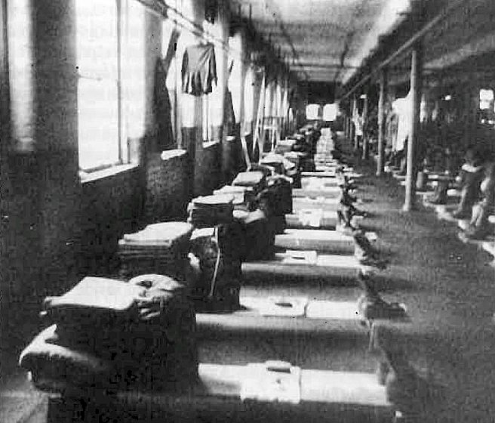

Many escape attempts were made. One was held during the early morning mass visits to the latrines - three pows used a handmade ladder to get over the barbed wire fence and then jump down. One broke his leg, the other two were captured within 2 days. Tunnel escapes were also attempted, but construction was usually poor resulting in flooded or caved-in tunnels. One had to be abandoned having struck a water pipe.

There were 12 cells which were nearly always full. See 'Thresholds of Peace'. Also mentioned in 'Prisoners of England'.

Some improvements to conditions were carried out in the camp such as extending the exercise yard, but over-crowding became a major problem with 6000 pows held at the camp. The picture on left shows fairly comfortable accommodation – however, several floors in the mill had three-tiered bunk beds with very little space between them. Out-buildings and tents had to be used for some time.1945 after VE Day – Most of the violent and disruptive behaviour diminished rapidly at the end of the war. Re-education and general education activities were successfully held. The pows formed a theatre company and orchestra.

1946 - Laws against fraternisation were gradually removed and improved links with local organisations and people were developed, (eg Salvation Army, Tabernacle Choir, churches, Oldham Athletic FC and rugby clubs). Many pows were able to attend Christmas meals with families in the local area. During the severe winter conditions of 1946/47 pows were used to clear snow. There are photographs of pows from Glen Mill at the old Watersheddings RLFC ground.

Camp 176 magazine – Die Umschau

1947 – The camp changed from being a base camp back to a transit camp. It was at this time that the camp number changed to 168.  Postcard from Camp 168, Glen Mill, dated February 1947 to Germany >  September 1947 - The camp closed.  Known Camp Commandants –  1939 - ? Lieutenant Colonel Harold Anthony Denison, M.C. served with Kings Royal Rifle Corps during World War 1, and then with the Pioneer Corps as commandant of Camp 2. Later Commandant at Camp 9 Quorn Camp.  c.1945 Major Walter L James –  c.1947 Lieutenant Colonel William Stanley Tanner O.B.E., TD (Royal Pioneer Corps).  After the camp: 1949/1950 ‘Vitafoam’ was created making latex foam in the mill. The company was successful and expanded to other sites.  Glen Mill was demolished in 1970. The site is now largely residential. | 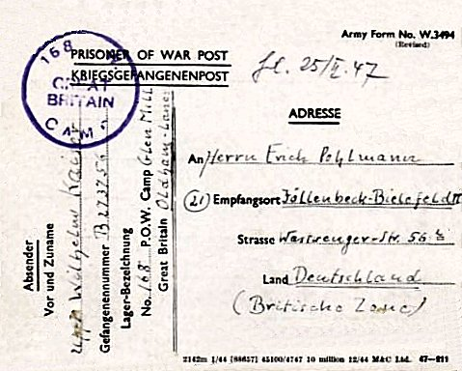
Further information:

aircrashsites.co.uk – excellent further information about Glen Mill pow camp, including copies of a sketchbook by a pow at the camp showing daily scenes. https://aircrashsites.co.uk/038/

The Imperial War Museum has a collection of ‘official’ photographs of the camp.

* Further details of Colonel Scotland at the camp – ‘The London Cage’ by Helen Fry.

Channel 4 – Great British Dig - https://www.channel4.com/programmes/the-great-british-dig-history-in-your-garden/on-demand/72396-006

