Camp 7 - Winter Quarter Camp, Ascot, Berkshire (aka Swinley Estate Camp)

Prisoner of War Camps (1939 – 1948) - Project report by Roger J.C. Thomas - English Heritage 2003
OS NGR | Sheet | No. | Name & Location | County | Cond’n | Type 1945 | Comments
SU 905 679 | 175 | 7 | Winter Quarter Camp, Ascot | Berkshire | 2 | Special Camp | c.20 huts in guards’ compound, 26 huts & football field within prisoners' compound enclosed by a double perimeter fence.

Location: centred NGR SU 903 682.  Previous use: Part of the site was the ‘winter quarters’ for Betram Mills touring circus - part Crown Swinley Estate. Prior to holding pows the site was used to hold internees from July 1940 to March 1941.  POW Camp: Held Italian then German pows, sometimes mixed.  Site plan shows approximately 14 acres of land acquired for a pow camp in late 1939 (pink). Additional land was acquired during 1940/1941 (blue / green). Hutted camp.  1941/1942 - pow camp opened initially with Italian pows.  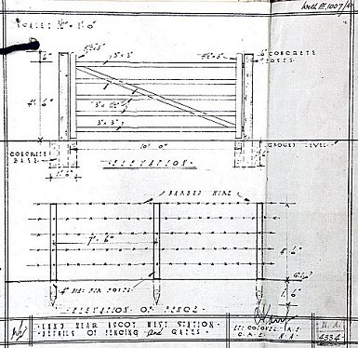 | 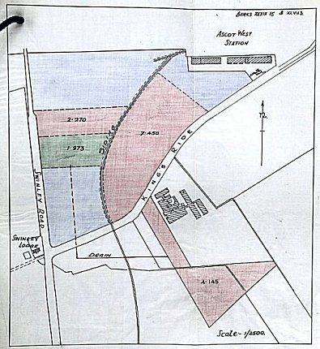 | 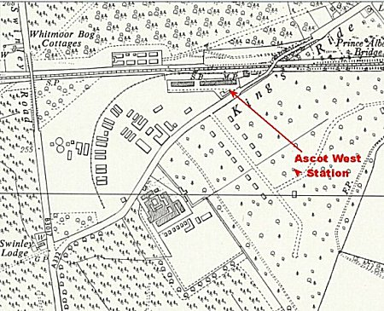
 | Site plan 11/1941. | Ordnance Survey 1961
 | <<< Details of fences to be 4’6” high – (137cm) and gates to be same height, 10 feet long (3.04m).  Photo on Pinterest headed – “The Administrative Staff, No 7, Prisoner of War camp 1942. My Uncle, Leslie Norman HISTED (Standing on Right) was posted in WWII at this camp - 'Winter Quarters Camp', Ascot, Windsor, Berkshire.”  https://www.pinterest.co.uk/maureencate/  1943 - A persistent group of German pows attempted various escapes: |  | 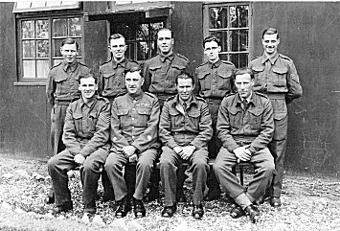

January 1943 – War Diary entries – (27th) Weather windy-dry; no moon. “Three Ps/W, by cutting three sections of wire, with improvised wire cutters made from P/W barrack furniture, made an escape from the Compound. Escape discovered on calling the roll at 0700 hrs 28.1.43.

Three Ps/W re-captured by civilian fire watcher at Newbury, Berks at approximately 2100 hrs 30.1.43 and detained at Newbury Police Station. Ps/W collected by escort at 2330 hrs 30.1.43, and placed in cells. Awarded 28 days detention on 31.1.43 by Lt Col W D’Arcy Hall, MC.”

5 February 1943 – War Diary entries – Weather mild-slight wind; very dark; no moon. “Seven Ps/W attempted to escape by breaking out of their huts after being locked in, but were discovered and captured by Unit Night Patrols proceeding to the compound wire. The Ps/W were searched and improvised wire cutters were found in their possession together with a quantity of rations. Ps/W placed in cells.

An emergency roll call was made at 2300 hrs and dummy heads, made from clay were found in escapee’s beds together with bottles and clothes. Ps/W awarded 28 days detention by Capt A H Potterton on 6.2.43.”

13 February 1943 – War Diary entries – Weather dry-mild. The German pows were informed that they were being shipped to Canada. At 1000 hrs they were formed onto groups of 50 and when they were counted, two pows were missing. Search parties were formed. “2230 2 German Ps/W found by search party hiding in a tunnel seven feet deep and several feet long which had been excavated underneath a flag-stone at the north side of No.8 hut and continued in the direction of the wire. Ps/W in an exhausted condition when found but soon recovered.” Again, the escapees were awarded 28 days detention.

14 February 1943 – War Diary entries – 2 German pows escaped from the train taking them to the port. They were captured by Home Guard and escorted back to this camp on 16.2.43. They were awarded 12 days bread and water by the Commandant.

1944 - For a while from May to September 1944 the camp held Italian and German pows. This time the Germans were a mixed group of selected anti-fascists and pows still to be interrogated. Tensions were high until these groups were separated in October 1944.

The camp became a ‘special camp’ for re-education of German pows. The Commandant, Major Steed, stated that; “Camp Ascot is a community of anti-fascist prisoners of war, run on a democratic basis.” The initial idea was that pows trained here would be returned to Germany to take up mainly political and civil posts; “Operation Oberon.” Some did, but on more of an ad hoc, rather than planned basis.

Pows were given the opportunity to discuss current affairs and future developments. Activities included reading, lectures, films, and work groups presenting ideas on social and political issues. One pow described the camp as being more casual and unmilitary than other camps – and the food was better. “It was a physical and mental convalescence that I experienced after the shock of the invasion and the clearly foreseeable ruin of my own citizens…. You 'found' yourself again, still alive and beginning to prepare for a 'comeback'. Ascot in its motley composition and its emerging political tendencies, (Christian democrats and ‘progressive Socialists') was good preparation for returning to post-war Germany... Ascot spared illusions and forced self-reflection in the midst of a shattered world that still needed to be rebuilt.” (Translated from; Zer Geschichte Der Deutschen Kriegsgefangenen… Band XI/2 – H Faulk – München 1970 – p410).

Groups of pows were specially selected to attend Brondesbury Hostel to produce re-education materials, see below.

September 1945 - Listed in the Appendix to HQ Southern Command War Diary– “Winter Quarters, Ascot – Special camp – capacity 1250”.

December 1945 – the camp was closed. Brondesbury hostel was transferred to Rayner’s Lane Camp 11 / 122. Some other pows moved to Wilton Park special camp to prepare the first course, others went to normal pow camps.

Known Commandants:

1943 – Lt Col W D’Arcy Hall, MC and Bar, (1891 – 1980). Soldier, M.P. and hunter. Born in Australia, moved to England when he was 4 years old. Educated at Eton and Sandhurst. Joined the 20th Hussars in 1911.

1945 - Lt Col P L Grimwood MC – he transferred to South Brent Camp 7 when this camp closed.
After the camp:

Used as a storage depot. Now residential area.

Further information:

National Archives - WO 166/14167 dated Jan/Feb 1943 - ‘7 Prisoner of war camp at Ascot – Escape attempts made by unidentified (German) prisoners of war, (used above).

National Archives - CRES 35/1408 – Swinley Estate: prisoner of war camp near Ascot West Station, (used above).

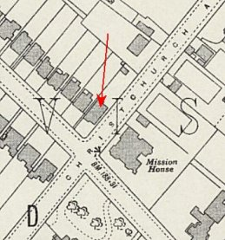 | Brondesbury Park Hostel, Kilburn  The hostel was located at 1a Brondesbury Park Road, Kilburn, London, NW6 7BS (NGR TQ 241 841).  It was at first attached to Winter Quarter Camp 7 from late 1944. Pows were selected in the main camp to work at the hostel. It held up to 90 pows.  The pows worked with the Political Intelligence Department (PID) a branch of the Political Warfare Executive (PWE). During the war, most of the pows produced propaganda materials for the Allies, some assisted with intelligence work; after the war they developed re-education materials for the camps.  About 30 pows worked with PID / BBC under the ‘Ascot-Brondesbury Scheme.’ | 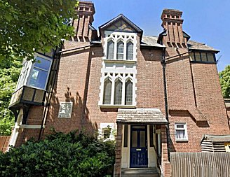
OS Map 1935 |  | Side view of house - 1a Brondesbury Park Road

The Ascot-Brondesbury Scheme. In late 1943 proposals were made to the PWE that suitable, anti-Nazi, German pows could broadcast propaganda to serving German troops. A scheme was developed by the PID / MI19 (responsible for obtaining information from pows) / and DWP (Directorate of Prisoners of War). Because pows were the responsibility of the War Office, and PID were under the Foreign Office, ‘Terms of Reference’ were established, (see Document at end).

Pows arriving at Kempton Park were quickly screened and any deemed as possibly suitable for work with the PID were sent to Lingfield Cage (Surrey). At Lingfield a CSDIC, (Combined Services Detailed Interrogation Centre) staff officer carried out a further selection to find willing pows who were sent on to Ascot Camp (Winter Quarter Camp 7). At Ascot a further refinement of pows established groups to work at the PID centre at Brondesbury. Some of those selected worked with PID / BBC to make recordings at Bush House, the HQ for the BBC World Service under an Anglo-American scheme.

Broadcasts started in December 1944. The pow’s wages were paid for by the BBC. At the BBC, recordings were arranged by Marius Goring, (the actor and intelligence officer). A steady flow of new pows were required in order to keep broadcast information up to date. As well as the BBC, the recordings were re-broadcast from New York and by the ABSIE (American Broadcasting Station in Europe). Broadcasts continued up to Autumn 1946.

“The Ascot-Brondesbury Scheme and the Brondesbury Hostel were throughout a great success and were the means for making friendly German Ps/W contribute first to the defeat and then to the spread of democratic ideas in Germany and among Ps/W” (from; ‘The Secret History of PWE’ – David Garnett – St Ermin’s Press – 2002).

December 1945 – When the main Ascot Camp closed, Brondesbury Hostel was attached to Rayners Lane Camp 11 / 122.

Transcript of undated document in file FO 1120/175 Education: Brondesbury Park Hostel; organisation and administration.

THE ORGANISATION AND ADMINISTRATION OF THE BRONDESBURY GERMAN PS/W HOSTEL.

TERMS OF REFERENCE FOR B.B.C. / P.I.D.

1. The Hostel for German Ps/W at No 1a Brondesbury Park is under requisition for London District Command and is placed at the disposal of PID by the Director of Prisoners of War, War Office.

2. The responsibility for the administration of the Hostel itself and for P/W discipline rests with the Wat Office authorities. In no circumstances will members of the BBC or PID contravene standing instructions or issue orders to the British staff or to the Ps/W, except those authorised to do so. Before any action is taken regarding the use of Ps/W for BBC or PID purposes, individual members of both Departments will make certain that such action is agreed by the controller Ps/W Division, PID in all details.

3. Requests for any new procedure regarding the use of Ps/W for BBC or PID purposes will be submitted to the Controller Ps/W Division, PID, who will discuss the suggestions, if approved by PID, with the DPW and obtain their approval.

4. When any privileges or changes in the agreed arrangements for the welfare or payment, etc., of the Ps/W are suggested by individual members of the BBC or PID, the same procedure for approval will be adopted as in No.3 above.

5. Escorts for Ps/W when leaving the Hostel are provided by the Military authorities. For instructions they will come under the senior PID uniformed officer at the Brondesbury Hostel, and no escorts will be used except by his authority.

6. PID has allocated a staff of two to the Brondesbury Hostel. Their functions are to select suitable German Ps/W, under directives issued by the BBC and/or PID and, in liaison with the resident staff of the military authorities, to ensure the smooth running of the Hostel in the interests of the BBC and PID work.

7. BBC has allocated one official to the Brondesbury Hostel. His functions are to work closely with the PID staff as the liaison officer for the BBC; to be the main contact for the BBC with the German Ps/W, and to coordinate and supervise their work.

8. The BBC are responsible for supplying all transport required in connection with the work they may wish the Ps/W to undertake.

9. All scripts prepared for broadcasting will be submitted to the senior PID officer at Brondesbury for DPW censorship at least twenty-four hours before it is desired to use them.

10. No visitor will be admitted to the Brondesbury Hostel without the approval first of the Controller Ps/W Division, PID. Visitors whose names appear on the permanent visitors’ list will be issued with one type of pass. There will be a different type for casual visitors. Both types will be issued by the Controller Ps/W Division PID.

11. Visitors to the Hostel will be warned that they are not allowed to make promises to the Ps/W nor to discuss matters with them outside the scope of their particular function; neither are they allowed to give them books or other printed matter, presents, etc., without first obtaining approval from the Senior PID Officer at the Brondesbury Hostel.

F.H. Hitch Controller
Ps/W Division, PID.

