Camp 31 - Ettington Park Camp, Newbold-on-Stour, Warwickshire

Included in the 1945 ICRC Camp list – Labour Camp. 31. Ettington Park Camp, Newbold-on-Stour, Stratford-on-Avon, Warwicks.

1947 Camp List
31(G.W.C.) | Ettington Park Camp, Newbold-on-Stour, Stratford-on-Avon, Warwickshire | N. | Priswar, Newbold-on-Stour | Ettington,  243 | Ettington, (via Stratford-on-Avon) | Lt.Col.R.E.A.G. Badger | v/1453/2

Prisoner of War Camps (1939 – 1948) - Project report by Roger J.C. Thomas - English Heritage 2003
OS NGR | Sheet | No. | Name & Location | County | Cond’n | Type 1945 | Comments
SP 249 476 | 151 | 31 | Ettington Park Camp, Newbold-on-Stour | Warwickshire | 4 | German Working Camp | STANDARD type

Location: The camp is about 1.5 km N of Newbold-on-Stour, Warwickshire in the estate grounds of Ettington Hall. NGR for centre of camp SP 250 476.  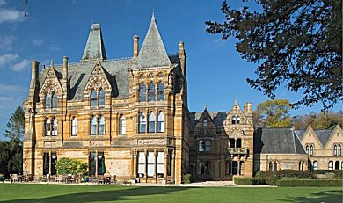  Previous use: The Park was part of the estate owned by the Shirley family since the time of the Domesday book. The House is a large 19th century country house. The house became a nursing home in the 1930’s. The camp was located in the Park. I do not know if the House was also used, but in similar camps it would have been used for officers and offices.  Pow camp:  December 1941 – listed with Italian pow, some of whom were formed as a construction crew to build Maxstoke Camp 39. Initially listed under Pioneer Corps guards with capacity for 750 pows.  Purpose built, standard camp. Mainly Nissen huts with some use of tents when the camp expanded. Guards’ huts and offices can be seen S of the pow camp. Italian and then German pows.  30 December 1943 - International Red Cross visit. Italian prisoners, capacity 800. A number of hostels in local area also used.  1943 – Hostels listed for Italians; Chipping Campden; Horley House, Banbury; Stratford-on-Avon.  May and November 1944 - The camp was listed as an Italian Labour Battalion under the Western Command area, (WO 32/10737). The Italians were being replaced by German pows.  The German pows were mainly low risk white (A) and grey (B) category. | 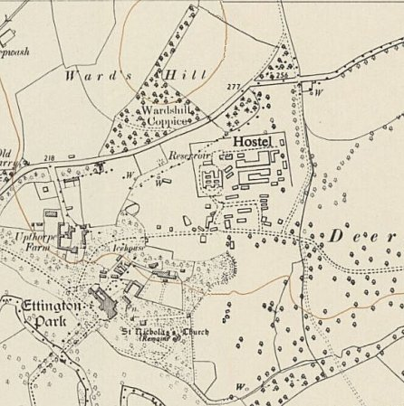
 | Ordnance Survey 1955 – The camp shown as a hostel
Oversight and development of re-education activities and English teaching for German pows was carried out by PID (Political Intelligence Department of the Foreign Office) / COGA (Control Office for Germany and Austria – UK). Visits and reports were made. The standard of the reports varied greatly. The visitors took little interest in activities other than re-education, they rarely mention welfare, sports, games, pastimes, crafts, etc of the pows.

May 1945 - During 1945, news and films of the concentration camps were released to pows throughout the UK. Reactions were very mixed. The official weekly ‘newspaper’ for pows, ‘Wochenpost’ carried a response by some of the pows at Ettington:

“It is with revulsion that the inmates of Camp 31 have through press, radio and films received the information of the inhuman cruelty which has been perpetrated in the concentration camps of Buchenwald and elsewhere. We share the opinion of the ten English MPs who have visited these unheard of abominations that the system of exterminating whole groups with inhuman bestiality represents the lowest level to which mankind has ever fallen.

We do not want to be mentioned in the same breath with creatures such as these who have sinned against human rights so grievously. We will eliminate this cancerous growth from the German people. They are not a part of Germany, but an evil minority which has dragged the image of Germany into the mire in the eyes of the world.” (Wochenpost – 12 May 1945).

19 September 1945 – Visit by ICRC, see below. Comments only on German sections.

10/11 November 1945 – Visit by English Inspector. 5 English classes in the main camp.

Commandant: Lt Col R E A G Badger Camp leader: S/Fwb. (Walter) Krűger.
2nd i/c: Major V G Matthews
Adjutant: Capt S W Wren
Interpreter Officers: S/Sgt T W Regan (Italian Section) / S/Sgt H James (German Section).

The commandant remained with this camp until its closure in 1948. He was supportive of re-education activities throughout.

The Camp leader was described in a later report; aged 43, a professional soldier since 1933, no marked political tendencies, efficient; “a typical regular German NCO.”

The Inspector believed that teaching and the pow’s educational standards were low. There were very vague references to problems arising in the camp.

December 1945 – PID wrote asking if this camp would set up an Information Room. Materials such as “photographic, statistical and other suitable material,” would be sent for a committee of pows to create an exhibition on a subject that interested them. This would be one of the first Information Rooms created and was set up in the canteen.

The idea was enthusiastically agreed to by the assistant commandant, Major V G Matthews. The pows suggested an exhibition on the Russian Zone of Germany, or another re-education topic. There was a request for coloured paper to mount display materials.

Unfortunately, the response from PID was poor. They did not even reply until February, with excuses of flu and moving office. The idea of the Russian Zone was turned down due to lack of materials. It was stated that the pows should buy mounting materials from their own welfare fund.

Some materials on the theme of ‘Democracy’ were sent. In May PID requested that the materials be returned.

3/6 May 1946 – Three members of PID arrived to report on screening. Overall political grading – “grey.”

Screening in main camp | A+ | A | A- | B+ | B | B- | C | C+ | Unk.
 | 5 | 112 | 1 | 134 | 322 | 86 | 69 | 7 | 17

Camp leader – as above, Walter Krűger (B), aged 42, Nazi Party and Nazi Motor Corps member 1937/42. “Seems to be an opportunist but has no convictions.”

Deputy leader - OberWm Gerhard Albrecht (B), aged 32, SA (brownshirts) member 1933/36. In army since 1939, “looks forward to a democratic form of government in Germany. A military type.”

ICRC Report, written in French, translated by M Sanders.

B/PFV/JRh/MB Great Britain.  Translation  CAMP 31  Visited on 19 September 1945  Address: German POW Camp 31, GB.  Commandant: Lieutenant Colonel R.E.A.G. BADGER  Camp speaker: KRUGER Walter, "Stabsfw." 957877  Deputy: NIESE Ernest, "Zahlmeister-Anwärter" 300203  Capacity: 850 men in huts and  100 men in tents (also some in hostels)  Actual Number: 1322 prisoners including 16 protected personnel, 1 officer and 199  non-commissioned officers;  1055 in the camp  69 at "hostel" No 1  198 at “hostel” No 2.  Of these prisoners:  1061 are from the Army  152 Navy  109 Air Force  1296 Germans  11 Austrians  1 Slovak  14 Czechs  General and accommodation  This camp has housed Germans since 2 October 1944. A question is raised about transferring the prisoners who are in tents before winter, either to the existing huts or to new huts, if possible.  Out of 42 huts, 22 are used for accommodation, (an average of 45 men in each). The others are used as - a kitchen, bakery, storage, infirmary (3), theatre, showers, refectory (4), a chapel, canteen, toilets (2), office, barber’s and craftsmen’s workshops.  All locations are lit by electricity and heated by stoves.  34 military tents shelter 184 men, (average 5 in each). |  | At the beginning all the pows came from camps 18, 22 and 181. Subsequently, some were replaced by men from other camps. About 20 prisoners were captured before D-Day, all the others since then.  Each man received 3 blankets.  The camp speaker posses a copy of the Geneva Convention.  Sanitary installations These are good. (Hot and cold showers, flushing toilets).  Food  No complaints were raised. There were the usual remarks about insufficient rations for working youths. [Youth = Under-25]  Menu on the day of our visit:  Breakfast: Bread, jam, tea.  Lunch (take away): Bread, margarine, sausages.  Dinner: Peas, meat, bread, tea.  Infirmary This is well equipped, clean and spacious.  Medical Officer: FLOTHO Wolfgang, "Oberarzt" 451636  Protected personnel: in the infirmary: 1 officer  4 junior officers and soldiers  In the "compound": 7  In the “hostels”: 4  Medical supplies are sufficient.  A general medical inspection is carried out once a month.  Dental care is provided by a British officer who visits the camp once a week. The  prisoners asked for a German dental technician.  An average of 70 to 80 prisoners show-up daily.  The infirmary has 20 beds in a large ward and 2 isolation wards;  4 beds were occupied on the day of our visit, (3 cases of tonsillitis and 1 of flu).  No serious, contagious or epidemic diseases have been declared.  Death: LAU Franz, "Obergefr.” 957088, on 18 August 1945 at Nuneaton Hospital (heart problem). [Buried at Nuneaton (Oaston Road) Cemetery]  Protected personnel are authorized to take walks out of the camp.

No complaints were made.  The German doctor declares that the general state of health is good. He is not entirely of the same opinion of their nutritional status. He attributes this to the rations being too small during the harvest.  Clothes and uniforms  Approximately 80% of the prisoners possess, in addition to their own clothing, hard work clothes; approximately 300 prisoners are still deprived of a second pair of shoes due to the lack of certain sizes. The distribution of other items is satisfactory. About 20% of the pows possess a complete uniform.  Work  All the pows are involved with agricultural work (including forestry work). They earn an average of 5/- [5 shillings = 25p] per week. Additional rations for pows employed with harvesting has not been granted.  Canteen  This is well provisioned. The welfare fund is up to £150.0.0  Religious services  The protestant chaplain OLLECH Helmut, “Uffz.” 533098, holds services every Sunday; approximately 70 prisoners take part. About 30 follow Bible studies. Meetings occur once or twice a fortnight with about 40 pows.  The catholic chaplain LANGLOUIS Eduard, "Uffz." 533083, holds Mass every Sunday; approximately 200 prisoners attend. 100 pows attend evening services and meeting on Sunday mornings.  Activities  Prisoners have use of a football pitch.  The library has about 540 volumes, (including study manuals, etc.)  Education Director: NIESE “Zahlmeister-Anwtärter,” 300203  Students  English 96  French 8  Latin 5  Italian 4 |  | Russian 5  Arithmetic 45  Accountancy 45  Technical subjects 50  History 60  Geography 40  German 65  Shorthand 30  Calligraphy 10  Esperanto 4  Prisoners have formed a choir with 20 members. A protestant choir and a catholic choir also have 20 members each.  The theatre group consists of 15 to 18 members.  The orchestra has six musicians, (1 accordion, 1 violin, 1 piano, 1 guitar, 1 mandolin, 1 drum set.)  Cinema shows take place once per week, (newsreels every week and a movie every three weeks). Pows in the “hostels” also benefit to some extent.  Prisoners can listen to the radio.  Correspondence  Since March 1945, 340 letters, 69 postcards and 27 parcels have arrived. 157 letters and cards have arrived from countries other than Germany.  Discipline  This is good. No escape attempts have occurred. No one has complained.  Requests The camp speaker asks for:  various scores for popular songs.  footballs  table tennis balls  packs of cards  texts, dictionaries, etc. for different subjects  The protestant chaplain would like:  Some hymn books,  Theological textbooks,  An ecclesiastical magazine,  Sheet music for each church.

The catholic chaplain would like:  Catholic theology textbooks,  Some Catholic New Testaments.  The medical officer would like:  A German-English medical dictionary.  Hostels  We visited the German pow “hostels” accompanied by the commandant. Each “hostel” is surrounded by barbed wire. The camp speaker for Camp 31 is responsible for the welfare of all.  “Hostel” No 1: [Chipping Campden]  Hostel leader: FRERICHS Erich-Ede, “Hptfw.” 743341  Strength: 69 German prisoners since 11 August 1945.  This "hostel" is about 12 miles from Camp 31. Containing one small “compound” with huts; 2 huts serve for accommodation; each can contain 35 men; 1 for the kitchen; 1 as refectory; and the last is for washroom and toilets.  Sanitary installations  These are good. Hot and cold showers, flushing toilets.  Food No complaints were received about the food.  Menu on the day of the visit:  Breakfast: Bread, blackberry jam (made here with fruit picked by the  pows), tea, milk.  Lunch (take away); bread, margarine, sausages.  Dinner: white cabbage with potatoes, bread.  General remarks  The pows are satisfied with their conditions, they grow vegetables and flowers.  Discipline is excellent. This is a very good camp.  Hostel No 2 [Over Norton]  Hostel leader: KAUFHOLD Christian, "Stabsoberfw.” 959586  Deputy: ADAMIETZ Alfred, Wm. B115732.  Strength: 198 prisoners arrived on 22 August, 1945. |  | Distance from Camp 31: About 16 miles.  General description  "Hostel" No 2 is part of a disused American camp, from which it is separated by barbed wire. It includes American huts of different sizes. Everything is carefully maintained.  13 huts are used:  1 British guards, (outside of the "compound”)  5 accommodation huts, (approximately 50 men in each)  1 empty hut  1 office  1 canteen and drying room  1 showers  1 large refectory  1 kitchen  1 toilets  Sanitary installations  These are good. Hot and cold showers and toilets with buckets.  Food No complaints were made.  Menu on the day of our visit:  Breakfast: milk soup with dry raisins  Lunch (take away): little sausages, margarine, bread  Dinner: single dish of vegetables  Complaints No complaints.  General remarks  The prisoners appreciate the conditions which are provided; they have improved the surroundings around the huts with flower beds, vegetable gardens, etc.).  They can use a football pitch.  This is a very good camp.  General impressions of Camp 31 and the 2 “hostels”  All the prisoners in these camps seem satisfied, except for correspondence. The  camp and the "hostels” are very well maintained. Camp 31 is excellent and well organized in every way.

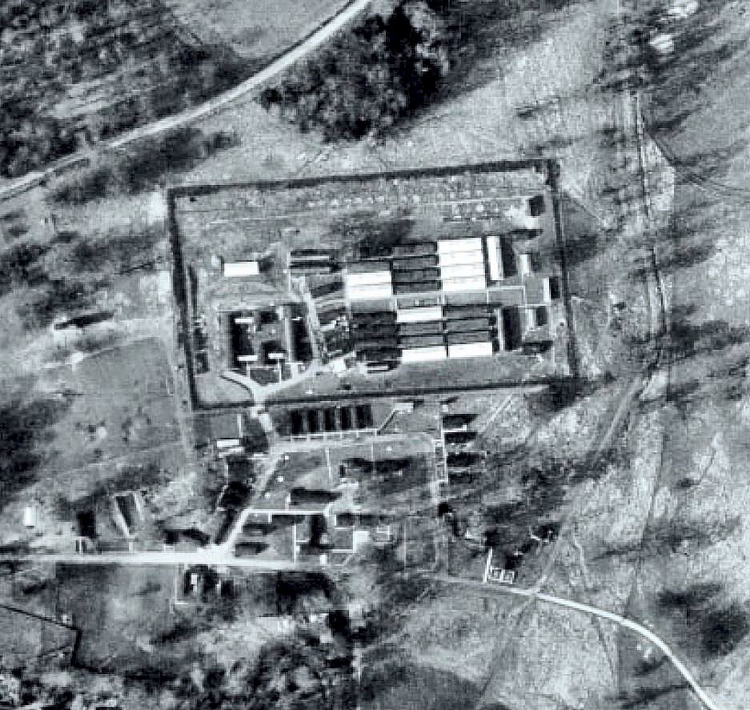 | Some political problems were identified in the camp:  “The team detected a distinct tendency towards communism… The expression ‘slave workers’ cropped up frequently in the conversation of even non-Nazi inmates and, on one occasion, a member of the team found the words ‘Slave workers’ chalked on the door of his room…” The commandant was informed.  15/17 May 1946 – English Inspector’s Report. German Working Company. All in huts. Lights out: 10.30pm. 2 beginner and 3 advanced English classes in the main camp.  1 change to senior personnel, S/Sgt T W Regan replaced by S/Sgt Hayhurst.  4/5 June 1946 – Mr W G Cook from PID reported on the camp. Strength; 2 officers; 1247 O.R.  No changes to senior personnel. German MO named as O/Arzt Flotho (B).  With the pows held at the hostels included in the political screening, a considerable number more were graded as ‘A’ (white) – A+ 6 / A 490 / A- 1.  The British senior staff were seen to be generally supportive of re-education.  Morale was stated as ‘fair.’ Some of the pows stated that they had been imprisoned by the Nazis – reports on these were sent to PID.  Mail was being received in the camp – a large batch from Russia during this visit. Unsatisfactory deliveries were noted from the Polish, Czech and USA zones.  140 pows were ‘youth’ (under-25) – they were not regarded as a problem, and there was no special provision for them.  A small committee of pows were organising re-education activities. The standard list was given:  Wochenpost and Ausblick – separate appendix.  Newspapers – A range of British papers bought and distributed to the main camp and hostels. More were requested. Only a few German newspapers were received from PID, more requested.  Library – 900 books. 50 sent to each hostel and changed fortnightly. Billetees not provided for.
1946 aerial view
Lectures – visits started.

Discussion groups – Held on Wednesdays with 350 pows.

Films – Weekly, alternate from PID (mainly newsreels) / YMCA (mainly movies).

Wireless – In main and hostels.

Camp magazine - Echo Zeitschrift Des P.O.W. Camp 31 (Echo Magazine for pows at Camp 31). 200 copies weekly. Shortage of duplicating ink – a replacement supply could not be found.

Information room – current exhibition on ‘India’ was not very popular.

Press review – Daily news sheet as well as the magazine.  English instruction – separate report.  ‘English For All’ – 100 copies received – very popular.  Other camp activities -  Religion – Equal number of protestants and Catholics. Hostels were visited by the two padres.  Education – Classes for Esperanto (10); French (18); Russian (10); and Shorthand (20).  Theatre Group – 15 members concentrating on one-act plays. Play scripts needed.  Orchestra – In main and Over Norton. Mainly classical music.  There were excellent sports facilities.  7/9 September 1946 – English Inspector’s Report. Total strength 1061.  5 classes with just 19 pupils in the main camp, (0 in hostels). Main reasons given for low numbers; the camp was being reorganised and classes had been disrupted + late working for harvest.  December 1946 - At the nearby village of Alderminster, German pows were recorded working on farms from 1945, especially for the sugar beet harvest, and doing forestry work in the woodlands. At Christmas time 1946, a service was held at the church with 66 pows and the German padre who preached in German and English. | 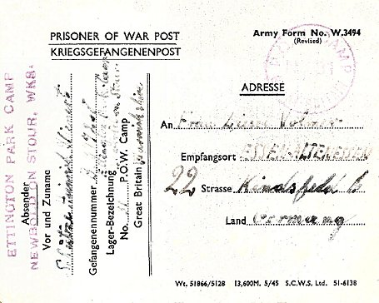
 | POW Postcard, September 1946

Fraternisation restrictions were increasingly relaxed. Many families hosted pows at Christmas dinner.

30 December 1946 – 4 January 1947 – Report on re-education. Total strength; 2 officers, 1358 OR.

Despite reorganisations there was remarkably little change in the senior personnel – New Deputy Camp leader; H.FWb Ph Schwarz, aged 32, metal worker, not a Nazi party member, “not very intelligent, but acts satisfactorily.”

The IO S/Sgt James was regarded by the visitor as; “too young and inexperienced for his job.” He had been in this post since at least November 1945.

Simplified screening figures were used: A 59 / B 765 / C 54 / Unscreened 482.

Morale was recorded as ‘Fair.’ 160 pows had recently been repatriated which had a positive effect. The attitude of the British staff was also seen as a positive factor. However, as many of those repatriated were politically ‘A’ graded, the camp was still regarded as grey. There was a “reasonable Anti-Nazi spirit and sickness of militarism,” but little interest in democratic ideas.

125 youth pows were not seen as a problem.

There was not much enthusiasm shown by the pows in further developing re-education activities. The standard list was given with only a few changes from the previous report: 1280 library books; 3 radios and 11 loudspeakers; a new information room was being constructed; magazine 200 copies each fortnight rather than weekly.

Other activities –

Religion – Services in the camp and some visits to local churches.

Evangelical pastor – Ollech (A+) / Catholic priest Father Langlius – both had a strong influence on the pows.

Education – classes for French, shorthand, building and engineering.

Entertainments – A cabaret or short comedy was performed each week in the main camp only.

5/6 February 1947 – English Inspector’s Report. Total strength 1286. 4 classes with 49 pupils from beginners to advanced.

28 April 1947 – Re-education survey. Total strength 1 officer; 1230 OR.

Senior personnel, no change. Simplified screening; A 60 / B 1095 / C 76.

Morale regarded as ‘good’ – the future of Germany and bad news received especially from the Russian zone, caused anxiety.

There had been a large increase in youth pows to 500. [These were most likely pows transferred from camps in Belgium and Germany].

There were few changes to the standard list of activities; more books needed; films were supplied by YMCA and Gaumont British.

Other activities – Education, just English and French classes; the theatre group was down to 6 members, the orchestra down to 4.

27-29 May 1947 – English Inspector’s Report. Total strength 1363. 51 pupils in 4 classes.

Pows were able to buy various items from money earned, however it was noted that – “with cigarettes at their present prices (pows pay 1/- (1 shilling = 5p) per 10 for 1 brand, and 3/1 (3 shillings and 1 penny – 15½p) per 20 of the other) there is hardly a prisoner left who can afford to buy a book.”

12 August 1947 – Re-education survey. Total strength; 2 officers, 1196 OR

No change to senior personnel. S/Sgt James, who had been recommended for transfer in January; “takes an active interest in re-education. He speaks good German and is industrious and intelligent.”

Simplified screening; A 2 / B 1196, (was 60/ 1095/ 76 – most of the A’s had been repatriated; at this time many C’s were upgraded to B, only hard-core Nazis would have been transferred to other camps). 257 pows repatriated to date.

Improving morale especially with an easing of fraternisation restrictions and greater outside contacts. In all reports, this was the most influential factor in developing positive pow attitudes if they occurred.

The standard list of re-education activities continued - they were affected by repatriations and greater freedom to leave the camp in the evenings. New books had been received from the ICRC in Geneva – Warwick public library also sent books on loan.

In January it was stated a new Information Room was being built – in this report it stated there was no information room, there was, but very little information for exhibitions was being sent.

Outside contacts – Groups had visited Oxford University and Warwick Castle.

24/25 September 1947 - English Inspector’s Report. Total strength 888 + billetees. 31 pupils in 5 classes.

14-17 October and 5 November 1947 – Two Re-education Surveys. Total strength; 2 officers, 1080 OR.

All senior personnel unchanged. S/Sgt James was due to be demobilised. Pointless screening figures – A 2; B 1080.

Bad news from Germany, especially from wives in very poor circumstances, lowered morale. Repatriation was just about all the pows were interested in.

Films sent were regarded as poor. The theatre group had disbanded due to repatriations. The 4 man orchestra continued. Table tennis, chess and football matches were played against local teams.

Outside contacts – visits to Shakespeare Theatre in Stratford, Oxford University, Leamington Spa Council meetings and the Courts of Justice, Warwick Castle. Many Pows developed their own links with families.

14 November 1947 - Camp number included in an ‘Urgent Memorandum’ (FO 939/270) regarding inspection of food parcels.

20/22 December 1947 – Purpose of visit - Re-education survey; Cultural contacts; Screen pows (why?), Strength 2 officers, 1460 OR.

New Interpreter – S/Sgt H B Dowall – “has little understanding of re-education activities.”

Screening – “Not available in camp.” 1090 pows repatriated to date. Fairly high morale throughout, except at Studley.

Standard re-education activities continued, but outside camp attractions often enticed pows away. There were 22 loudspeakers in the main camp.

Additional outside contacts – Coventry Council and Technical College, Warwick UN Association and Labour Party, WEA courses, Friends of Music and Society of Friends at Redditch. More were planned.

A mention of the main sports – “football, handball, Faustball and table-tennis. The skittle alley is very popular.” Football and table tennis matches with local teams continued.

An English Inspector arrived at the same time – 38 pupils in 5 classes + 120 studying privately.

31 January / 3 February 1948 - Re-education survey; Cultural contacts. Total strength 2 officers, 1290 OR (including 3 in jail).

Commandant: Lt Col R E A G Badger Camp leader: O/Stm Philipp Fateiger (B+) [was hostel leader at Banner Hill]
Interpreter: S/Sgt H B Dowell Deputy C/L: Hfw Philip Schwarz (B) [as before]
German M.O.: Dr Wolfgang Flotho (B-) [as before]
Dentist: Lieut Felix Roedes (B)

Fair morale with increased repatriations. 1364 pows repatriated to date.

Activities were winding down as leading pows were repatriated. There were no general education classes. However, it seems that a new intake of pows from other camps led to a new theatre group of 12 players, and an orchestra of 16.

A wide range of outside contacts were maintained.

This is the final report in the National Archive file – the camp closed down not long after.

Known Camp Commandants:
c.1944 Major E R Warrens DSO (Camp WE v/1264/2)
c.1945 - 1947 Lieutenant Colonel R E A G Badger - St Edward’s School, Oxford – Sandhurst - Devonshire Regiment.

After the Camp: The site was used as a Polish resettlement camp with 38 families living there in 1953 – it is now farmland. The splendid Ettington Park Hotel is alongside the camp site.

The site as it is now: https://repatriatedlandscape.org/england/pow-sites-in-the-west-midlands/pow-camp-31-ettington-park/

Camp and hostels + number of pows where known:

 | Not open |  | Unknown |  | Open |  | With another camp

 | 1941 | 1943 | 11/45 | 5/46 | 6/46 | 9/46 | 1/47 | 2/47 | 4/47 | 5/47 | 8/47 | 9/47 | 10/47 | 12/47 | 2/48
Main | Cap.750 I | Cap.800 I | 954 G | 735 | 702 | 711 | 581 | 648 | 768* | 657 | 727 | 699 | 895* | 601 | 543
Chipping C. |  | I | 70 G | 70 | 68 | With C185
Horley House |  | I |  |  | 1 | 39 | With C185
Stratford OA |  | I
Over Norton |  |  | 265 G | 266 | 256 | With C185 |  |  |  |  |  |  |  | With C43 | With C25
Shipston |  |  |  | 65 | 66 | 52
Bodicote |  |  | With C87 |  | 7 | With C87 | With C185
Long Marston |  |  |  | Camp 6 |  |  |  |  |  |  |  |  |  |  | 316
Bridge End |  |  |  |  |  | With C97 |  |  |  |  |  |  |  | 219 | 97
Banner Hill |  |  |  |  |  | With C97 |  |  |  |  |  |  |  | 216 | 68
Lapworth |  | With C39 |  |  |  | 67 | 63 | 49 | 68 | 62
Snitterfield |  |  |  |  |  | 2 | 344 | 262 | 256 | 299
Studley |  |  |  |  |  |  | 115 | 84 | 90 | 83 | 167 | 145 | 144 | 121 | 27
Pitchill / Red H. |  |  | With unknown C |  |  |  | 50 | 39 | 49 | 45 | 47 | 46 | 43 | 42 | 37
With No1 ESD |  |  |  |  |  |  |  |  |  |  |  |  |  | 14 | 13
Stoneleigh |  |  | Camp 667 |  |  |  |  |  |  |  |  |  |  |  | 28
Billets |  |  | ? | 149 | 149 | 190 | 207 | 200 | ? | 217 | 257 | ? | ? | 249 | 159
Total |  |  | 1289 | 1285 | 1249 | 1061 | 1360 | 1286 | 1231 | 1363 | 1198 | 888 ** | 1082 | 1462 | 1292
1941 to 1945; I = Italian / G = German Slight discrepancies in totals were often due to pows in hospital or in detention. * includes billetees ** + billetees

Further information:

National Archives – FO 939/115 31 Working Camp, Ettington Park Camp, Newbold on Stour, Warwickshire – dated 1945-48 – used above.
FO 939/273 Exhibition: 31 Working camp, Ettington Park Camp, Newbold on Stour, Warwickshire. Dated 1945-47 – used above.

Warwickshire County Council Information for record number MWA9592 – site survey

Conservation Bulletin – English Heritage – 2003, Issue 44

The IWM have a copy of the magazine dated Christmas 1946. Catalogue LBY E.J.346

Hostels –

Banner Hill. Map and previous details see Birdingbury Camp 97.

October 1947 – transferred from Camp 97 to Ettington. Same hostel leader; P Fateiger.

December 1947 – Hostel leader; O/Stm Philipp Fateiger (B+), aged 38, electrician and haulage contractor, “ordinary type but efficient and pleasant…. He had rigged himself out in a composite uniform comprising Belgian officer’s tunic, police breeches and riding boots all purchased at second hand shops in Warwick.”

February 1948 – Hostel leader Uffz Herbert Busch (B+)

 | 1941 | 1943 | 11/45 | 5/46 | 6/46 | 9/46 | 1/47 | 2/47 | 4/47 | 5/47 | 8/47 | 9/47 | 10/47 | 12/47 | 2/48
Banner Hill |  |  |  |  |  | With C97 |  |  |  |  |  |  |  | 216 | 68

Bodicote. Map and previous details see Byfield Camp 87.

June 1946 – Hostel leader O/Fw Seiterle (B)

July 1946 – again listed with Byfield Camp 87 but only for a very short time.

7 August 1946 – transferred to Springhill Camp 185.

 | 1941 | 1943 | 11/45 | 5/46 | 6/46 | 9/46 | 1/47 | 2/47 | 4/47 | 5/47 | 8/47 | 9/47 | 10/47 | 12/47 | 2/48
Bodicote |  |  | With C87 |  | 7 | C87 | C185

Bridge End. Map and previous details see Birdingbury Camp 97.

October 1947 – transferred from Camp 97 to Ettington. Same hostel leader.

December 1947 – Hostel leader; Uffz Horst Schellak (B-)

February 1948 – same leader. The leader organised a farewell evening at St Nicholas, Warwick. 160 civilians accepted. The pow orchestra from Banner Hill and choir from Bridge End provided an evening of music, song, dance and light refreshments.

 | 1941 | 1943 | 11/45 | 5/46 | 6/46 | 9/46 | 1/47 | 2/47 | 4/47 | 5/47 | 8/47 | 9/47 | 10/47 | 12/47 | 2/48
Bridge End |  |  |  |  |  | With C97 |  |  |  |  |  |  |  | 219 | 97

Chipping Campden.  “On the right hand side of the road to Broad Campden, in Keyte’s Field, Catbrook (now The Green), there was a small working camp of wooden huts erected for the Italian POWs.” [Approx NGR SP 152 386]  I am fairly certain that this is ‘Chipping Campden Hostel’ in the Camp 31 reports. There is a link – “Alfredo Sposini, a PoW from Southern Italy, was stationed at Prisoner of War Camp 31, Ettington Park, and came to Ebrington to work with Farmer Stanley, where he met Betty Grant, an Ebrington girl. Alfredo stayed on after the war and they married, living in Ebrington until his death.”  “The Camp was built during the first years of the war in a field belonging to W. Keyte of The Sheppey. The site was about four acres in size and was surrounded by a wire fence but not escape proof…. There was a large building with accommodation for about 10 soldiers who acted as guards, with the cookhouse and mess room, another one was toilets and showers and I think there were three long accommodation blocks for the prisoners. They were not dangerous people and went out in parties to work on the local farms.”  Details above – and many more on - https://www.chippingcampdenhistory.org.uk/content/history/campden_in_wartime/italian_pows_in_campden_in_wwii | 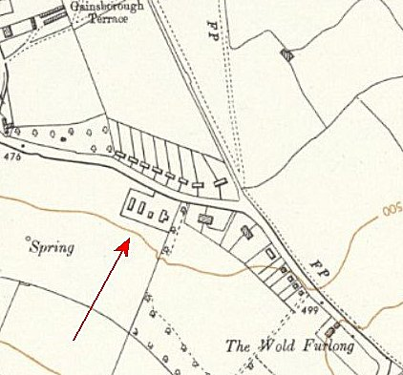
 | Ordnance Survey 1955

1943 – Recorded as a hostel holding Italian pows.

September 1945 – included as “Hostel” 1 in ICRC report, see above.

November 1945 – 2 English classes.

May 1946 – 1 English class of just 4 pupils. No radio.

June 1946 – hostel leader H/Fw Erich Ede Frerichs (B). Radio now provided.

30 July 1946 – taken over by Springhill Camp 185.

March 1947 - last record of the hostel in Springhill reports.

 | 1941 | 1943 | 11/45 | 5/46 | 6/46 | 9/46 | 1/47 | 2/47 | 4/47 | 5/47 | 8/47 | 9/47 | 10/47 | 12/47 | 2/48
Chipping C. |  | I | 70 G | 70 | 68 | With C185

Horley House, Banbury. About 15 miles from the main camp. NGR SP 417 442.  1943 – listed with Italian pows.  Gap in the records until June 1946 with just 1 pow. (Was he there to ensure the house was not taken over by squatters? Or, perhaps working on the house?)  June 1946 – Hostel leader Fw Erhardt Schuster (B).  June 1947 - listed with Chipping Campden Camp 185 (39 pows).  Recorded that the pows built the bridge over the stream between Horley and Hanwell.  1941 1943 11/45 5/46 6/46 9/46 1/47 2/47 4/47 5/47 8/47 9/47 10/47 12/47 2/48  Horley H I 1 39 With C185  After the camp, used to house displaced persons. | 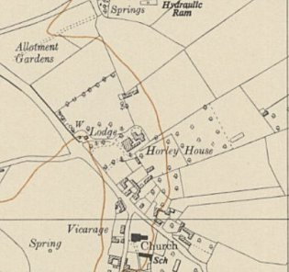
 | Ordnance Survey 1955

Lapworth. About 20 miles from the main camp.  “..alongside the railway line on Rising Lane…” / “..site now known as Kingswood Close.” NGR SP 190 722.  1943 – listed as a hostel with Italian pows attached to Maxstoke Camp 39.  Not listed with C39 in 1944 – almost certainly attached to another main camp until September 1946,  January 1947 – Hostel leader M.St.F.W Flierl (B)  April 1947 – Same leader.  1941 1943 11/45 5/46 6/46 9/46 1/47 2/47 4/47 5/47 8/47 9/47 10/47 12/47 2/48  Lapworth With C39 67 63 49 68 62 | 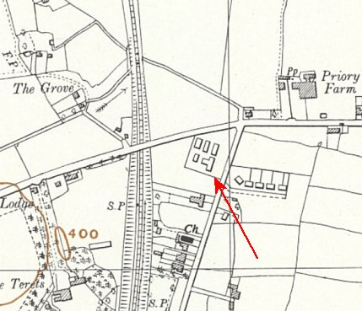
 | Ordnance Survey 1955

Long Marston - Long Marston see Camp 6. “Situated in Royal Engineer depot a mile from entrance and with no public or other transport facilities near.”

February 1948 – Hostel leader Fw Gerhard Scholz (B), aged 36, artisan; “pleasant understanding personality with whom the British staff are highly satisfied.”

 | 1941 | 1943 | 11/45 | 5/46 | 6/46 | 9/46 | 1/47 | 2/47 | 4/47 | 5/47 | 8/47 | 9/47 | 10/47 | 12/47 | 2/48
Long Marston |  |  |  | Camp 6 |  |  |  |  |  |  |  |  |  |  | 316

Over Norton.

1945 - Opened before September with 200 pows (FO939/383)

September 1945 – included as “Hostel” 2 in ICRC report, see above. Stated to be; “part of a disused American camp, from which it is separated by barbed wire.”

November 1945 – 2 English classes.

May 1946 – 2 English classes. Fr Coplestone, a Jesuit from Heythrop, visited the camp to give Mass.

June 1946 – Hostel leader St/Fw W Feuer (B). Had its own orchestra.

30 July 1946 – transferred to Springhill Camp 185. (See 185 for map).

Short time with Harcourt Camp 43

January 1948 – attached to Lodge Farm Camp 25

 | 1941 | 1943 | 11/45 | 5/46 | 6/46 | 9/46 | 1/47 | 2/47 | 4/47 | 5/47 | 8/47 | 9/47 | 10/47 | c.12/47 | 2/48
Over Norton |  |  | 265 G | 266 | 256 | With C185 |  |  |  |  |  |  |  | With C43 | With C25

Pitchill / Red House (“Upper Salford”). About 17 miles from the main camp.  NOTE – there was another Red House attached to Byfield Camp 87, then Springhill Camp 185. Its location was recorded at Bodicote, near Banbury. It was still open in March 1947 with 150 pows.  This Pitchill (1 on map) was at SP 051 516, then at Red House, Abbots Salford (2) SP 069 502.  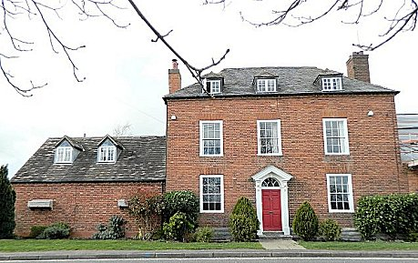  1945 – The October 1947 report stated that the hostel leader Ofw.Gregor had held this position since September 1945. As it was not listed with Ettington until January 1947, the hostel must have been attached to another main camp.  January 1947 – Hostel leader Ob.F.W. Johannes Gregor (B+), aged 32, professional soldier; “Appears efficient and is a pleasant personality.”  April 1947 – same leader. No electricity, so no films. Battery radio.  August 1947 – same leader. A lady from Durrington visited to give English lessons. | 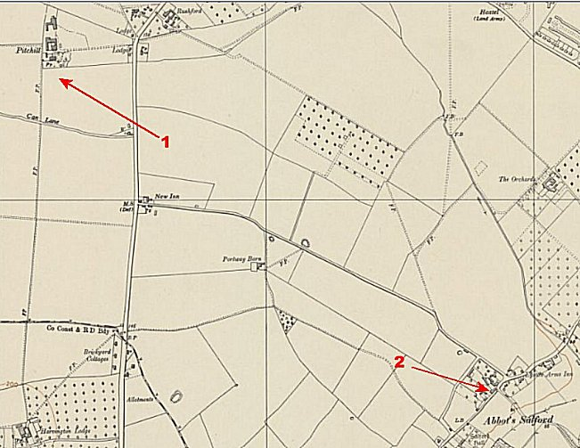
 | Ordnance Survey 1955
September 1947 – Red House (above) “is the old Pitchill site relocated to better premises”. Listed as “a building.”

October > February 1948 – same leader.

 | 1941 | 1943 | 11/45 | 5/46 | 6/46 | 9/46 | 1/47 | 2/47 | 4/47 | 5/47 | 8/47 | 9/47 | 10/47 | 12/47 | 2/48
Pitchill / Red H. |  |  | With unknown C |  |  |  | 50 | 39 | 49 | 45 | 47 | 46 | 43 | 42 | 37

Shipston-on-Stour. About 4 miles from the main camp. NGR SP 253 407.  November 1945 – NOT included in PID report.  May 1946 – 2 English classes.  June 1946 – Hostel leader Fw W Schmidt (B)  1941 1943 11/45 5/46 6/46 9/46 1/47 2/47 4/47 5/47 8/47 9/47 10/47 12/47 2/48  Shipston 65 66 52 | 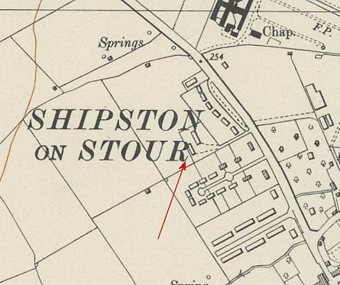
 | Ordnance Survey 1955

Snitterfield. About 10 miles from the main camp. Huts (in one description ‘stone huts’). Snitterfield is about 3.5 km to the E, but the site was alongside RAF Snitterfield. SP 178 607.  Probably attached to another main camp prior to 9/46.  January 1947 – Hostel leader E Karste (B+)  April 1947 – same leader  1941 1943 11/45 5/46 6/46 9/46 1/47 2/47 4/47 5/47 8/47 9/47 10/47 12/47 2/48  Snitterfield 2 344 262 256 299 | 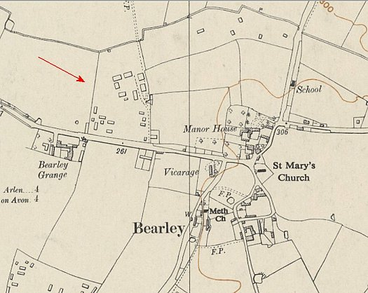
 | Ordnance Survey 1955

Stonleigh. (Was camp 667)

February 1948 – hostel leader; Gefr Artur Lange (B), aged 43, jurist and administrative officer, “intelligent and intellectual person but anti-British… formerly graded C and still holds that Nazism was not a dictatorship, that it sought peace and that these aims were ended by Britain declaring war on Germany.”

 | 1941 | 1943 | 11/45 | 5/46 | 6/46 | 9/46 | 1/47 | 2/47 | 4/47 | 5/47 | 8/47 | 9/47 | 10/47 | 12/47 | 2/48
Stoneleigh |  |  | Camp 667 |  |  |  |  |  |  |  |  |  |  |  | 28

Stratford On Avon

No further information.

 | 1941 | 1943 | 11/45 | 5/46 | 6/46 | 9/46 | 1/47 | 2/47 | 4/47 | 5/47 | 8/47 | 9/47 | 10/47 | 12/47 | 2/48
Stratford OA |  | I

Two sites have been mentioned as possibilities – Stratford Racecourse and Clopton Road where there had previously been a Women’s Land Army hostel.

Studley. About 18 miles from the main camp. NGR SP 079 630.  Known to have held Italian pows, so open well before 1947 – attached to a different main camp.  January 1947 – Hostel leader F/W A Schneider. Had been held in a pow camp in Belgium before being sent to the UK under ‘Operation Fox.’ Many of the pows had been badly mistreated.  April 1947 – Hostel leader Fw Lorenz (B+). No electricity, so no films. Battery radio.  August 1947 – Hostel leader for about 3 months; Ofw Gruihm (B), aged 29, Hitler Youth 1933 to 1935, clerk then joined Luftwaffe. “Not very intelligent and generally a poor type. Unfortunately there is no one better available.”  October 1947 – same leader, opposite description; “He is a good type, and carries out his duties satisfactorily.”  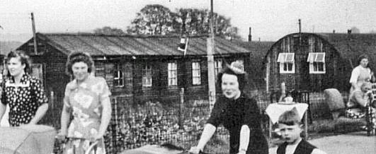  December 1947 – same leader. Low morale recorded, reported as partly due to the hostel leader, partly from slow clothing exchange.  February 1948 – Hostel leader; Uffz Winkelmann (B)  < Picture from 1955, showing a pram race – in background wooden huts and Nissen type huts shown. | 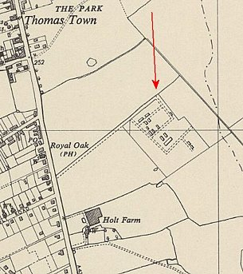
 | Ordnance Survey 1955

Memories of the hostel – Italian then German pows; Original camp was tents, then wooden huts built; Pows came to the Roman Catholic Church in Studley and joined the choir; 1947 pows invited to Christmas dinner by many families.

 | 1941 | 1943 | 11/45 | 5/46 | 6/46 | 9/46 | 1/47 | 2/47 | 4/47 | 5/47 | 8/47 | 9/47 | 10/47 | 12/47 | 2/48
Studley |  |  |  |  |  |  | 115 | 84 | 90 | 83 | 167 | 145 | 144 | 121 | 27

“With No1 ESD” – I think this was (Royal) Engineers Supply Depot which was listed at Long Marston.

 | 1941 | 1943 | 11/45 | 5/46 | 6/46 | 9/46 | 1/47 | 2/47 | 4/47 | 5/47 | 8/47 | 9/47 | 10/47 | 12/47 | 2/48
With No1 ESD |  |  |  |  |  |  |  |  |  |  |  |  |  | 14 | 13

