Camp 11 (& 122) - Rayner’s Lane, Harrow-on-the-Hill, Middlesex

Included in the 1945 ICRC – Labour Camp. 122. Rayners Lane Camp, Rayners Lane, Harrow, Middlesex.

Prisoner of War Camps (1939 – 1948) - Project report by Roger J.C. Thomas - English Heritage 2003
OS NGR | Sheet | No. | Name & Location | County | Cond’n | Type 1945 | Comments
TQ 51 18* | 176 | 11a | Rayner's Lane, Harrow-on- the-Hill | Middlesex | 5
TQ 13 87 | 176 | 122 | Rayner's Lane Camp, Harrow-on-the-Hill | Middlesex | 5 | See Camp no.11a

1947 Camp list
122(G.W.C.) | Rayners Lane Camp, Rayners Lane, Harrow, Middlesex | L.D. | Priswar, Harro | Byron 4471 | Harrow Wealdstone (L.M.S.) Northolt G.W.R. Rayners Lane (Met and Picc Lines) | Lt.Col.G.F.Tillman | v/1453/2
The entry is crossed out and details for Oxhey Lane Camp 122 inserted

Location: TQ 13 87. *The NGR for Camp 11 above is incorrect. Rayners Lane is the name of a suburban district in Harrow, as well as the road.  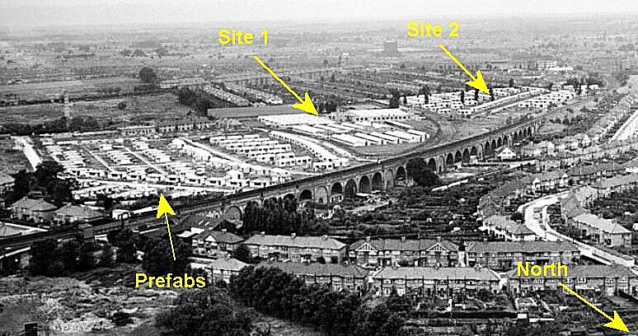  "Ministry of Works temporary office buildings, erected in November 1942, were taken over to house Italian collaborator prisoners of war in October 1944. When they finally moved out (some time after July 1945), they were replaced by German P.O.W.s (122 German Prisoner of War Working Camp). The Germans moved to a camp on the site of the later Bannister Sports Centre, off the Uxbridge Road, on March 15th 1947". Bob Thomson, Local History Librarian. | 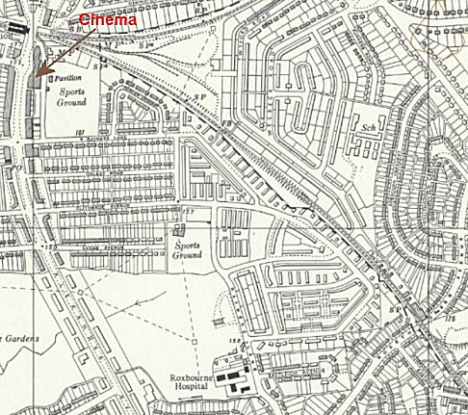
OS 1960 – located in centre (camp area at TQ 135 870)

From descriptions of the location, Site 1 is the most likely position for the camp. Site 2 is a second possibility for a position behind the Gaumont, (see below). It is known that the camp changed location within the Rayners Lane area.

Previous use: mainly farm land, then temporary office buildings.

POW Camp:

Memories of Italian pow camp – this description with a Captain C.O. and a small site with Nissen huts would seem to describe an annex (possibly site 2 above) for the main site located in office buildings, (site 1). “… I met… an Army Captain who I never knew other than as 'Johnny'. He was the C.O. of an Italian Prisoner of War camp which was situated only about a quarter of a mile from my home on what had been waste ground behind our local 'Gaumont' Cinema in Rayners Lane, in the north west London suburbs. He invited me to dinner at the camp. There were only four officers on the camp so the Officers’ Mess was not large. It was in a Nissen hut exactly the same as those in which all the prisoners were accommodated. The security was extremely lax since none of the prisoners had any desire to escape! They were mostly employed locally doing odd jobs or being 'let-out' to farmers further outside London. Those that remained on camp were the ones whose skills could contribute most to the comfort of the camp staff!

The Officer's Mess was staffed by ex waiters, some of whom had been with large hotels in Italy; there were also three top flight chefs and experienced kitchen staff. The Catering Officer, an elderly, to my eyes at the time, pre-war hotelier had co-opted the services of several English-speaking prisoners who had been barmen and had made suitable arrangements with several local pubs and hotels to provide staff in exchange for certain 'perks'. Thus it was that, in the middle of war-rationed Britain I was treated to a superb four-course Italian dinner which included wine and liqueurs!
The evening even included a short concert of operatic arias by ten of the prisoners who had formed a choir. This was the first of many visits I paid to this POW camp and it was still in existence at the end of the war. In fact quite a lot of the prisoners opted to stay in Britain and carry on with their war-time jobs. At least two of them later obtained licences and became pub landlords in their own right!” Peter Brett's memoirs - Settling down to Squadron life - https://northoltgrange.files.wordpress.com

The Italian pows at the camp were classed as co-operators. However, within a very short time of arriving, they were on the receiving end of what appears to be an anti-Italian campaign being led by some of the press and reflected by some local people;

November 1944 - the Italian camp leader, Major G Rescazzi wrote to the camp commandant to complain about the way his men were being treated with, “cases of insults, provocations and even spitting … as everyday occurrences”. He pointed out that a press campaign was also being waged against Italians and stirring up trouble; “The public has described the co-operator with the most injurious titles, i.e. “WOP”, “Lazy Devils”, “Third Rate People”.” (WO 32/10737, Major G. Rescazzi to Commandant 122nd Italian Labour Battalion, Rayners Lane Camp, 28 Nov. 1944).

28 November 1944 - The matter was raised, from an opposing point of view, in the House of Commons:

“Mr. Norman Bower (MP for Harrow) asked the Secretary of State for War if he is aware that women are being continually molested after dark by Italian co-operators camped at Rayners Lane, Pinner; and if he will issue instructions to the camp commandant that these men are not to be allowed outside the camp after dark.

Sir J. Grigg - Seventeen hundred Italian co-operators have been accommodated in this camp for nearly six weeks, and only a very few complaints of this nature have been made, either to the police or to the camp commandant. I do not consider that this justifies the withdrawal from all these co-operators of the privilege to exercise outside their camp until 10 p.m.

Mr. Bower - Is my right hon. Friend aware that there are very many complaints about this sort of thing, that it is causing great anxiety and indignation in the neighbourhood, and that complaints to the camp commandant appear to be utterly ineffective?

Sir J. Grigg - My information is not in accord with that of the hon. Member. There have been a few complaints to the police. I may be a little out of date, but when I last heard there had not been a single complaint to the camp commandant.

Mr Bower did not get much support for his claims, even from members of his own party:
​
Sir Reginald Blair (MP for Hendon) - Is my right hon. Friend aware that the hon. Member who represents the constituency in which Rayners Lane is situated has not received a single complaint, and that from his own personal investigations and other inquiries he believes that the behaviour of these Italian co-operators is very good indeed?

Mr. Ivor Thomas - Is the right hon. Gentleman aware that this campaign against Italian co-operators bears many of the marks of the anti-Semitic campaign in Germany? Will he also bear in mind the words of the Foreign Secretary a few years ago that there is no such word as "vendetta" in the English language?”
(House of Commons, 28 November, 1944, Vol 404, Col 2384).

December 1945 - Brondesbury Park Hostel transferred from Winter Quarters Camp 7 to Camp 122. (See below).

Summer 1946 - the Harrow Housing committee discussed the future of the pow camp; “Rayners Lane Housing Site Adjoining Prisoner of War Camp: The committee considered the question... as to the continued occupation by German prisoners of war of the temporary office buildings erected by the Ministry of Works on the land at Rayners Lane housing estate, held under requisition by the Minister of Works, in view of the undesirability of maintaining the camp in close proximity to the Council houses, which will soon be completed and occupied.” They resolved to request that the temporary buildings be removed as soon a possible. The Ministry of Works informed the Harrow Housing Committee on 10 August that they intended to remove the pows from the camp at the end of September, 1946. (Harrow Housing Committee, ad-hoc committee, and 28 September 1946; Minute 616).

After the camp: Became temporary housing estate with prefabricated buildings - pow workers were part of the building workforce. Later brick built residential estate.

Brondesbury Park Hostel.

The hostel was located at 1a Brondesbury Park Road, Kilburn, London, NW6 7BS (NGR TQ 241 841).

It was at first attached to Winter Quarter Camp 7 from late 1944. Pows were selected to work at the hostel with the Political Intelligence Department (PID). It held up to 90 pows.

December 1945 – Hostel attached to Camp 122. The pows were mainly involved in producing materials for re-education activities. About 30 worked with PID / BBC to produce radio broadcasts, (see Ascot-Brondesbury Scheme under Camp 7).

Lecturers regularly visited the hostel, their reports are in file FO 939/309 32 Working Camp, Brondesbury Hostel Camp, Kilburn, dated 1946-47. Most reports only concerned the lecture and the pow’s responses, some gave minor snippets of information about the site. The pows were anti-Nazi’s – amongst them were at least two padres, trade unionists, social democrats, teachers…

1946 - Commandant Captain Green.

20 March 1946 – The first report by a visiting lecturer (Dr Demuth) in the FO file. The lecture, under the title ‘How a Nation is Built Up,’ was given to 70 pows at the hostel. He had visited here before. Only 7 pows had been there for some time, the rest were newcomers arriving 2/3 days before. Listed as a hostel for Rayner’s Lane Camp 122. German and Austrian pows.

May 1946 onwards – Austrian pows left for repatriation. The hostel was referred to as number 122G or 122B. Attendance at lectures was mostly between 40 to 60. High intelligence noted as well as high standards of English.

October 1946 – the War Office stopped funding the Ascot-Brondesbury Scheme. Radio broadcasts by pows continued, but costs for board and lodging of the pows was paid for by the BBC, (they had paid the POWs' wages since December 1944).

March 1947 – Brondesbury hostel was taken over by Wormwood Scrubbs Camp 32.

Further information:

National Archives: FO 939/309 32 Working Camp, Brondesbury Hostel Camp, Kilburn. Dated 1946-47.

