Camp 30 - Anglesey House, Heath End, Aldershot, Hampshire

Prisoner of War Camps (1939 – 1948) - Project report by Roger J.C. Thomas - English Heritage 2003
OS NGR | Sheet | No. | Name & Location | County | Cond’n | Type 1945 | Comments
SU 86 50 | 186 | 30 | Anglesey House, Hoath End, Aldershot | Hampshire | 5

Location: The NGR above is a general location. ‘Hoath End’ should be Heath End. Anglesey House is a Grade 2 listed building on the Farnborough Road, (A325), just N of Heath End – NGR SU 847 499. Anglesey Lodge is a nearby building which was a former coach house and stable block.  Previous use: Originally this was the house of the Divisional Commander of the Cavalry Brigade. It was part of the permanent barracks at Aldershot.  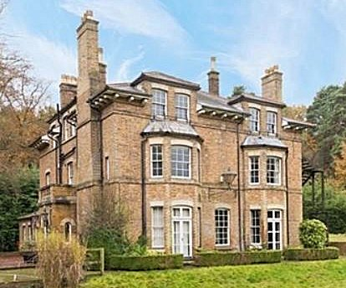  Pow camp: The house had a large area of land surrounding it – not known if the camp was based on the land or in the house, or both.  After the camp:  The site as it is now:  https://repatriatedlandscape.org/england/pow-sites-in-the-south-east/pow-camp-30-anglesey-house/ | 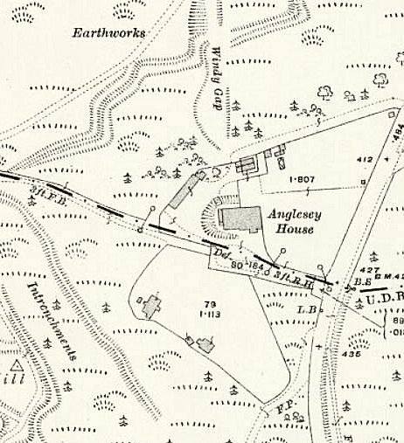
 | Ordnance Survey 1915

