Camp 29 - Ormskirk, Lancashire (aka Rainford)

Prisoner of War Camps (1939 – 1948) - Project report by Roger J.C. Thomas - English Heritage 2003
OS NGR | Sheet | No. | Name & Location | County | Cond’n | Type 1945 | Comments
SD 41 08 | 108 | 29 | Ormskirk | Lancashire | 5

Location: The NGR above is just a general location for Ormskirk.  With thanks to Martin Richards - https://www.systonimages.co.uk/ (see Banged Up Abroad) who carried out a site survey and identified a most likely location for this camp. X = NGR SD 466 020.  There was a hostel listed for Garswood Camp 50 at Old Coach Lane which is just 1 km away. Links???  An archived reference for the camp:  “ARCHIVE: Ormskirk POW Camp, Ormskirk, March 09 - 16-04-2009, 12:09  This must be one of the best kept secrets in the MOD, only because I cannot find any history on this site. The only reason I know where it is, is because my Great Uncle was a Prisoner here.  From what he has told me, he was here from 1942 to 1945. There were 6 to 8 sleeping buildings, a large workshop a few out buildings and a reservoir.  There was a large bunker at the site. He was sent to work on local farms as he wasn’t skilled, the skilled POW's were to work in the workshops repairing local Farming equipment. The reservoir was used for swimming and cleaning.”  From this description the reservoir is shown on the map - and I am wondering if the ‘large bunker’ could be the clay pit?  The site as it is now:  https://repatriatedlandscape.org/england/pow-sites-in-the-north-west/pow-camp-29-rainford/ | 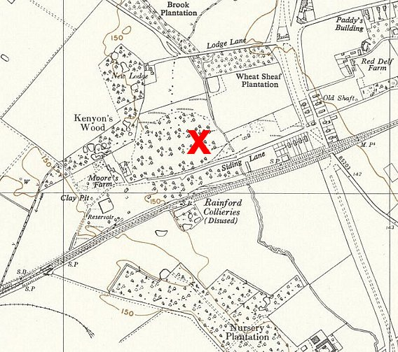
 | Ordnance Survey 1955

