Camp 27 - 3 Magdala Road, Nottingham, Nottinghamshire

Prisoner of War Camps (1939 – 1948) - Project report by Roger J.C. Thomas - English Heritage 2003
OS NGR | Sheet | No. | Name & Location | County | Cond’n | Type 1945 | Comments
SK 570 418 | 129 | 27 | 3 Magdala Road, Nottingham | Nottinghamshire | 1 |  | Reported by DoB Project

Location: The house is on the corner of Magdala Road and Zulla Road in Nottingham.  Before the camp: Large house.  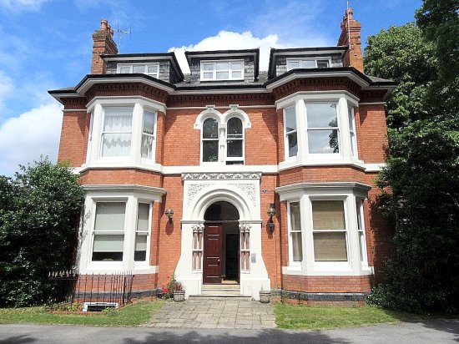  POW camp:  Historic England records that – “It was possibly staffed by the Royal Pioneer Corps based at Mapperley...”  The question is - why was this house recorded by the Defence of Britain Project as a camp, rather than a hostel? It was not recorded in the 1945 or 1947 lists.  I have been unable to trace any further records / memories.  After the war: Now flats.  https://repatriatedlandscape.org/england/pow-sites-in-the-east-midlands/pow-camp-27-3-magdala-road/ | 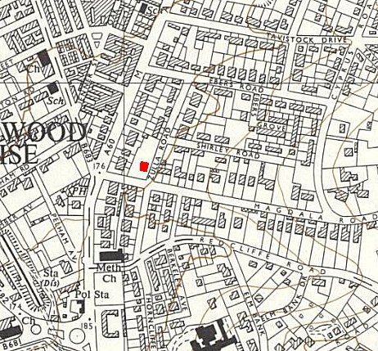
 | Ordnance Survey 1955

