Camp 24 – Knutsford Military Hospital, Knutsford, Cheshire

Prisoner of War Camps (1939 – 1948) - Project report by Roger J.C. Thomas - English Heritage 2003
OS NGR | Sheet | No. | Name & Location | County | Cond’n | Type 1945 | Comments
SJ 75 78 | 118 | 24 | No.4 General Hospital (Military Hospital) Knutsford | Cheshire | 5

Location: Information in news articles indicate that several buildings in and around the main hospital area were used.  At various times different hospital units were based here. No.4 General Military Hospital listed by English Heritage was just one of those units:  Units listed in WO 222/1568:  No.4 British General Hospital – (Leeds to) Knutsford 7/10/40 to 10/5/42 then overseas  No.9 British General Hospital – (Cairo to) Knutsford 12/43 to 15/4/44 then to Goodwood  No.101 British General Hospital – Knutsford 6/43 to 8/44 then to St-Loup-Hors  No.121 British General Hospital – (Goodwood to) Knutsford 4/44 to 7/44 then to Gruchet  From 1944, pows worked as staff within the hospital alongside British medical staff.  1940 General Hospital > 1942 Military Hospital > 1944 24 POW Hospital:  7 October 1940 - Part of the Knutsford site was used as a hospital for pows. It was listed as; ‘4 General Hospital, Knutsford’ in Appendix to WO 199/405.  19 November 1941, 11 March 1942, 26 May 1942 - International Red Cross visits were carried out, they recorded that German and Italian prisoners were present.  October 1942 – War Diary (WD): Knutsford became a Military Hospital. New CO, Lt-Col W S Evans, RAMC, arrived (13th) – Military Hospital formed (24th) – ‘84 General Hospital’ left Knutsford and the Military Hospital took over the site with 71 patients (27th). Throughout the month 4 officers and 42 Other Ranks arrived.  The War Diary often gave brief details of visitors – but usually not the purpose or outcome of the visit. These entries are omitted below unless the purpose was given.  November 1942 – WD: Entries at this time often focused on social events. | 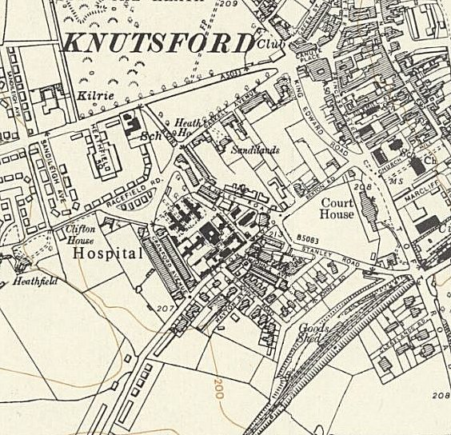
 | Ordnance Survey 1954 – Black buildings in centre are the hospital

Entertainments Committee formed. Then through the month there were: 5 dances; 4 whist drives; 2 football matches against Knutsford F.C.; 2 ENSA Concerts; 1 theatre performance; 1 cinema show; and a church parade. 2 libraries were opened, 1 for the company, 1 for the patients.

Military hospital activities were just – appointments of a sanitation officer, gas officer, salvage officer and a temporary venereologist; a cancelled conference; a kit inspection; and an inspection of the hospital by a district officer.

The average number of patients was 92, but the diary gave no indication of what type of patient. There were 5 British officers and 47 OR, but the War Establishment number for the site had not been settled.

December 1942 to April 1943 – WD; all similar to previous – social events, inspections, transfers to and from the unit.

13 April 1943 – WD; New C.O. Lt Col J N Atkinson RAMC.

May 1943 – WD; Social events are no longer included in the diary.

5 June 1943 – WD; New C.O. Lt Col D G Rice-Oxley, RAMC.

7 June 1943 – WD; War Establishment reduced from 200 to 50 beds.

30 June 1943 – WD; passing reference states the pow hostel at Comberbatch, (attached to Racecourse Camp 74) came under the care of this hospital.

July 1943 to June 1944 - WD; Little recorded other than personnel matters. (February / July / August 1944 diaries are missing from the file).

4 September 1944 – WD; Hospital expanded to 430 beds.

24 POW Guard Company took over from CMP personnel. (Corps of Military Police).

21 September 1944 – WD; New C.O. Lt Col. G D Yates.

NOTE – The War Diary entries continue under the name of Knutsford Military Hospital, and not referred to as Camp 24. The C.O. was listed as Lt Col Yates (RAMC) throughout – he was the Senior British M.O.

At the same time the site was listed as; ‘Camp 24 Knutsford Military Hospital’. A separate Commandant and the 24 POW Guard Company were in place for overseeing the pow camp which were mainly German staff – pows and Protected Personnel. The Political Intelligence Department (PID) were responsible for overseeing re-education of pows. They started to visit from October 1945 and always referred to the site as Camp 24.

It is perhaps not surprising that there was some friction between the medical C.O. and the camp Commandant – see 5 July 1946, below.

24 September 1944 – WD; 421 patients, highest to date. The hospital had difficulties in finding pow camps able to receive patients after being discharged due to congestion in the camps.

Barbed wire fences were erected under the direction of the pow Guard Company. General hospital staff are transferred from the camp throughout September and October.

30 October 1944 – WD; Arrival of German Protected Personnel for staff duty; 4 officers and 27 OR. Patient numbers – see table below.

9 December 1944 – WD; Visit by the Director of Prisoners of War.

15 December 1944 – WD; Visit by Swiss delegate.

March 1945 – The medical C.O., Lt Col Yates, visited various pow camps and hospitals as a member of a Mixed Medical Commission (MMC). Under Articles 69 and 70 of the Geneva Convention the MMC’s consisted of 3 members; “two of whom shall belong to a neutral country and one appointed by the Detaining Power; one of the medical officers of the neutral country shall preside. These mixed medical commissions shall proceed to the examination of sick or wounded prisoners and shall make all appropriate decisions with regard to them.”

13 March 1945 - WD; Visit by Swiss delegates.

17 March 1945 – WD; A search of the hospital was conducted by No2 Ind Coy, Middlesex Regt. Searching for what?

20 March 1945 – WD; A German Protestant Padre was transferred to the camp.

24 March 1945 – WD; “Inquest on POW Cremer”. No reasons given. This would be Josef Cremer, from the Luftwaffe, died 21 March 1945. Later reburied at Cannock Chase German Military Cemetery.

16 September 1945 – WD; 88 German pows repatriated by train.

7 October 1945 – Camp 24: Report on English Instruction by Mr R D Miller. Strength 433, (Staff 144 Patients 279).

Commandant: Lt Col H Mason.

23 members of the German pow staff participated in English lessons – patients were not included due to the temporary nature of the stay at the camp. Two pows acted as teachers – Karl Friedrich Prueter and Martin Kollat.

21 October 1945 – WD; 26 German pows repatriated by train.

1 December 1945 – WD: Visit from PID to interview various pows.

No more War Diaries in the file after this date.

Numbers of pows recorded in War Diaries:

 | Oct 44 | Nov 44 | Dec 44 | Jan 45 | Feb 45 | Mar 45 | Apr 45 | May 45 | Jun 45 | Jul 45 | Aug 45 | Sep 45 | Oct 45 | Nov 45 | Dec 45
Admitted | 1068 | 785 | 89 | 133 | 195 | 241 | 153 | 394 | 165 | 160 | 134 | 161 | 211 | 204 | 182
Discharged | 1026 | 792 | 226 | 122 | 157 | 155 | 180 | 290 | 205 | 193 | 129 | 179 | 162 | 176 | 165
Deaths | 0 | 0 | 0 | 1 | 1 | 7 | 2 | 1 | 5 | 3 | 1 | 5 | 1 | 0 | 0

Early 1946 – (detailed in a later report below), the camp was visited by Lt Col Faulk – senior officer in charge of re-education at the PID.

28 June 1946 – Mr Miller returned for another English Instruction Report. Strength – 160 permanent staff, 340 patients – all recorded as being in a building, not in huts.

Commandant Maj. H Mason, MC. Lagersprecher (Camp leader) ‘Lersch.’

There were three teachers – M Kollat / H Hasselmann / J Wicker – for 34 pow students.

5 July 1946 – Visit to ‘Check up and report on Camp Staff and P.P.’ (Protected Personnel) carried out by Major C H B Readman, (listed with the Intelligence Corps, and formerly with the Durham Light infantry).

Commandant: Major Mason, M.C. Camp Leader: O/Fw Lersch (B).
Interpreters: S/Sgt Alder and S/Sgt Schmidmeyer [‘age 31, a soldier since 1935, typical German senior NCO. Politically innocuous, does his job satisfactorily’]
Senior German M.O. Oberst.Arzt.Dr Schmid (B).

Strength – 162: 12 officers / 150 other ranks. 323 patients. Only 46 of the staff had been politically screened – A 11 / B 30 / C 4 / C+ 1.

The visitor reported: “I was very cordially received by the Commandant, Major Mason, who has had previous experience of PW camps and is full of sympathy with PID aims. There is considerable friction between him, his staff and the senior British M.O., Lt Col Yates. The latter, a sick man, is only interested in the PW staff from the professional medical angle. He is not in the least interested in their political views and regards PID visits as a nuisance which have always tended to upset his staff and therefore to be regarded with the gravest suspicion.”

Considering how few re-education activities were recorded as taking place in this camp due to its nature as a hospital, it is perhaps not surprising that Lt Col Yates found visits to be a ‘nuisance’. This visit only had a very vague purpose and it is hard to say that it achieved anything. The staff were most likely ‘upset’ due to their desire for repatriation - knowing that their political grading had a bearing on the dates for repatriation – and not getting any answers as to when repatriation was likely to take place.

The C+ pow is recorded as; “One of the doctors, the bacteriologist working in the hospital laboratory, St.Arzt Schulz Utermoehl (C+) should be removed, but a substitute will have to be provided. This man was a P.G. from 1.4.1933, a N.S.F.O. (National Socialist leadership Officer) ‘gottglaubig’ (dedicated believer) since joining the party and although he has been less in evidence since Lt.Col Faulk’s visit some six months ago, he is a bad influence in the camp. Both the Commandant and the senior German M.O. would be glad to see the last of him.”

16 September 1946 – a further English Inspection by Mr Miller. The commandant was still Major G H Mason. Lagersprecher: Susen.

Strength: 160 staff / 290 patients. The three teachers were the same as in June. 21 pows from the staff attending English classes.

There are no further reports after this date so it is likely the pow hospital unit was closed in late 1946. It was functioning as an NHS Hospital by 1948.

Known C.O.’s and Commandants:

October 1942 – April 1943: Lt-Col W S Evans, R.A.M.C.

April 1943 – June 1943: Lt Col J N Atkinson, RAMC.

June 1943 – September 1944: Lt Col D G Rice-Oxley, RAMC, MC.

September 1944 – Lt Col. G D Yates, M.B. – RAMC - Senior British M.O. – retired on account of disability, 19 March 1947.

c.1945 - Commandant: Lt Col H Mason, M.C.

After the camp:

For images of the site today see: https://repatriatedlandscape.org/england/pow-sites-in-the-north-west/pow-camp-24-no4-general-hospital-knutsford/

Further information:

National Archives

FO 939/108 24 Hospital Camp, Military Hospital, Knutsford, Cheshire – dated 1945-1946. Used above.
WO 177/1017 Knutsford – dated 1942 Oct-1944 Jan, Mar-June, Sept-1945 Dec. Used above.

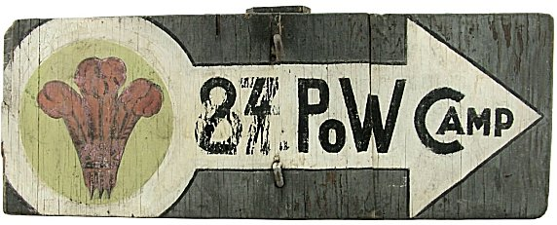
?????????????? This sign came up for sale (2021?) by the historicflyingclothing.com. It was described as;
“Original painted wooden Prisoner of War Camp sign. It measures 60 cm wide x 22 cm in height and is made from relatively thin ply mounted with large bolts and square nuts to a section of the original post. The handpainted design is a modified arrow with Prince of Wales type feathers on the left and lettering to the right. Interestingly the camp number has been changed at some point from 87 to 24. Unfortunately, there is little information about British POW camps and we have been unable to establish exactly where this came from. PoW camp No.24 was at the No.4 General Hospital (Military), Knutsford, Cheshire and presumably used as a secure hospital for injured prisoners. There was also a camp No.24 at the remote location of Knapdale, Lochgilphead, Argyll in Scotland. No.87 ‘Byfleet Camp’ was a standard camp situated South West of Daventry in Northamptonshire that held mainly Italian prisoners….”

Did this relate to a prisoner of war camp – or to a Prince of Wales Camp, hence the PoW feathers?

