Camp 24 - Knapdale, Lochgilphead, Argyll (aka Cairnbaan)

Prisoner of War Camps (1939 – 1948) - Project report by Roger J.C. Thomas - English Heritage 2003
OS NGR | Sheet | No. | Name & Location | County | Cond’n | Type 1945 | Comments
 |  | 24 | Knapedale, Lochgilphead | Argyll |  |  | Scotland

Location: ‘Knapedale’ is a spelling error. Knapdale district and Knapdale forest forms a large area of Argyll and Bute.  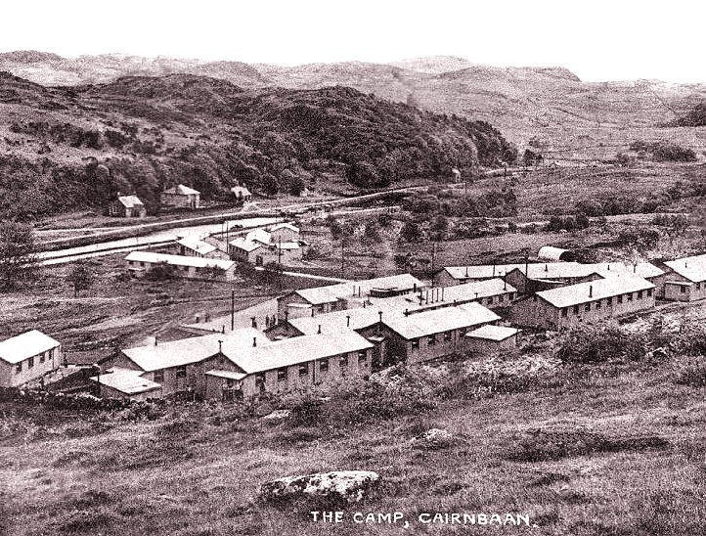  NGR - NR 829 906 – Cairnbaan, about 4.5 km NW of Lochgilphead. Marked X, with a smaller group of huts just N of this alongside the Crinan Canal. | 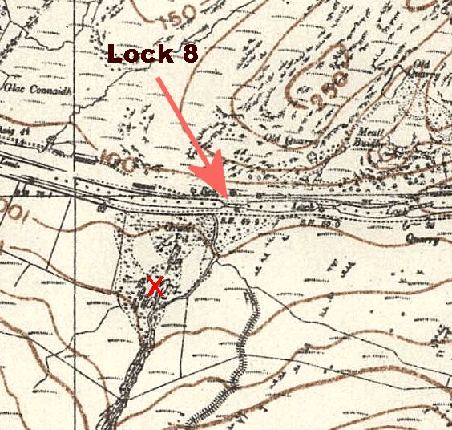
Ordnance Survey 1945

< Postcard view of the Labour Camp, two groups of huts and Lock 8.

Previous use: A Ministry of Labour, Instructional Training Centre, (or Labour Camp for the unemployed) was built. This is similar to Glenbranter, Camp 6, in Argyll, which was also a labour camp before becoming a pow camp. About 20 wooden huts + at least 1 Nissen type hut shown in picture.

In 1940 it was listed as Camp 015 Alien Internment camp, (Appendix to WO 199/405 - 28 January 1941).

29 October 1940 - Czech (76) and French Foreign Legion (17) captives transferred from Glenbranter Camp 6.
POW Camp: There was some overlap between the Alien Internment Camp and the pow camp – a practice which was soon abandoned. A mixture of nationalities was sent to Knapdale, many with debatable internee or pow status.
There is a story that some Italian pows escaped from the camp and then returned as there was nowhere to go and the local conditions were so bleak.

Vladimir Clementis, a former Czechoslovak foreign minister was held at Camp 6, Glenbranter under an uncertain legal position as an internee or pow, then transferred to Knapdale from late 1941 to early 1942. (He was later released in Britain during the war, but was executed in Czechoslovakia after a show trial in 1952).
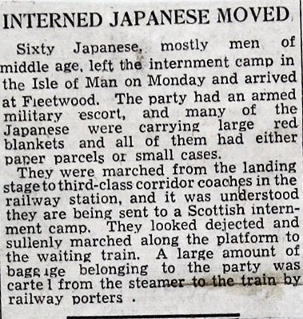 | Japanese held at Knapdale  After the attack on Pearl Harbour, Britain declared war on Japan on 8 December 1941. 114 Japanese residing within Britain were arrested. At first, they were sent to an internment camp on the Isle of Man. Negotiations for an Anglo-Japanese exchange of citizens began in January 1942 and were agreed, but anyone considered to be of military use was excluded; this included seamen who were re-classified as POWs. Of the 114 Japanese interned, 47 were voluntarily repatriated, the rest were either detained on the Isle of Man and released soon after, or were transferred to the Knapdale POW Camp in March 1942. The Home Office list on 21 March recorded 58 Japanese seamen transferred to Knapdale, and 2 more (ship’s officers) arrived later.  Nisaburo Murai was one of the internees transferred to become a pow. He was born 2 April 1890 in Ishikawa-ken, Japan. He worked in the engine room of various British Merchant ships, (a ‘donkeyman’) and was living at 73 Seymour Street, South Shields when he was arrested on 9 December 1941.  Murai died at Knapdale of a coronary thrombosis on 14 May 1942, aged 52 (Lochgilphead Register of Deaths, though his age was recorded as 51). | 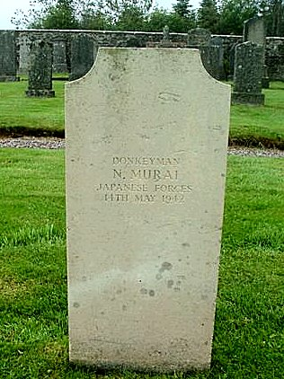
Manchester Guardian 31 March 1942
He was buried at the nearby Achnabreck Cemetery. The inscription reads;

“DONKEYMAN - N.MURAI – JAPANESE FORCES – 14TH MAY 1942”.
 |  | www.findagrave.com/memorial/23895931/
In September 1944, Knutsford Military Hospital became pow camp 24, so I believe that this camp closed before then.

After the camp: The site was used as a Forestry Commission Camp. Reported that a surviving building remains in use as a Forestry and Land Scotland workshop. The area is now residential.

Further information:

Historic Environment Scotland - http://canmore.org.uk/event/707195 and an oblique aerial photograph taken facing south-west - http://canmore.org.uk/collection/1314798

National Archives HO 215/251 – Transfer of Japanese merchant seamen from Isle of Man to Knapdale POW camp – dated 1942-1943 – used above.

Aerial photo and information - https://www.forestry-memories.org.uk/picture/number4617

