Camp 26 - Barton Field Camp, Ely, Cambridgeshire

Included in the ICRC 1945 Camp list – Labour Camp. 26. Barton Field Camp, Ely, Cambridge.

1947 Camp list
26(G.W.C.) | Barton Field Camp, Ely, Cambs. | E. | Priswar Ely. | Ely 436/7 | Ely(Cambs) (L.N.E.R.) | Lt.Col.H.G.T.de Sausmarez | v/1453/2

Prisoner of War Camps (1939 – 1948) - Project report by Roger J.C. Thomas - English Heritage 2003
OS NGR | Sheet | No. | Name & Location | County | Cond’n | Type 1945 | Comments
TL 5353 7957 | 154 | 26 | Barton Field Camp, Ely | Cambridgeshire | 4 | German Working Camp | Presently the site of housing and a golf course

Location: SW side of Ely. Alongside Barton Farm.  Before the camp: Agriculture.  POW Camp: Camp established during 1941 housing Italian pows to work on farms in the areas of Cambridgeshire, Isle of Ely, Huntingdonshire, Norfolk, Soke of Peterborough and West Suffolk. Camp surrounded by barbed wire fencing and guard posts. At first a small camp with an initial capacity for up to 500, but soon expanded with some of the pows used to construct new buildings.  Five of the Italian pows had been members of the Corpo Aero Italiano, (CAI – Italian Air Corps). |  | 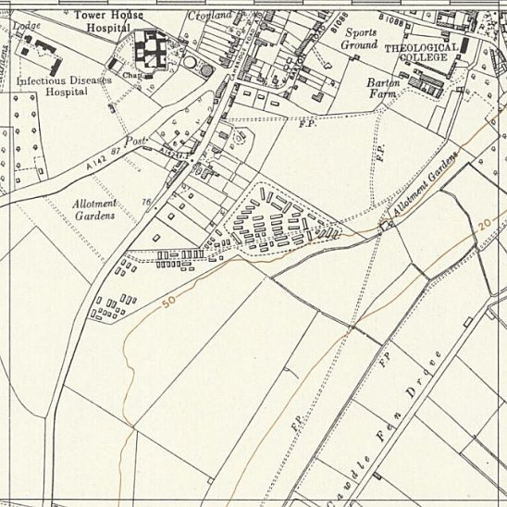
The CAI had bases in Belgium. They took part in the Battle of Britain and the Blitz supporting the Luftwaffe from 24 October to April 1941 with 454 offensive and over 1000 defensive sorties, including bomber escorts.  The survivors of downed aircraft were taken to the London Cage for interrogation. It was noted that the pilots had low morale. They were then transported to Barton Field camp, (another 2 were sent to Camp 29). At some point they would have either been moved to another camp or accommodated in billets. | 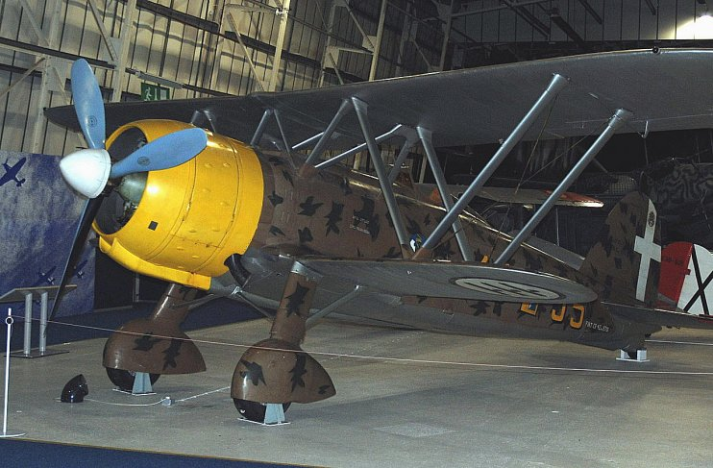  Fiat Cr 42 – flown over Britain by the CAI.  Photograph by Roland Turner from Birmingham, Great Britain - Fiat CR-42, RAF Museum, Hendon., CC BY-SA 2.0, https://commons.wikimedia.org/w/index.php?curid=46805094
 |  | Ordnance Survey 1955

1 December 1941 – War Diary. Commandant L W Blakiston. Italian pows – 1 medical officer and 488 OR.

British: HQ staff and guard – 8 officers from various regiments and 110 O.R. from the Pioneer Corps + Attached detachment from the 30 Bn Royal Norfolk Regiment – 1 officer and 25 OR.

The Pioneer Corps guards were completing the perimeter defence posts. The detachment were constructing the guard camp.  375 pows were in 16 parties working on farms. 75 were constructing camp buildings. Others were employed within the camp.  8 December 1941 – A meeting was held with representatives from the Ministry of Agriculture, War Agricultural Committee, and labour officers from this camp and Wilton Park Camp 20, to consider complaints about poor work of the pows and methods to rectify this.  During December the pows were inspected at work several times by others from outside of the camp. Their work was described as “satisfactory” and did not accept there were any grounds for complaint.  December 1941 - Some of the Italian pows were formed as construction crews to build Camps 56 and 59.  January 1942 – 1 pow working party at Swavesey was seen to be working poorly. The Italian sergeant was replaced and the gang deprived 2 days working pay. A follow-up check found that the work became satisfactory with a new leader.  19 January 1942 – 4 pow sergeants were sent to Camp 16 as they were unwilling to work and were having a bad effect on other pows.  24 January 1942 – The camp was inspected by Colonel Buckley, the War Office Inspector of camps. Inspections were made fairly regularly by other area / district officers.  31 January 1942 – A new commandant started; Major W G Saville.  February 1942 - Pow numbers remained fairly steady, 490 ±10. | 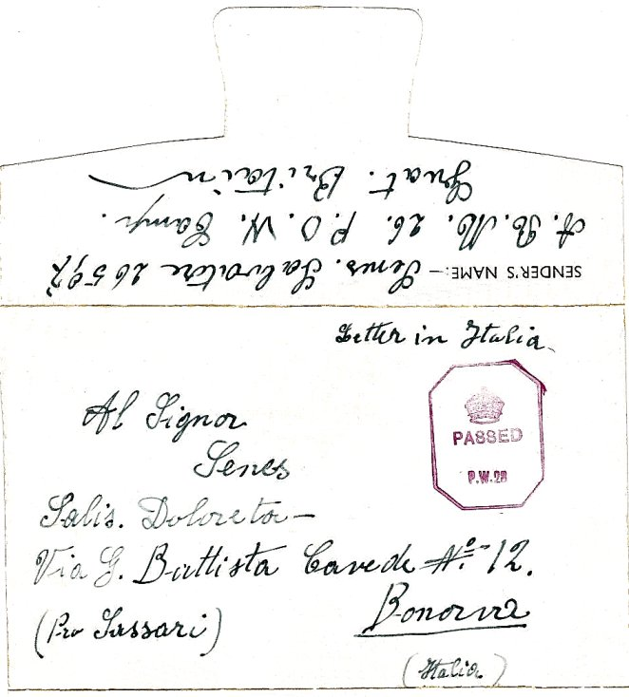
Front and flap of pow letter-sheet to Italy, May 1942.
No return address allowed – just the camp number.

British: HQ staff and guard – 9 officers and 110 Pioneer Corps + the attached detachment was down to just 6 OR constructing the guard camp + 2 RAMC + 1 Intelligence Corps.

9 February 1942 – Half an acre of the ground in the guard compound was to be ploughed to produce food.

10 February 1943 - An ICRC inspection took place; capacity 750.

1943 – Hostels listed for Italians; Feltwell Fen; Poppylot Road, Feltwell; Methwold Hythe; C.O.D. Ely; C.S.D. Newmarket.

Late 1943 – After the Italian armistice there was a report of disturbances at this camp when the Italian pows were described as ‘volunteer’ pows by the Daily Herald. Some were “co-operators”, others “non-co-operators”.

November 1944 - listed as an Italian Working camp, (+Pioneer Corps Groups), (WO 32/10737).

1 August 1945 - an urgent memorandum was sent to this camp, and others, about maintaining records of Italians who were classed as ‘co-operators’. At this point many, sometimes all, of the Italian pows were transferred to hostels and billets.

From 1945 - the English Heritage report records it as a German Working Camp though the reports for the camp state this did not occur until 1946. It grew considerably in size.

24 March 1946 – The camp was recorded as having changed from an Italian Labour Battalion to a German Working Camp.

Oversight and development of re-education activities for pows was carried out by PID (Political Intelligence Department of the Foreign Office) / COGA (Control Office for Germany and Austria – UK). Visits and reports were made. The standard of the reports varied greatly. The visitors took little interest in activities other than re-education, they rarely mention sports, games, pastimes, crafts, etc of the pows.

6 July 1946 - Captain G S Littlejohn Cook visited to survey re-education. Strength - 1 officer; 1127 OR. [This is the 2nd PID visit, but a report for the first is not in the file].

987 at main camp; 50 at Soham hostel; 100 in billets; 0 at Ely satellite camp.

Commandant: Lt Col H G T De Sausmarez Camp leader: St.Fwl Kassing, Herman (A) - “a good influence on the men under him.”
Interpreters: 2/Lt Peters Deputy C/L: Hwachtm. Lindner, Herbert (est B)
S/Sgt Levi German M.O.: O.Arzt Beckmann (C)

There were some political screening figures, but less than half had been carried out. Although the visitor was well received, there was little evidence of re-education being promoted by the British staff. Most of the pows had previously been held in camps in USA and Canada.

Morale was recorded as ‘very high’ – which is unusual, especially amongst pows that had been in the USA and had been misinformed there that they would be sent back to Germany. The cause of the positive morale was put down to the influence of the camp and hostel leaders. It was estimated that 10/15% of the pows were Nazis – about 15% anti-Nazi – only 2/3 communists. Most were beginning to gain a positive outlook on democracy.

The pows were starting to organise re-education activities. One had attended the special training centre at Wilton Park. The standard list of activities was recorded:

Wochenpost – 250, sufficient.

Newspapers – a number of English papers.

Library – 300 books, insufficient.

Lectures – visiting lecturers had started two months previous.

Discussion groups – editorial team mainly discussing the magazine.

Films – YMCA fortnightly, no films from PID.

Radio – 1 set with three loudspeakers. Some programmes written down and circulated.

Camp Magazine – fortnightly with a high standard [Wir und die Welt: Lagerzeitung K.G. – Lager No.26 (The World and Us – Camp News).] There was also a fortnightly political broadsheet.

Press reviews – undertaken by the discussion group.

English Instruction – 3 classes at main camp Insufficient texts and teaching materials.

Other activities –

Religion – Protestant padre, Heck (C) “not very positive but is doing no harm.” RC’s to be allowed to visit Ely.

Education – some general education classes.

Theatre and Orchestra – not started.

27 August – 5 September 1946 – 3 members of the ‘Segregation Section’ came to carry out further political screening. Strength - 1 officer; 1167 OR. Main camp + 1 hostel.

Screening: | A+ | A | A- | B+ | B | B- | C | C+ | Not known
 | 5 | 132 | - | 413 | 463 | 123 | 28 | 1 | 3

There was no mention of 2/Lt Peters. S/Sgt Levi was called the Senior Interpreter and described as; “a man of experience, wide sympathies and very efficient. His knowledge of English leaves something to be desired, but he is a man quite capable of interrogating a pow adequately and accurately.” Later in the report it was stated that his; “work cannot be too highly praised.” The was another S/Sgt – Gruenbaum who was “young and speaks both English and German well.”

Some of the German camp staff were briefly described;

“Kassing H (A+), Camp leader, is in every respect a first class man who has been a pow for 6 years.” Aged 34, a regular soldier.

“Lindner, H (A), aged 35, is a good organiser and an indefatigable worker of the sound type.”

“Beckmann, Ferdinand, Dr.Oberarzt (B) [previously C] the camp doctor is a rather unpleasant and not very popular type, who is unwilling to co-operate in re-education, but is not Nazi-minded and has never had an active Nazi affiliation.”

28/29 November 1946 – English Inspector’s Report by Major R L S Raffles. Strength 1445. Main camp + 1 satellite and 1 hostel. 160 billetees.

A new camp leader – ‘Witthaus.’ 74 pupils in 4 classes at the main camp.

14 – 17 January 1947 – Mr Oliver Nash carried out a re-educational and screening survey. Strength – 2 officers; 1199 OR.

587 main camp; 440 West Fen satellite; 32 Moatfield, Soham; 27 Welney; 115 billets. Some of the pows were Rumanian Volksdeutsche with an uncertain future.

Commandant: Lt Col H G T De Sausmarez Camp leader: Hfw. Witthaus, Eugen (B+)
Interpreters: S/Sgt Levi Deputy C/L: Hfw. Boettcher, Gerhard (B)
S/Sgt T Gruenbaum [at satellite]. German M.O.: St.Arzt Dr Beysiegel, Karl (C)

Screening: | A | B+ | B | B- | C | Unscreened
 | 12 | 208 | 397 | 116 | 97 | 371

It is very surprising that so many pows had not been screened by this very late date. 86 pows were appealing against their gradings – a better grade resulted in earlier repatriation. 526 repatriated to date.

Camp leader – “age 27, joined the army 1938, dairyman from eastern Germany; surrendered 1945. Member of HJ [Hitler Youth] and a P.A. Good type but unimaginative.”

Deputy – “age 31, joined the army in 1936, was a merchant in Dresden. He has no political background.”

Morale still regarded as excellent due to the administration and repatriations. Negative factors were news from Germany; poor exchange rate, (pows were able to send small amounts of money earned to families); postal services from the Russian zone; poor quality and high price of cigarettes.

Standard list for re-education recorded increased activities:

Wochenpost – adequate.

Newspapers – English national papers bought from camp welfare fund; Some Swiss and German papers. All distributed through main and hostels.

Library – 712 book + supply at hostels.

Lectures – regular

Discussion groups – 50 pows, held on Mondays.

Wireless – satisfactory in main and hostels.

Camp magazine – 250 copies issued fortnightly, small number of contributors.

Press review – translations posted daily. Experiment to be held with news reviews and discussion.

English instruction – separate report (November 1946). Attendance is poor.

Information room – regular exhibitions from COGA.

Other activities –

Religion – Protestant padre Heck received a more positive review – “congregation about 50-60 and is a very good influence.”

RC Priest visited from Victoria Camp 85 – “unyielding and intolerant attitude towards the protestant padre has caused some friction and unpleasantness in the camp.” Congregation about 40

Education – a few courses at main and satellite, “of no special significance.”

Entertainment – Theatre group, band and choir provided light entertainment at main and hostels.

1947 (March?) - The pows assisted the emergency operations in Ely during a flood.

26/29 April 1947 – Major Raffles returned to carry out English examinations. Strength – 1394 in main, satellite and 2 hostels.

Noted that the commandant was retiring at the end of the month and the camp to be reduced to Major’s command as it was under 1250 pows.

14-16 May 1947 – Oliver Nash carried out a re-education survey. Strength – 2 officers; 1351 OR.

779 at main camp; 398 at satellite; 50 at Soham hostel; 29 at Welney hostel; 90 billeted; 7 in hospital. 649 pows repatriated to date.

Commandant: Major G C Williams Camp leader: Hfw. Witthaus, Eugen (B+)
Interpreters: S/Sgt Levi Deputy C/L: Fw. Henke, Albert (B)
S/Sgt Burstyn (at satellite). German M.O.: St.Arzt Dr Beysiegel, Kurt (B) (previously called Karl).

The new commandant had worked in a pow camp in Scotland – it was later reported that he had been a pow. The MO had been upgraded from C to B, and was cooperating with re-education activities.

Morale still recorded as high. There had been a ban on pows visiting Ely, imposed at the request of the Council, this had now been lifted.

Youth pows (under-25) were not regarded as a problem.

5 pows had attended the special training course at Wilton Park for re-education. The standard list of activities had changed little since the previous report – some more books; the choir was performing at local churches.

22/25 July 1947 – Oliver Nash arrived to carry out another re-education survey, (accompanied by a trainee). Strength – 2 officers, 1136 OR.

733 main camp; 226 satellite; 52 Soham; 27 Welney; 94 billetees; 6 in hospital. Simplified screening figures – A 7; B1131

Very similar report to previous, two months earlier. Comments about the RC Priest Schiffhauer from Victoria Camp 85; “He is an unpleasant person with anti-semitic outlook, who needs watching.”

A new activity promoted for re-education was developing ‘outside contacts’ now that fraternisation regulations had been relaxed. It was often the most positive aspect of captivity for many pows. At this time there were limited contacts for pows at Camp 26 – outside concerts by the choir; groups of pows attended local police and sessional courts. It was hoped more would be developed.

23/25 October 1947 – Major Raffles provided another English Inspector’s Report. Strength 948.

Main 754; Soham 49; Billetees 145.

The camp was in the process of being taken over by Victoria Camp 85. The Commandant was Captain E A Jones. The camp leader was still E Witthaus.

October/November 1947 – site became a satellite camp for Victoria Camp 85 for a short time. There was a COGA inspection at this time – included in Camp 85 details.
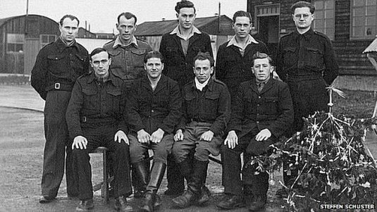

< Photograph taken Christmas time 1947, after it had become a satellite for Camp 85. It shows a mixture of hut types in the background.

Known Commandants;

1941 – 1942: Commandant L W Blakiston

1942 - Major W G Saville from the Royal Fusiliers.

? – April 1947 Lieutenant Colonel H. G. T. De Sausmarez, was from the Royal Artillery.

May 1947 – Major G C Williams

After the camp: From 1958, a large part of the site was cleared to become Ely City Golf Club.

https://repatriatedlandscape.org/england/pow-sites-in-eastern-england/pow-camp-26-barton-fields/

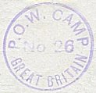
Further information:

National Archives: Used above.
WO 166/5979 – Miscellaneous: Prisoners of war camps: 26 POW Camp at Ely, Cambridgeshire. Prisoners included Italians. Dated 1941 Dec.
WO 166/10296 – same title and details. Dated 1942 Jan.-Mar
FO 939/110 – 26 Working Camp, Barton Field Camp, Ely, Cambridgeshire. Dated 1946-1947

‘The Chianti Raiders’ – Peter Haining – Robson Books – 2005. Details of the CAI.

The Imperial War Museum has copies of the magazine dated November and Christmas 1946; February and September 1947. Ref LBY E.J. 446

Hostels

Ely Satellite Camp - formerly West Fen Militia Camp 130, with capacity of 600.

July 1946 – 0 pows. Italian pows removed – awaiting German pows.

August 1946 – not open.

November 1946 – 630 German pows in huts. 3 classes for English Instruction. Hostel leader ‘Rosenberg.’

January 1947 – 440 pows. Camp leader Stfw Kurt Rink (B+) – newly appointed, “age 39, was in the Schupo [uniformed police] from 1930/35, then transferred to Luftwaffe. Pleasant type.”

April 1947 – 407 pows.

May 1947 – 398 pows. Camp leader Hptscha Friedrich Seiworth (B+) – “age 54, agricultural expert, Volksdeutscher from Rumania, served in the Austro-Hungarian Army in 1914 war, joined SS by government decree in 1943. Upright bluff man who leads the democratic discussion group at West Fen.”

July 1947 – 226 pows. Same camp leader.

Not recorded as being transferred to Victoria Camp 85 in October 1947.

C.O.D. Ely; Central Ordnance Depot

1943 – Hostel listed for Italians – no further information.

Not listed in any of the PID reports from 1946. Possibly closed, or under a different main camp.

C.S.D. Newmarket; Central Supplies Depot

1943 – Hostel listed for Italians – no further information.

Not listed in any of the PID reports from 1946. Possibly closed, or under a different main camp.

Feltwell Fen;

1943 – Hostel listed for Italians – no further information.

Not listed in any of the PID reports from 1946. Possibly closed, or under a different main camp.

Methwold Hythe;

1943 – Hostel listed for Italians.

Brief reference in passage below for Poppylot Road. Only other reference found from someone who lived in the area – “About 1943 there were soldiers of the Eighth Army (the Desert Rats) camped in the area. I learned from some of them a few choice words in Italian. I also learned enough of their experiences in the desert to give a talk to my class at school. On the bus ride to school sometimes we passed Italian prisoners or war working in the fields, and we would call out these choice words from the bus windows. Many of these Italians were billeted in a large house near the church in Stoke Ferry [about 5km N of Methwold Hythe]. They were easily recognised because they had round patches on their brown clothing.

Some Italian prisoners of war were billeted at the army camp at Cranwich [about 5km E of Methwold Hythe] and some of our school girls living in Methwold would walk along the road towards Mundford to flirt with them.”

https://joemasonspage.wordpress.com/2012/12/13/a-norfolk-schoolboys-memories-of-w-w-ii/?fbclid=IwAR3PiWhhWTwGUNaevFqRmFTewMXG-fWau8umkZP3fO_GcPSCIsLmR9t1IC8

Not listed in any of the PID reports from 1946 – yet the memories below mention this hostel in 1947.

Poppylot Road, Feltwell; A sketch map placed the camp alongside Poppylot Farm – NGR TL 666 924.  1943 – Hostel listed for Italians  Abbreviated notes from Mr Peter Jordan talking about POW Camps in Feltwell during WW2;  “April 1946 - Sergeant Jordan had been brought by 15cw truck, driven by a German driver with escort in the back, to take command of Poppylot POW Camp… unlike Barton Field, no barbed wire, no Crows-Nests, only three guards, a Sergeant, a Corporal and a Lance Corporal…  They lived at the camp, ate the same food as the POWs and looked after 250 German prisoners, their only protection being a Sten gun each, loaded with 35 rounds. The POWs had a Camp Leader; the most senior ranker there and Peter communicated his orders to him through an Interpreter, another prisoner. The prisoners were infantrymen aged from 25 upward and in their spare time they played football on one of Ernie Elmer’s fields on the other side of the road to the camp. They had a very good team and played against other camps and even, on one occasion, the village.  A typical day for a prisoner would begin with wake-up at 5.30am followed by breakfast and roll call at 6.30. After that he would get on his bicycle, supplied by the War Ag. and travel to his designated farm to begin work by 7. Work would consist of leading horses, ploughing, weeding, harvesting, etc. Arriving back at camp by 6pm he would have tea and be free to go to bed at whatever time he liked. Bicycles were provided when the farmers began to complain about the cost of picking up the prisoners and returning them back at night. Weasenham took most prisoners, at Middle Farm and Schrub Hill, with others going to Duchy Farm, owned by Claud Stubbings and Larmen’s Fen. Peter and Ken would have to ride around on their bikes to make sure everything was going all right. | 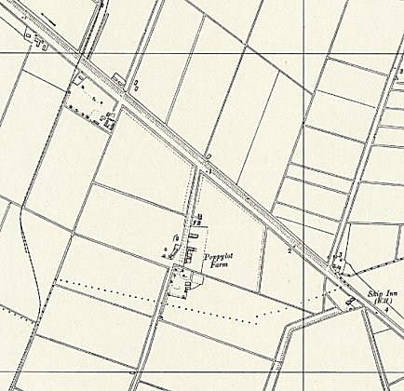
 | Ordnance Survey 1958

Many open camps existed in the area including Plough Camp, opposite The Plough public house down Blackdyke road, Poppylot Sidings Camp and one at Methwold Hythe. Prisoners from these camps were not allowed to mix. For a period of two months Peter ran both Poppylot and Poppylot Sidings camps together. Several were the times that Peter would have to cycle, in the early hours of the morning, to collect an escaped prisoner from the police at Southery. The escapee would then be marched back to camp, his name taken and then he would be sent back to GHQ at Barton Fields to spend 3-4 weeks in the guardhouse. Good behaviour resulted in them being sent back to the Sidings.

Accommodation at the camp consisted of 7 wooden huts with 35-40 prisoners in each. Two combustion stoves heated each hut, one at each end. In addition, there was an ablutions hut, a boiler house for hot water and the cookhouse. Standing orders said that each hut had to be cleared out and cleaned once a week and the cookhouse daily. The prisoners slept in bunks whilst Peter and his staff slept in a separate room in single beds. Off this room was an office where Peter would do his paperwork. Requisitions for materials went originally back to Barton and later through HQ Cockley Cley (3-4000 prisoners) to the new GHQ at North Field Farm Camp near Kings Lynn (4-5000 prisoners).
During the 1947 floods the prisoners were evacuated to North Field, but Peter was posted to Plough Camp. After 2 weeks there he was sent to Methwold Hythe where he spent 5 months before re-opening Poppylot. After the floodwaters had receded the prisoners returned and were put to work on repairing the damaged riverbanks at Lakenheath.

Later that year Peter was given his blue pinstriped demob suit in which he promptly got married.” https://www.feltwell.net/feltwell2/times/powcamps.htm

Not listed in any of the PID reports from 1946 – was it under Cockley Cley by then?

Soham Hostel, (Moatfield).

? - Start

January 1946 – Italian prisoners were replaced by Germans.

July 1946 - 50 pows at Soham hostel. Hostel leader Ofwl. Pohl (A+) – “very reliable and will be posted to the new satellite when it is formed.” 1 English Instruction class.

Pohl was described in the next report as – “POHL, Konrad Oberfeldwebel (A+) aged 53… an insurance broker and a first class type, a strong RC, but perhaps a little inclined to favour his co-religionists.”

November 1946 – 46 pows in huts. 1 class for English Instruction. The Rector of Soham visited the hostel to help the German padre with Bible-class.

January 1947 – 32 pows.

Hostel leader - Hwchm. Klose, Karl (B) – “age 37… joined the police force in 1927… was captured in 1944 in a police battalion…” The visitor found him to be suspicious and raised “Query – War criminal?”

April 1947 – 30 pows.

May 1947 – 50 pows. Same hostel leader. The previous suspicions raised in January seem justified as he is described as; “most co-operative and his behaviour is unimpeachable but he is Crowcass wanted.” [List of suspected war criminals].

July 1947 – 52 pows. Hostel leader Fw Loewert. There was a band with four members.

October 1947 – 49 pows. In the process of being transferred to Victoria Camp 85.

Welney, West Fen

January 1947 – 27 pows. Hostel leader Uffz. Bittner, Rudolf (B+)

April 1947 – 25 pows.

May 1947 – 29 pows. Same hostel leader, no interest in re-education.

July 1947 – 27 pows. Same hostel leader.

Closed before October 1947.

