Camp 25 - Cloister Crofts Camp, Leamington Spa, Warwickshire

Prisoner of War Camps (1939 – 1948) - Project report by Roger J.C. Thomas - English Heritage 2003
OS NGR | Sheet | No. | Name & Location | County | Cond’n | Type 1945 | Comments
SP 319 672 | 151 | 25 | Cloister Croft Camp, Leamington Spa | Warwickshire | 4

Location: The NGR above is for the centre of Cloister Crofts, a road in the N of Leamington Spa. Along the S side of the road some houses had been built before the war. Local memories record the camp as being on the N side of Cloister Crofts where the Sports Grounds are shown.  POW Camp: Entrances to the camp were off Kenilworth Road, (main road running along left side of map) and off Cloister Crofts.  The Lillington Local History Society provided further details in their March 2014 Newsletter after interviews with local residents. The pows were accommodated in huts that, “had vertical wooden walls with gables supporting the sloping roofs.” Italian pows remembered.  After the camp: The huts provided temporary housing until the 1950’s. Nearly all of the green space has been built on as a residential area. The Leamington Cricket Ground just S of the road is still there.  [Some of the memories are of US Troops based at the Cloister Crofts camp – so did they take over the site from the Italian pows? – Note that it was not listed as a camp in the EH report above or in the ICRC list for 1945. As Camp 25 Lodge Farm opened in late 1941, this camp could have closed during that year].  Further information:  https://repatriatedlandscape.org/england/pow-sites-in-the-west-midlands/pow-camp-25-cloister-croft/ | 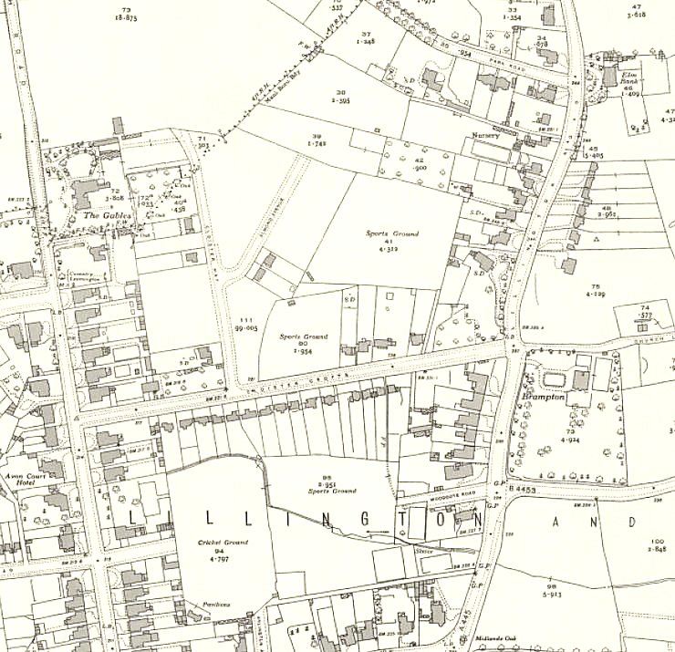
 | Ordnance Survey 1946

