Camp 23 (& 1004 / 1023) - Sudbury Camp, Oaks Green, Sudbury, Derbyshire

1947 POW Camp list
No. | Address | Cmd |  | Telephone No. | Railway St | Commandant | WE
23(B.C.) | Sudbury Camp, Sudbury, Derby. | W. | Priswar, Sudbury, Derbyshire | Tutbury (Nr.Derby) 6401 | Sudbury | Lt.Col.P.R.Ayers,M.C. | v/202/4
No. | Address | Cmd | - | Telephone No. | - | Group administering | WE
1004(G.W.Coy) | No.1 Camp, Sudbury, Nr.Derby | W |  | Tutbury 6401 Ext.226 |  | 23 | V/1270/4
1023(G.Wkg.Coy) | No 1 Camp, Sudbury, Derby | N |  | Tutbury 6401 |  | 27 | V/1270/4

Prisoner of War Camps (1939 – 1948) - Project report by Roger J.C. Thomas - English Heritage 2003
OS NGR | Sheet | No. | Name & Location | County | Cond’n | Type 1945 | Comments
SK 1596 3329 | 128 | 23 | Sudbury Camp, Oaks Green, Sudbury | Derbyshire | 1 | - | Originally a military hospital, presently a prison. | See camp no 1023
 |  | 1004 | No 1 Camp, Oaks Green, Sudbury |  |  | German Working Company |  | See camp no 23 & 1023
 |  | 1023 | Sudbury Camp, Oaks Green, Sudbury |  |  |  |  | See camp no 23

Location: Various large compounds in and around the Sudbury Prison area.  Before the camp: The land was part of the Sudbury Park Estate. A hospital for the US Air Force was built prior to the D-day landings.  3 POW Camps: It seems that at times camps 1004 / 1023 were within the administration of Camp 23, and at other times being administered separately.  1945 (possibly 1944) – Wide site used for two working camps, 1004 and 1023, under two different commands, west and north.  18 March 1946 - 342 British and German Staff – including the Commandant, Lt Col Ayers - came from Le Marchant Camp to establish Base Camp 23 in this area. (Le Marchant was previously Camp 23 – it then became Camp 410 with a new Commandant *). There were several compounds and a ‘Medical Academy’ which treated injured pows in the military hospital site.  An oral history interview was held by the Imperial War Museum with Hans Detlef Teske who was a pow from 1943 to 1947. Teske was held in the US and then transferred to Sudbury in mid-1946. While in America the pows had been told they were returning to Germany, instead they arrived in Liverpool and were sent to camps around the UK, including Sudbury. I have changed the narration to text form:  “…we were met by a German speaking officer who said that; ‘Gentlemen, you are now a British POW. Don’t try to escape, you are guarded by Poles and they are only too eager to shoot you…. So, then we had to go into different huts and were given some straw to make up a straw bag on which to rest or sleep…  It was a small compound, but this compound had an enormous lot of barbed wire around it, reels | 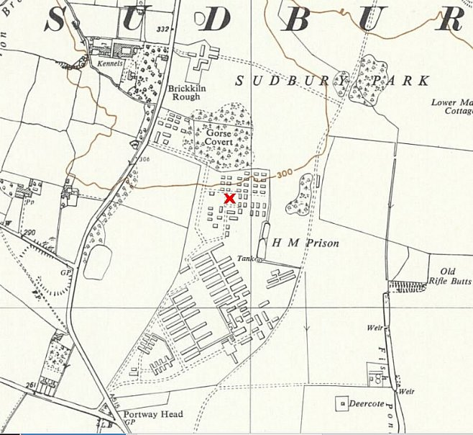
 | Ordnance Survey 1955 – Oaks Green just to left.
and reels of barbed wire piled up high… and around there were four guard posts with Poles… There was a team of intelligence corps men, they had different lists to follow-up and so on for different interrogations.”
He went on to state that just as in America they were treated like cattle; “we were degraded and they tried to do their best to continue it.” Regarding the Polish guards, “they told us they themselves were betrayed because they could not go home, so they had no grievance against us…” He believed there were spies in the camp and one tried to get information from him. (Having been a pow for three years, and the war over, I am not sure what information would have been gained). (Audio - IWM, Cat No. 1910, Reel 7).

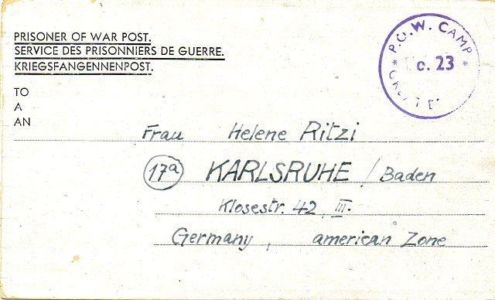 | The Medical Academy –  There is an entry in the ‘Report of the ICRC,’ Volume 1, 1948, about the Academy, but with incorrect details about its origin:  “In Great Britain, nearly 200 German medical students were collected in Camp 23, near Birmingham, at the request of the Committee's delegation in London. Led by 24 doctors, from March 1945 onward they became what was known as the " Medical Academy ". As they had good accommodation with excellent lighting, they were able to work late at night. Two huts were exclusively reserved for lectures, one for a clinical course, and the other for pre-clinical lectures. To illustrate their teaching, the doctors carried out demonstrations on patients in the camp hospital. In 1945, the ICRC sent this school complete and illustrated editions of works on anatomy and other branches of medicine, and equipment for their studies.”  The Medical Academy was first established at Le Marchant Camp 23, Devizes in March 1945, not at Sudbury ‘near Birmingham’. It was Inspected by the ICRC in April – the opening statement from the report is shown below.  When Le Marchant Camp 23 changed its status from a Base camp to a Working camp in March 1946, German pow staff and British staff were transferred to a new Base Camp at Sudbury – it then became Camp 23, and Le Marchant became Camp 410. This transfer included the Medical Academy.  < Pow letter-sheet – November 1946 from Max Ritzi at the Medical Academy.
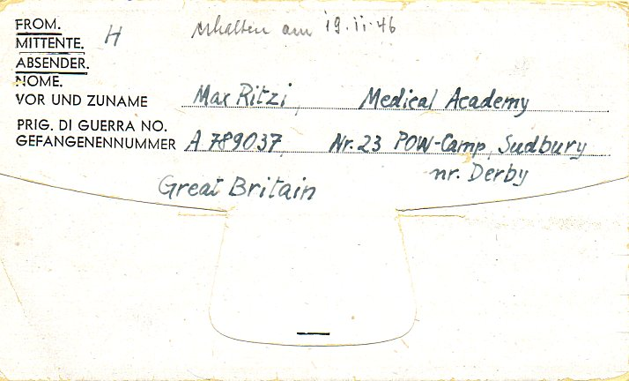

General ICRC Report on the ‘Medical Academy’ In Camp No. 23 / Devizes
(Nr 3480 from April 1945)

I. General –

We have found among captive German medical personnel in Great Britain about 200 medical students in small groups in different camps. These prisoners were captured during Summer and Autumn 1944 and have been transferred from one camp to another, (the usual fate of all the pows ​​during the winter of 1944/45, for lack of accommodation and guards) - and so they have been unable to resume their studies. Furthermore, they have no textbooks, apart from 1 or 2 volumes of general medicine available in camp hospitals, if they had access. Although anxious to continue their studies, they were not able to as there is in general a great shortage of works of this type.

The report went on to state that requests had been sent out for textbooks and equipment. It listed the courses taken, and the teachers providing them.

Oversight / development of re-education activities for pows was carried out by PID (Political Intelligence Department of the Foreign Office) / COGA (Control Office for Germany and Austria – UK). Visits and reports were made. The standard of the reports varied greatly. The visitors took little interest in activities other than re-education, they rarely mention sports, games, pastimes, crafts, etc of the pows.
ALL of the inspection and lecturer reports below were for Camp 23. There is a mystery here as there is not one reference to Camps 1004 or 1023 - no shared visits, inspections, lectures, facilities…. nothing at all. This is strange as they are listed as sharing the same site at Oaks Green – even the same telephone number in the 1947 camp list. A possible theory – with NO evidence; at times the large compounds within Camp 23 were one and the same as Camps 1004/1023, but they were sometimes separately administered by the two commands, west and north. This is very partially shown in an entry about Spanish pows in the next report.

13-15 May 1946 – The camp was visited by Mr W G Cook with regard to; 1. Organise re-education; 2. Check ballot screening. Strength – 2 officers (M.O.s); 741 other ranks; all recorded as German. Note that the numbers only included the German staff pows – there were many other pows at the camp, but they were in transit and so not included in this report.

Political screening figures:

 | A+ | A | A- | B+ | B | B- | C | Unscreened | TOTAL
Old Staff Ex Devizes | 3 | 36 | 1 | 3 | 139 | 1 | - | 59 | 342
New Staff ex USA ‘ballot screened’ | - | 38 | 1 | 2 | 276 | 54 | 28 | - | 399
 |  |  |  |  |  |  |  |  | 741

Commandant: Lt.Col P.R. Ayers, MC Camp Leader: O/Fw (Willi) Sűssmann (C)
Interpreters: Capt McDonald Deputy C/L: S/Wm Thayssen (unscr)
S/Sgt Raymor German M.O. Stabs.Arzt Reichel (unscr)
Dr Heinrich (unscr).

The commandant was described as being “most hospitable and co-operative”. The Interpreter, Capt McDonald, was “extremely efficient”, but due for release at the end of May.

A further 399 pows from the USA were added to the staff in April.

There were 6 compounds, A-F. The capacity of each compound was:

A | B | C | D | E | F
“Occupied by Spaniards” | 700 | 1100 | 1600 | 1584 | 1600

The pow staff were mainly held in compound B, with about 90 in each of the compounds C – F.

C Compound, Camp leader: O/Fw Schaffer (B)
D Compound, C/L S/Fw Pott (C)
E Compound, C/L Fw Meyer (B)
F Compound, C/L O/Fw Tobias (A)

“The whole camp has an air of efficiency and I attended the processing of PW from the time of their arrival at the camp until their disposal into the various barrack rooms. The entire process of searching, ballot-screening, documentation was smoothly and efficiently carried out. This camp has dealt with 6000 PW from USA since 8th April, 1946, and is dealing with another 6000 before the end of this month.”

Morale for the camp staff was seen as ‘good’. Mail was being received apart from for some pows from Silesia. “There are excellent entertainment and sport facilities”.

“Owing to the vast amount of work which had to be done in order to make these large, widely dispersed camps habitable, political activities have had to cease.” It was noted that when the camp was located at Devizes (Le Marchant) there was an excellent record for re-education. It was hoped to recommence activities at Sudbury in the near future.

Part of the larger camp held ‘youth’ pows - described here as under-23; more usually as under 25. English language instruction and a general education scheme were in place for these pows. Two pows had returned from the special training camp at Wilton Park.

The standard list of re-education activities was given:

Wochenpost / Ausblick – Received, but more wanted.

Newspapers – all usual English dailies + New Statesman and Spectator received. Some German newspapers received, but more erequested from the British zone.

Library – excellent with 1500 books. 70% were novels.

Lectures – one so far.

Discussion groups – a small group of 15 held weekly meetings.

Films – requested.

Wireless – a large set with a microphone system controlled by the pow staff - amplifiers going to the distant camps.

Camp magazine – monthly, but problems with paper supply.

Press review – issued daily

English Instruction – 2 groups for beginners and 2 for intermediates. 345 GOS books held (language teaching texts).

Other activities:

Religion: 50% of the pows were Roman Catholic. Padres Gefr. Hanneken and Gefr. Nevrzella. Protestant padres – O.Fw Sengle and O.Gefr Discau
Attendance at services was poor, mainly due to work demands.

Education: Classes held for geography, maths, algebra, shorthand, French – mainly attended by youth pows.

Theatre: hoped to start with a new intake. A theatre was being built within a hut.

Orchestra: excellent with over 20 instruments. Swing and classical music.

The Spanish pows - Just over 220 Spaniards were captured by allied troops in France. They were originally refugees from Franco’s Spain and claimed to have been forced by the Germans to join various military and para-military forces. Because they were in German uniform the army had no choice but to regard them as pows. They were held for some time at various camps and then at an unfenced pow camp near Chorley, Lancashire. A response raised in the House of Commons suggests that they were moved to Sudbury prior to demobilisation:

“Group-Captain Wilcock asked the Secretary of State for War why Press representatives are not permitted to visit No. 1 Camp, Sudbury, where the Republican Spaniards are now held, pending demobilisation.

Mr. Lawson - It is the normal practice to ask the Commanding Officer's permission before allowing the Press to visit military camps, and in this particular case the Commanding Officer considered that a Press visit would be inopportune at the present time.” Hansard - 21 May 1946, Volume 423, Column 39.

NOTE – The report for Camp 23 recorded the Spanish pows as being in Compound A – the reference in Hansard is to them being in ‘No. 1 Camp’; which was Camp 1004 in the English Heritage Report. So it seems that Compound A in Camp 23 , and No 1 Camp (1004), were the same place in May 1946.

9 June 1946 – English Inspector’s Report by R D Miller. Total strength – 570 permanent staff / 4034 pows in transit.

10 English language groups were taking place.

21 September 1946 - English Inspector’s Report by E F Peeler. Total strength – 593 permanent staff / 4649 pows in transit.

9 English language groups were taking place.

5 October 1946 - a pow was shot dead by a Polish guard at Sudbury. A question was raised in the House of Commons about the suitability of having Polish guards at German pow camps;

“Mr. Skeffington-Lodge [MP for Bedford] asked the Secretary of State for War whether he will make a statement regarding the circumstances in which Otto Jankowick, a German prisoner of war, was shot dead at Sudbury, near Derby, by a Polish sentry; and whether it is customary for Poles in this country to be given duties in connection with the continued retention of German prisoners.
Mr. Bellenger - This prisoner and one other were seen outside the wire of their camp at 1.30 a.m. on 5th October, attempting to escape. They were challenged four times by the Polish sentry on guard. One stopped but the other, Otto Jankowick, continued to run. The sentry then shot at the escaping prisoner, in accordance with standing orders for guards and sentries. He died in hospital at 6 a.m. on the same day. Polish guard companies have been employed at certain camps in relief of British manpower. Some have been withdrawn and the remainder will cease to be available for these duties in the near future.” (House of Commons - 22 October 1946, Vol 427, Col 1469)

The shot pow’s name was recorded as Otto Jankowiak, a member of the German army. He was buried at Burton-Upon-Trent Cemetery, but was NOT reinterred at the Cannock Chase German Military Cemetery

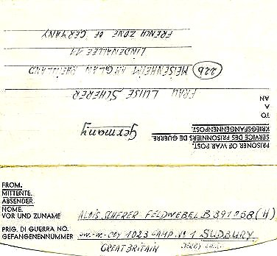 | < Pw.W.Coy 1023 Camp No. 1 – German POW Working Company, 1946.  11-15 and 20-23 December 1946 – Visit by Mr P MacDonald for; 1. Progress of re-education, 2. Screen new PW staff. Strength 7 officers (Medical) / 549 Other ranks.  The visit only reviewed the permanent pow staff – there were about 4000 other pows in transit.  Political screening:  A A- B+ B B- C C+ TOTAL  78 1 63 268 68 69 2 549  1 appeal had been made, and allowed, against the screening category; 30 more appeals were pending – a lower category meant earlier repatriation.  820 pows had been repatriated to date.  Commandant: Lt.Col P.R. Ayers, MC Camp Leader: San.Obgefr. Hasselmann (B+)  Interpreters: Capt Newth Deputy C/L: Feldw. Mauch (B)  S/Sgt Balla German M.O. Obstarzt. Schaefer (C); St.Arzt Heinrich (C) Ob.Arzt Thoaman (B) Ob.Arzt Wallis (B-) U.Arzt Halfmann (B+) U.Arzt Kuhn (B-)  Ass Arzt Schwithal (B)  This was a very large camp and the I.O. Captain Newth worked mainly with pows in transit and did not develop re-education activities with the permanent pows.

S/Sgt Bella was of ‘Austrian origin’ and was involved with re-education, but had not sufficient experience to take charge. The Educational NCO, Sgt Sharpe, was also developing re-education activities, in particular a political discussion group.

There was a rapid turnover of the main pow staff – only 20 of the original staff transferred from Le Marchant were left and they were due to leave soon. The repatriation scheme kept morale ‘fairly satisfied,’ but many thought the scheme was unfair.

The new camp leader, Obgefr Hasselmann, aged 25, had been, “selected for his administrative ability rather than his strength of personality. A medical student, son of doctor who resisted inducements to join the NSDAP, he has an open political outlook and takes a genuine interest in discussions, without assuming a leading part. Was for two years employed as interpreter at Knutsford PW hospital.”

The main pow staff were held under conditions similar to a working pow camp, while those in transit had no work or pay which caused some resentment.

The Medical Academy had problems arising from repatriation: “All faith in the medical standards was undermined when 60% of the 250 Medical Academy students were passed for repatriation on medical grounds, including all the instructors except one. The single instructor remaining is A, whereas at least one of the repatriated was C+.” To put it bluntly, the medical students and staff had faked their medical reports in order to get an earlier repatriation.

35% of pows were ‘youth’ (now correctly listed as being under-25). A good deal of re-education work was directed towards these prisoners. For a while there had been a ‘Youth Group’ within the camp with daily educational activities – this had since been discontinued.

Despite the problems of turnover of pows, a good deal of re-education work was taking place:

Wochenpost and Ausblick – received.

Newspapers – 60 daily newspapers were bought from the Welfare Fund, though distribution of these to all the compounds was sometimes a problem. Periodicals were also received. German and Swiss newspapers were sent by COGA (Control Office for Germany and Austria).

Library – excellent – 5344 volumes.

Lectures – regular, from COGA.

Discussion Group – restricted, but intended to expand to all compounds.

Films – received regularly from COGA and the YMCA.

Wireless – as before regarding microphone system and loudspeakers in each compound. Compound huts also had internal speakers. Some pows owned their own sets brought from the USA.

Camp magazine – ‘Der Zaungast’ (The Onlooker) was published weekly. The editor was Uffz.Schein (B) who had been a municipal employee and Nazi party member. “He took part in the Olympic Games of 1936” (so probably Egon Schein, 200m runner). “His political outlook is not constructive and he is not well suited to this job.” The content of the magazine was not well regarded and a new editorial committee was formed.

Press review – weekly review of the English press.

English Instruction – separate appendix.

Information Room – none, but was being considered.

Other activities:

Religion: Protestant padre Hartung (A) “was an opponent of Nazism and serves as a good indirect influence politically by his personal example, although he does not take an active part in discussion. His assistant, Klatt (B-) has a long record of collaboration with NSDAP and is not a desirable character.”

Roman Catholic padre Hanneken (A) “is very sound but has to look after three other camps.”

Interest in religion was very limited. There was a hut available for use as a chapel.

The orchestra had been disbanded due to repatriations. There was a small band that gave monthly concerts.

21 January 1947 - a peculiar question was raised in the House of Commons about; “the existing wasteful practice of burning pitch pine planks 2 by 12 inches and 2 by 9 ​ inches suitable for building purposes in the stoves of the prisoner-of-war camp near Sudbury…”

The response was; “Investigations have disclosed no such practice. No wood has been issued as fuel at this camp and no stocks are known to be missing. A strict watch, however, is being maintained...” (House of Commons – 21 January 1947, Vol 432).

28 January / 1 February 1947 – Visit by J E Morris for 1. Re-educational Progress, 2. Screening Priority Repats.

Strength was given as 503 officers and 2722 OR’s. However, there was a note – “Little importance can be attached to the above strength and screening figures, since this is a Transit Camp and numbers fluctuate from day to day.”

Commandant: Lt.Col P.R. Ayers, MC Camp Leader: Ofw. Wittman, H (B-)
Interpreters: Capt Newth Deputy C/L: Wm. Callegari, H (B)
S/Sgt Balla German M.O. Obstarzt. Schaefer (C)

Compound leaders:

A | B | C | D | E | F
Wm Callegari (B) | Fw. Schmittinger (B) | Uffz. Hoefelmeier (B-) | Uffz. Frohnhofs (C) | Wm. Ullman (B) | Fw. Efers (B)

Captain Newth was absent on sick leave , reported as “quite efficient and interested in re-education.”

S/Sgt Balla was reported as “fairly efficient and professing interest in COGA aims and activities, has done nothing of a constructional nature, and does not command the respect of the PsW.”

There was a high turnover of German staff with the new camp leader expecting to be repatriated. The deputy, Callegari, was expected to take over – “an honest, hard-working man who should prove quite satisfactory.”

Morale of the aproximately 350 German camp staff was regarded as ‘fairly high’, though some complained about ‘domestic troubles’ or political gradings.

Morale of the pows in transit was mixed, depending on how long they had been held at this camp. Transit time varied from 1 to 9 weeks. Low morale came from:

a. Change in food scale and conditions - as working pows in previous camps they would have had a higher ration of food. A 2d allowance was used to buy bulk food such as potatoes to supplement the ration.
b. Pows alleged that they had been told they would be repatriated within 2 to 3 days.
c. “No freedom, work, pay or cigarettes.”
d. Poor facilities for physical recreation.
e. Occasional overcrowding
f. Heating restrictions.

25% of the camp staff were under-25, but this was not seen as a problem.

Re-educational activities were affected by the rapid repatriations. Activities were assisted by Sgt Porter attached here from the Army Educational Corps; “takes a great interest in the PsW, and is a decided asset.”

There was little change from the previous report regarding standard re-education activities. A need for more British newspapers and some problems with receiving German newspapers was noted. The camp magazine had improved, but there was a shortage of paper. Press reviews were very popular, and an information room was under development.

Religion – previously recorded as being of limited interest, was stated as being; “rather large”. No explanation for this rapid change was given, but there was a note that there were some theological students assisting the padres. There were 2 protestant and 1 RC service. Pows were able to attend the church in Marchington, and the pow choir sang at the church in Hanbury. Daily bible classes were held in all compounds.

The three padres were the same as before, including Klatt, previously described as; “not a desirable character.” The report stated that “All are popular and very active - genuinely attempting to raise morale by their example and actions. It is perhaps significant that the morale of PsW regularly attending services and Bible Class etc., is noticeably high.”

There were classes for English Instruction at various levels, French and Spanish.

Entertainments were poor – the orchestra and theatre group had ended and there was a lack of accommodation.

17/18 June 1947 – English Inspector’s Report by Mr E F Peeler. Strength 4389 German pows.

Camp leader (Lagersprecher) was Frohnhoffs, H – he had been leader in Compound D back in January.

There were 4 English classes for different levels being held. Mr J Robinson from Broxford Hall Preparatory School was assisting as an English teacher.

The Welfare Fund was recorded as £241.18.6½.

24 – 27 June 1947 – J E Morris returned for a re-educational survey. Strength: 3 officers and 361 OR’s (Camp staff only).

No change to senior personnel. Screening has been simplified to A – 2 / B – 362.

Compound leaders:

A | B | C | D | E | F
Not in use | Fw. Hofmann (B-) | Uffz. Knauber (B-) | Uffz. Grove (B) | Fw. Ullman (B) as before | Uffz. Mewis (B-)

The commandant was due to leave the army. Captain Newth was efficient, but had a good deal of work to do and so could not contribute much to re-education activities.

Standard re-education activities were carried out as before. The planned Information Room opened on 10 May 1947 and was regarded as a tremendous success, especially for the pows in transit. Exhibitions in the room included subjects such as; ‘British Parliament’, ‘Famous Painters’, and ‘Life in Germany.’

Religious activities had reverted to being “adequate but interest is waning”. Padres:

Protestant Lt Klatt (B-) – “commands the most respect”
Protestant OGefr. Hartung (A) – “very honest and outspoken”
RC PW. Goetzmann (B-) – “doing more harm than good. He is opportunistic, hypocritical, and speaks in very bitter terms about the screening procedure…” (his appeal had been recently rejected). Mr Morris recommended that this padre should be replaced.

A dance orchestra had started up.

For the pows in transit, some very limited work had been made available and the average time spent at the transit camp had decreased. There was mention of a “cupboard factory” which could only employ 200-250 pows who were paid 2 cigarettes a day. A particular problem of pows not working was that they were placed onto the non-working ration which was very low and described as; “inadequate and near-demoralising”.

A new re-educational activity was being promoted for outside visits and contacts. So far none had been organised for this camp, and the commandant had his doubts about them. The visitor hoped that links with Uttoxeter would be formed and possibly visits to Lichfield Cathedral.

Shortly after this report the camp was re-organised and the camp staff and offices were moved to Compound D.

August 1947 – it was reported that there was resentment towards the officers in the Medical Academy who had formed a clique. Agreement was reached with all concerned that there should be an effort to eliminate the ‘class consciousness.’ (Reported in Zur Geschicte Der Deutschen Kriegsgefangenen… Vol 11/2, p709).

16 October 1947 – English Inspector’s Reort by E F Peeler. Strength (staff only) 380 German pows.

New Commandant: Lt Col Tucker. Lagersprecher: Frohoffs, [sic] Heinrich.

3 English classes were being held.

3-6 November 1947 – A G George conducted a Re-education Survey. Strength of camp staff: 6 officers; 372 OR.

Commandant: Lt.Col Tucker Camp Leader: Uffz. Frohnhofs, Heinrich (B+)
Interpreters: Capt Henderson Deputy C/L: Wm. Callegari, H (B)
S/Sgt Balla German M.O. Obstarzt. Schaefer, Jobst (B+) [downgraded fom C]

The IO Captain Henderson was described as having “the greatest interest in re-education and exercises inifinite patience in his work. He enjoys the full confidence of the Ps/W, who respect him and really appreciate his efforts on their behalf. In this direction he is most ably assisted by S/Sgt Balla.” [Balla was transferred to Stamford Camp 116 when this camp closed].

The German camp leader was 38 years old, “a Druggist by profession with no party affiliations. Is a pleasant efficient type. He does not take an active part in re-education, but gives his full support to the Studienleiter, Gefr. Krebs, Joachim (B+), a young medical student.”

The camp was shortly to be disbanded. Morale amongst the German staff varied due to the uncertainity of what would happen to them. Although a good deal of re-education activities continued, contacts with local families and groups had increased and this was having a positive affect. Non-working rations for the pows due to be repatriated continued to be a negative influence on their attitudes.

Religion – the three padres remained the same as before, despite the recommendation that the RC padre be removed.

Entertainments – A six-piece band was giving concerts for pows. Football matches were organised, including against civilian teams.

14 November 1947 – the camp number was included in an ‘Urgent Memorandum’ (FO 939/270) regarding inspection of food parcels.

It is believed the camp closed late 1947.

Known commandants –
1946 – 1947 - Lt Col P.R. Ayers, MC. Previously with Le Marchant Camp 23. I think he was from the Welch Regiment.
1947 – closure - Lt Col Tucker (A Lt Col Tucker started at Victoria Camp 85 in early 1948 – possibly same person).

After the camp: Now mixed part residential, part agriculture. The hospital section was converted to a prison in 1948.

Further information:

* Details of the transfer are in FO 939/318 – 410 Working Camp, Le Marchant camp, Devizes, Wiltshire.

National Archives: F0 939/107 – 23 Base Camp, Sudbury camp, Derbyshire – dated 1946 – 1947 (used above).

