Camp 23 - Kingwood, Wormley, Godalming, Surrey

Prisoner of War Camps (1939 – 1948) - Project report by Roger J.C. Thomas - English Heritage 2003
OS NGR | Sheet | No. | Name & Location | County | Cond’n | Type 1945 | Comments
SU 94 38 | 186 | 23 | Kingwood, Wormley, Godalming | Surrey | 5

Location: The NGR above is a general area. The stables for Kingwood House are shown on modern OS maps at SU 9373 3789. Older maps show ‘Sand House’ in this location.  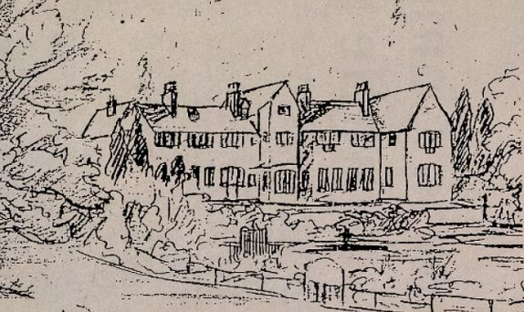  POW Camp: | 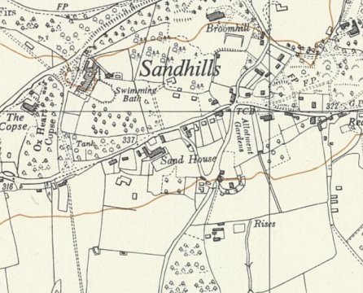
 | Ordnance Survey 1955

An article in “The Advertiser” on 27 August 1993 – “German pilot searches for his old POW camp – A Luftwaffe pilot shot down in Kent in the last war is back in this country to retrace some steps and to try and find Camp 23, near Godalming where he was imprisoned.

Heinz Mollenbrook has written to Godalming police to help trace what he describes as the ‘great house’ in which he was interned for about seven months. He was with 10 badly wounded officers and 10 navy doctors.

He said the house became an internment camp in 1940. He arrived there in October 1941.

Her Mollenbrook (70) did some sketches of the house during his stay and hopes publication of a drawing may jog the memory of someone who knows the house…” [Above]

A response to Mr Mollenbrook identified the house as ‘Kingwood’ in Sandhills, Wormley. He revisited the site in September 1993. He described conditions at the camp as being like a comfortable convalescent home and the inmates were well fed and encouraged to have fresh air and exercise – “We had bacon and eggs for breakfast… It was October when I arrived and I found the last blackberries and hazelnuts. We had permission to go on walks and I discovered the whole region. The camp made a great impression because of its hospitality. I have never forgotten the wonderful colours of autumn.” [I have seen his name spelled as Möllenbrok].

Mr Mollenbrook was transferred to Shap Wells Camp 15 where he made a series of sketches and paintings.

There is a record of Miss Franziska Valchar, an Austrian, first interned at Rushen Internment Camp, Isle of Man, being transferred to Sandhill Cottage, Wormley, Godalming, Surrey [just a little to the NE of Sand House, at SU 9404 3821 – shown on map as small outline building at top edge just to R of Broomhill]. This confirms the use of buildings in the area for internees. [https://www.imuseum.im/search/collections/people/mnh-agent-109207.html]

The use of the house for convalescing pows was short lived as Italian Pows were recorded there from late 1942

I have seen pow mail February and April 1945 to Italy.
Believed to have held German pows after the Italians.

