Camp 23 - Greenfields Camp, Ellesmere Road, Shrewsbury, Shropshire

Prisoner of War Camps (1939 – 1948) - Project report by Roger J.C. Thomas - English Heritage 2003
OS NGR | Sheet | No. | Name & Location | County | Cond’n | Type 1945 | Comments
SJ 492 138 | 126 | 23 | Green Fields Camp, Ellesmere Road, Shrewsbury | Shropshire | 5

Location: The NGR above is at the end of Elm Street (what a nightmare!) just off Ellesmere Road, marked X. The housing in the area pre-dates the war. There was a narrow strip of land running alongside the railway line that could have been used for a small camp.  However, a 2018 Development Management Report for Shropshire Council, stated that the pow camp was located adjacent to the house shown as ‘Greenfields’, marked Y.  No further details.  No camp reports from the re-education inspections – no ICRC reports – not recorded in Italian camp lists – it is therefore very likely that this camp had a short existence.  The site as it is now:  https://repatriatedlandscape.org/england/pow-sites-in-the-west-midlands/pow-camp-23-green-fields/ | 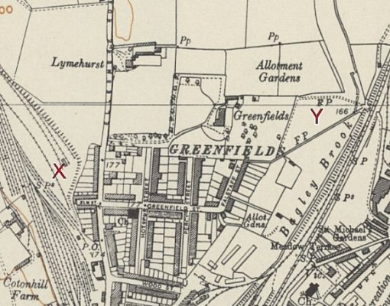
 | Ordnance Survey 1954

