Camp 22 - Pennylands Camp, Cumnock, Ayrshire (aka Auchinleck)

Prisoner of War Camps (1939 – 1948) - Project report by Roger J.C. Thomas - English Heritage 2003
OS NGR | Sheet | No. | Name & Location | County | Cond’n | Type 1945 | Comments
 |  | 22 | Pennylands Camp, Cumnock | Ayrshire |  | Base Camp | Scotland

Historic Environment Scotland states that the site was also known as Auchinleck or Temple, but I can find no other reference to the use of these names for the POW camp.

Location: NGR 541 211. About 3 km NW of Cumnock  Previous Use: Land located within the Dumfries House estate. The site was used as a military training camp for various units from 1939 to 1944. At first troops were mainly in tents, then during 1942 a mixture of Nissen and Ministry of Works and Planning Standard (MOWP) huts were built. Free French paratroopers were based in the area from January to June 1944.  POW Camp: Italian and then German pows. 1 or 2 compounds recorded at different times.  1943 - a pow camp was established on the site – most likely only using a section of the whole army camp, (troops were still based there). Historic Environment Scotland record – “A possible prisoner-of-war camp has been identified on vertical air photographs (RAF 106G/UK/571, 3135-37, flown 1945). Visible on the air photographs is a double fence-line enclosing the southern section of the camp. Immediately to the N is what may be the accommodation units for the camp guards. The sewage treatment plant, still depicted on the latest edition of the OS 1:10560 scale map, (1968), to the S of the camp lies at NS 5415 2091. Examination of the air photographs reveals well over 100 huts within the compound, several of which have 'formal gardens' to the rear. In the central area of the camp is a group of larger huts, presumably the mess, kitchen and recreation buildings.”  December 1944 – No.6 Polish Guard Company came to the camp to replace many of the Pioneer Corps guards. (PGCs were used up to late 1946).  1945 - It is not known what percentage of the German pows were Category C ‘Black’ Nazis, but a high proportion would seem likely as intimidation and violence was recorded at Pennylands. In April 1945, two pows “…complained that they were threatened with hanging by | 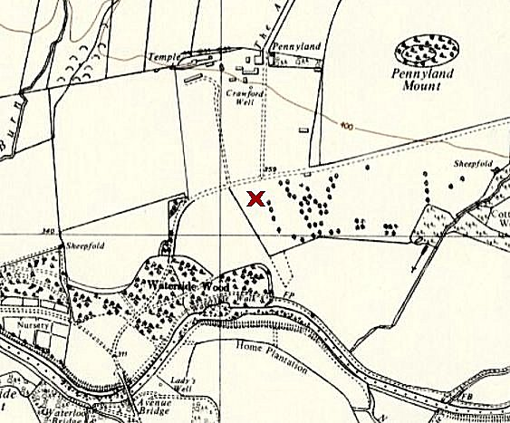
 | Ordnance Survey 1958
their camp-mates for participating in anti-Nazi propaganda. One of them was assaulted and received minor injuries. Another prisoner in the same camp was beaten up because he was foreman of a working gang. He was treated for head wounds caused by kicks and blows. The prisoners concerned in the attack were punished with detentions and transferred to a camp for Nazi prisoners [note below*]. In addition, all prisoners considered likely to cause trouble were segregated in a newly constructed compound at the camp. Another 500 or so less ardent Nazis were transferred to other camps. The victims of the assault and any prisoners who felt threatened were immediately given protection.” (‘Prisoners of England’ p69-70 – Miriam Kochan – Palgrave Macmillan – 1980).

[*] There is a record of pows being transferred from this camp to high security Watten Camp 165. The division of the camp into 2 compounds is confirmed in the ICRC report below – however, by November 1945, the camp had returned to being just 1 compound].

31 May 1945 - An ICRC report listed the use of huts in Compound A with about 3400 pows:

Accommodation 110
Washrooms 9 / Toilets 9 / Showers 4 / Drying rooms 3 / Delousing 1
Kitchens 5 / Dining 5
Storage & craftrooms 5 / “Hobby shop” 1
Infirmary 9
Chapel 1
Canteen 1
Theatre 1
Not in use 2

14 November 1945 – ICRC inspection. It had an interesting ‘detachment’ with pows held in U-boats. The main camp was inspected the following day. The two reports are given below. The Camp Commandant at this time was Lieutenant Colonel F.M. Elliot. M.C. (I believe he was with the Argyll and Sutherland Highlanders).

Mid-1946 - POWs moved out of the camp.  Listed as American pow Transit Camp No. 5A located in the UK  After the Camp: Used by the Polish Resettlement Corps from November 1946 to 1947. It was then used as a housing camp to the late 1950’s. Due to various redevelopments in the locality, the site has been excavated several times.  Further information:  Excellent local history group – www.cumnockhistorygroup.org  Historic Environment Scotland - http://canmore.org.uk/event/802728 + other Canmore details of excavations.  National Archives – WO 166/16297 – 1944 223 Prisoner of war camp at Aldershot, Hampshire. Moved to Haltwhistle, Northumberland; from there to Cumnock; from there to South Woodford – dated 1944 Feb-Apr.  BELOW  1. ICRC Report on submarine detachment – 14 November 1945. Although it does not state the location, it would have been Loch Ryan, some 60 miles away from Cumnock. ‘The Scotsman’ reported that there were more than 60 surrendered U-boats there by 28 June 1945.  2. ICRC report on Camp 22 – 15 November 1945. The documents are held at the National Archives. Translated from French by M Sanders. M(onsieur) Bieri (Frédérick), conducted many visits to camps on behalf of the ICRC. | 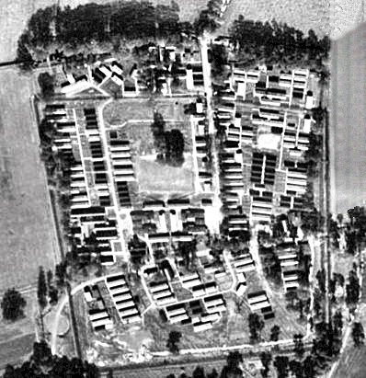
 | 1945 aerial photograph – the pow camp was probably the lower section below the track

Great Britain  SUBMARINE DETACHMENT AT CAMP 22.  Visited on 14 November, 1945 by M. Bieri.  Address: German POW Camp 22, Submarine, Great Britain.  Commandant: Captain STUDHOLME, Royal Navy.  Camp leaders: FRANZEN Gerd., "Marine Stabsarzt", B 215001 (also senior doctor; he has a copy of the Convention)  Capacity: 625 German prisoners, including 37 officers, 2 officer-doctors, 219 warrant officers and 5 members of protected personnel; 2 prisoners are within camp 22, all are navy.  General information  The prisoners are held on various types of German submarines, under the orders of a group of German submariner officers. The submarines are moored in groups of approximately 5 in the middle of a basin, and are guarded by a small Royal Navy ship. On board each submarine of these 15 groups are some submarine officers and approximately 40 warrant officers and soldiers. These groups are sufficiently isolated from each other.  Officers and members of the crews in the submarines, which are a little narrow, benefit from the comforts and installations which can be found there. Each one has 2 or 3 blankets. Four water-hydrants are provided in each submarine, in case of fire. Lighting, heating and the kitchen are supplied with electricity.  The 15 groups of prisoners are classified in 4 sections and each day one of these sections is authorized to disembark to play football, to take exercise and to bathe. The majority of the submarines, coming from Norway, have been in British hands since June 1945.  Food  The food is prepared separately by each group, and did not raise any complaints. The kitchens are small, but clean and have electric cookers.  Menu on the day of our visit:  breakfast: tea, bread, jam  lunch : vegetable meal  dinner : tea, canned fish, margarine, bread.  Medical care  The submarines do not have a special infirmary. Minor cases are treated by German officer-doctors; other cases, when necessary, are transported by Captain Studholme to another vessel, which is not the guard ship. Serious cases are transferred to a land-based hospital. |  | Assistant officer-doctor: von KELLE, "Marine Ober Ass. Arzt" , 215103.  The supply of medicines is sufficient. General medical inspections take place from time to time. Dental care is provided by a dental surgeon of the Royal Navy.  On the day of our visit, a man had a glandular infection, but there were no cases of serious disease, contagious or epidemic.  On 16 September, 1945, JAKOB Artur, "Ob. Gefr" 215207, died after a blood transfusion.  The medical personnel is composed of two officers and three warrant officers and soldiers.  No complaints were raised about the medical care. The senior German officer-doctor believes that the health and nutrition of prisoners is good.  Clothing  The prisoners have sufficient clothing and uniforms and officers may keep personal effects. All officers, warrant officers and soldiers have complete German uniforms.  Work and pay  Work mainly consists of maintaining the submarines (machines, etc).  The officers receive regular pay and all the warrant officers and soldiers earn 6/- per week.  Canteen  No canteen has been set up for the prisoners, however they are sent sufficient cigarettes, razor blades, etc., from camp 22.  The prisoners are allowed to smoke in certain places and at certain times, in accordance with the orders given by the German officers.  Religious services  No religious service has taken place, because it is impossible to assemble the men for this purpose.  Education and leisure  Courses in English and some courses of mathematics were organized by almost all of the groups.  A football field is reserved for the prisoners. The men have sufficient books as they still have the libraries on the submarines. No film show has taken place, but the men use the T.S.F. apparatus on the submarines.

Correspondence  Approximately 200 answers have already returned after a recent despatch of brown cards.  Discipline  The discipline is excellent and no complaints were raised in this respect.  Requests  The camp leader asked for:  Some English-German dictionaries for the 15 groups; some text books for the English courses; some film shows.  FRANZEN "Marine Stabsarzt"; asked for some books on homeopathy for himself and for another doctor, as well as German medical publications.  Family benefits  Officers and sailors were worried about whether their families still received any family benefits. During the war, all allowances were distributed by a special office in Wilhemshaven and the prisoners fear that this office either no longer exists, or is unable to function.  Legal  The crews of the submarines would like their legal status to be specified.  Conclusion  The naval authorities well appreciate that the prisoners and the camp leader believe they are treated fairly. The prisoners appear content and the submarine that we visited was very well maintained. |  | Artur Jakob, died 16 September 1945, was later reinterred at the Cannock Chase German Military Cemetery.  ‘brown cards’ – ‘cartes chamois’ – postcards notifying family etc., of a prisoner’s location.  Stabsarzt Dr. Franzen served on U-155, one of the u-boats scuttled under Operation Deadlight at the end of the war.  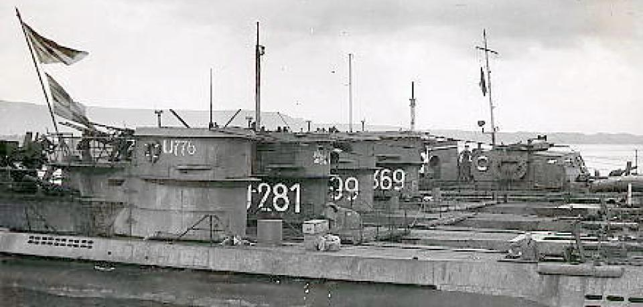  U-boats awaiting to be scuttled at Loch Ryan  For more details on this operation see - https://uboat.net/articles/84.html

Great Britain  CAMP 22.  Visited on November 15, 1945 by M. Bieri.  Address: German POW Base Camp 22, Great Britain.  Capacity: 4000 men.  Commandant: Lieutenant-colonel F.M. ELLIOT. M.C.  Camp leader: NESTLER Max, "Obermaat", B 4461.  Assistant: WERNER Oscar, "Hpt, Fw.", 490708 (They possess copies of the Convention).  Actual numbers: 2431 prisoners, including 12 officers, 564 warrant officers, 265 members of protected personnel and 14 prisoners attached to camp 14,  among which: approximately 150 Austrians  6 Dutchmen  approximately 100 Czechs  7 Poles  1 Yugoslavian;  made up in the following way: 1743 Army  236 Navy  422 Air Force  11 of "RAD"  19 civilians.  1020 of these prisoners will soon be repatriated.  [R.A.D. = Reichsarbeitsdienst; the Reich Labour Service. They were considered to be auxiliary forces and so came under the Geneva Convention – The civilians were most likely Protected Personnel].  General information  At the time of our last visit, the camp was composed of 2 "Compounds". Since then, the barbed wire which separated both "Compounds" has been removed so there is now just one "Compound". The number of huts and other installations has not changed. By contrast, new paths and flower gardens have been created and several improvements were made to communal areas of the camp (opening a bakery, etc.). All buildings are heated by stoves and lit with electricity.  Each man receives a sleeping bag and two blankets. |  | Food  No complaints were raised on this subject.  On the day of our visit, the menus were;  breakfast: soup with milk  lunch: mashed potatoes, cabbage, roast sausage  dinner: bread, margarine, tea.  Infirmary  (See preceding reports)  German head doctor; JANSEN Helmut, "Stabsarzt", A. 836494.  Assistant Doctors; POSPIECH Karlheinz, "Stabsarzt", 523537.  ARABIN Erich, "Stabsarzt", B. 34702.  GLOGGL Anton, "Oberarzt", A. 382539.  STEINFELTZ Hans, "Stabsarzt”, 814695.  ZIERZ Paul, "Stabsarzt", 523555.  WASSENECH Walter, "Unterarzt", 28692.  Pharmacist: MAYER Hubert, "Oberapotheker", 523482.  Protected personnel:  With the infirmary: 7 officers  21 other ranks  In the "Compound" 50 medical orderlies and 187 who are not employed as members of the protected personnel.  Medical supplies are sufficient.  A general medical inspection takes place each month (pows due for repatriation are examined every day).  A German dental technician undertakes dental work.  An average of 230 prisoners present themselves for treatment each day.  Of the 60 beds in the infirmary, 52 were occupied on the day of our visit.  old wounds 25  boils 1  cellulitis 2  influenza 4  pleurisy (old) 2

lumbago 5  bronchial asthma 4  cystitis 2  myocarditis 1  angina 2  enteritis 2  syphilis 2  In the camp barracks there are about 30 prisoners who are amputees.  There were no serious or contagious cases.  There was no complaint about the medical department.  Repatriates.  The German head doctor made an observation that 20% of the repatriates are aged more than 50 years old and need more care than the other prisoners. He asks if it would not be possible to obtain an increase in the fuel quota intended for these repatriates. This question also arises in other camps and will be looked at in London.  The German head doctor estimates that the health of the repatriates varies, whereas that of the other prisoners is good.  The state of nutrition of all prisoners (repatriates included) is generally good, except for some cases who have stomach problems.  Clothing and uniforms.  Within the camp the distribution of clothing is not yet completed. The repatriates need a shirt, socks, pants, etc.  Approximately 30% of the prisoners have a complete German uniform.  Work  Among the prisoners, 1185 (including 353 members of the permanent personnel) are assigned to agricultural or construction work. Approximately 40% earn on average 5/6 per week, the others 2/6 per week.  Canteen  The canteen is well supplied (except in toothpaste).  Funds amount to £27. -. - (available money; the remainder is retained to compensate for possible damage with the huts). |  | Religious services  The protestant chaplain, KRUSE Johannes, "Uffz.", 500587, leads an act of worship every Sunday for about sixty prisoners. Two services take place during evenings each week.  There is not a catholic priest in this camp, but a British military chaplain celebrates mass each Sunday.  On the day of our visit, the catholic priest from camp 19 spent one week at camp 22.  Leisure  A football pitch belongs to the camp.  The library has approximately 800 instructional books, 150 religious works, approximately 300 books in foreign languages, 20 works on the music and approximately 1500 novels in German, booklets, texts of comedies, etc. Approximately 200 novels are very damaged and will have to be repaired.  The choir has 26 members.  The excellent orchestra, is composed of 30 members led by COMPACH Fred, " Fw.", B. 180502 (12 violins, 2 guitars, 1 piano, 1 violin-cello, 3 trumpets, 1 clarinet, 2 jazz drums, 4 accordions, 1 saxophone, 2 basses, etc.)  The theatrical troop of 14 members recently gave various performances among which was, "The broken jug" and "Faust”.  The director of studies MEUNIER Wilhelm, navy, 109100, (professor and holder of two doctorates) has organized the following courses:  Pupils  a) Foreign languages:  English 233  French 47  Russian 61  Spanish 13  Latin 13  b) Mathematics and natural science:  mathematics 41  “ general course 12  calculation 25  physics 10  electrical engineering 14  chemistry 20  astronomy 50  nature study 65  biology 22

c) German:  grammar 18  Grammar for pupils of foreign languages 10  popular philology 25  Faust 17  d) Commercial courses:  accountancy 26  economic science 26  e) Law:  introduction to law 40  civil law 40  penal law 40  f) Apprentice crafts:  German 12  professional calculation 20  g) Theory of music:  interpretation of piano music 24  h) Various:  shorthand 14  drawing and painting 6  speech 25  music 10  i) General knowledge: (Professor Meunier)  philosophy 56  philosophical discussion 17  seminar of philosophy 18  ethics 58  political and economic science 39  art 46  Conferences (by Professor Meunier)  a) Problems of life.  Series of conferences on: the meaning life  the nature of man  the nature of society  the rights of the individual compared to society  the duties of individuals within society  These conferences are held in a strictly democratic spirit (average attendance; 150 to 160 prisoners). |  | b) Political problems. Short conferences discussing an exchange of views concerning the people, the state, the country. Construction work and general economic questions. These conferences have a democratic basis. (Average attendance; 150 to 160 prisoners).  Other conferences;  a) "Stabsarzt" Jansen has given 2 conferences on the colonisation of Panama.  b) A series of conferences on the political conditions in Germany between the two last wars.  c) Weekly press review, giving summaries of world news.  d) The community of work, "democratic action".  Each week a British film is shown and each month a German film is shown. The prisoners can also listen to the radio.  Correspondence  On 17 September, 1945, the prisoners sent 2000 brown cards and they received 600 replies, that is:  570 from the British zone  20 “ “ American zone  10 “ “ French zone.  Discipline  Discipline has not raised any comments. No escapes have been attempted.  Requests  The camp leader would like:  handbooks on artisan work, (particularly gardening and agricultural work)(urgent).  popular songs  music (traditional and operettas) for the camp orchestra  classical music for quartets and quintets.  music paper.  The officer doctors have requested works about modern medicine and for periodicals.  Conclusion  Apart from the repatriates whose situation remains provisional, they must be constantly ready to leave - the prisoners of this camp are satisfied with conditions. In general matters, this camp seems excellent.

