Camp 296 – Ravenfield Park Camp, Rotherham, Yorkshire
Prisoner of War Camps (1939 – 1948) - Project report by Roger J.C. Thomas - English Heritage 2003
OS NGR | Sheet | No. | Name & Location | County | Cond’n | Type 1945 | Comments
SK 4847 9550 | 111 | 296 | Ravensfield Park Camp, Rotherham | Yorkshire | 4 |  | Farmland

Location: SK 4847 9550. The camp was in Ravenfield Park, near to the fish ponds. Guard officers used Ravenfield Hall.  Previous use: Large country estate.  POW camp: Started as an independent camp 296.  November 1945 – had become a hostel for Potters Hill Camp 127 listed as Thryberg, the nearby village, in an ICRC inspection report.  September 1946 – a hostel for Lodge Moor Camp (17)  After the war: | 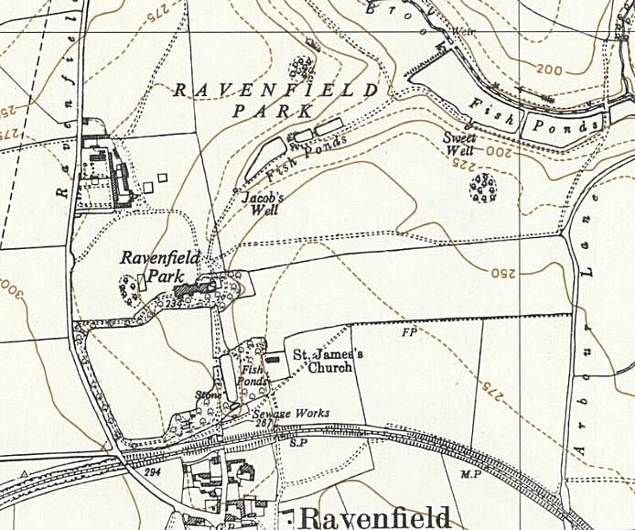
 | Ordnance Survey 1956

