Camp 20 & 158 - Bramham Camp, Bramham, Boston Spa, Yorkshire

Prisoner of War Camps (1939 – 1948) - Project report by Roger J.C. Thomas - English Heritage 2003
OS NGR | Sheet | No. | Name & Location | County | Cond’n | Type 1945 | Comments
SE 42 43 | 105 | 20 | Bramham No.1 Camp, Bramham, Boston Spa | Yorkshire | 5 | Base Camp

Location: the NGR given above is for Bramham, a small village in the north-east corner of the Leeds district, 4.5m miles (7km) south-east of Wetherby and 1.0 (1.5km) south of Clifford.  POW Camp(s):  There were two ‘camps’ located within Bramham Park, simply referred to as No.1 and No.2.  At times there were different camp numbers associated with these two sites, e.g. Camp 20 and Camp 158 – see below.  There are memories of Italian pows here as early as 1943, but the camp is not recorded in the Italian Camp lists that I have seen. The pavilion marked on the map was recorded as holding pows.  - - -  1944 / 1945 Russian pows:  “Mr Harry Lewis, for example, recalled with lively amusement his days as Accounts Clerk at Bramham No.2 Camp in Yorkshire, where 500 prisoners were housed. They were drawn from an assortment of races, being for the most part powerfully built, with immense heads and feet. For their heads they were issued with the largest British | 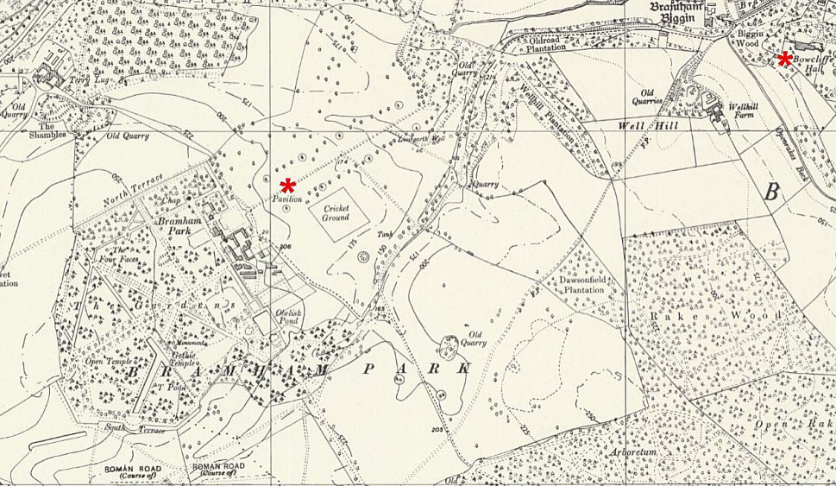
 | Ordnance Survey 1958
forage caps obtainable, but even these perched on their heads ‘like a pimple on a haystack’. Boots large enough were found, and these the Russians wore stuffed with paper, explaining that such had been their practice in the Red Army.

Their major pursuits were threefold, being, in the words of the old Russian song, ‘wine, women and cards’. Every week they were given five shillings pocket money, in the form of two half-crowns. By the same evening, after a frenzied bout of gambling, virtually all this money had passed into the hands of a lucky few. Those who had money then rushed to the camp canteen with a heterogeneous collection of receptacles to buy beer. When asked how much, they replied as they had learned in Germany: ‘Alles’. They would travel by bus into Leeds, the conductress giving up the vain linguistic struggle by demanding no fare. There in the lowest pubs were passed happy hours, purged as often as not by violent vomiting in the returning late-night bus. A fortunate few managed to earn extra money on these occasions by sleeping with soldiers’ wives in the city, and returning with a grubby pound note as reward.

During the day the prisoners were marched out to work on neighbouring farms. They were not guarded, (there were only thirteen unarmed British soldiers in the camp) and seemed to have enjoyed their work. Their tastes, as indicated, were simple. They often sang – beautifully – the songs of their native lands, and were good natured, humorous and loyal. It was a hard winter in 1944-5, and the prisoners insisted on having their barracks’ stoves burning twenty-four hours a day, with the result that they had soon burned not only their ration of coal, but also most of the camp furniture. On the other hand, a popular pastime was to emerge into the frosty Yorkshire air and drench each other with ice-cold water from stirrup-pumps.

The British staff also conducted their lives on musical-comedy lines. One of the senior officers was in private life connected with the clothing trade, and conducted a great deal of business from the camp HQ, which was filled with specimen skeins of wool. Another was an Irish man who scarcely appeared, being busy with a girl in Thorner, and the remainder of the staff got up to all the usual camp dodges, such as plundering the stores and making threepence a pint on the beer by selling the Russians short measure. Nobody minded and everybody enjoyed himself.

Harry Lewis became interested in the men, and learned from them the familiar tales of indescribable hardships in the Red Army and the Wehrmacht, coupled with an extreme and universal aversion to returning to Russia. As accounts clerk, he had occasion to observe that an overwhelming majority of the prisoners were illiterate, being obliged to record the receipt of their pay with a mark. This chance survey may throw some light on the critical faculties of Western experts, who had swallowed the Soviet Union’s pre-war claim to have reduced illiteracy to a mere 2 per cent. All in all, Harry Lewis retains very affectionate memories of his bear-like Russian charges. ‘They were great gamblers, they were great drinkers, they were great womanisers, they were rotten with V.D… but they were very likeable’ was his verdict.”

[pp151-153, ‘Victims of Yalta’ – Nikolai Tolstoy – Corgi Books – 1986.]

Most of these Soviet citizens had been forced to serve in the German army, or for Organisation Todt - or face execution or starvation. Some were willing volunteers in the Wehrmacht. Their status was in question – prisoners, or unfortunate allies? Note that this account refers to 500 Soviets in Camp No.2 at Bramham, the place where Harry Lewis worked - but an article in The Yorkshire Evening News began with the number 2000 and it seems that camp 1 and 2 were in use (*):

“West Riding farmers’ appreciation of ex-slaves of Germans…. 2,000 men in Bramham Park camp.

..tribute was paid to the Russians working on the land in the West Riding… The farm workers soon convinced me that the Russians were better on the land than the Germans or the Italians…

There are several camps in Yorkshire and two of them (*), containing a total of over 2,000 men, are in the grounds of Bramham Park, home of Lord Bingley.

The Russians live in huts formerly occupied by the military authorities, and to-day the Red Flag flies proudly above them. They are not prisoners of war as has been stated in some other newspapers, but “Liberated Citizens”. That is their official designation, and they are not under guard at the camps or in the fields. The farmers call for them and provide transport where necessary.

The majority of the men fought in the Russian Army and, after being captured, were forced to work for the Germans. Many were sent to build defence works in N.W. Europe where they were captured by our soldiers. Others managed to escape from captivity in Germany and Poland and reached our lines by routes and assistance which cannot be mentioned now, for security reasons….

In their ranks are young and old, men from the Caucasus, White Russia, Mongolia and the Ukraine. They are a cheerful lot of men, whether in camp, on the farms, or on the march for exercise. On any evening you can hear the sounds of song half a mile away.

The men are clothed in British battledress. One of them told me, in a mixture of English and French, that they are proud to wear it. Another had a German tunic underneath and he shook his head when I examined it as if to say ‘No good’. The material was very poor compared with our own cloth….

Another man pointed to a mark across his face and explained that he had received a cut from a whip while working in the Todt organisation, where conditions were bad and treatment harsh….

…some of the men have returned home, and the remainder will leave for home as soon as shipping arrangements are completed.”

Many of these Soviets were aware that a harsh fate awaited them on return to the USSR, where the act of surrender was regarded as an act of treason. They were returned as soon as transport ships were available. On return most were imprisoned, sent to labour camps, or executed.

- - -

After the Soviets were removed, Camps 20 and 158 were located here for a very brief time in order to form up without pows.

POW Camp 20: War diary details:

28 April 1945 – Formation of unit for POW Camp 20 at Bramham Park. At this point its purpose seems to have been undecided – they were told later that they were to hold Austrian pows. Commandant Lt.Col J.P.F. Scott R.A. was joined by the quartermaster and 15 O.R. They were accommodated at Wetherby and attached to a Special Training Unit.

30 April 1945 – 7 more officers and 140 OR from the Pioneer Corps arrived.

17-19 May 1945 – Pow Camp 20 (still no pows) moved from Bramham Camp to Abbotsfield House, Tavistock. A few days later it moved to Bickham to receive its first pows.

Further - see Bickham Camp 20

POW Camp 158: War diary details:  28 April 1945 – Formation of unit for 158 Bramham German Pow Camp; 3 officers and 60 O.R. from the Pioneer Corps joined. They were accommodated at Wetherby and attached to a Special Training Unit.  30 April 1945 – Commandant Lt Col A F B Powell and 6 more officers joined the unit. They were no longer attached to the STU and moved to ‘Number 2 Camp Bramham Park.’ (Presumably No 1 Camp was the site being used for Camp 20).  1 May 1945 – 150 O.R. posted from the Pioneer Corps.  6 / 8 May 1945 – Pow Camp 158 (still no pows) moved from Bramham Camp to North Burton Camp, Burton Fleming, Yorkshire.  Further - see North Burton Camp 158. | 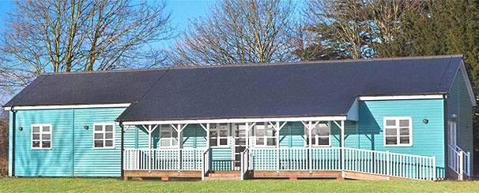
 | The pavilion which may have housed pows at Bramham Park

Not certain how long the camps at Bramham remained after this. The English Heritage Report only lists No.1 as a base camp in 1945.

Further references:

National Archives: WO 166/17821 – 20 Pow camp moved from Bramham Park, Yorkshire to Tavistock, Devon; and from Tavistock to Bickham. Austrian prisoners of war arrived June-August 1945. Dated 1945 Apr-Aug. Used above.

WO 166/17824 – 158 (German) POW camp, North Burton, Burton Fleming, and Bramham Park, Yorkshire. 1000 prisoners arrived from 9 POW camp, 22 May 1945. Dated 1945 Apr-Aug. Used above.

