Camp 20 - Bickham Camp, Bickham Common, Bickham, Yelverton, Devon

Prisoner of War Camps (1939 – 1948) - Project report by Roger J.C. Thomas - English Heritage 2003
OS NGR | Sheet | No. | Name & Location | County | Cond’n | Type 1945 | Comments
SX 504 651 | 201 | 20 | Bickham Camp, Bickham Common, Bickham, Yelverton | Devon | 5 |  | Guards' compound in Bickham Park, four large and one small double wire perimeter fenced enclosures for tented accommodation, guarded by watch towers.

Location: On the SW edge of Dartmoor  POW Camp: It is possible that Italian pows were at this site, but there is no record of this in Italian pow site lists. If there was an Italian pow camp it would not have had the number 20 as this was formed in 1945 at Bramham, Yorkshire – I have not traced any other camp number for Bickham. Sometimes Italian pows were used to build compounds – it may have been the case here, (see 26 May 1945 below).  28 April 1945 – Formation of unit for POW Camp 20 at Bramham Park, Yorkshire. Commandant Lt.Col J.P.F. Scott R.A. He was joined by the quartermaster and 15 O.R. – accommodated at Wetherby. No pows. 7 more officers and 140 OR from the Pioneer Corps arrived on 30 April. Training and various duties.  17-19 May 1945 – Pow Camp 20 (no pows) moved from Bramham Camp to Abbotsfield House, Tavistock.  26 May 1945 – Advance Party moved from Abbotsfield House to Bickham Camp 20. Tents were delivered for German POWs direct to the compound at Bickham. It is likely that apart from tented accommodation, huts were erected for general use – cookhouse, ablutions, toilets, etc.  28 May 1945 – Main body moved to Bickham Camp.  7 June 1945 – Commandant informed SW District HQ that the camp was ready to receive prisoners.  14 June 1945 – Camp informed that owing to a shortage of Interpreter Officers, a craftsman from R.E.M.E. would be posted instead.  23 June 1945 – 41 Austrians arrived from Dunham Park Camp 189. These comprised the Camp Leader, M.O. and pow staff. A further 4 Austrian officers and 44 O.R. arrived later in the day. | 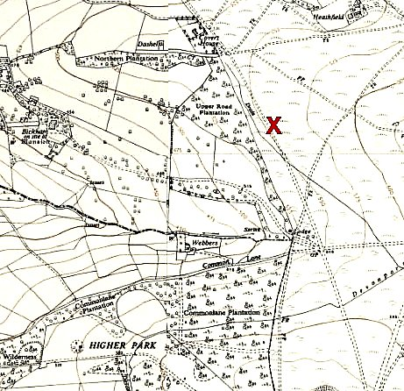
 | Ordnance Survey 1954

25-30 June 1945 – Austrian pows arrive from various camps. Pow strength on 30 June = 9 officers, 743 O.R.

2 July 1945 – 50 pows started work on building prefabs in Plymouth + 25 working at Manadon, suburb of Plymouth + 25 by Efford Cemetery. Further pows were added to these building sites, reaching 240 by the end of August. Camp Strength 9 officers, 1170 O.R.

9 July 1945 – Strength 55 officers; 1299 OR.

30 July 1945 – 97 pows working at local farms, rising to 233 by end of August.

August 1945 – war diary lists numbers of Austrian pows being transferred in and out of the camp. An improved bakery was built – all bread baked on site and described as ‘very good.’

13 August 1945 – 11 pows who were bringing enemy ships from Spain to Devonport were attached to this camp, however they remained on two ships and available to the Royal Navy.

War diary in the National Archive file ends here. It is believed the camp was open to 1947, but there are no inspection reports on file.

After the camp: Returned to common park land.

The camp is it is now - https://repatriatedlandscape.org/england/pow-sites-in-the-south-west/pow-camp-20-bickham/

Further information:

National Archives; WO 166/17821 – 20 Prisoner of War camp; Camp moved from Bramham Park, Yorkshire to Tavistock, Devon; and from Tavistock to Bickham. Austrian prisoners of war arrived June-August 1945 – dated 1945 Apr.-Aug. Used above.

