Camp 17 - 22 Hyde Park Gardens, London, W2

Prisoner of War Camps (1939 – 1948) - Project report by Roger J.C. Thomas - English Heritage 2003
OS NGR | Sheet | No. | Name & Location | County | Cond’n | Type 1945 | Comments
TQ 270 809 | 176 | 17 | 22 Hyde Park Gardens, London, W2 | London | 5

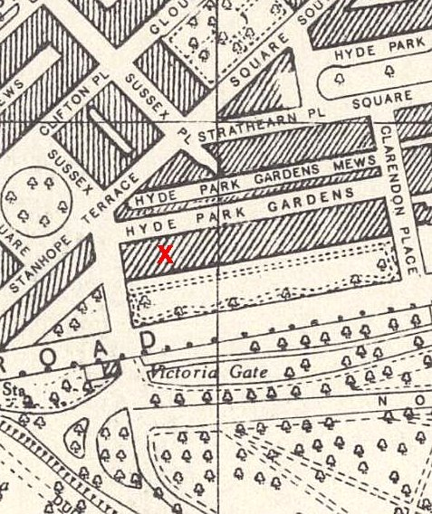 | Large, 6 storey, very expensive terrace house next to Hyde Park. Designed 1836.  I can find no information, but a guess seems plausible.  The Times stated that The Hon. Rupert Evelyn Beckett lived at 22 Hyde Park Gardens up until at least 1938. He was a senior figure in banking and newspapers.  His daughter, Pamela, (after a divorce) married Major-General Sir Stewart Graham Menzies.  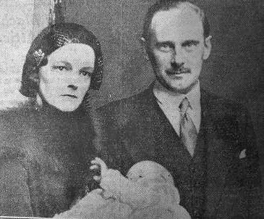  Pamela and Stewart Menzies | 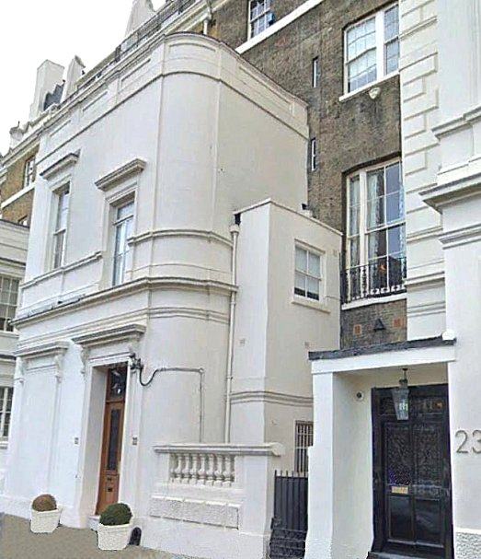
Ordnance Survey 1951 |  | 22 Hyde Park Gardens (brown door)

He became the Chief of the Secret Intelligence Service in 1939. The house would certainly not have been used to hold other-ranks. My guess is that it was intended to be used to accommodate senior captured officers - the London Cage at Kensington Gardens is only just over 1½ km away across Hyde Park. Second guess, it was a postal address for another camp.

The house is now expensive London flats; 2019 a ground and first floor flat sold for £7.9M, a 2nd floor flat for £3.7M. 2020, extensive planning documents available including history / heritage of the site, does not mention it being a pow camp.

The site as it is today - https://repatriatedlandscape.org/england/pow-sites-in-greater-london/pow-camp-17-22-hyde-park-gardens/

