Camp 158 – North Burton Camp, North Burton, Yorkshire

Not included in the English Heritage list.

Location: Vicarage Closes – fields NE of North Burton. NGR TA 069 725  North Burton is now known as Burton Fleming.  POW Camp:  28 April 1945 – The unit ‘Pow Camp 158’ was formed at Bramham, Yorkshire. The commandant, Lt Col A F B Powell, joined them on 30 April. No pows.  6 / 8 May 1945 – Pow Camp 158 (still no pows) moved from Bramham Camp to North Burton Camp, Burton Fleming, Yorkshire. 10 officers and 210 O.R. from the Pioneer Corps.  9 May 1945 – 4 Italian co-operator pows arrived as cooks.  12 May 1945 – 2 officers and 12 OR German pows arrived.  14 May 1945 – Camp stated to be functioning as a Base Camp for German pows. 33 pows from Butterwick Camp 163 arrived to form the permanent pow staff.  16-24 May 1945 – nearly 3000 pows arrived – most from Kempton Park.  June 1945 – war diary recorded pows being transferred to and from the camp.  5 July 1945 – Captain Perry and British staff received training from the Political Intelligence Department (PID) to politically grade pows.  13 July 1945 – film about concentration camps shown to 3,243 pows. This | 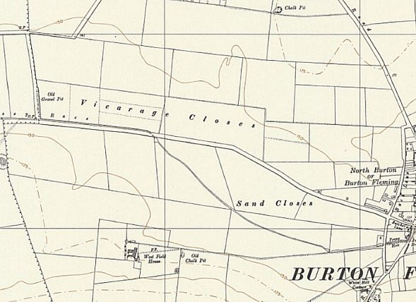
 | Ordnance Survey 1958
was compulsory and afterwards a report was submitted on the pows reaction, (not detailed in the war diary).

15 July 1945 – Uffz Martin Peetz, a pow from this camp, died at Driffield Emergency Medical Service hospital. He was later re-interred at Cannock Chase German Military Cemetery.

August 1945 – Various inspections took place. Lecture visits started, arranged by the PID, marking the start of re-education activities at the camp.

The War Diary at the National Archive ends at the end of August 1945, though the camp continued.

1946 - pows from this camp repaired and painted the church walls, and a pow who was a glazier repaired some windows.

26 October 1946 – Hull Daily Mail article referred to Pows attending church services and the vicar, Rev. D Murphey arranged film shows for them.

Known Commandants:
1945 - ? Commandant Lt Col A F B Powell R.A. – from the Royal Artillery. Recorded as Commandant at Camp 22 Bourton, Gloucestershire in 1947.

After the camp.

The site as it is now - https://repatriatedlandscape.org/england/pow-sites-in-yorks-humber-and-lincs/pow-camp-158-north-burton/

Further references:

WO 166/17824 – 158 (German) POW camp, North Burton, Burton Fleming, and Bramham Park, Yorkshire. 1000 prisoners arrived from 9 POW camp, 22 May 1945. Dated 1945 Apr-Aug. Used above.

