Camp 10 (& 106) - Stamford Camp, Empingham Road, Stamford, Lincolnshire

Included in the 1945 ICRC list – Labour Camp. 106. Stamford Camp, Lincs.

1947 Camp List
106(G.W.C.) | Stamford Camp, Stamford, Lincs | E | Priswar, Stamford | Stamford 2050 | Stamford | Lt.Col.A.H.C.Potter | v/1453/2

Prisoner of War Camps (1939 – 1948) - Project report by Roger J.C. Thomas - English Heritage 2003
OS NGR | Sheet | No. | Name & Location | County | Cond’n | Type 1945 | Comments
TF 014 071 | 141 | 10 | Stamford Camp, Empingham Road, Stamford | Lincolnshire | 4 |  | STANDARD type. See Camp no.106
 |  | 106 |  |  |  | German working camp | Standard type. Site occupied by housing. See Camp no 10.

Location: Just off the Empingham Road, to E of Stamford.  Previous use: agricultural land.  POW Camp: Italian pows, then German. Photograph of camp below shows British / administrative compound at front by the road, with pow compound behind.  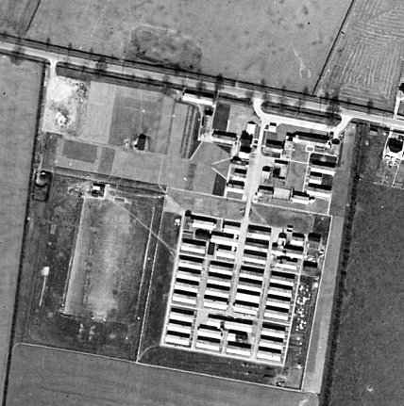  1943 / 1944 – Attached hostels listed for Italian pows in 1943 and on 5 May 1944, (WO 32/10737):  Blatherwycke, Northamptonshire / Normanton Hall, Grantham, Lincolnshire  1944 - The site was listed as an Italian Labour Battalion (106) under the Eastern Command area in May 1944 and as an Italian POW Working Camp (106) in November 1944, (WO 32/10737). The Italians were recorded as non-co-operators.  1 February 1945 - nearly 1200 Italian pows at the camp – most transferred from Camp 28 at Loughborough.  1945 - Hostels listed for pows from this camp (106) on 15 September 1945, (WO 32/10737):  Barnack, Stamford, Lincolnshire / Blatherwycke, Bulwich, Northamptonshire  21 May 1946 – valid concerns were raised about conditions in pow camps in France, Belgium and Germany. Richard Stokes M.P. asked the Secretary of State for War:  “…whether he is aware that as recently as the beginning of April, 100 men are said to have arrived | 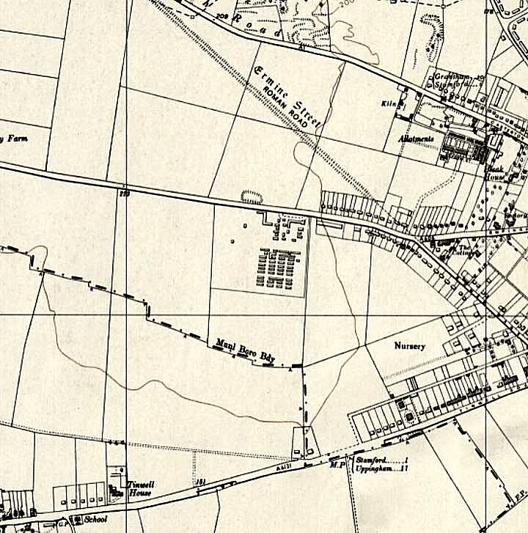
 | The camp shown on Ordnance Survey map 1958
at Stamford from a Belgian camp, and it is admitted by both medical officers of health that they were entirely unfitted for work through starvation…” (House of Commons, 21 May 1946, Vol 423, Col 187).

He was assured that the matter would be investigated.

Oversight of re-education activities for pows was carried out by PID (Political Intelligence Department of the Foreign Office) / COGA (Control Office for Germany and Austria – UK). Visits and reports were made. The standard of the reports varied greatly – those for Stamford contained many inconsistencies. The visitors took little interest in activities other than re-education, they rarely mention sports, games, pastimes, crafts, etc of the pows.

14 August 1946 – Major A W Turner visited to review re-education. Strength – 1 officer; 2050 OR. Visit number 4 - earlier reports are not in the National Archive file.

No of pows: | Stamford | Wansford | Blatherwick | Ridlington | Whissendine | Collyweston | Billetees
 | 736 | 928 | 62 | 65 | 46 | 46 | 165

Commandant: Lt Col H P Potter RA [AHC were correct initials] Camp leader: Ernst Betterman (B)
Interpreter: S/Sgt H Greenwood Deputy C/L: Werner Victor (A) [Vicktor]
German MO: Dr Norff (B) [Norf]

The commandant was keen to assist in the development of re-education activities.

Interpreters often played an important part in re-education. S/Sgt H Greenwood was clearly very active – but received remarkably mixed reports.

In this August 1946 report he had been in place for just a few months and was described as; “conscientious and keen worker in re-education.”

In October 1946 he received heavy criticism; “…a very poor type and has been reprimanded for threatening Ps/W with concentration camp penalties. His influence on re-education is not noticeable. He is quite unable to cope with his problems. He unfortunately saw his parents killed by the Gestapo and his dealings with Ps/W rather reflect his past experiences.”

Despite this harsh criticism, he remained in place, and in April 1947 received very high praise; “particularly suited to re-education and is an active power and influence in the Cultural Life of the camp…. Outstanding… the backbone and inspiration of the Ps/W re-education.”

He continued at the camp until he was demobilised in late Spring / Summer 1947. A review was then issued in the August 1947 report;

“There is no doubt that S/Sgt Greenwood’s departure a few months ago was greeted with universal relief in the camp. I never met Greenwood, but testimony is united to the effect that through his friends an extreme left-wing, virtually communist line was propagated in the Democratic Study Union…” It was considered that he viewed Catholics, “who are strong and active” with extreme disfavour. There was also a belief that anyone who opposed him were transferred to another camp. “There is no doubt that free speech wilted away.”

These damning comments are inconsistent with other remarks in the same report that he was; “extremely able” - “there is unusually little Nazi nationalism here,” and, “This is one of the few places where political discussion is continuing during the summer.” In a short summary of morale in the camp, the report stated that there was; “a feeling that the camp is a home” – this seems very much at odds with a regime described as “extreme left-wing, virtually communist….”

There is a particular aspect which seems very much to favour S/Sgt Greenwood. In the August 1946 report, when he was active, it was noted that discussion groups were held weekly with good attendance of about 400 pows. A few months after he had left, attendance at such groups was approximately 50, and by November 1947 the groups had entirely collapsed.

It should also be in Greenwood’s favour that the commandant, regarded as “outstanding”, kept him on.

[A very similar situation arose at Garswood Camp 50 with S/Sgt K Bloch. Bloch was also a German Jewish refugee. He was described as excellent and positively leading re-education until the end of 1946. After he was demobilised, he too received very harsh criticism].

Morale in the camp was improving after the removal of one pow who had been a bad influence, and news of future repatriation. It was recommended that three C category (Nazi) pows should be removed.

One of the pows recommended for removal as a bad influence was the M.O., Dr Hans Norf. In this report he was first listed as ‘B’, then as ‘C’. Further inconsistencies arose in later reports (10/47 and others) when he was described as; “A friendly man, with some camaraderie about him… a good influence… excellent.” He would remain in post until the camp closed in 1948.

About 15% of the pows were “youths” (under-25).

Re-education activities were developing mainly with the assistance of the interpreter and a group of eager pows. The standard list of re-education activities was given:

Wochenpost and Ausblick – 300 / 80 copies respectively

Newspapers – 7 British daily papers and 5 weeklies were purchased. Only 4 Swiss newspapers received that week. Few foreign papers were arriving. Interest shown in repatriation news and the Paris Conference.

Library – Inadequate

Lectures – 2 that month by visiting lecturers.

Discussion groups – Weekly with good attendance of about 400 pows.

Films – regular.

Wireless – adequate. Comments arising from broadcasts - the hope that Germany would not be divided into two spheres. BBC broadcasts to Germany were popular.

Camp Magazine - Originally a monthly called ‘Feierabend’, (After Work) - then ‘Baustein’ issued fortnightly, (In full - Der Baustein Halbmonatsschrift fur Kriegsgefeangenen des Lagers 106 Stamford. (The Building Block for pows?)). Articles mainly produced by the pows were sent to an editorial board. Paper was in short supply, it was purchased from camp funds, though COGA had promised to supply. A duplicator was being purchased.

Press Review – weekly meeting to discuss press cuttings with about 200 pows.

English Instruction – separate appendix.

An Information Room had newly been set up with display materials about democracy. This exhibition would later be sent to the Wansford hostel.

Other activities:

Religion – a ‘fair interest’. Weekly protestant services with 50-60 pows. A monthly service in Stamford was attended by about 200. RC services, alternate weekly in camp with a visiting priest from Kings Cliffe Camp 702 – about 100 pows, then in Stamford.

Theatre – theatre capable of holding 300 pows. Operas, dramas and light comedies.

Orchestra – Important part in camp life. About 50 instruments, string, brass, wind and percussion. Mostly classical music.

1 day September + several October 1946 – 3 members of the Segregation Section carried out political screening. Total strength; 2 officers; 2399 OR.

No changes to senior personnel. No of pows in Main camp + 5 hostels + billetees;

Stamford | Wansford | Blatherwick | Ridlington | Whissendine | Collyweston | Billetees
1162 | 782 | 50 | 22 | 11 | 279 | 93

1624 pows were placed into the following categories:

A+ | A | A- | B+ | B | B- | C | C+
14 | 170 | 1 | 547 | 792 | 74 | 24 | 2

This was a lower level of ‘C’ pows than in many other camps.

Brief descriptions of the pow leaders were given:

Camp Leader – H/Fw Ernst Betterman (A) was a professional book-keeper with no Nazi Party record. Became Leader in June – “..excellent type and does his job very well. He is well thought of by British staff.”

Deputy C/L – Werner Vicktor (A) – 28 years old, professional musician – “ordinary type and doing a good job.”

MO – Stabsarzt Dr Hans Norf (B+) – catholic – joined Nazi Party in 1938 and called up in 1939. No comment made about him needing to be re-assessed as a C from last report.

Protestant Padre – San.Uffz Ernst Eisele (B+) – congregation of 60/70, but unable to visit hostels due to transport difficulties. Member of the SA 1933 – 1936, but “turned out as he refused to become more active.” He was later reported as being “very troublesome” and was removed from the camp.

The report also made brief comments about hostel leaders – see below – but names and details were different from the previous report in all sites except Wansford.

Repatriation was the main concern for the pows. There were complaints that letters from home stated that Nazis had been returned home before others – C category pows were supposed to be returned last. Interest was also shown in the Nuremberg trials, which were generally held to be fair.

Re-education activities had decreased due to work requirements and long hours getting the harvest in.

Other education lessons in the main camp and hostels included; English, chemistry, mathematics, biology, accountancy, and handcrafts.

There was an excellent concert party in the main camp which also toured the hostels on Sundays.

23 – 25 October 1946 – Supplementary report to previous.  There was a new lagersprecher (Camp leader), appointed 20 October – F.W Hans Kummer (B+) – aged 32, served 4 years in Guernsey – “A very good type and is shaping well.”  Late 1946 - Incidental information from a German theatre group journal held by the Deutsches Historisches Museum. The group toured pow camps around England during 1946. It recorded its visit to Stamford Camp 106 in late 1946 for 7 performances.  Winter 1946 / 1947 – pows sang at a Christmas service held at St Mary and St Augustine RC Church in Stamford. They were also utilised to clear heavy snow in the area.  25-27 February 1947 - As part of the re-education programme administered by COGA, Paul Bondy, a German-speaking refugee gave lectures at the main camp (106) and 2 hostels. | 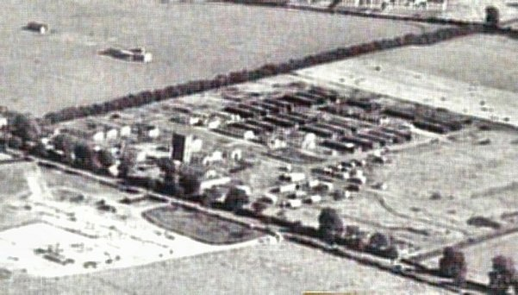

21 April 1947 – Mr Arrigoni arrived to carry out a re-education survey and screening of ‘C’s’. Strength; 3 officers; 2307 OR.

No of pows: | Stamford | Wansford | Blatherwycke | Ridlington | Whissendine | Collyweston | Billetees
 | 818 | 708 | 71 | 56 | 39 | 448 | 170

Political screening: | A | B+ | B | B- | C | C+
 | 43 | 474 | 1544 | 242 | 6 | 1

247 pows were appealing their screening categories – the better categories were sooner repatriated. 85 appeals had already been accepted, only 2 rejected – this frequency of successful appeals was often the case. 738 pows had been repatriated from this camp so far.

New Camp Leader – Guenther Witte (A) was due for repatriation - and new Deputy C/L, Hans Reisener (A) was expected to become leader; “well suited to this post.”

There was a new studienleiter – Edward Liernert (A); aged 23, student of medicine, Catholic, no Party history and had attended the special training camp at Wilton Park. He had deferred his repatriation to stay on.

Morale was generally good except at Collyweston, (see below). There had been some ‘disunity and trouble‘ at the main camp a few weeks earlier – unfortunately this was not described further in this report. Some pows had been transferred as a result and it was considered that; “The equilibrium has now been restored.” There was a large group of about 200 active pro-democracy pows, but some of the B+ pows were still somewhat dubious. At least 60% of the pows were regarded as anti-Nazi.

‘Youth’ – 30% under-25. Most were not considered to be a problem. About 150 were active in re-education, a small group had been selected for special training. Some were ex-Waffen-SS and were more defiant, one of the pows was tasked to work with these “awkward youths.”

The standard list of re-education activities was given. All areas were back to being active again.

Religion – after the removal of the last padre, the new Evangelical Pastor, Ulrich Boehmer, aged 40, was regarded as “a fairly good influence.” He had been a member of the SA for three years, but left disliking its ideas. He was later described as; “Sincere, but serious to the point of gloominess.” He was screened to assess his suitability for this position. A RC padre continued to visit once a week. A chapel had been built at the main camp by the pows.

August 1947 – Three hostels previously attached to Stamford Camp 106 were reassigned to Weekley Camp 259 – Blatherwycke, Wansford and Collyweston, (see details under Camp 259).

28-31 August 1947 – E E M Rolfe carried out a re-education survey. Strength – 2 officers; 854 OR.

Changes to pow leadership – Camp leader (from 3 September); Leberecht Rueter (B+) / Deputy; Richard Stein (B+)

Simplified political screening: | A | B | C
 | 7 | 848 | 1

1108 pows repatriated to date.

The previous camp leader, Guenther Witte, had still not been repatriated – he was described as, “outstanding.” His replacement was different from the name mentioned in the last report in April.

There were no British interpreters – S/Sgt Greenwood had been demobilised and his replacement had also left.

Morale was recorded as above average – “a feeling that the camp is a home.” Positive factors mentioned were the attitude of the British staff and entertainment facilities – steady repatriation would have been a major factor. The only negative factor recorded was the attitude of civilians at Stamford, “which is reserved.”

The standard list of re-education activities was given;

Wochenpost and Ausblick – received, separate appendix.

Newspapers – A range of British daily and weekly papers received. German newspapers were put on display.

Library – Adequate.

Lectures – Regular with 60/70 attending in Summer and up to 180 in Winter. Intellectual level was considered to be slightly above average.

Discussion group – 50 or more attending in summer months.

Films – regular, but German films were old, British films used to be better, and the sound was bad.

Wireless – “Admirable.”

Camp magazine – monthly, a creditable production, but reliant on one man. The visitor tried to encourage others to contribute.

Press review – Fortnightly.

English Instruction – separate appendix.

Information room – an exhibition about the UNO was criticised for too much text. There was a weekly display of newspaper articles.

Outside contacts – it was hoped that these would be developed soon.

Other activities;

Religion – A strong Catholic group. 60 pows attended mass in Stamford on Sundays and there was excellent contact with the parish. A German pow priest visited once a month. Protestant congregation was about 30.

Education – the list from October 1946 had dwindled to just English classes. Contact had been made with the WEA (Workers Education Alliance).

Entertainment – an operetta (‘Elvira’) had been written in the camp and performed by the theatre group and band in the concert hall at Stamford Grammar School with great success. The commandant was trying to launch the music with a London publisher. The band was affected by repatriation. Pow dances were held at Oddfellow’s Hall in Stamford on Saturday nights – “60 pows and 40 British girls”. Swimming was allowed in the river Welland. Pows played football matches against other pow teams.

9 – 11 October 1947 – Mr Rolfe returned for another re-education survey. Strength; 2 officers, 1438 OR.

Previous satellites and hostels have been attached to other camps or closed down. This comp comprised 627 pows at Stamford, 642 at Woolfox Satellite, and 171 billetees.

No changes to senior British / German personnel. Screening – B 1439 / C 1 – it was suggested that the 1 ‘C’ should be re-screened. 1231 pows repatriated to date.

The camp leader was described briefly – “Volunteered for German Navy 1935. Not a firebrand. Not particularly interested in re-education.”

…and the deputy – aged 38, divorced, “Disgruntled” due to his job arranging allocation of labour.

Morale had declined and there was general political apathy. Negative points included; foodstuffs restricted in parcels to/from Germany; news articles in Germany that pow life was easy going; slow mail service; restrictions on wearing civilian clothing. Positive points; “the buoyancy and bonhomie of the commandant”; material conditions. One of the major factors for good morale in any camp was the development of local contacts – these were few in this “rural and conservative neighbourhood.”

The standard list of re-education activities was similar to the last.

The theatre group and band had been depleted due to repatriations. The visitor suggested that a pianist, violinist and saxophonist should be transferred from another camp – hard to take this recommendation as serious.

There were still very limited outside contacts. Links continued with the WEA. A concert at the local methodist church had been attended by 12-14 pows. There had been a small tour of Stamford historical sites. The visitor left a list of possible further contacts.

14 November 1947 - Camp number included in an ‘Urgent Memorandum’ (FO 939/270) regarding inspection of food parcels.

26 / 30 November 1947 – Mr Rolfe was back again for another re-education survey and to select a study leader. Strength; 2 officers; 1281 OR.

639 at Stamford / 507 at Woolfox / 137 Billetees. Political screening: B+ 244 / B 869 / B- 169. 1404 pows repatriated to date. Senior personnel unchanged, still no interpreter.

The camp leader and deputy were described as; “nonentities so far as re-education is concerned.” The visitor did not bother to consider any other aspect of their roles – discipline, administration, repatriation arrangements, morale, welfare, arranging labour…..

The matter of appointing a study leader after the previous one was repatriated had already been resolved. A pow from this camp had attended the special camp (174) at Norton Park – he was appointed to be study leader on his return.

Morale and political outlook – general apathy was noted as the pows main concern was repatriation. No communist influence was seen. There were still some antisemitic prejudices.

The standard list of re-education activities was repeated. Little change except that the discussion group had ended – the visitor was trying to revive it.

Outside contacts - still few. 4 to 6 attending weekly WEA courses; weekly dance. There were small groups of between 3 to 7 pows attending small events such as an art exhibition, a council meeting, a music recital, the evening institute.

17-20 February 1948 – Oliver Nash carried out a re-educational survey. Strength; 2 officers; 971 OR.

328 at Stamford / 44 billetees / 601 Ukrainians at Woolfox.

Commandant: Lt Col A H C Potter RA Camp leader: Uffz R Stein [previously deputy]
Interpreter: S/Sgt E H Balla Deputy C/L: None
German MO: Dr Hans Norf (B)

The commandant – highly praised in previous reports, received the following comment; “The C.O. whilst well disposed towards the Ps/W takes little interest in their doings so long as everything runs smoothly.” Later in the report it stated that the commandant’s popularity was a positive factor.

The new interpreter had been transferred from Sudbury Camp 23.

The camp leader; “an unpleasant bullying type whom I consider undesirable.” Fortunately, he was due for repatriation. A suggested replacement was described as; “an arrogant youth from Berlin.”

High morale with more rapid repatriations. Non-fraternisation restrictions had been eased considerably; “The camp is only a few minutes walk from the town and full use is made of its shopping and entertainment facilities. The men’s only worry at present is whether the camp will be disbanded and they lose their civilian contacts through whom many facilities are available.” Some pows were resentful that restrictions still applied. Formal outside contacts were still very limited, 15 attending WEA; very small groups at Youth Club and Farmers Club – 3 attended council meetings.

Political complexion – some pows were still dubious about democracy and its imperfections. Some, especially the younger pows, held on to Nazi views – it was all many had ever experienced.
.
Re-education activities continued, but were affected by repatriations. Discussion groups, camp magazine, theatre and band had ended.  April 1948 – Stamford was administered by Allington Camp 51 as it was being closed down.  After the camp: Huts used for temporary housing. The huts were demolished in the early 1960’s and for a while there was a caravan park. Now a residential area.  Right - A photo of the camp in late 1950’s / early 60’s sent by Joe Perduno to the Ancestor Gateway Forum in 2012. Although much would have changed, the type of huts is shown.  The site as it is now –  https://repatriatedlandscape.org/england/pow-sites-in-yorks-humber-and-lincs/pow-camp-106-stamford-camp/  Further information:  National Archives - FO 1120/224 – ‘Re-educational survey visit reports for camps 100 to 106’. Used above.  IWM have a copy of the magazine, dated March 1947. Ref LBY E.J. 336. | 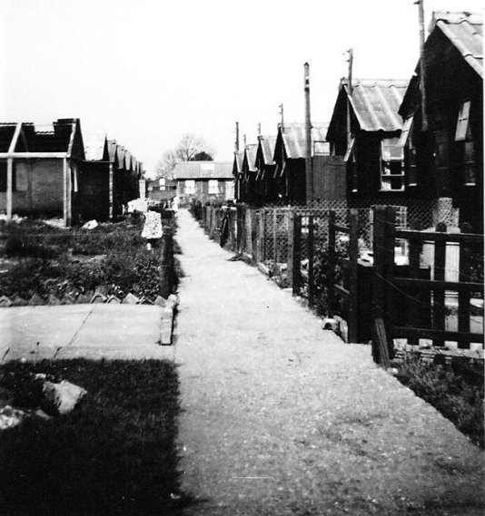

Satellites / Hostels

Barnack, Stamford, Lincolnshire

From details below, Italian, then German pows.

Listed for German pows from camp 106 on 15 September 1945, (WO 32/10737):

Memories – “On the site of what is now "Bishop's Walk" there used to be about 14 Nissan huts which were used late in the War as a P.O.W. Camp for Italian prisoners. Evidently there was a certain amount of freedom for them as they worked on local farms, were driven into Stamford and also some frequented the local pubs. One particular Italian used to play the accordion in the Pub and in so doing managed to captivate the heart of some of the local girls. This fellow used to work for Mr. Bratley's farm at Bainton where he joined others potato picking. He formed a relationship with one young girl working with him on the farm and in 1945 she gave birth to a daughter named Val. Sadly Val never found out about her father's name or origin in Italy which has troubled her all her life. Her mother, only about 18 at the time of her pregnancy, was thrown out of home and made to go and live with her grandmother in Bainton. Her name was Nona Gayle. At the time it was looked at as a disgrace in the community so nothing was ever mentioned about it again, especially since Val's mother married a local farmer who was rather embarrassed about the whole sordid affair so wouldn't speak if it to his now stepdaughter. He and Val's mother died years ago and the secret of the Italian's identity went with them.”
Nick Black (February 2019) - http://www.closedpubs.co.uk/cambridgeshire/barnack_fox.html

Not listed with this camp in August 1946.

Blatherwycke, Bulwich, Northamptonshire. 12 miles SSW.

Listed for Italian pows in 1943 and 5 May 1944, (WO 32/10737); and for German pows on 15 September 1945, (WO 32/10737).

August 1946 – 62 German pows. Hostel leader; R Riefer (est B-)

October 1946 – 50 pows. Hostel leader Franz Schroeder (A) - “...has no Party record and is a good type.” Report stated that leader had been in place since the hostel opened, but this is at odds with previous report.

April 1947 – 71 pows. Hostel leader Walther Graeber (A)

August 1947 – Re-assigned to Weekley Camp 259 – approximately 60/70 German pows. Separate details.

Collyweston. 7 miles SW of main camp.

August 1946 – 46 German pows. Hostel leader; A Senatzer (A).

“..has only been occupied a week and most of the pows are young without any political ideas.” The camp leader was; “a very good man with good ideas and will shortly get re-education started.” Arrangements being made for wireless set.

October 1946 – 279 pows. Hostel leader Uffz Kurt Richter (A) [differing from previous report]. Aged 43, was a teacher. Joined the Nazi Party 1937/9.

No re-education activities at this hostel. The pows worked at the London Brick Company on 2 shifts – one day, one night, and were changed over fortnightly. Many complained that the work was too heavy, and the company returned some pows as being unfit – the matter was being investigated.

April 1947 – 448 pows. Interpreter at this site S/Sgt Buchler. Hostel leader as before. Regarded as having a low morale for two reasons. Firstly, 107 ‘C’ graded pows – these were rescreened and the majority reclassified as ‘B’; the commandant also agreed to disperse 100 of the B-/C pows around the camp. Secondly, they were employed in heavy shift-work.

August 1947 – Reassigned to Weekley Camp 259 – approximately 500 German pows. Separate details + map, see Camp 259.

The site as it is today - https://repatriatedlandscape.org/england/pow-sites-in-the-east-midlands/pow-hostel-259-collyweston/

Normanton Hall, Grantham, Lincolnshire

Hostel listed for Italian pows in 1943 and on 5 May 1944, (WO 32/10737).

Not listed with this camp in August 1946.

Ridlington. 15 miles SW of main camp. NGR SK 843 024, on both side of what is now called Hollygate Road.  1943 – 1945 Listed with Gaulby Road Camp 94 – Italian pows.  There is a photograph described as; “Head and shoulders portrait of an Italian prisoner of war identified as Mario ???? [sic] from Ridlington prisoner of war camp who worked at Manor Farm, Pilton during the war.”  https://ibccdigitalarchive.lincoln.ac.uk/omeka/collections/document/18482  August 1946 – 65 German pows. Hostel leader; J Ruether (est B).  October 1946 – 22 pows. Hostel leader Uffz Franz Bruck (A), a professional soldier, “a very good type, interested in Democracy and is fully co-operative.” Report stated that he had been leader since February 1946, but this is at odds with previous report.  One other pow at the hostel was mentioned – H/Gefr Willi Reichert (A+), leader of Social Democratic movement here, “was in a concentration camp owing to his anti-nazi activities (1942)”.  April 1947 – 56 pows. Hostel leader Kurt Terlinden (B+) | 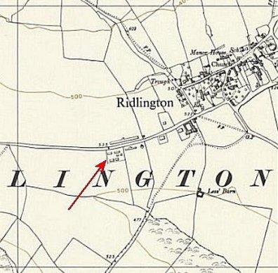
 | Ordnance Survey 1959

Wansford. 9 miles S of main camp. Sometimes referred to as a satellite camp, at other times as a hostel.

August 1946 – 928 German pows. Hostel leader; F Schroeder (B+)

Additional details to the main camp report: “This hostel has a very healthy atmosphere, possibly due to good amenities and a good camp leader.”

Religion – weekly services for about 60 pows.

Newspapers – 7 British dailies. Cuttings discussed every 3 to 4 days.

Discussion group – weekly with about 300 pows. An Information Room being developed.

Lectures - needed to start.

Library – books obtained from main camp library.

Theatre – able to hold 350 pows.

Films – fortnightly from PID – London, and YMCA.

Orchestra – instruments being purchased.

October 1946 – 782 pows. Hostel leader Sold. Friederich Schroeder (A) – “…excellent man doing a good job of work.” There were many educational activities at this hostel.

At the end of October, a new group of young pows arrived aged between 16 and 18. Some had volunteered to come to this country from pow camps in mainland Europe – one was 16 years old. It was stated that; “Amongst these boys are 8 civilians who nevertheless have P/W numbers.”

April 1947 – 708 pows. Hostel leader Otto Sibbe (B+)

August 1947 – Re-assigned to Weekley Camp 259 – approximately 700 German pows. Separate details.

Whissendine. 15 miles NW of main camp. NGR SK 825 146.  1943 – 1945 Listed with Gaulby Road Camp 94 – Italian pows.  August 1946 – 46 German pows. Hostel leader; Johann Siegfried (est B-).  The camp visitor and commandant went to check reports from the interpreter that there was a, “strong Nazi flavour” at this hostel. The leader seemed to be reliable and stated that re-education was restricted due to 12 men who were “unrepentant Nazis….. abusive about democratic ideas and anybody expounding them.” It was suggested by the visitor that a more experienced NCO who was a strict disciplinarian might achieve more as a camp leader.  October 1946 – 11 pows. Hostel leader Uffz Paul Moormann (A), “has no party record and is a good type.” Report stated that he had been leader since March 1946, but this is at odds with previous report.  April 1947 – 39 pows. Hostel leader Walter Tiedemann (B+)  A model of St Andrew's church, made from local reed stems, is inside the church. It was made by a pow at the camp. | 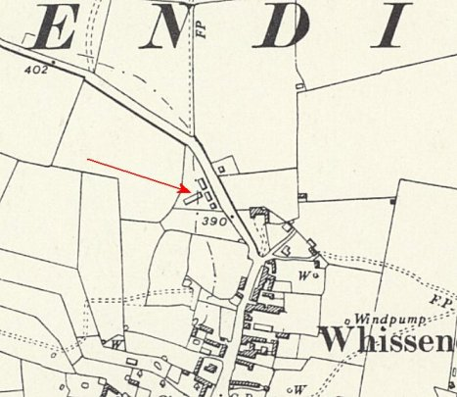
 | Ordnance Survey 1959

Woolfox Lodge – Satellite Camp – Stretton / Stamford (near Oakham). 20 miles from main camp. Hutted. Most likely ex-RAF accommodation huts at the Woolfox Lodge airfield

Previously administered by Allington Camp 51.

October 1947 – 642 pows. Hostel leader; Ofw Oskar Kruesel (B+) – “Possibly a good administrator. His attitude towards the British is too compliant.”

“The Capt i/c Woolfox Hostel does not seem disposed to encourage outside contacts.” He refused to let one of the visiting lecturers speak to the camp leader on her own. This was taken up with the commandant. Overall, it does not seem to be a happy camp – “Woolfox Satellite is very isolated, and there is no football pitch there… There was a rush of applications for the Youth Camp, and it is clear that the young Ps/W who form the majority here do not desire to remain in this satellite.” (85% were under-25).

Particular comments were made about the study leader, Gefr. Horst Waldner. “Youthful and serious… Had connections with a German youth resistance movement during the war.” He was recommended for training at Wilton Park.

November 1947 – 507 pows. Hostel leader as before – due to be repatriated.

There was discontent for about 200 pows as seasonal employment left them without work, and no pay. No pows had yet attended the youth camp.

With no football pitch, handball was popular at this camp.

February 1948 – 601 Ukrainian pows.

