Camp 9 (& 183) - Quorn Camp, Wood Lane, Quorn, Leicestershire

1947 Camp List
9(B.C.) | Quorn Camp, Quorn, Loughborough, Leics | N. | Priswar, Quorn | Quorn 221 | Barrow-on-Sour & Quorn (L.M.S.) Quorn & Woodhouse (L.N.E.R.) | Lt.Col.H.A.Denison,M.C. | v/202/4

Prisoner of War Camps (1939 – 1948) - Project report by Roger J.C. Thomas - English Heritage 2003
OS NGR | Sheet | No. | Name & Location | County | Cond’n | Type 1945 | Comments
SK 561 161 | 129 | 9 | Quorn Camp, Wood Lane, Quorn, (Quorndon) | Leicestershire | 4 |  | STANDARD type. See Camp no.183
 |  | 183 |  |  |  | Base camp | STANDARD type. See Camp no.9

Location: NGR above is for a point to the left of the camp shown on the map – SK 565 161 is nearer. Quorndon / Quorn – village shortened its name to Quorn to avoid confusion with another village called Quarndon.  Previous use: Land was part of the Quorn House parkland. The US Army 82nd Airborne Division’s 505th Parachute Infantry Regiment was based here from 14 February 1944 - the camp was mainly tents at this time. The US troops took part in D-Day, and later for Operation Market Garden into the Netherlands, leaving the camp on 15 September 1944. There are records that more than fifty huts were built in 1944/45, each hut accommodating up to 40/50 men.  POW Camp: There are memories of Italian pows prior to the Americans leaving. This is backed up by the FPHS Journal 309 with pow mail to Italy dated February 1943.  The camp was number 183 before it became camp 9.  Acceptance of the pows in the area was mixed, just as elsewhere. In 1946, despite agreement of the local vicar and Bishop, the church council at nearby St Bartholomew’s refused to let pows hold services there. For a short time, the Quorn Methodist church was used until St Bartholomew’s changed their mind. Many good relationships with local people were recorded during 1947. (Further details - https://www.quornmuseum.com/display.php?id=1107  March 1946 – postcard (in German) from the camp still as number 183  9 July 1946 - Pows were working in many local farms and industries.  The following written response was given in the House of Commons;  “Mr. Champion asked the secretary of State for War if he will inquire into the circumstances surrounding the removal of prisoners of war from the Quorn camp, which resulted in the loss of the services of 30 prisoners of war to the firm of Ensor Company, Woodville, Derbyshire, causing a loss of production of building | 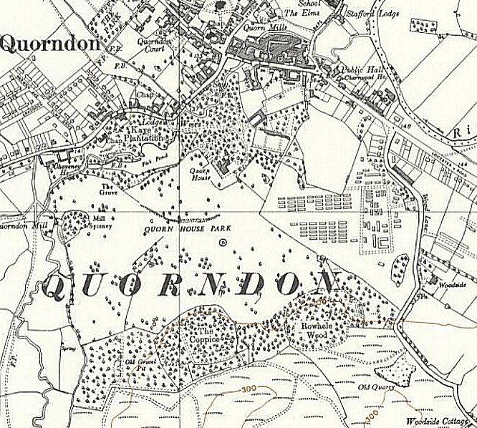
 | Ordnance Survey Revised before 1930, Published 1955

materials; and why the firm did not receive adequate warning of the pending event in order that it might re-plan production for the period taken by the removal.

Mr. Bellenger - It became necessary to close this particular camp and, although the firm knew that the labour would be withdrawn for that reason, they were admittedly not given adequate warning of the actual date. Instructions have been issued that sufficient notice must be given to employers about the withdrawal of labour and I much regret the failure to do so in this case.” (House of Commons written responses, 9 July 1946, Volume 425 Col 47).

I believe that this entry refers to the closure of Quorn Camp 183, (the number 183 was then used by Saltby Aerodrome Camp). The site re-opened as Quorn Camp 9. There are various possible reasons for this, e.g. changing status or purpose of the camp.

All entries below are from records for Quorn Camp 9.

The camp is described as a Base Camp by some, as a Repatriation Camp by others. The reports show that it was a base camp until 1 August 1947 – but with groups of pows in transit. It was then a repatriation camp and received about 2000 pows per month and had a German pow staff of just over 200.

21 September 1946 – a visiting lecturer, Dr W Ullman, clearly did not think highly of the S/Sgt interpreter who made comments at the end of the lecture – “I personally think that only the gross stupidity of this man gave rise to such silly remarks.”

2 November 1946 – Capt J L Martin gave an English Inspector’s Report. Listed as a reception camp. Strength 197 – this is only the German staff, many others passing through.

Commandant and Camp leader, as January report below. Due to repatriation of teachers, there were no classes for teaching English, but all of the 197 staff were studying English privately. It was hoped that classes would restart very soon.

Other activities noted – orchestra, discussion groups, one film per week.

16 January 1947 – L P D Cooper visited the camp to survey re-education. This was the first visit to this camp for this purpose - the camp was listed as a Repatriation Camp.

Strength – 1 officer; 219 OR. Regarded as politically ‘grey’ (A white – non-Nazi / B grey / C black – Nazi). There were no hostels.

Commandant: Lt.Col Denison Camp leader: Matrose (sailor) Mutschall, Walter (B+)
Interpreter: Capt Brandt Deputy: Uffz. Vogel, Leo (B)
German M.O. Stabsarzt Messelhauser (C)

Morale was regarded as high. As this was a repatriation camp, the German staff were frequently changed.

Re-education was not well developed in the camp due to the frequent repatriation of personnel. An abbreviated standard list of activities was given:

Wochenpost / Ausblick – not included in report.

Newspapers – not included in report

Library: 747 books of various kinds.

Lectures – not included in report

Discussion groups - None

Films - YMCA films monthly, and Gaumont British fortnightly. The Gaumont films were not generally liked – here or elsewhere.

Wireless - Good. Controlled in the camp leader’s office.

Camp newspaper - Discontinued. (It had been called – Kiebitz (Lapwing)).

Press review – not included in report

English instruction – separate appendix.

Other activities, (sport and games were rarely reported);

Religion: A Catholic priest came every Sunday from Saltby Camp 183. There was no protestant padre. Pows attended services in the village church and the local vicar visited the camp now and then to give talks which were translated.

Theatre: impromptu, if pows available to give entertainment.

Orchestra – instruments available, but no orchestra.

12 March 1947– a letter to COGA, (Control Office for Germany and Austria based at Bush House, Aldwych – responsible for overseeing re-education of pows), requested more lectures for the camp. It was stated that the site; “now operates as a Base Camp with a strength of nearly 450 P/W Officers and over 1000 Other Ranks”. Regular reports were submitted after this by visiting lecturers.

22 March 1947 - Pow letter-sheet to Germany commented; “…On the 21.02 we erected Camp 9. Accommodation better than in Sheffield (25 men per barrack – no … huts) 3 minute [should this be 3 km or miles?] walks without guards – Surrounding quite nice. The disadvantage: During the last few cold weeks not a single piece of coal – Food quite thin (Lunch time thinnest turnip soup all the time) Sundays for a change pea soup…… - Last week hearing completed. To my knowledge all got B or A……” *

The camp had both tents and some huts prior to this, so it seems that it became all hutted in February 1947. The final remarks concern the political grading of pows to ascertain who would get priority for repatriation. (A’s went home before B’s, C/C+ was the worst grading).

12/13 April 1947 – Lecturer B Reichenbach gave some brief remarks about the camp in his report –

“This is a very interesting camp. Although rather old-fashioned with a lot of barbed wire – and a special compound for the SS; and although the officers there are still running about with their badges of rank etc. I had one of the most interesting audiences ever yet.” He commented how officers and OR mixed with each other. There was also a political “Arbeitsgemeinschaft” (working group or committee). Similar committees in other camps arranged political and educational activities for the pows.

19 & 20 May 1947 – In a report by lecturer W Derkow, he mentioned that the camp was; “used both as transit [base] and repat camp”. The follow-up report about the lecture from the Camp used the name; No.9 POW Base Camp – it also stated that the site was not a work camp.

23 June 1947 – A report by lecturer, Hans Gottfurcht, gave some details about the nature of the camp which provided an explanation as to why it was not a work camp:

“The special character of the camp (repat of physically unfit Ps) creates a certain atmosphere of nervousness which is successfully counter-balanced by the Ps in charge of education etc….. There are only 800 Ps in this camp, of whom about 250 are officers.”

Repatriations were occurring according to political grading, and by priority listing. Those pows medically unfit for work, sometimes referred to in reports as ‘Crocks’, were given priority. The next groups to go through Quorn were pows with ‘compassionate needs’, those with particular talents needed urgently back in Germany identified by COGA, and ‘A’ categories.

25 June 1947 – Report by L P D Cooper on Re-education. Listed as a base camp – with a later hand-written note; “now Repat Camp”. Strength 280 officers; 535 OR.

Commandant: Lt Col I.P. Carter [new] Camp leader: Matrose Walter Muttschall (A)
Interpreter: S/Sgt Sondheim K.J. Deputy C/L: Uffz Fedder (B)
German M.O.: Stabs Arzt Messelhauser (B-)

The camp leader was described as aged 25, an electrical engineer, ex-German navy…. “Possesses no marked political tendencies. He is an intelligent, pleasant personality and caries out his duties satisfactorily.” The deputy was 34, not political, efficient and a “good type”.

The Interpreting Officer was in hospital. The S/Sgt had been posted from Featherstone Camp 18.

Simplified political screening figures were given: A – 2; B - 810; C – 3. There had been 32 appeals against the screening as the better grades were repatriated first – all had been successful. 624 pows had been repatriated since March 1947. Despite the low number of category C (black) pows, the visitor assessed the camp as a whole as grey/black. He noted there were about 25 malcontents, while the rest were only interested in repatriation.

With the removal of the ‘Crocks’ the nature of the camp had changed again. Morale had improved and it was noted that “the fact that the officers are shortly to work on farms, has also tended to raise morale.” About 200 pows were ‘youth’ (under-25) – but they were not regarded as a problem.

The standard list of re-education activities showed signs of a little more activity:

Wochenpost / Ausblick – separate appendix

Newspapers – adequate

Library – adequate

Lectures – regular.

Discussion group – 30 to 50 pows met every Friday evening.

Films – adequate

Wireless – 12 sets and 15 loudspeakers. German news and pow programmes were popular.

Camp magazine – none, but might restart of the necessary materials were sent.

Press review – extracts translated and discussed.

Information room – due to start. Materials for display needed to be sent by COGA.

English Instruction – just 18 pow pupils in three classes.

Other activities:
 | Religion – The protestant padre, Hitzer (B) was regarded as, “not very good”. The Catholic padre came from Camp 248.  Education – Small classes for French, Spanish, mathematics, architecture, book-keeping and building construction.  Entertainment – a theatre group could form if it had materials. There was an orchestra of 10 players, performing mainly classical music, including concerts in Loughborough and in Quorn.  27 June 1947 – a report about a lecture stated that there would be, “a large Crock repatriation in the near future.”  3/4 July 1947 – Mr P Donovan carried out an English Education Inspection. Listing it as a base camp. Strength 823.  There were 2 classes for teaching English with just 6 pupils each.  August 1947 – The camp magazine (Kiebitz) restarted. Quorn Museum has 3 copies from August / September. It has been made available as 3 pdf’s – start, no.1: https://www.quornmuseum.com/display.php?id=2468 | 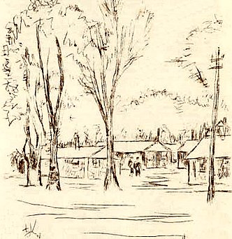
Front page of restarted camp magazine. |  | Enhanced sketch of camp in pow magazine.

12 August 1947 – From the Nottingham Evening Post; “A German prisoner-of-war, Baumann Hubert, died suddenly at the Quorn Camp yesterday. The body was removed to the Loughborough mortuary and the facts reported to the Coroner for North Leicestershire.” Hubert Baumann is listed with the CWGC as having served in the German navy, buried/commemorated at Loughborough Cemetery.

18 & 19 September 1947 – a report on a lecture named the camp as; “Base Camp (Transit).”

8 - 9 November 1947 – A report by lecturer W Derkow stated the total strength was about 1100. He regarded the morale and political outlook at the camp to be, “only fair”. He questioned the conditions for pows about to be repatriated; “lower rations, a lot of barbed wire and ‘improved’ discipline are in my considered opinion not just the right psychological means to convey a last good impression.” [Pows received lower rations if they were not working].

14 November 1947 - Camp number included in an ‘Urgent Memorandum’ (FO 939/270) regarding inspection of food parcels.

14 November 1947 – Mr P Donovan gave a brief report on English Education. The camp was expected to close on 31 December. All re-education activities were winding down.

24/27 November 1947 – A G George visited the camp for a general re-educational survey. This was the last report for the camp by COGA that is in the file. The camp was listed as a Repatriation Camp. Strength 4 officers; 215 OR.

Commandant: Lt Col I.P. Carter Camp leader: Matrose Muttschall (A)
Interpreter: Capt Kingston [new] Deputy C/L: Lt Boettcher, W (B+)
2nd i/c: Major Holding German M.O.: Stabs Arzt Kreissner (B)

The camp was in the process of closing down. Uncertainty about the future had led to a, “very adverse effect on morale”. There were good relationships between the British and German staff and the other pows. Following on from a previous comment, camp discipline was regarded as good, with no undue stress, “although the 2 i/c has the reputation of being able to turn on the pressure when necessary.”

By this time there were good relationships with the local citizens and nearly all pows had developed local links. Leicester and Loughborough were visited by the pows.

Re-education activities had all but ceased due to imminent closure. Entertainment consisted of film shows, cards and chess.

< Camp cachets for Camp 183 and 9
December 1945 | March 1946 | March 1947

Known Commandants:  1945 Lieutenant Colonel Richard St.John Hartley, (he was recorded as Commandant at Camp 251 East Cams in 1947). While Commandant he lived with his wife and children at Quorn House with the Farnham family. I believe he served with the Devonshire Regiment. There was also a book published by a Richard St.John Hartley – ‘The soldiers’ book of English-German phrases and vocabulary’, first published 1915, and again c1940.  1947 Lieutenant Colonel Harold Anthony Denison, OBE, M.C. (1891 – 1961). Kings Royal Rifle Corps. He was wounded five times during WW1, was awarded the MC and Bar. Commandant at Camp 2 Glen Mill then at Camp 9. (Some entries in WO 339/20203)  1947 Lieutenant Colonel I P Carter – I think he was with the Royal Artillery | 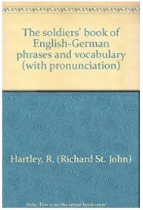
After the camp: The site remained in military use until 1959. Now part parkland, but also housing estate.

A survey carried out in 2018 for the ‘World War 2 Treasure Hunters’ TV series found German dog tags and some foreign coins related to the pows. For the guards, buttons and cap badges were found for; Northamptonshire Regiment, Leicestershire Regiment, Royal Armoured Corps, Sherwood Foresters, and the Royal Pioneer Corps.

The site as it is now - https://repatriatedlandscape.org/england/pow-sites-in-the-east-midlands/pow-camp-9-repatriation-camp-quorn/

Further information:

* Excellent quornmuseum.com – site includes copies of the camp magazine, letters and postcards, memories - https://www.quornmuseum.com/wartime_quorn.php

https://www.quorndon.com/localhistory/index.php

National Archives reference: FO 939/98 – 9 Base Camp, Quorn Camp, Leicestershire & 9 Reception Camp, Kempton Park Camp – dated 1945-47. Used above.

FO 939/93 – 9 Repatriation Camp, Quorn Camp, Loughborough, Leicestershire – dated 1946-47. Used above (most reports also in file above).

The German Federal Archive has a copy of the camp magazine.

