Camp 8 (& 9, 12a, 177 + attached to 50) - Warth Mills, Bury, Lancashire

1947 Camp List
177(G.W.C.) | Warth Mills Camp, Bury, Lewes | W. | Priswar, Bury | Bury 2486 | Bury | Lt.Col. (blank) | v/1453/2

Prisoner of War Camps (1939 – 1948) - Project report by Roger J.C. Thomas - English Heritage 2003
OS NGR | Sheet | No. | Name & Location | County | Cond’n | Type 1945 | Comments
SD 7965 0914 | 109 | 8 | Warth Mills, Bury | Lancashire | 3 |  | Cotton Mill. See Camp no.9, 12a and 177

Location: built alongside the River Irwell to the SE of Bury.  Previous use: Built in 1891 by Mellor Limited as a cotton mill. Closed during the mid 1930’s.  For a short time from June 1940 the building housed German and then Italian internees – conditions were extremely poor – see: https://www.warthmillsproject.com/  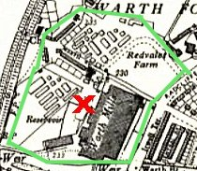  Many of the internees were sent to camps on the Isle of Man. Some due to be transported to Canada, together with some pows, were on board the SS Arandora Star which was sunk en route with a loss of 805 lives.  POW Camp:  Summer 1940 – The camp changed from holding internees to pows. During the change-over, the camp had to be thoroughly cleaned and many alterations made to unsatisfactory and unhygienic conditions.  September 1940 - The first intake of 3000 pows, (Appendix to WO 199/405). They were guarded by the Pioneer Corps.  A resident from the area, (‘DeeTee’ on the aircrashsites.co.uk website) gave a description of the boundaries of the camp, shown in the inset picture.  The camp was enclosed by a barbed wire fence. A small school room at the end of Warth Road was requisitioned for use as an orderly room. Other buildings provided guards’ accommodation, mess, stores and workshops. The enclosed field from Redvale Farm was used as a recreation area.  Mixed Italian and German pows – held here to be shipped to Canada. | 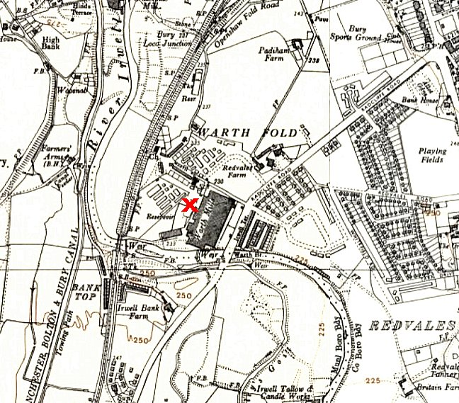
 | Ordnance Survey 1955
A guard recalled: “We used to patrol inside the camp at night with a revolver. A guard walked round the perimeter carrying a rifle and there were look-out posts, the exercise compound for the prisoners was on the Bury side in a field. We used to go over the River Irwell. They made a swing bridge by the side of the ordinary stone bridge. (Radcliffe Road Bridge) We could cross over the river without going on to the road. It was like a rope bridge. We used to have fun with that with any of the lads coming in late.” (From a manuscript by Ken Howarth on the Lancashire At War website).

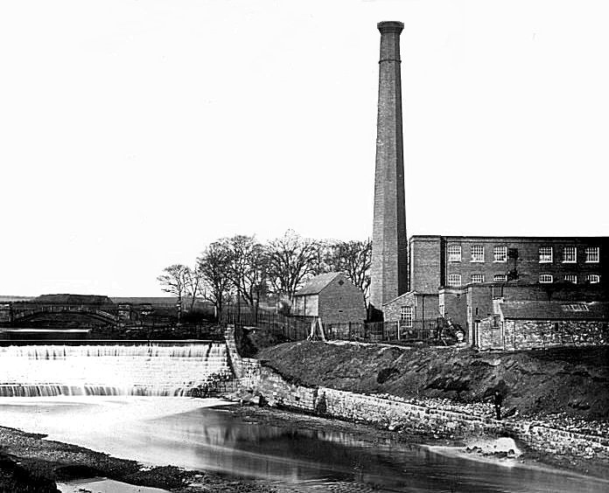 | 21 May 1941 – Story in the Bury Times:  "NAZI PRISONERS RE-CAPTURED ON MOORLAND - With police and mobile Home Guard Units scouring the countryside over an area of many miles, the last of the five German prisoners of war who escaped from a north-west internment camp on Friday were re-captured in the early hours of Sunday morning after having been at liberty for more than 48 hours. Cutting their way through a thick barbed-wire fence surrounding the camp, the five men, four of them air pilots and the fifth a naval wireless operator in civilian clothes, evaded capture and headed into the open moorland countryside. There at once began the largest and most dramatic manhunt the north has ever seen. Police with bloodhounds to track down the escaped men, military and members of the Home Guard including mobile attachments, threw a cordon over a wide area. Messages giving the ages and descriptions of the men were flashed around and in less than 12 hours two of the men were re-captured about 12 miles from the camp.  The search was intensified, the already strong cordon tightened and some two hours later, two more were taken into custody. The fifth, stated to be wearing a prison uniform with a distinguishable white star on the shoulder and a gold star on the back eluded capture for a few more hours, but was eventually caught by a policeman patrolling a country road. Tired and hungry he offered no resistance... One theory of how the men eluded capture after cutting through the fence is that they boarded a slow-moving goods train and jumped clear as soon as they were in open country.”  Further details from https://www.lancashireatwar.co.uk/warthpow - A camp driver vividly recalled the event:  “I remember very well, first of all the adjutant came in. He shouts, "Platt, Platt - get up". "Yes Sir. Yes Sir." Get in that lorry right away - and we were off. That's all he said and he  was in his pyjamas. So, I gets the lorry out and off we go over the moors to Bacup.
Warth Mills by the weir on the River Irwell

So, we gets to Bacup police station and he says, "Right pull that tail-board down." They (the guards) went into the police station and I was outside with the tail-board down and they brought these prisoners out. And they didn't half belt 'em with the butts of their rifles. The women up the valley were saying ‘leave 'em alone'. One had a patch over his eye, didn't he? We brought them back to Bury.

What was that officer called? He kicked him right up the backside and he went sprawling. He took them into the cells and he didn't half lace 'em. He sprained all his hand with hitting them.

What they'd done, they'd got a string from round the edge of a blanket and put the string round their forehead with the blanket across their back and crawled under the wire and snipped the main wires. As far as we could tell they made for the Monkey Bridge because when the police came they had these dogs, and the dogs made straight for the Monkey Bridge. They (the men) tried to follow the railway line up to Bacup.”

There were several other escape attempts from the camp.

December 1941 - The camp was listed as having Italian pows, some of whom were formed as a construction crew to build Garswood Park Camp 50. There may have been times when German pows were also held here from this time, though it would have been in a separate area/compound.

October 1942 - a young lad told his pal that he had seen Italian prisoners with their hands tied behind their backs at Bolton Street Station in Bury. His mate informed the police and he was fined £1 plus paid 15 shillings expenses. Alderman Whitehead told him, “You ought to have more sense and be careful in your conversation about war. You never know who is listening.”
1944 – Italian pows were transferred to billets and other camps. It was listed as a German pow camp.

‘DeeTee’, mentioned earlier, also recalled that towards the end of the war the pows were guarded by the US Army. The ‘Yanks’ were popular with the local children who asked for treats such as chewing gum. (http://aircrashsites.co.uk/history/warth-mills-prisoner-of-war-camp/)
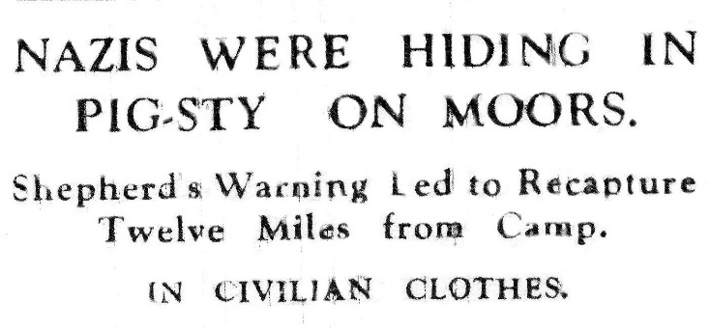
November 1944 - Bury Times; “A shepherd named Nutter, who noticed the two suspicious looking characters on the moor notified the police who threw a cordon round the area and recaptured the two men. Unshaven and grimy, the airmen had taken refuge at Grane Heights, Haslingden”. A third prisoner was recaptured at Stubbins. They were Karl Hanickel, Ernst Geller and Ottomar Kruse. They had used moorland tracks and the thick fog which had descended on Lancashire to avoid capture, planning to head east with the hope of finding an airfield and stealing a plane.

March 2 1945 – “the Daily Mail published a picture of two women outside Bury Magistrates Court. With three others who were employed at the Florence Nightingale Hospital, they had been summoned to the court for breaching the non-fraternisation order. This was the first high profile case of fraternisation between British women and German POWs. The two Sisters and three nurses were accused of exchanging letters and gifting sundry items to German POWs who had received treatment at the hospital in January and February that year. The letter racket was described in court as 'a persistent, clever, and crafty system of communication'. On inspection, a Sergeant of the Pioneer Corps had uncovered a stitched-up bag which was concealed underneath the uniform of a German POW leaving the hospital. Nicknamed 'Mosquito' by the POWs, Sister Helena Mulvenna admitted to sending letters to Erich Neumeister, and visiting Warth Mills camp, where the POWs were held, on several occasions.

Read out in court, the content of the letters was described by the prosecution as 'rather warm'. However, they were considered 'romantic' and 'harmless', with Mulvenna stating that her 'high regard' for Erich had affected her judgement. Sister Winnie Cunnane admitted that she had given cigarettes, soap, and razor blades, to Rudolph Frommert, arguing that it was fair given that the British patients were given these items as well. Cunnane admitted having a 'slight attachment' to Frommert, and that 'there had been a little kissing in the kitchen', but claimed that she had refused a proposal of marriage from Frommert and the question of escape was never discussed. Nurse Ivy Knott had sent a cigarette case engraved with her name and address to another POW. The Detective-Sergeant investigating the case had a first though they were assisting the POWs to escape, but inquires had confirmed that this was 'only a serious case of fraternisation and the nurses had no ulterior motives'. Found guilty, the women were not branded traitors, anti-citizens, or collaborators. They were considered foolish by the Bench, silly for having let their excitements overcome their judgement. While it was noted that the magistrates had considered sending them to prison as a deterrent to others from acting similarly irresponsibly, they were instead fined: the two Sisters £15, Knott and Hodges £1, with Owen dismissed on payment of costs.”

Extract from: ‘British Attitudes towards German prisoners of war and their treatment’ by Alan Patrick Malpass – Available from Sheffield Hallam University Research Archive (SHURA)

May 1945 to August 1946 – Camp leader; O/S Friedrich Claussen (B). Served in U-boats. Transferred to be leader of Stanhill hostel to restore order there.

Pow postcard in German seen dated May 1946 Warth Mill as Camp 177.

4 September 1946 – Major A W Turner visited Camp 177 to carry out “Special Screening and short report on re-education.” Strength; 3 officers; 1498 OR.

Numbers of pows in camp and hostels:

Main | Newton | Fishwick | Longridge | Salesbury | Stanhill | Garstang | Myerscough | Moor Park | Billettees
481 | 175 | 64 | 42 | 61 | 207 | 51 | 139 | 41 | 240

A comment about the ‘formation of hostels’ seems that most of these were newly formed.

Political screening: | A | B | C | C+ | Unscreened
 | 5 | 268 | 201 | 45 | 1001
Commandant: Lt Col J E Selby MC RA. Camp Leader: Ofw Schweikel (B) (due to be repatriated).
Interpreter: Capt F R Marx MC of the 9th Lancers. Deputy C/L: O/S Stemmler (B)
(due to leave the following week). German MO: O/A Mayenfels (est B-)

Morale was regarded as having improved due to a relaxation of rules regarding confinement and expectations for repatriation. Youth pows (under-25) were not seen as a problem.

There were few re-education activities. The standard list was given:

Wochenpost and Ausblick – 350/400 Wochenpost and 100 Ausblick received.

Newspapers – 8 British daily newspapers and 18 weeklies. 4 German and 2 Swiss papers also received.

Library – 3000 books; 100 sent to hostels monthly.

Lectures – just started.

Discussion groups – none

Films – YMCA films were shown, but none since July.

Wireless – a set with 12 loudspeakers was adequate. POWs were interested in BBC broadcasts to Germany.

Camp magazine – “Stacheldraht Reporter” (Barbed Wire reporter). 500 copies per week, but suffering from a paper shortage which should have been supplied by COGA. In October the magazine was described as being a negative influence.

Press reviews – halted.

English instruction – separate appendix.

Other activities:

Religion – Regular services. A Protestant padre, not named, was seen as a good influence, (probably Gerhard Schodde, see below).

Education – none

Theatre – Musical and variety shows were put on in the dining room.

Orchestra – Classical and light music played by a 15-member orchestra.

Within a month, many of the hostel leaders were replaced.

14 to 29 October 1946 – 3 members of the segregation section carried out political screening. Strength: 6 officers, 2369 OR. (5 of the 6 officers were medical staff).

Hostels: | Fishwick | Garstang | Hazel Bottom | Longridge | Moor Park | Myerscough | Newton | Salesbury | Stanhill | Walkden | Witton Park
 | 39 | 33 | 103 | 45 | 15 | 137 | 129 | 60 | 157 | 44 | 123

Final screening: | A+ | A | A- | B+ | B | B- | C | C+ | Unknown
 | 4 | 82 | - | 452 | 953 | 344 | 357 | 36 | 148
Total = 2376; 1 more than the recorded total strength.

Commandant: Lt Col J E Selby MC RA. Camp Leader: Ob.Junker Wolfgang Schmidt (B-)
Interpreter: S/Sgt C Davies Deputy C/L: Stabsscharf Arthur Loose (B)

The British staff were co-operative, but lacked enterprise and imagination as far as re-education was concerned. The new interpreter was young and lacked experience, but was not inefficient.

The new camp leader had previously been graded as C+ (Nazi), but this was changed to B-. In 1931 he joined the Nazi party, then left in 1932 as he joined the Reichswehr. He refused to re-join the party when he became a policeman in 1934. He was transferred to the Waffen-SS in 1944. Co-operative, but not particularly active in re-education activities.

The new deputy leader had joined the SS in 1933 in the ‘Liebstandarte Adolf Hitler’, (Hitler’s personal bodyguard). He was promoted in 1937 and again 1940 becoming Stabsscharfűhrer, (senior SS NCO). Stated he was not interested in politics, but considering his history and agreement with Hitler, the screening team believed he should be regraded from B to C. He took no interest in re-education activities.

The organiser of studies – Uffz Herbert Suettmann – was regarded as; “…totally unsuitable. He should be replaced by a man with more drive.”

Overall, the camp was regarded as grey-black (grades A - white/non-nazi; B - grey; C - black/nazi). A high number of C/C+ (black) nazis were in the camp, many holding on to pro-Nazi views, though re-education was seen as having some effect. There was some slight communist activity – mainly amongst those due to return to the Russian zone, “to adapt themselves for their return [rather] than out of conviction.” The political complexion and negative attitudes of some, influenced the amount of re-education work being carried out.

It was considered that the camp needed “new blood” and preferably some pows who had attended the special training camp at Wilton Park

One of the pows was Austrian and was recommended to be transferred from this camp.

Religion –

Protestant padre; Gefr. Gerhard Schodde (A). Had been engaged in, “active and increasing fight against the anti Christian and satanic might of the nazi regime through sermons, religious instruction, etc especially among young people.” Believer in democracy, a; “Very sincere and sound character.”

Protestant padre; Haupt. Werner Lashner (B). Joined the SA in 1933, left in 1934. Although a member of the ‘Bekenntniskirche’ which refused to accept the primacy of the Nazi state over the church, he supported Hitler during the war.

Catholic padre; Uffz. Josef-Maria Jansen (A). At first an admirer of Hitler, then rejected Nazi ideology in 1934 on moral, religious and humanitarian grounds. He was known for his views, but managed to avoid being sent to a concentration camp. Small number of Catholics in the camp.
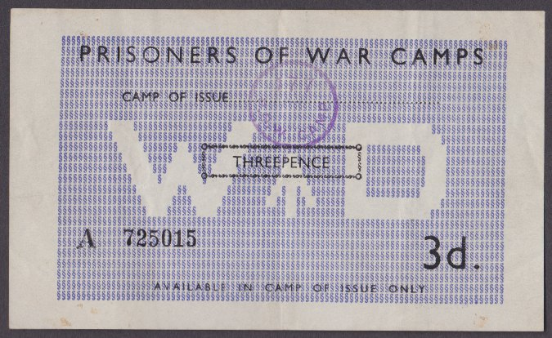
Christmas 1946 - As fraternisation rules were relaxed the camp received 300 letters inviting POWs to various Christmas celebrations.

By June 1947 - Camp 177 became a satellite camp for Garswood Camp 50, and soon after it was downgraded to a hostel with just 108 pows.

1947 – a small detachment of pows working with a bomb disposal platoon were based at this camp, (listed under the main camp as Camp 50). (FO 939/83).

1948 - The camp closed. By the end of the camp, it was estimated that 100,000 pows had spent some time at Warth Mills.

< Camp ‘money’ – stamped for use at Warth Mills, Camp 177. There were several values each with a different colour. The money could only be used in the camp that issued them. On the back were spaces for the camp stamp and dates to show use.

Further information:

National Archives - FO 1120/231 – ‘Re-educational survey visit reports for camps 177 to 186’. Just 2 reports for Camp 177 – used above.

The Imperial War Museum has copies of the magazine dated 1946/1947 New Year and February 1947. Ref LBY E.J. 421.

As an Internment Camp - https://www.warthmillsproject.com/

http://aircrashsites.co.uk/history/warth-mills-prisoner-of-war-camp/

Satellite and Hostels

Newton Satellite Camp – 35 miles away. Previously Newton Camp 146.

September 1946 – Hostel leader: Fw Kurt Possiwan (B+). Described in October 1946 survey; a member of the Social Democratic Party in youth, and consequently not allowed to study at a higher level because of his ‘political background’. “Reliable, but lacks personality.”

When Warth Mills camp was transferred to Garswood Camp 50 during 1947, Newton camp was not listed.

Fishwick – 29 miles away

September 1946 – Hostel leader: Wm Schmitz T

October 1946 – Hostel leader; Ofw.z.See Heinz Schnaedelbruch (B+). Merchant seaman aged 24. Had been a member of Hitler Youth, and then the Nazi Students Union in 1939. Not interested in re-education activities.

When Warth Mills camp was transferred to Garswood Camp 50 during 1947, this hostel was not listed.

Garstang – 37 miles away

September 1946 – Hostel leader: Ofw Heinz Kandelhardt (B-). Described in October survey – “Joined SS in 1933 because he was unemployed. Chosen as camp leader because he was senior. Not very suitable..” The team suggested a replacement.

When Warth Mills camp was transferred to Garswood Camp 50 during 1947, this hostel was not listed.

Hazel Bottom – first listed October 1946

October 1946 – Hostel leader Obfwl. Karl Schott (A). Hitler Youth member 1933 to 1934. “He understands his responsibilities with regard to entertainment and re-education.”

When Warth Mills camp was transferred to Garswood Camp 50 during 1947, this hostel was not listed.
Longridge – 35 miles away

1943 – Listed as a hostel for Italian pows administered by Garswood Camp 50

September 1946 – Hostel for Camp 177. Hostel leader: O/WM Mueller H

October 1946 – Hostel leader Fwbl. Hermann Bauer (A). “Belonged to youth branch of centre party. Founded democratic working group at this hostel (one of the few in this camp). Held lecture on British parliament with materials obtained from British troops and farmers.”

When Warth Mills camp was transferred to Garswood Camp 50 during 1947, this hostel was not listed.

Moor Park – 28 miles away.

1944 attached to Garswood Camp 50 with Italian pows. (Further details on that page).

September 1946 – Hostel for Camp 177. Hostel leader; Fw Effmert (B)

October 1946 – Hostel leader; HptFw. Paul Dorsch (B+). “Joined Reichswehr in 1930. Quiet, efficient, but takes no part in re-educational activity.” Just 15 pows, so likely to be closed soon after.

When Warth Mills camp was transferred to Garswood Camp 50 during 1947, this hostel was not listed.

Myerscough – 28 miles away

September 1946 – Hostel leader; O/FH Hoppe T

October 1946 – Hostel leader; Gfr. Werner Gerlach (B). Aged 24. Member of Hitler Youth, then Nazi Party from 1940. Called up 1941. Had previously been held in a pow camp in USA. “He is interested in re-education and would be very useful with a certain amount of TA (Training Advisor) guidance”.

By June 1947, this camp was attached to Garswood Camp 50

Salesbury – 28 miles away

Hostel for Italian pows in 1943 attached to Garswood Camp 50.

September 1946 – Hostel for Camp 177. Hostel leader; H/Fw Leicher H

October 1946 – Hostel leader; Uffz Joseph Markstammer (uncertain spelling) (B+). “He lived in Ceylon and Burma as a teacher at a missionary school and returned to Germany for health reasons in 1938. Suitable for this hostel.”

When Warth Mills camp was transferred to Garswood Camp 50 during 1947, this hostel was not listed.

Stanhill - 20 miles away. NGR SD 719 280. Aka Knuzden pow camp.  Site began as anti-aircraft gun battery.  Became a pow camp with Italian pows (unknown main camp). Wooden huts.  September 1946 – Hostel leader: O/S Friedrich Claussen (B). “He was sent here to ‘restore order because hostel inmates were troublesome’. From a re-educational point of view he is a nonentity. In Nazi Party from 1935 to 1939. Joined U-boats in 1941. Camp leader at Bury May 1945 to August 1946.”  Pictures of the site - https://www.stanhillvillage.co.uk/heritagetrail/#Board5  When Warth Mills camp was transferred to Garswood Camp 50 during 1947, this hostel was not listed. | 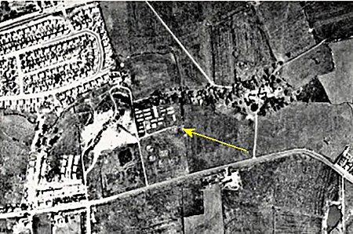

Walkden – first listed October 1946

October 1946 – Hostel leader; Uffz Otto Linse (B+). “Joined NSKK (Nazi Motor Corps) in 1934 and remained in it till 1937 in order to take his driving test. Travelled abroad in France, there experiencing democracy for the first time, but this was counteracted by pro-nazi arguments from his own people. He has now realised that national socialism was wrong after all.”

When Warth Mills camp was transferred to Garswood Camp 50 during 1947, this hostel was not listed.

Witton Park – first listed October 1946

October 1946 – hostel leader; Ofw Willi Klein (B). “He belonged to religious socialists before 1933. Requires guidance from TA (Training Advisor) for re-educational activities.”

When Warth Mills camp was transferred to Garswood Camp 50 during 1947, this hostel was not listed.

