Camp 6 - Glenbranter Camp, Argyll

Prisoner of War Camps (1939 – 1948) - Project report by Roger J.C. Thomas - English Heritage 2003
OS NGR | Sheet | No. | Name & Location | County | Cond’n | Type 1945 | Comments
 |  | 6 | Glenbranter Camp | Argyll | 5 |  | Scotland

Location: NS 1115 9766. The name arises from the main glen – Glenbranter. The forest is at the top of Loch Eck, 3 miles S of Strachur.  Previous use: The house and estate were the home of Harry Lauder, (Sir Henry Lauder). He sold the land in the early 1920’s. A Ministry of Labour ‘Industrial Centre’, (labour camp for the unemployed) was built there in 1933. There were protests over poor conditions.  POW Camp: Throughout the short time the camp was open there were records of both pows and internees, (often merchant seamen) being held there.  October 1940 - Recorded as being opened during 1940, (Appendix to WO 199/405). The camp was divided into 2 compounds enclosed by double perimeter barbed wire fences with wooden walkways, sentry posts and a main gate with slit trenches. (For the first month perimeter lighting was also used).  Canmore – “The camp occupies two areas, to the N and S of an avenue of trees which formerly led to Glenbranter House (NS 11087 97782). The area to the S consists of at least seventeen huts whilst N of the avenue is a further group of fourteen smaller huts.  The War Diary only sometimes recorded the numbers of pows / internees arriving or leaving. Most of the entries concern changes in personnel, staff on courses, etc.  8 October 1940 – War Diary – Commandant Major C E Wilson. Barbed wire fencing erected around the two compounds.  9 October 1940 – the company moved out of the pow camp to the British camp.  11 October 1940 – first prisoners arrived; 73 Czechs (3 more on 18th). | 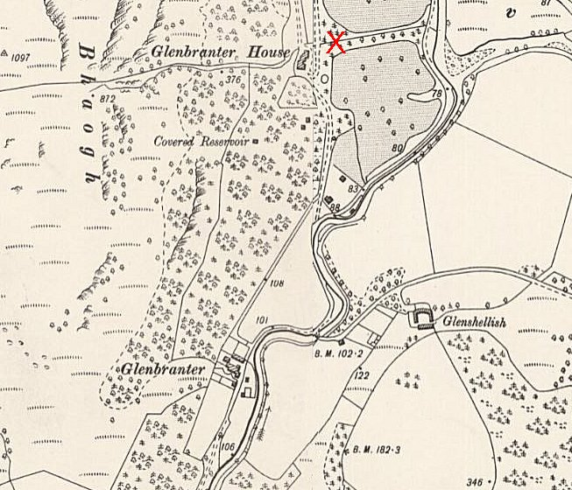
 | Ordnance Survey published 1900
12 October 1940 – 17 French Legion pow arrived.

[Note – not certain. On 1 July, 1940 French troops based at Trentham Park were given a choice to be repatriated to Vichy controlled North Africa, or to join the Free French Forces under De Gaulle. Were these some of the officers who chose to return to Vichy France?]

19/20 October 1940 – “Musketry practice”

22 October, 1940 - the status of some of the prisoners was questioned as to whether they were pows or internees. The matter was raised in the House of Lords on behalf of a Dr. Vladimir Clementis, a Czech citizen, whom Lord Faringdon claimed to be an internee held at Glenbranter.

The Duke of Devonshire replied; “…Clementis is one of a number of discontented Czech soldiers who were a centre of disaffection and disturbance at the Czech military camp at Cholmondeley, Cheshire. At the express request of the Czech military authorities, it was agreed that these discontented soldiers should be segregated.”

He explained the complicated legal reasons why the Czech authorities were unable to do this themselves, then continued; “…it was agreed that these Czech soldiers should be given an opportunity of enlisting in the Auxiliary Military Pioneer Corps. Of the total of 539 Czechs who were segregated and detained in Sutton Coldfield Internment Camp, about 460 have enlisted in the Auxiliary Military Pioneer Corps. The others have either refused to volunteer or were unacceptable for medical or other reasons, and these have been removed to Glenbranter Camp. Orders in Council under the Allied Forces Act have now been made, and the War Office have requested the Czech military authorities to take the remainder of these men back into their charge and to deal with each individual case on its merits, so that Dr. Clementis will not be interned for more than a very short time longer.” (House of Lords, 22 October 1940, Vol 117).

26 October 1940 – Major General C Borrett, an Inspector of POWs from the War office, visited.

29 October 1940 – Buses took all prisoners to Knapdale Internment Camp. 40 Italian pows were expected to arrive – but only 25 Italian seamen turned up.

5 November 1940 – 13 Italian submariners arrived.

25 November 1940 onwards – pow working parties were formed to work with the Forestry Commission.

1 December 1940 – Major Alexander Scotland, (Prisoner of War Interrogation Section) and Captain Stamp arrived to interrogate some of the pows.

11 December 1940 – 6 pow officers arrived – presumably Italian?

14 January 1941 – 52 pows transferred to The Hayes, Swanwick Camp 13.

19 March 1941 - 152 “internees” arrived. Not listed as pows – unfortunately the War Diary does not state who they were.

Spring 1941 - Pows included Germans captured on the Lofoten Islands.

1 May 1941 – 279 pows transferred to Donaldson’s Camp 12.

10 June 1941 – 62 Italian seamen arrived from Donaldson’s.

22 October 1941 – a tunnel was discovered underneath the Hospital floor.

24 October 1941 – another tunnel discovered, this one under No.11 hut.

26 October 1941 – 3 members of the Brazilian Embassy visited the camp. [Why?]

10 / 13 November 1941 – Inspected by Lt-Col Buckley and then by General Jepp.

6 January 1942 – Merchant Seaman Strangilus, from this camp, died at Drymen Military Hospital – no cause stated. [Strange surname – does not Google].

13 February 1942 – a new Commandant arrives; Major E W Shaul,

17 February 1942 - Major C E Wilson left to ‘Z’ Camp. [Z Camp was where Rudolf Hess was held from May 1941 to June 1942 – Mytchett Place, near Aldershot]

4 March 1942 – two members of the Swiss Consulate visited.

September 1942 – 84 German pows received during this month, mainly armed services, some merchant seamen.

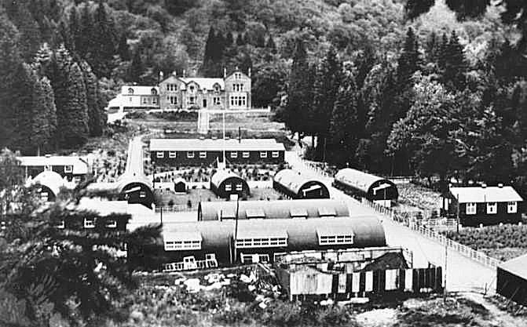 | Memories recorded by the Strachur and District History Society include the possibility that some high-ranking German naval officers were held here. The local doctor (Dr McLellan) was presented with a carved wooden box, shown on the society’s webpage. Isabel Montgomery cycled from Strachur Post Office to bring the pows their mail.  3 pow hostels were linked to Glenbranter. Recorded as holding Italian pows in 1942, possibly longer – Garvald (later hostel for Gosford Camp 16) / Pathhead / Livingston.  Towards end 1942 – pow camp closed.  After September, there are no further War Diaries and by December 1942 the site was used to base HMS Pasco, a Combined Ops training centre for landing craft signalmen.
Glenbranter Camp – as there is no sign of the barbed wire fencing that was in place in front of the house this was either the labour camp or HMS Pasco.

After the camp: Glenbranter House was demolished during the 1960’s. Most of the estate was purchased by the Forestry Commission. No remains are recorded.

The site as it is now: https://repatriatedlandscape.org/pow-sites-in-scotland/pow-camp-6-glenbranter-camp/

Further information:

Historic Environment Scotland: http://canmore.org.uk/site/272561 States that an alternative name for the camp was Glenshellish Burn.

National Archives references:
WO 166/10294 - 6 Prisoner of War Camp Glenbranter (Strachur) Jan-Apr, Sept 1942. Used above
WO 166/5977 – Miscellaneous Prisoner of War Camps, 6 Glenbranter, Italian submariners and seamen. German, Czech, French Legion and other prisoners of war. 152 internees arrived 19 March 1941. Used above.

Hostels

Garvald – now Burnside Court area, NGR NT 587 708.

1942 – hostel attached to Glenbranter.

Italian pows from Garvald recorded as working at nearby Eastfield Farm, Whittingehame.

Memories – “The main impact of the Second World War on the village was the building of a small prison camp behind the hotel. The prisoners were, I think, mainly Italian and worked on the farms. They were popular enough in the village and provided partners at the dances. One of them occupied his time making a model of his home village on the banks of the burn. What a shame it was not preserved! The Roman Catholic Padre got permission to say Mass for the prisoners in the hall.” From - https://www.garvald.org.uk/wp-content/uploads/2012/02/Garvald-History20apr_webversion.pdf

5 May 1944 - listed as a hostel for Italian pows attached to Donaldson’s School Camp, (WO 32/10737):

1946 listed as a hostel attached to Gosford Camp 16 with German pows.

Pathhead  1942 - Italian pows recorded in early years.  Memories of Christmas Eve at St Mary’s Pathhead – “Molly Lusk shares her memories of Christmas Eve during the War….. When the air was frosty, and the snow lay deep around our little chapel of St. Mary? As there was no electricity, we worshipped by candle-light, and the heating came from a coal-burning stove… The little crib, the same one to which we still kneel today, nestling in the corner.  We had a special choir that night. In the village were billeted German prisoners-of-war, and as they marched down the road and into the Chapel, they sang ‘Stille Nacht’. There must have been many sore hearts in our congregation during those dark days of war. My cousin, Pat, who served Mass in St. Mary’s, was killed while coming back from a bombing mission. He was just nineteen years old. Bernard McNamara, another altar boy, served as a Royal Marine and was spared to come home. I was too young to realise that these German soldiers may also have been weeping for their loved ones, and their home-land on that long ago Christmas Eve.”  Pathhead AFC - The amateur side were formed in 1950 from the remnants of a team that previously consisted of local men and Italians who were part of the POW camp based in the village after the Second World War and many stayed behind in the village after the War.  5 May 1944 - listed as a hostel for Italian pows attached to Donaldson’s School Camp, (WO 32/10737). | 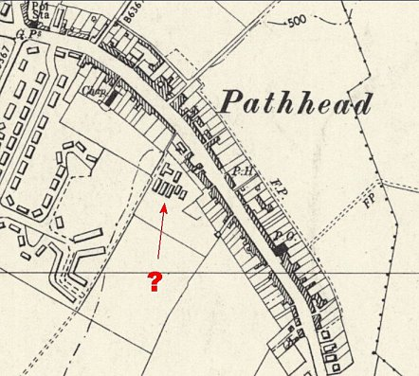
Possible site – NOT confirmed. NGR NT 395 641
OS map – 1959.
Livingston

1942 - listed as a hostel with Italian pows attached to Glenbranter.

5 May 1944 - listed as a hostel for Italian pows attached to Donaldson’s School Camp, (WO 32/10737).

