Camp 16 - Prees Heath, Whitchurch, Shropshire

Prisoner of War Camps (1939 – 1948) - Project report by Roger J.C. Thomas - English Heritage 2003
OS NGR | Sheet | No. | Name & Location | County | Cond’n | Type 1945 | Comments
SU* 55 37 | 126 | 16 | Prees Heath, Whitchurch | Shropshire | 4 |  | Capacity 2,000 men, closed 4th Oct 1941

Location: (*SU incorrect) SJ 55 37 (probably nearer the airfield to the west).  Previous use: Large army camp in the area from 1915. Early in WW2 the site was used as an internment camp mainly for Austrian and Germans. Conditions were reported to be ‘primitive’ with tented accommodation, including the camp hospital. (Raised in House of Commons, 22 August 1940, Vol 364). The internment camp closed October/November 1940.  POW Camp: Not certain if pow camp opened late 1940 or early 1941. Tented accommodation for Italian pows.  Used for a short time as one of 2 transit camps for the first bulk arrival of Italian pows from Africa in Autumn 1941. (Lodge Moor Camp 17 being the other).  Closed 4 October 1941 for the construction of an airfield.  After the camp: RAF airfield Whitchurch Heath, later called Tilstock, for bomber training.  The site as it is now - https://repatriatedlandscape.org/england/pow-sites-in-the-west-midlands/pow-camp-16-press-heath/ | 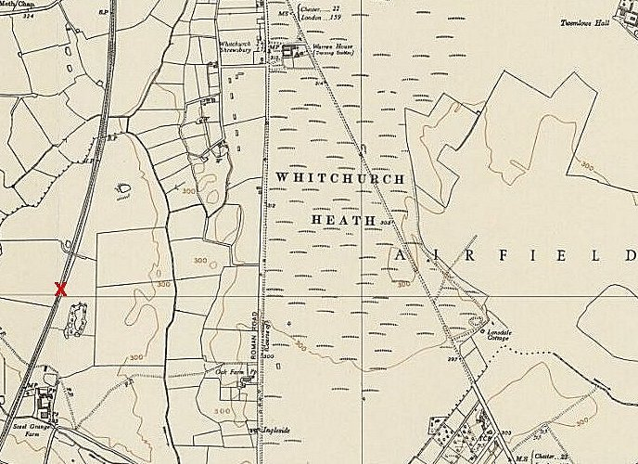
 | Ordnance Survey 1954

