Camp 16 - Gosford Camp, Aberlady, Longniddry, East Lothian

Included in the 1945 ICRC camp list – Base Camp. 16. Gosford Camp, Aberlady, East Lothian.

1947 Camp List
16(G.W.C.) | Gosford Camp, Aberlady, Longniddry, East Lothian. | Sc. | Priswar.Aberlady. | Aberlady 65 | Longniddry. | Lt.Col.J.H.Stitt. | v/1453/2

Prisoner of War Camps (1939 – 1948) - Project report by Roger J.C. Thomas - English Heritage 2003
OS NGR | Sheet | No. | Name & Location | County | Cond’n | Type 1945 | Comments
 |  | 16 | Gosford Camp, Aberlady, Longniddry | East Lothian |  | Base Camp | Scotland

Location: NT 453 782 (Canmore) / NT 449 779 huts shown on map. Camp within Gosford Park grounds on the S side of the Firth of Forth.  Previous use: The large country house was the seat of the Earls of Wemyss and March. The parkland of 5000 acres was used as an army camp from 1940.  POW Camp: Opened as POW Camp 16 in 1944.  “The prisoner-of-war camp is visible on vertical air photograph (106G/Scot/UK 20, 5233, flown 15 April 1946) which shows the hutted camp and the perimeter fence. Many of the huts are set out in 'spokes of a wheel' form with others (Nissens) grouped together. The perimeter fence shows clearly along with what may a second fence in sections.” (Information from RCAHMS (DE), June 2006).  The huts were able to accommodate 50 men each. There was some use of tents in 1944 when the site became over-crowded, especially during the Winter – conditions were poor at these times.  Within the camp was a bakery, cinema/concert hall, football pitch, sports ground and gardens. The pows worked mainly on local farms. At the end of the war, many worked on removing anti-tank obstacles and on reconstruction.  1944 - Recorded as holding mixed co-operator and non-co-operator Italian pows. At some point during this year, the Italians were replaced by German pows – the Italians being moved to other camps or to billets before repatriation.  Henry Faulk began his re-education work with pows at this camp in 1944. He was appointed as the camp interpreter. He found a reluctance of the sergeant-major pows to take on responsibility for internal leadership. “Faulk had his remedy for this. ‘I lined them up, gave each one as stood to attention the command, ‘Arms bend, open hand!’ and into each open hand I | 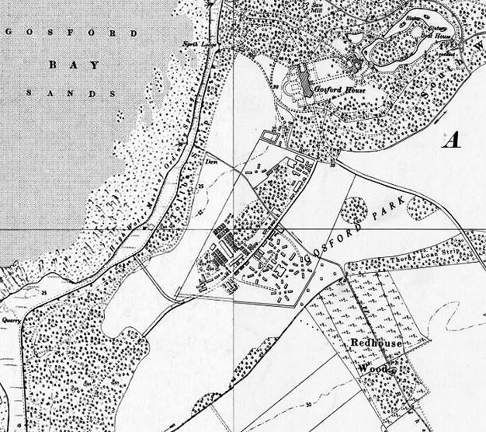
 | Ordnance Survey 1957
put a piece of screwed up paper. Then came the order, ‘Open papers!’ Then: ‘Who has the paper with the cross on it?’ and, when I got the answer, ‘You are the camp leader’. Dead silence! Then one man – and only one – slowly grinned and said clearly, ‘Das war gut!’’ While at the camp he put a stop to an attempt by the Nazis there to take over the camp’s medical centre. Henry Faulk later became the Chief Executive Field Officer for the Prisoner of War Division of the Foreign Office.

September 1944 – SS Sergeant Gotfried Lachmann and Corporal Paul Schmucker, both aged 24, escaped – later recaptured.

December 1944 – from a comment made in the next report, the Italian pows had been replaced by Germans by this time.

Aerial photograph dated 1945 >  5 August 1945 – A report of a visit made by Captain G S Littlejohn Cook from the re-education section. Strength 3982, including 13 officers, (1 padre, 3 M.O.’s and 9 others awaiting transfer to officers’ camps).  Commandant: Lt Col J Duguid Camp Leader: S/Fwl Osterberg  Interpreter Officer: Lieut Markos Deputy: Maier  S/Sgt Vayden German M.O.: S/Arzt Dobler  Interpreter: Gef. Borzechows  IO Markos could not speak German! It was recommended that he be removed. S/Sgt Vayden was ‘competent’.  The Camp leader was originally politically graded as ‘C’ as he had been a Nazi Party member, but the visitor believed this should be downgraded. He had been a regular soldier for 23 years, then a Civil Servant – this was why it was necessary for him to join the party.  Many pows were passing through this Base Camp – about 40,000 in the last 8 months – “of whom some 8000 were sent to Black Camps.” (Black = Nazis, category C). | 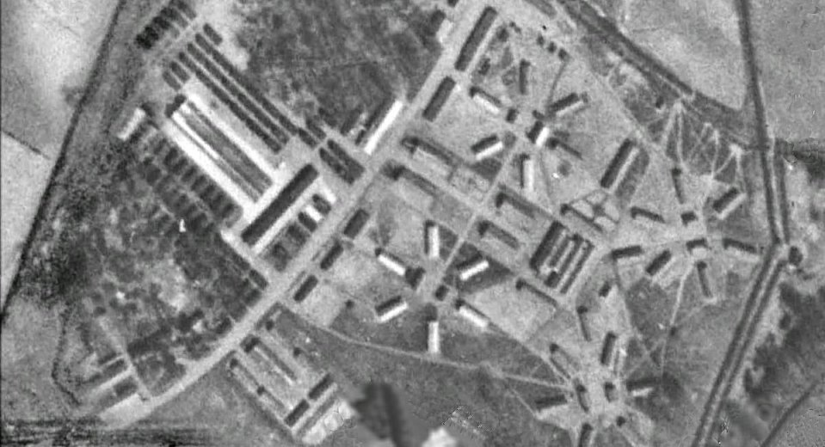

Approximate political categories: | A | B | C | New intake
 | 1000 | 1900 | 200 (inc 20 ‘CX’) | 800

1 of the M.O.’s, S/Arzt Friedrich Dobler, was regarded as an uncompromising Nazi, but Scottish Command had kept him at the camp as they were short of doctors. It was recommended that he be replaced as soon as possible.

About 5% of the pows were considered to be communists, though mainly because they thought this advisable as their homes were in the Russian zone.

General education classes were a priority for the German pows, rather than re-education activities.

21 & 22 August 1945 – A report by Mr James Grant from PID on his visit to the camp. Strength; 3380.

“…this must be the most luxurious camp in the country. The Interpreter Staff Sergeant, Weyden, [Vayden / Wehden - spelling?] told me that no-one would want to escape from it… They have the biggest hall I have ever seen in a camp, fitted up as a gymnasium, where they do their Leichtathletik when the weather is inclement. On a magnificent stage I heard their really fine orchestra play Schubert and Haydn.”

However, Mr Grant found that there was little re-education taking place due to the lack of a ‘driving force’ and the distraction of facilities for games.

There had been pow teachers of English, but many had been transferred. The visitor tried to encourage others to take their place.

20-21 / 28 September 1945 – Mr Grant returned to review English Instruction.

The Camp Commandant was leaving this month. The Interpreter, Staff Sergeant Louis ‘Wehden’, was found to be efficient, but too dominant. The issue over transfer of teachers remained.

29 and 30 October 1945 – a visiting lecturer, Harald von Waldheim, commented on the very long working hours for the pows. Reveille was often as early as 05.30, some working parties were travelling up to 2 hours by truck, many did not arrive back at the camp until 19.00.

He gave lectures under the titles; ‘Collapse’ and ‘Freedom’. The lectures were given to large audiences of 1000 men – however the discussions afterwards were not successful as, “nobody dared to speak”. No reasons for this were given and there are mixed reports about the nature of the camp – further negative remarks were made throughout 1946.

23 and 24 February 1946 – R McIlvenna, a visiting lecturer, gave a different impression of the camp stating that he was impressed by everything that he saw and heard at Gosford. The discussions were lively, relevant and interesting. He toured the camp and spoke to many pows – “Their morale seemed to be high, to judge from the efforts they had made towards improving their conditions, and the obvious pride they took in their camp.” The band was again described as excellent.

14 – 16 June 1946 – a report on a lecture lists Woodhouselee as a hostel for Camp 16 with German pows - there was also a separate Woodhouselee Camp 780 which still held Italian pows.

20 June 1946 – English Inspector’s Report by Mr James Grant. Total strength 1971 German pows, including 300 in Woodhouselee hostel.

Commandant: Lt Col Hewitt Camp Leader: S/Fwl Georg Osterberg

English classes were being taken at various levels by 160 pows with 7 teachers + some studying privately.

21 / 23 June 1946 – W G Aston visited to; 1. Interview suitable pows for attendance at Wilton Park special training camp; 2. Screen new pows; 3. Review re-education.

Strength 2319, all Other Ranks – of which 307 were based at Woodhouselee.

Commandant: Lt Col Hewatt, M.C. Camp Leader: Stabsfw. Osterberg (B+)
Interpreter: Lt A Barnett (German) Deputy C/L: Hptwn. Maier (B-)
S/Sgt K S Leigh German MO.s: Unterarzt Dr Ludwig (B) and Dr Hack (B-)
Dentist: Dr Fraenzel (A)

Screening figures were not available as the majority of pows were in transit. 130 pows were listed as ‘staff’ at the camp with a high morale. There were 3 candidates for Wilton Park.

Most of the pows in transit were from camps in USA, Belgium and Germany. Most were considered to be politically grey/black. The pows from the USA had a low morale as they had been mis-informed that they were to be returned to Germany. Many pows from camps in Belgium had lived in squalid conditions, some were in poor health due to this.

Youth pows (under 25). Re-education activities were available for them. A popular activity was ‘Heimabend’ which included talks, singing and re-educational games. It was hoped that a youth parliament would be established when the camp became a working camp.

Despite the camp having mainly transit pows, re-education work was being carried out. The standard list given:

Wochenpost / Ausblick – 500 / 250 copies received.

Newspapers – a wide range of British newspapers + German newspapers from the British zone.

Library – 2000 books, but many wearing out.

Lectures – regular and popular

Discussion groups – a weekly review which was well attended with 400/500 pows.

Films – regular from PID and YMCA.

Wireless – the set was in the camp leader’s office + 5 loudspeakers around the camp.

Camp Magazine - Der Aufbau – (The Structure) – published weekly. One of the editors, Gefr Hollerbach, was to be replaced as he was category ‘C’, though not suspected of any Nazi activity at the camp.

Press review – weekly wall display.

English Instruction – variable with transit pows. Some classes were taking place and pows started to receive exam certificates and diplomas.

Other activities -

Religion – 1050 Evangelicals; padre, Obgefr Wendeburg (A). A small chapel + Sunday services in larger canteen. Religious discussion every evening. Bible studies weekly.

750 RC; padre Uffz Degenhardt (A). A small chapel + Sunday services in larger hall. RC service each evening. Religious discussions after Sunday mass.

Both padres gave weekly services at Amisfield Camp 243, and at Woodhouselee hostel every other Sunday.

Education – courses in German literature, French, Latin, History of Art, Philosophy, Maths, Chemistry, Physics, Geography, Civics, mechanics, draughtsmanship, book-keeping, economics and engineering.

Theatre – Plays were produced by eight leading members. There was also a choir with 8 members. 18 pows in the orchestra played major classical music to audiences of 700 in the main hall. The orchestra was rated as excellent. Sport included football, handball, boxing, wrestling and athletics.

6 July 1946 – a note by a lecturer stated that the camp changed on this date from a base / transit camp, to a labour camp.

11 August 1946 – K W Rothschild gave a lecture at the camp and at 16a (Amisfield). Strength approximately 700 in the main camp.

The lecturer reported that difficulties were arising in the main camp with many pows on a ‘go-slow’. The pows from America were seen as the main group showing defiance – though comments below indicate it may also have been other pows transferred from a less strict camp. A group were justifying German fascism as opposition to Russia, and there was cynicism about democracy. Rumours about ill treatment of pows were circulating.

The report from the camp about the lecture also reported that; “a relatively small number of men are succeeding in suppressing the healthy opinions of the others.” A request was made that these ‘incorrigible Nazis’ be transferred to a special camp.

c.1946 / early 1947 – It was a camp with difficulties in relationships. British staff were apathetic towards the pows, taking a ‘hands-off’ approach. The camp was largely run by the pows themselves - which was also a source of the troubles in the camp. One pow, Harry Dittrich commented:

“After two years in Haddington [Amisfield Hostel 16A] the camp was closed. We were sent back to the main camp in Gosford and that’s where the trouble started. After two years of comparative freedom, with hardly a wire round our camp, we were suddenly confronted by our old friends, the German Army sergeants, ordering us about. We couldn’t believe our eyes. It looked as though nobody had told them that the war was long finished. They strutted about in their uniforms, covered in medals. I had never seen so many Iron Crosses in my life. We found out later that they had all been fashioned out of tin from the cook-house and hand painted. The only thing missing in that camp was the old Hitler salute; it was unbelievable! And the majority of them were still Nazis.
The old sergeants went hysterical when we told them we weren’t in the German army any more. We refused to follow their orders, all one thousand of us. The guard had to be called out, bugles were blown and I believe even the Fire Brigade were there, but they couldn’t do a thing with us. Most of us ‘foreigners’ and trouble-makers were transferred to other camps up and down the country as soon as possible after that.” (from https://eastlothianatwar.co.uk/PoW%20Camps.html)

13 & 15 September 1946 – a visiting lecturer, Dr Deneke, was requested to speak to the pows by the Camp Labour Officer about their “slackening in work”. He warned the men that they were at risk of being put down on the repatriation list. It is interesting to note that a visitor was requested to speak to the pows about this and it had not already been told to them by the commandant or other British staff. It seems to indicate at least a lack of interest and contact between the British staff and the pows, maybe hostility.

In most camps, reports submitted about lecturers were written by British staff – often the Commandant or Interpreter Officer – sometimes the German Camp leader also gave a report. In this camp, for many months, the only reports submitted were from the German camp leader. This is a further indication of distant relationships within the camp. See also note 10 March 1947, below.

13 & 14 November 1946 – Another English Inspector’s report by Mr Grant. Total strength 3094.

Strength: | Main - Gosford | Thornton Loch Hostel | Garvel Hostel | Statiford Hostel | Amisfield Satellite | Billetees
 | 1582 | 105 | 65 | 50 | 961 | 331

All education work had stopped for 6 weeks for pows to work on the potato harvest. Classes were just restarting. (Garvel = Garvald / Statiford = Slateford).

19-24 November 1946 – further disquiet about the camp was expressed by lecturer, Dr R Laufer. He gave lectures at the main camp, Amisfield Satellite, and three hostels – Slateford, Garvald, Thornton Loch.

For the main camp – “Pows seem to be afraid, haunted by some sort of fear to come forward and voice their opinion… The whole atmosphere is a depressed one.” He asked the pows in charge of education for an explanation, but received only evasive answers. He stated that; “This camp seems to be drifting towards enmity to democracy.” The other sites were less depressed, despite worse conditions.

7 – 10 January 1947 – 2 members of the Segregation Section carried out political screening – possibly as a result of previous comments. Total strength “over 750”.

Commandant: Lt Col F A Hewat, M.C. Camp Leader: F Pohlandt
Interpreter: Lt A Barnett (German)

The camp leader had been in place for just a month. He had previously been a member of the Camp Police Staff; “though not appearing to be an outstanding personality he is apparently acceptable to the Commandant and to the POW.”

22 January 1947 – Mr Grant carried out another English Inspection. Total strength 1933. 930 in main camp. 259 billetees.

The three hostels previously attached in the last report had been passed over to the Polish Resettlement Corps.

10 March 1947 – Lecturer Dr Rawitzky made the comment; “Not the slightest interest shown for re-education by the British staff, not even by the British captain interpreter.” As usual, the report on the lecture was submitted by the Camp Leader.

24/27 March 1947 – S Denham Jacobs visited to make a re-education report. Total strength 1506.

Numbers: | Main | Amisfield | Billets | ‘Sundries’
 | 771 | 459 | 246 | 30

Screening: | A | B | C
 | 19 | 1479 | 8

Commandant: Lt Col F Stitt Camp Leader: F Pohlandt (B)
Interpreter: Capt A Barnett Deputy C/L: Fw Schall (B+)
German M.O. U/Arzt Dr Erfurth (B+)

A new commandant. The Interpreter Officer was described as the; “only active member of the British staff” towards re-education – and he was due to leave.

Morale was regarded as high mainly due to interest in the pows well-being shown by the commandant and the IO + plenty of room in the camp for activities. Politically there was a split between pows who were going back to east or to west Germany. Those going to the east – Russian zone – had resigned themselves to this.

About 20% of the pows were ‘youth’ – they were not seen as a problem. The protestant padre was mentioned as having organised a club providing activities for the under 25’s – I believe that the RC padre did the same and this is referred to in later reports.

The standard list of re-education activities was given, it had changed very little from previous reports, see June 1946 above. There was a very wide range of other education activities available. Overall, it was regarded as a very active camp.

11-13 April 1947 – Lecturer, Heinrich Fraenkel, visited the main camp, satellite and hostels.

With the new commandant, there seems to have been a rapid change in the atmosphere within the camp. This may be due to the commandant, the lecturer, or perhaps a change of pows and removal of the troublesome ones – probably all three.

Rather than meet a fear to speak out, the lecturer answered questions about Germany for nearly three hours after his lecture in the main camp! A similar response was found at Amisfield Satellite. There were no further comments about pows being afraid to speak out from any future lecturer.

It was unusual for lecturers to visit pows in billets - Mr Fraenkel attended about a dozen farms and talked to over 30 men. “Some of these men seemed to be badly in need of more intellectual help and activity, and the one library book a month they are now getting, is surely not enough.” The Interpreter Officer was to investigate this. Mr Fraenkel also commented on the “excessive manual labour” the pows were having to undertake.

For the first time in many months, the lecture report was submitted by the commandant.

22 May 1947 – Mr Grant carried out an English Inspection. Total strength 1400.

Commandant: Lt Col Maxwell Camp Leader: Hans Plecker

No hostels or satellite camp listed. Amisfield had Ukrainian pows.

20-22 & 27-29 May 1947 - S Denham Jacobs visited to conduct a re-education survey. Strength 1514 O.R.

Strength: | Main | Billets | Amisfield | ‘Sundries’
 | 1203 | 267 | 32 | 12

Screening: | A | B+ | B | B- | Unscreened
 | 15 | 426 | 879 | 193 | 1 (Absentee)

542 pows repatriated to date.

Commandant: Lt Col W A H Maxwell Camp Leader: Uffz Plenker (B+)
Interpreter Officer: Lt C K Murray Deputy C/L: Fw Schall (B+)
German M.O.: U/Arzt Dr Hack (B)

The new Commandant was seen as “exceptionally keen; he does all he can to further welfare, sport and re-education. He commands the respect of the entire camp.”

The interpreter was also new; “enthusiastic and particularly energetic in furthering re-educational activities.”

The camp leader had recently been transferred from Amisfield – “He has firmness and common-sense without much initiative, and is thoroughly reliable, in spite of his former Party background.”

Morale was rated as ‘good’ due to the understanding attitude of the CO, the efforts of the IO and full employment. Few of the pows had “any positive democratic outlook.” Anti-Russian feeling was high. The pows were positively influenced by the friendliness of the local civilians.

540 pows were youth (under-25). They were not seen as a problem. The padres ran youth groups.

The list of standard re-education activities:

Wochenpost & Ausblick – separate report

Newspapers – excellent, a wide selection. German newspapers received, but criticised for being too party political.

Library – 3000 books in a spacious library with a librarian who was also a book-binder.

Lectures – regular. Swiss lecturers were popular.

Discussion Groups – regular with about 60 pows attending.

Films – regular from YMCA and Travelling Films Ltd

Wireless – very good, including a weekly published list of selected BBC German broadcasts and German stations.

Camp Magazine – Regular + an English supplement.

English Instruction – separate report

Information room – none.

Other activities –

Religion – two churches in the camp, well attended services. Both padres ran youth groups.

Education – varied classes including one for the Abitur, (end of secondary school level exam). Bee-keeping class. An art/craft-school for painting, drawing, wood and metal work.

Entertainment – The camp orchestra of 12 players gave regular concerts and were allowed to tour some of the billets. There was also a theatrical group.

Some visits to Edinburgh were taking place on Sundays.

13 July 1947 – A lecturer commented that Sunday was a bad day to visit, also that on his visit it just happened to be the first day that pows had been given British money, and so attendance was very small.

14 July 1947 – Johannes Schall, Deputy Camp Leader died at Bangour Hospital. His usual address was recorded as Berghausen, Germany, later amended to Prisoner of War Camp, Gosford. Cause of death – “Injuries received when thrown from a truck travelling on the public road between Quarryford Farm House and Village of Gifford…. When said truck overturned into the Sink Field on the farm of Castlemains…” Other injuries were sustained by pows, including the Camp Leader.

Johannes Schall was later re-interred at the Cannock Chase German Military Cemetery, he was recorded as having been a member of the German Air Force.

4-8 August 1947 – S Denham Jacobs returned for another Re-education survey. Total strength 933.

Simplified screening figures were given: A – 9 / B – 923. There was also 1 escapee. 647 pows had been repatriated to date.

The only change to senior personnel was a new Deputy Camp Leader: Uffz Rivet (B+)

Despite an improved morale, the British staff still did not contribute much to re-education – “There is a certain lack of unity among the officers on the subject of PW re-education. The Commandant is keen and well liked but he makes mistakes… The IO is energetic, but lacks tact and the other officers are either not interested or antagonistic.”

The new deputy C/L had been in charge of Camp Police for a long time and was a policeman by profession.

There was good morale in the camp – bolstered by the new privileges allowed to pows for fraternisation. Political progress was made often due to the friendliness and hospitality of the local citizens.

Some of the standard re-education activities had decreased or stopped, (lectures / discussion groups) mainly due to increased freedoms to leave the camp and good weather being more appealing, and to the repatriation of some leaders of activities. Radio reception was often poor as the set needed new valves. Other activities had also decreased – though there was a new bee-keeping course.

27-30 October 1947 – S Denham Jacobs returned for another Re-educational Survey. Total strength = 1000.

Numbers – 706 in main / 10 at Amisfield / 284 in billets. 812 pows had been repatriated to date.

Commandant: Lt Col W A H Maxwell Camp Leader: Uffz Hans Plenker
Interpreter Officer: - Deputy C/L: Uffz Wilhelm Rivet
German M.O.: U/Arzt Dr Karl Hack

Pow Gefr Werner Petersen was being employed as the interpreter.

The commandant was described as; “very understanding towards his PsW and is well liked by them”. He was finding problems with the lack of a British Interpreter.

There was a new camp adjutant (unnamed) regarded as; “a great improvement upon his predecessor who had been antagonistic to PsW.”

Morale was seen as quite good, but many elder pows had “a distinct “barbed wire” complex”. The recently announced increase in the speed of repatriation had a positive impact.

The standard list of activities was given, there was a general feeling of winding down in the camp:

Wochenpost and Ausblick – Adequate, though number of Ausblick varied and was sometimes insufficient.

Newspapers – excellent range

Library – more than 2000 books, Swiss books were very popular.

Lectures – these had slowed down. Only one visit since harvest break.

Films – YMCA every 2-3 weeks (several showings when films arrived). Travelling Film Ltd were irregular.

Wireless – ‘fairly adequate’; loudspeakers were faulty.

Camp Magazine – 350 copies a month, duplicator worn-out.

Discussion groups – press reviews, one group about to restart.

Information room – this had started and an exhibition held.

Other activities –

Religion – the two padres; “still doing good work, particularly in their youth groups.”

Education – classes for stenography; commercial subjects; mathematics, draughtsmanship, and the arts/crafts group.

Entertainment – There was a ban on the use of transport for entertainment imposed by the Scottish Command – this prevented outside links, visits to Edinburgh, and tours of the orchestra to billets. There was still an orchestra/band and a theatre group – it was expected that the current play was probably the last to be given.

4/5 November 1947 – English Inspector’s Report by A Robinson. Total strength 992 – 698 in main camp + 294 Ukrainians at Amisfield.

No change to senior personnel. There were 2 English classes, plus a number of pows studying privately.

14 November 1947 - Camp number included in an ‘Urgent Memorandum’ (FO 939/270) regarding inspection of food parcels.

8/9 December 1947 – a lecturer commented on the lack of interest shown by pows – their focus entirely on repatriation.

9/10 February 1948 – K Bloch, lecturer made a report.

He listed Gosford as Main Camp 16 – total Strength 360 and Deer Park Camp as a hostel with total strength of 300.

9 – 13 February 1948 – S Denham Jacobs visited the camp to conduct a Re-educational Survey. Total strength 882.

Numbers: | Main | Deerpark hostel | Woodhouselee | Mortonhall | Billetees
 | 357 | 337 | 10 | 34 | 84

Commandant: Lt Col W A H Maxwell Camp Leader: O/Fw Schulz
Interpreter Officer: - Deputy C/L: -
German M.O.: U/Arzt Dr Karl Hack
Interpreter: Gefr Lungwitz

The lack of an Interpreter Officer continued to be a problem for the Commandant. The 2nd i/c was Major Taylor, described as “an old soldier” and obstructive to re-education activities.

The new camp leader was regarded as being “weak” in comparison to his predecessor, but he was managing satisfactorily and developing re-education activities.

Morale was high as the pows expected to be repatriated soon. The pows were to be transferred to Deer Park Camp, Dalkeith, which would then be numbered as Camp 16 – and Gosford would close. This was not a popular move with pows at Gosford as it had superior accommodation and grounds.

The visitor commented on the effect that repatriation has had on re-education – “There is very little mental cream now left in a camp that was once overflowing, and what little there is, has become cynical in political matters.” A lot of the cynicism was due to movements of pows into inferior sites, while the better camps were used for European Voluntary Workers.

The 300 youth pows were not regarded as a problem. The groups run by the padres continued and contact had been made with Church of Scotland youth organisations at Aberlady. 4 pows were attending the special training course, 13 had already completed it, at Trumpington Camp 180.

The standard list of re-education activities was given. It was very similar to previous lists with activities being wound down with imminent camp closure. The discussion groups had already ended.

There were few outside contacts, mainly due to the camp’s isolation and lack of transport.

End February / Early March 1948 – Gosford was wound down and became for a brief time a hostel to Deer Park Camp. Deer Park took the HQ camp number 16 during this time. Commandant Maxwell became commandant at deer park.

27-29 April 1946 – as a hostel to Deer Park camp 16 – just 14 pows remaining.

Known Camp commandants:
1944/5? – September 1945: Lieutenant Colonel Duguid
1945/6? - 1947 Lieutenant Colonel F A Hewat from the Pioneer Corps. Spelling variations Hewatt / Hewitt
1947 Lieutenant Colonel J H Stitt from the Gordon Highlanders (became Commandant at Balhary Camp 3)
1947 Lieutenant Colonel W A Maxwell from the Kings Own Scottish Borderers, also Commandant at Deer Park Camp 16 when it closed down.

After the camp: Parkland restored to the estate. Some brick-built buildings still exist, see below.

The site as it is today - https://repatriatedlandscape.org/pow-sites-in-scotland/pow-camp-16-gosford/

The house is an excellent place to visit with very friendly, informative guides.

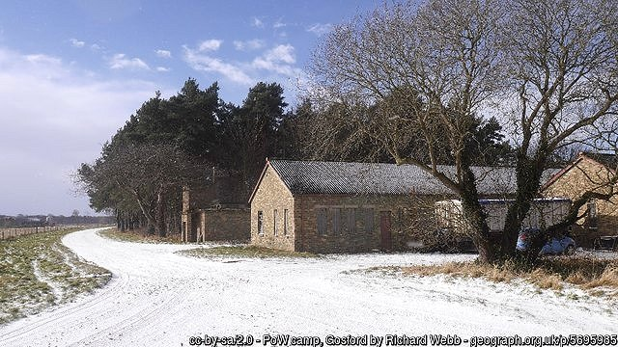 | Further information: Historic Environment Scotland –  http://canmore.org.uk/site/207573  National Archives; FO 939/100 and 101 – 16 Working Camp, Deer Park Camp, Dalkieth, Midlothian and Gosford Camp, Longniddry, East Lothian – dated 1945 to 1948. Both files used above.  https://eastlothianatwar.co.uk/PoW%20Camps.html  Excellent site includes personal accounts of life in the camp, pictures and etchings.  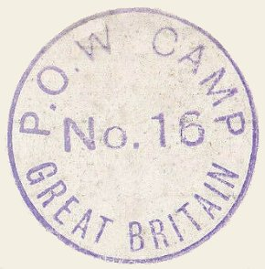  The German Federal Archives has copies of the camp magazine - Dezember 1946, Juli 1947

Hostels

AMISFIELD camp began as Italian Camp 188 – then a sub-camp (16A) of Gosford Park. It later became Camp 243.

For information see Amisfield Camp 188.

DEER PARK, Dalkeith - Previously an independent camp with numbers 1013 and 1024.

For information see Deer Park Camp 16.

Garvald – now Burnside Court area, NGR NT 587 708.

Listed as a hostel holding Italian pows in 1942 and 1943. This is confirmed with Italian pows from Garvald recorded as working at nearby Eastfield Farm, Whittingehame. The list records that the hostel was initially administered by the main camp at Glenbranter (Camp 6).

Glenbranter Camp closed towards the end of 1942 – this hostel is later listed for Donaldson’s School Camp on 5 May 1944 with Italian pows, (WO 32/10737):

November 1946 – hostel attached to Gosford Camp 16 for German pows - strength 65. (Not listed in Camp records for Gosford before this).

22 January 1947 – noted that this hostel had been passed over to the Polish Resettlement Corps. Shortly after this, workers who constructed Nunraw Abbey in 1947 were recorded as being located here.

See - http://eastlothianatwar.co.uk/page-9/PoW%20Camps.html – for a picture of the camp before it was demolished.

Mortonhall - NGR NT 2585 6808  Canmore – “The concrete bases of the huts for this camp are situated along a wall at the edge of a field to the E of the Princess Margaret Rose Hospital at Mortonhall. Many of the hut bases are broken.  The huts were originally built for the Durham Light Infantry c.1940, and were subsequently re-used as a prisoner-of-war camp. In the immediate post-war period the camp became a displaced persons centre.  J A Guy 1997; NMRS MS 810/5, 81, 83. https://canmore.org.uk/site/121757/edinburgh-mortonhall-army-camp  1944 / 1945 ? – Attached to Dalmahoy Camp 123. Not sure when this hostel opened.  1946 – 1948 – Diary of Luftwaffe pow Gerhard Paul records he was held in the US, then Belgium, then on to the UK where he was held in August 1946 at Dalmahoy Camp 123; then Sighthill Hostel and finally at Mortonhall where he stayed until 1948. [Entry from Craig A Benner -  http://www.edinphoto.org.uk/1_edin/1_edinburgh_history_-_recollections_sighthill.htm ]  13 February 1948 – listed as a hostel attached to Gosford Camp 16 with 34 pows. It was due to be closed.  April 1948 - Still open with just 9 pows – attached to Deer Park Camp 16. | 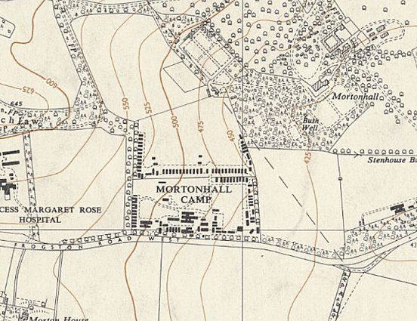
 | Ordnance Survey 1958

Slateford

Probably linked to another main camp before these entries for Camp 16:

September 1946 – a lecturer reported that conditions were good at this camp – hard to see how they were good considering the next report.

October 1946 – different view of the site than above by a different lecturer – “This is a rather miserable place without electric light, looking rather drab and untidy”.

November 1946 – strength 50.

22 January 1947 – noted that this hostel had been passed over to the Polish Resettlement Corps.

Thorntonloch – Approx NGR NT 751 745

Probably linked to another main camp before these entries for Camp 16:

September 1946 – lecturer reported that this was; “a lovely place on the wind-swept sea-shore”, but conditions were bad – “not even a recreation room for its 100 inmates.” A marquee was in use for dining and recreation, but was unusable in bad weather. Morale was recorded as poor.

October 1946 – another lecturer recorded that there was no electric light in the hostel.

November 1946 – strength 105. A lecturer commented on the ‘adverse accommodation’.

22 January 1947 – noted that this hostel had been passed over to the Polish Resettlement Corps.

November 1947 – 82 Ukrainian pows – administered by Amisfield Satellite camp.

Woodhouslee (Woodhouse Lea). Previously listed as Camp 2, later as Camp 780.

For information see Woodhouselee Camp 2.

