Camp 16 (& 175) - Flaxley Green Camp, Stilecop Field, Rugeley, Staffordshire

1947 Camp List
175(B.C.) | Flaxley Green Camp, Rugeley, Staffs | W. | Priswar, Rugeley | Rugeley 293/4 | Brindley Heath | Lt.Col.H.W.Saunders | v/202/4

Prisoner of War Camps (1939 – 1948) - Project report by Roger J.C. Thomas - English Heritage 2003
OS NGR | Sheet | No. | Name & Location | County | Cond’n | Type 1945 | Comments
SK 034 158 | 128 | 16 | Flaxley Green Camp, Stilecop Field, Rugeley | Staffordshire | 4 |  | LARGE STANDARD. Camp consisting of a guards' compound and six prisoners' compounds, three for tents and three with hutting. See Camp no.175

Location: SK 034 158 for centre of camp, still shown on 1955 OS map.  POW Camp: Italian and later German pows.  British Camp 16 > American Transit Camp No. 2 > British Camp 175. These may have over-lapped at times as there were 6 compounds.  Camp 16  No records seen other than EH entry above.  American phase – American Transit Camp No.2  There were two serious incidents involving US troops, but not the pows in transit to the States.  1. Robert Stafford was a black soldier promoted to technician 5th grade in the segregated Company D, 390th Engineer General Service Regiment. He arrived in the UK, June 1943. In March 1944 his unit was stationed at Flaxley Green Camp to maintain and upgrade the site. Also stationed there was the 425th Military Police Escort Guard Company. (It was confirmed that this was American Transit Camp 2 in a witness statement – also present was the 440th Military Police Prisoner of War Processing Company).  On 4 March 1944, Robert Stafford was walking back to the camp from Rugeley with two others. They were about 400 yards away from the entrance when they were attacked by a group of white MPs from the 425 MPEGC. Stafford was knocked to the ground, beaten and strangled with his tie – the other two managed to run to the camp and alert the guards. Stafford was taken to the 312th Station Hospital where he was pronounced dead.  Five suspects were arrested – two went forward to court martial at Whittington Barracks. Private William C. Forester and Private Tracey Bryant were found guilty and sentenced to; “dishonorable discharge, total forfeitures and confinement at hard labor for life”. | 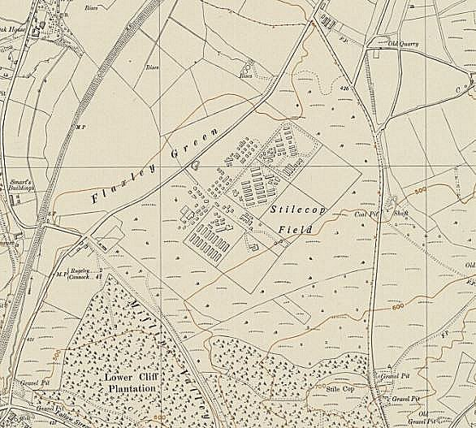
 | Ordnance Survey 1955

Research into Robert Stafford’s background; https://delawarewwiifallen.com/2022/01/26/technician-5th-grade-robert-stafford/

Record of the trial - https://tile.loc.gov/storage-services/service/ll/llmlp/ETO-BOR_Vol-6/ETO-BOR_Vol-6.pdf

2. One of the American guards at the camp, Aniceto Martinez, was found guilty of raping an elderly local woman in August 1944. Found guilty under US military law, he became the last man to be executed for rape in the UK on 15 June 1945.

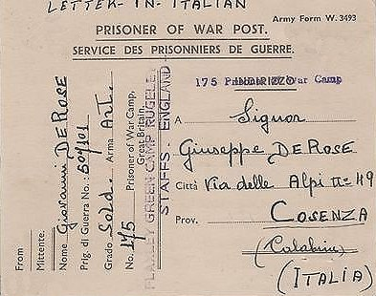
British POW Camp 175

March 1947 – recorded that 250 Youth (under-25) German pows being transferred to Radwinter Camp 180 (via Tarporley Camp 74) – “former C+ who were rescreened early this year and mostly up-graded”. (FO939/311).

14 November 1947 - Camp number included in an ‘Urgent Memorandum’ of (FO 939/270) regarding inspection of food parcels.

Camp magazine – ‘Zukunft’ (Future).

Postal items seen: C175 POW Card shown 1945; Letter-sheets, all Italian – 11/7/45; 1/12/45; 10 April 1946 – all C175. Italian pows would have been held in separate compounds from the Germans.

After the camp: An army camp on Stile Cop, formerly used for prisoners of war, was abandoned in 1957. Council Survey - The site of the camp is largely covered by trees and aerial photographs (taken circa 2000) suggest that several of the huts’ bases survive and others may be present under the trees.

The site as it is today - https://repatriatedlandscape.org/england/pow-sites-in-the-west-midlands/pow-camp-16-flaxley-green/

