Camp 14 (& 112) - Doonfoot (Bun) Camp, Ayr

Included in the 1945 ICRC list – Base Camp. 14. Doonfoot Camp, Ayr.

1947 Camp list
112(G.W.C.) | Doonfoot Camp, Ayr | Sc | Priswar, Ayr | Ayr 4685 | Ayr | (Blank) | v/1453/2

Prisoner of War Camps (1939 – 1948) - Project report by Roger J.C. Thomas - English Heritage 2003
OS NGR | Sheet | No. | Name & Location | County | Cond’n | Type 1945 | Comments
 |  | 14 | Doonfoot (Bun) Camp, Ayr | Ayrshire |  |  | Scotland

Location: NS 3203 1924 About 3 km SW of Ayr.  POW Camp: Italian and then German pows. Triangular layout to the camp with the staff accommodation at the NE end. Perimeter fence with guard towers.  December 1944 - The largest escape attempt in the UK was made from this camp on the night of 15/16 December, 1944. 97 (94 in some accounts) Italian pows escaped by tunnel. Although the initial escape was successful, the escapees seemed to have few plans once on the outside. 93 were found soon after, four more evaded capture for a few more days, (a soldier Pirisinu, and 3 naval officers Gianoli, Corini, Foglia). It was reported that the camp contained Italian non-co-operators - ‘malcontents’, Fascists and others unfit for work. Censor reports monitoring mail after the pows were returned to the camp noted that many had escaped just to experience freedom for a while, or to cause trouble for the guards, (FO 371/49859/ZM 696).  The ‘Daily Record’ ran a story about the escape and the reasons for it in 2016; “…it seems that discontent with conditions at the camp was the main motivating factor behind the escape. Upon being recaptured, one of the Italians reportedly handed a note to a British officer, signed ‘Italian PoWs’ and listing ten grievances the prisoners had about conditions at Doonfoot.  Top of the list was the confiscation of their radio, which they were using to listen to fascist propaganda stations broadcasting speeches by Mussolini.  “The Commandant of our camp has deprived us of our only enjoyable pastime, the radio, the only tie uniting us to the Italians beyond the Alps, who are still fighting with our German comrades. This is why 96 soldiers and an officer escaped from the camp,” an unnamed Italian prisoner at Doonfoot wrote in a letter to his family shortly after the escape.”  The escape was raised in the House of Commons; | 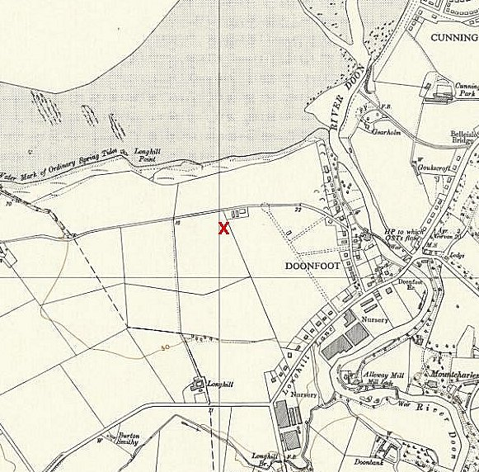
 | Ordnance Survey 1958
Arthur Henderson, (Financial Secretary to the War Office) – “Ninety seven Italian non-co-operator prisoners escaped from a prisoner-of-war camp in Scotland during the night of 15th-16th December. Eighty-nine have so far been recaptured. A full inquiry into the circumstances is being made.” (House of Commons, 21 December 1944, Vol 406, Col 1950).

1945 – recorded that ‘ardent fascist’ Italian pows were held here. It was suggested that escape attempts were becoming more frequent, however Arthur Henderson disagreed. Although this followed just after the arrest of pows at Le Marchant Camp 23, I am not sure if those events were public knowledge at that time.

One Italian tragically committed suicide in early 1945. He left a note before hanging himself with a belt; "I have never been anyone's enemy. Perhaps for that reason, the burden is heavier on me. Today, however, I feel that I hate Fascism, which has been the cause of my country's downfall. Long live England and her great people!" (Cannot find reference for this).

May 1945 - An interesting personal memoir from The War Diary of 2888211 Sgt. James Simpson Robertson, 2nd Battalion Gordon Highlanders (for 1945):
"8th May. The war in Europe finished today. A sort of anti-climax as I had waited so long for this moment, and feel nothing. I suppose it will sink-in in a day or so. Nothing much to report just general camp duties and sleeping out when not on duty. Doing as little as possible.
Discipline will become difficult now especially with the ex prisoners of war. A prisoner of war camp at Doonfoot, housing about 500 Germans is supplying us with work parties for camp duties. Keeping the place tidy and doing a grand job as dining room orderlies.
Detailed today to go to their camp and take 25 of them to the Rozell estate to put up marquees for a garden fete. Marched them across the Belisle golf course with two of an escort and a Junkers pilot as an interpreter. Two women lost golf balls in the rough, gave the order for the party to extend and search. found the two balls which were received with thanks as they are almost unobtainable.
Proceeded to Rozell. On arrival a girl on a swing started screaming and ran into the house. I learned later that she was a German Jewess evacuated from Germany. She panicked when she saw the soldiers. Erected the marquees and stalls then returned to Doonfoot.
9th May. In charge of the working party in the morning to dismantle tents and tidy-up. Found the prisoners easy to work with. The Sergeants had quite a lot in common with us. None of them were SS just ordinary soldiers wearying to get home.
10th May. Went to Doonfoot again this morning looking for prisoners who had experience of interior decorating. Senior officers at the racecourse, needed their houses painted. Got quite a surprise when I was given a continental style wheel barrow for young Jimmy. It had been made by the inmates using only a pen knife. It was their way of showing their thanks for the odd cigarette and decent treatment." (From a post by ‘georgersweir’, 29 August 2009 to the threetowners.net/forum).

15 September 1945 - Hostels listed for pows from Camp 112, (WO 32/10737):
Dalry, Ayrshire or Castle Douglas, Kirkcudbrightshire [why OR?] / Kilmaurs, Kilmarnock, Argyll / Park Hill, Dalbeattie, Dumfries

14 November 1947 - Camp number included in an ‘Urgent Memorandum’ (FO 939/270) regarding inspection of food parcels.

There was a camp magazine – Das Echo Zeitschrift der Kriegsgefangenen des Lagers 112.

Also listed as American Transit Camp No. 5 located in the UK.

WHY - (BUN)?

After the camp: residential area.

The site as it is today - https://repatriatedlandscape.org/pow-sites-in-scotland/pow-camp-14-doonfoot-camp/

Further information: Historic Environment Scotland http://canmore.org.uk/site/252975

The Imperial War Museum has copies of the magazine, dated February/December 1947 and January 1948. Ref LBY E.J. 348.

