Camp 13 (& 15) - Shap Wells Camp, Shap, Cumberland

Included in the 1945 ICRC list – 13. Base Camp. Shap Wells Hotel Camp, Penrith, Cumb’d.

Prisoner of War Camps (1939 – 1948) - Project report by Roger J.C. Thomas - English Heritage 2003
OS NGR | Sheet | No. | Name & Location | County | Cond’n | Type 1945 | Comments
NY 579 096 | 91 | 13 | Shap Wells Camp, Shap | Cumberland | 2 | Base Camp | Country Hotel. See Camp no.15

Location: NY 579 096. About 6 km S of the village of Shap. Remote. Wonderfully bleak with very changeable weather, often heavy snow in winter. Railway nearby needed two engines to get trains over Shap Summit.  Previous use: Shap Wells hotel opened in 1833. The hotel closed in 1939 for the war.  POW Camp: The camp opened with the number 15, and later became 13.  1941 - Opened as a pow camp, with the first pows arriving in February. The hotel grounds and part of the golf course were surrounded by a double barbed wire fence and searchlights.  Capacity for 200/250 using rooms on the first and second floors. The ground floor had a dining room and offices for the British administrators. The guards were accommodated in Nissen huts in the grounds – there was some resentment that the pows had better accommodation and facilities than they did.  Some entries state that Italian and German officers were held here. There is little evidence of the Italians, but I have seen mail to Italy from the camp sent in 1943. Officer survivors of the Bismarck sunk in May 1941 were held here, including Burkard Baron von Müllenheim-Rechberg, the Bismarck's top-ranking survivor. Some other ranks were also held here to serve the officers.  The first camp commandant was Major Guy Alexander Ingram Dury, M.C. (1895 – 1976) of the London Regiment and Grenadier Guards. Between the wars, he played for army cricket teams in first class matches. He retired from the army in 1931, but was recalled at the outbreak of the war and became brevet major on taking up the post at Shap Wells.  The camp was apparently nicknamed ‘u-boat hotel’ – just the same as Grizedale Camp 1 in its early days. | 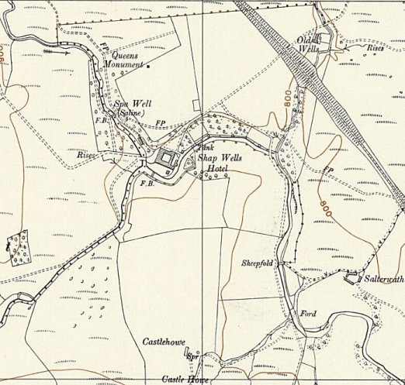
 | Ordnance Survey 1956

Prior to 1945 there were several escape attempts and a tunnel was discovered leading from the corner of a room used for music.

There was a notable escape attempt by two officers from Shap Wells. Unfortunately, a survey of the story, both in books and on the Internet, provides a complete ‘pick n’ mix’ approach to the events. Not only do the ‘facts’ vary, they come in many different combinations:

Leutnant Heinz Schnabel was the pilot of a ME109, shot down on 5 September 1940 over Kent. Oberleutnant Harry Wappler was the pilot of a Heinkel He111 bomber which crashed after hitting a barrage balloon in Newport.

- they met at the Royal Herbert Hospital in Woolwich
- Schnabel went to Grizedale Camp 1, then to Shap Wells
- they met at Shap Wells

Both arrived at Shap Wells in early 1941. At the camp they observed training flights over Shap Fell and planned to escape by flying home.

- they adapted Luftwaffe uniforms, including making fake buttons, to show they were Dutch pilots
- they wore flying jackets over their Luftwaffe uniforms in order not to be shot as spies
They also carried forged identity papers. In order to escape, on 23 September, they:

- hid in laundry baskets, managed to get out of the camp and stowed away on a train to Carlisle
- went for a walk, as this was allowed, if pows gave their word not to escape
- hid in a pile of firewood / log pile until night, escaped to Shap and at the railway cutting jumped onto a slow-moving freight train on its way to Carlisle.
- both feigned a toothache in order to be taken to Carlisle for treatment where they escaped.

At Carlisle they:
- laid low by watching a film until it got dark
- had a cold, but uneventful night
- made their way to Kingstown aerodrome where they hid overnight.

As there were mixed nationality trainee pilots at the aerodrome, the following day they persuaded an apprentice that they were Dutch airmen and he assisted by crank starting a ‘Miles Magister’ training plane and they took off.

- They initially planned to fly to Eire, but the weather in that direction was unsuitable.
- They planned to fly to the Netherlands, en route they landed and bluffed their way into getting the fuel tanks of the aircraft filled up again before continuing
- They ran out of fuel over Norfolk
Being short of fuel they:

- crash landed in a field and were detained
- landed in Norfolk. A policeman took Wappler to Caister police station to make a call to a nearby RAF base to request fuel, another policeman remained with the other ‘Dutchman’ at the aircraft.
- they landed and attempted to be re-fuelled at an RAF Station.

They were taken by car to RAF Horsham, still pretending to be Dutch airmen, where they did/not have tea/dinner and/or a bath, but were soon identified as escapees.

They were returned to Shap Wells camp where they received 28 days confinement as punishment. Later they were shipped to Canada with the other pows.

The camp commandant, Major Dury was said to have remarked: "One really has to take off one's hat to them ... I really regret having to lock them up."

These accounts read like a book where you can choose which route to take to make your own story! The variations on how they escaped are quite incredible.

Recommended : The One who (Almost) Got Away. - WW2Aircraft.net (pdf document of the story).

I have also seen two accounts that Rudolf Hess stayed here on his way to London – he did not.

A photograph album of 130 pows at Shap Wells was created in 1941 / 42 in order to aid identification if pows escaped. The album included photographs of Schnabel and Wappler. It was kept at Shap Police Station. A comment has been made that the pictures may have been used to identify the two escaped pilots – but, I wonder if it is more likely that the album was made after their escape and ended in 1942 when the pows were shipped to Canada.

March 1942, the pows at Shap Wells were sent to Canada. Further prisoners arrived later and were frequently shipped to Canada and the USA.

International Red Cross inspection visits were made to the camp on 18 March 1942, 15 October 1942, 4 June 1943; 19 August 1943, (205 German officers); 6 October 1943, (205 German officers); 17 November 1943; and 29 June 1944. There were complaints made about delays to letters and parcels arriving at the camp during the 1942 inspections.  The nature of the camp changed in late 1944 to become a camp for mainly politically white (Category A – non-Nazi) pow officers. The idea was to win ‘hearts and minds’ of the pows before sending them back to Germany. The pows were organised internally on largely democratic means with an elected executive committee.  Various sketches and paintings were made by pow Heinz-Georg Möllenbrok (aka Mollenbrook) at Shap. He had been shot down in 1941 and had been held at Kingwood Camp 23 for convalescence – his sketch of that camp later helped to identify the location.  November 1944. A group of ‘white’ pow officers were selected from those held at Comrie Camp 21 and transferred to Shap in December 1944. Amongst these was Prince Albrecht of Urach (German: Fürst Albrecht von Urach, Graf von Württemberg) (1903 – 1969) - a German nobleman, artist and wartime author, journalist, linguist and diplomat. Von Urach became the new Camp Leader, or Lagerfűhrer, though he liked to be called Lagerfűrst at Shap. (The previous camp leader was interviewed by Scotland Yard | 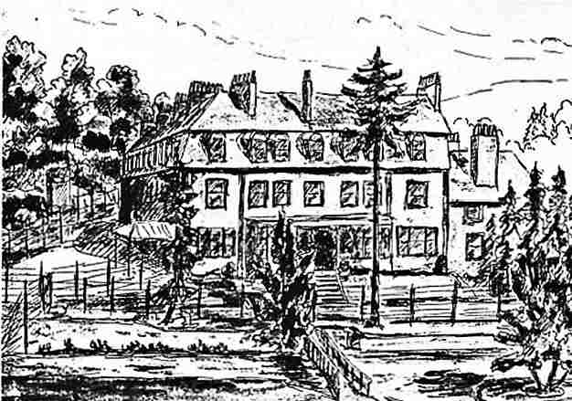
 | Shap Wells sketched by: Leutnant Heinz-Georg Möllenbrok
about the murder at Comrie). The Commandant soon passed over room inspections and overall camp discipline to von Urach.

Von Urach was not the only prince in the camp – there was also von Sayn-Wittgenstein, and there were other lesser aristocratic family members. The pows included doctors, academics, lawyers, architects, musicians…

Elected members of the committee included: Hubert Walter – deputy camp leader; Graf Podewils; Leutnant Mueller; Josef Huber (JoKarl – artist) and Joachim Ritter, (Professor of philosophy at Kiel University).

From 1945 visits were made to pow camps by the Political Intelligence Department on behalf of the Foreign Office. The quality of the reports and information given varied greatly.

25 / 26 August 1945. Report of a visit made by Mr James Grant.

Commandant: Lt Col Walker Lagerfűhrer: Fűrst von Urach.

Lieutenant Colonel Walker was described as; “a strong Tory of the hunting-and-shooting breed, who was delighted, indeed flattered, to have a prince as his camp leader…” ^{(*)} He even gave talks about hunting and shooting to the pows. I think this may be Cyril Frank Walker of the South Lancashire Regiment.

“This camp is considered to be very white, and is inhabited by about 150 officers and 90 other ranks. All except three are German.”

The visitor did not believe that the Commandant and his staff gave much encouragement for education / re-education courses. However, considering the range and level of courses available, I am not sure they needed to. Mr Grant described the atmosphere within the camp as being, “dilettante”. Despite this there were teaching sessions organised by the pows, largely under the direction of Professor Joachim Ritter for: English, French, Latin, History, Geography, Law, Architecture, Moral Philosophy and Commerce. (At one point Greek and Hebrew were also taught, but were not popular).

“They had an enormous library, run a camp newspaper, and appear to be very comfortable.” The newspaper was called; Arbeit zum Aufbau – (Work to build, or Construction Work – I have also seen it listed as Arbeit im Aufbau – ‘Work under Construction’). Other activities included lectures, poetry readings, and concerts. English and foreign newspapers were received.

The Other Ranks acted as orderlies, cleaners, cooks…. And received pay from the officers.

End 1945. Shap was one of the first pow camps to remove the barbed wire fencing. Uniform military decorations were removed, and many also removed their badges of rank.

13 January 1946. Mr R D Miller visited the camp to report on English language teaching. Strength 247 pows.

Commandant: Lt.Col C F Walker.

Almost half of the pows were attending English language lessons with six “entirely satisfactory” pow teachers.

One of the pows was described as; “the great luminary at this camp is of course WOELCKEN F., formerly lecturer at Edinburgh and Aberdeen.” It was suggested that he might be better employed elsewhere and his name did not appear as a teacher at this camp in the next report in June.

18 June 1946. Mr P Jackson visited the camp to report on English language teaching. Strength 214 German pows.

Commandant Lt.Col Tanner – “just taken over”. Lagersprecher: Von Urach

Four rooms within the building were used for lessons for up to 86 pows. Brief details were listed for the four pow teachers – Gutkess was a language master; Weth was a foreign correspondent; Baake was a schoolmaster; and Mientz was a business man (he was born in Southport, England). The teachers were described as “very able and keen”.

General remarks – “An Officers’ Camp, the standard of intelligence and the capacity for study were surprisingly high. There was a varied programme of subjects for study and of pastimes in the shape of choral singing, play reading, etc. Everything seemed well attended and to go with a swing.”

One of the pows at Shap was Oberst von Lindeiner-Wildau, previously Commandant of Stalag Luft III, Sagan, pow camp. Many comments were made of the respect pows and his staff held for him in that camp. There were many escapes from Stalag Luft III – the stories / films of ‘The Wooden Horse’ and ‘The Great Escape’ being just two events. There is confusion as to what happened to him after the Great Escape, but Hermann Goring revealed at the Nuremburg Trials that he was court martialled for the escape. He was sentenced to be imprisoned, but feigned mental illness and was admitted to an army hospital. He surrendered to the British and ended up at Shap. He visited the ‘London Cage’ to be interviewed several times, and gave evidence, about the murder of the 47 escapees from Sagan. He was repatriated in 1947 and died in 1963.

Werner Dűttmann, artist and architect, commented about his time as a pow at Shap; “I could be very lazy at Shap. I wasn’t involved in the quarrels of the camp. I had seen a great deal that was horrible and evil, but I was no longer in a situation that lay heavy upon me. On the contrary, I was full of hope for a better world, for the reception in England had been amazingly friendly. In comparison with all that had gone before, Shap was a good world.” ^{(*)}

3 camp magazine titles recorded for camp 13 – Arbeir zum (im) Aufbau / Zaungast / Sprachrohr

The last prisoners left in 1946.

Postal items: Pow mail to Italy dated October 1943.

After the camp: The hotel re-opened in 1947.

The site as it is today - https://repatriatedlandscape.org/england/pow-sites-in-the-north-west/pow-camp-13-shap-wells/

Further information:

National Archives – FO 939/99: 13 Officers Camp, Shap Wells Hotel, Shap, Cumberland, dated 1945 – 1946. (Used above).

(*) Thresholds of Peace – Matthew Barry Sullivan – 1979 – Hamish Hamilton. There are further details about some of the characters at Shap.

Cumbria Archive Centre, Kendal hold a CD copy of the photograph album of pows. WDX 1600 – dated 1941 – 1942. Also, WDY 634 various documents about the escape by Schnabel and Wappler.

There is a chapter about the attempted escape of the 2 pilots in the book, ‘A Taste of Freedom’ by R Jackson – 1964 – Arthur Baker Ltd. However, there are spoken words quoted which cannot possibly have been known by the author, and no references.

The German Federal Archives has a copy of the camp magazine.

