Camp 12 - Elmfield Camp, Gilford, Portadown, County Armagh

Included in the 1945 ICRC list - Base Camp. 12 Elmfield Camp, Gilford, Portadown, Co. Armagh.

Prisoner of War Camps (1939 – 1948) - Project report by Roger J.C. Thomas - English Heritage 2003
OS NGR | Sheet | No. | Name & Location | County | Cond’n | Type 1945 | Comments
 |  | 12 | Elmfield Camp, Gilford, Portadown | County Armagh |  |  | Northern Ireland

NOTE – The English Heritage list also records ‘Camp 11 Gilford, Elmsfield’ – there is no location for Elmsfield, only Elmfield.

Location: About 1.5 km NNE of Gilford, between the Moyallan and Plantation Roads. The camp was located in and around the grounds probably over-spilling into Wood Bank farm.  Previous use: Country estate owned before the war by the Uprichard family.  POW Camp: Italian and then German pows.  January 1945 – German pows arrived. Camp capacity stated to be 1800.  14 January 1945 - four pows escaped two days after arriving, intending to go to Eire. They used a plank of wood to lift the bottom strand of the barbed-wire fence. Martin Wolff, Luftwaffe and Heinrich Westermann, Army were captured on the same day at Tandragee. Horst Zimmerman and Ferdinand Kanowski (Kankowski?) were captured two days later.  26 May 1945 – a pow was killed in a lorry crash on the Portadown-Gilford Road at Knock Bridge. Several others were injured. Wilhelm Jungclaus was later reinterred at Cannock Chase German Military Cemetery. (Further, see https://archives.wartimeni.com/person/wilhelm-jungclaus/)  Camp commandant; Lieutenant Colonel (Thomas William?) Norrish, Royal Corps of Signals. | 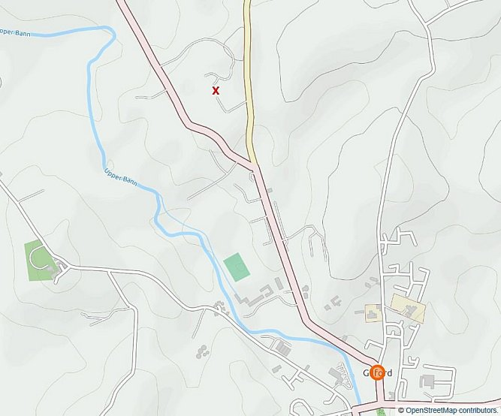
 | Estate about 1.5 km NNE of Gilford

After the camp: Camp huts sold in 1948. The house remained empty for about 10 years. Bought by the Shaw family and restored.

Further information.

Memories of the camp - https://www.wartimegilford.com/prisoner-of-war-camp/

https://wartimeni.com/article/german-pows/german-pows-gilford-tandragee-poyntzpass/

