Camp 12 (&15) - Donaldson’s School, West Coates, Edinburgh, Midlothian

Prisoner of War Camps (1939 – 1948) - Project report by Roger J.C. Thomas - English Heritage 2003
OS NGR | Sheet | No. | Name & Location | County | Cond’n | Type 1945 | Comments
 |  | 12 | Donaldson's School, West Coates, Edinburgh | Midlothian |  |  | Scotland

Location: NT 2354 7338. West Coates district of Edinburgh, close to Haymarket Station.  Previous use: School for deaf children opened in 1851. Children evacuated during the war from fear of air-raids on Edinburgh. In 1939 recorded as being used to hold internees.  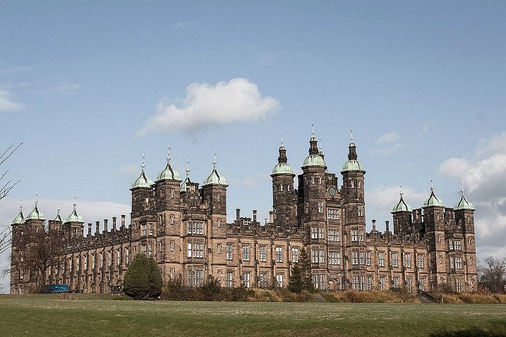  Photograph by David Monniaux - Own work, CC BY-SA 3.0 Wikipedia  POW Camp:  1940 - Recorded as being opened as Camp 12, (Appendix to WO 199/405). Italian and later German pows. Reported that Italians were housed in the east wing, and Germans in the west. It would appear to be mainly (completely?) Italian pows up to 1944. British guards were accommodated in tents on the lawn. | 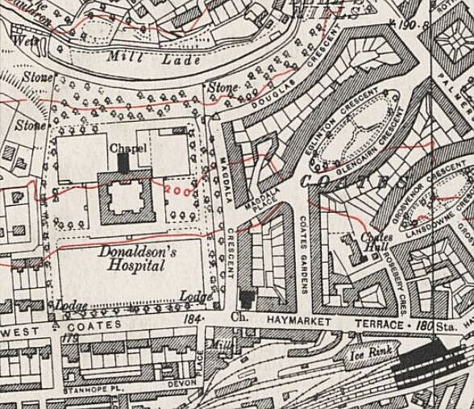
 | Ordnance Survey c 1944 – still shown as a hospital.

18 March 1942 – ICRC report on Camp 15 gives strength as 73 officers and 24 batmen – capacity 200.

5 May 1944 - Hostels listed for Italian pows from this camp, (WO 32/10737): Broughton, Biggar, Lanarkshire / Garvald, East Lothian / Livingston, West Lothian / Pathhead, Fife / Peebles

1944 - The camp was listed as an Italian Labour Battalion under the Scottish Command area in May 1944 and as a Pioneer Corps Group in November 1944, (WO 32/10737).

Historic Environment Scotland – “the building at West Coates was used for wounded German prisoners-of-war. Etchings drawn by soldiers were left on backs of shutters and the walls of the top floor.” https://blog.historicenvironment.scot/2022/04/donaldsons-school/

Postal items seen: POW Letter-sheets 30 August 1942 and 14 March 1943 in Italian to Italy

After the camp: Continued as a school for deaf children until 2008. Now apartments.

There was a sentry box kept after the war in the great hall, (not sure now that it has been converted).

Further information:

Historic Environment Scotland - http://canmore.org.uk/site/52623

Hostels

Broughton, Biggar, Lanarkshire. (Broughton NGR NT 112 364).

5 May 1944 - listed as a hostel for Italian pows for Donaldson’s School Camp, (WO 32/10737).

Garvald, East Lothian – now Burnside Court area, NGR NT 587 708.

1942 - Listed as a hostel with Italian pows, administered by Glenbranter Camp 6.

5 May 1944 - listed as a hostel for Italian pows for Donaldson’s School Camp, (WO 32/10737).

November 1946 – hostel administered by Gosford Camp 16 for German pows - strength 65.

Livingston, West Lothian

1942 - Listed as a hostel with Italian pows, administered by Glenbranter Camp 6.

5 May 1944 - listed as a hostel for Italian pows for Donaldson’s School Camp, (WO 32/10737).

Pathhead, Fife.

1942 - Listed as a hostel with Italian pows, administered by Glenbranter Camp 6.

5 May 1944 - listed as a hostel for Italian pows for Donaldson’s School Camp, (WO 32/10737).

Peebles

Memories – “The Caledonian road had a POW camp. Initially with Italians and latterly German. In fact, there were German POW's still there until 1947-8. My father who was manpowered during the war was in charge of POW's felling trees." By Aird Muir -

5 May 1944 - listed as a hostel for Italian pows for Donaldson’s School Camp, (WO 32/10737).

