Camp 11 - Racecourse Camp, Knavesmire, York, Yorkshire (aka York Racecourse Camp)

Prisoner of War Camps (1939 – 1948) - Project report by Roger J.C. Thomas - English Heritage 2003
OS NGR | Sheet | No. | Name & Location | County | Cond’n | Type 1945 | Comments
SE 59 49 | 105 | 11 | Racecourse Camp, Knavesmire, York | Yorkshire | 4

Location: Similar to some other racecourse sites, the camp was located inside the racecourse. The racecourse was next to the Terry’s Chocolate factory which made aircraft parts during the war.  Previous use: Racecourse. In 1940 it was listed as ‘003 Racecourse Aliens Camp, York’, this lasted until at least March 1941.  POW Camp: Recorded as being inside and around the main grandstand and administration buildings, surrounded by barbed wire fencing.  Memories of the camp record Italians and then German pows.  In April 1942 the Baedeker raid on York missed the camp and nearby Terry’s factory, though there was a fatality just north of the site. |  | 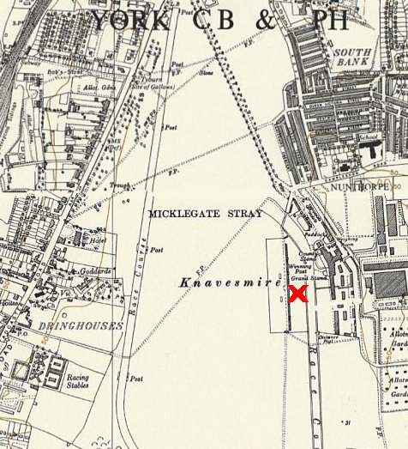
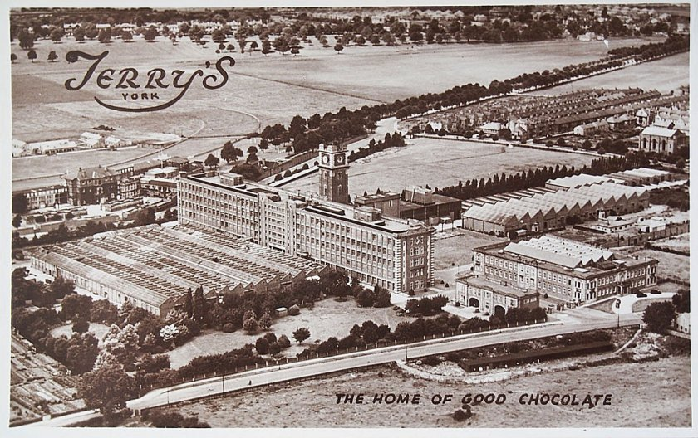 | Closed some time before September 1945.  < Terry’s Chocolate factory with racecourse behind.
 |  | Ordnance Survey 1950
 | After the camp: Racing at York resumed in September 1945.

The site as it is today – https://repatriatedlandscape.org/england/pow-sites-in-yorks-humber-and-lincs/pow-camp-11-racecourse-york/

