Camp 11 (& 198) - Island Farm Camp, Bridgend, Glamorganshire

Prisoner of War Camps (1939 – 1948) - Project report by Roger J.C. Thomas - English Heritage 2003
OS NGR | Sheet | No. | Name & Location | County | Cond’n | Type 1945 | Comments
 |  | 11 | Island Farm Camp, Bridgend | Glamorganshire |  |  | Wales. See Camp no.198
 |  | 198 |  |  |  | Base camp | Wales. See Camp no. 11

1947 Camp list
11(S.C.) | Island Farm Camp, Bridgend, Glam. | W. | Priswar. Bridgend. | Bridgend 541 | Bridgend | Major.D.B.Topham | v/202/4

Note – there is a good deal of material about this camp; websites (though often repetitive), books and documentaries. I give an outline here and some further details I have not seen on other websites.  Location: SS 899 784. On the outskirts of Bridgend, just off the A48.  Previous use: Built in 1938 to accommodate female workers from the Royal Ordnance factory in Bridgend, but they found it to be unsuitable. Temporary camp for US troops from October 1943 to D-day.  POW Camp: Prefabricated concrete huts, with catering, ablution and entertainment buildings in red brick. There was a parade ground and football pitch. Enclosed by barbed wire fences.  1944 - A list of Italian pow camps records that Italians were held here 1944/45 – not confirmed.  Opened as Camp 198 for up to 2000 German pows. At first there were mainly other ranks, but from November, 1944 some officers were also sent to the camp.  Serious discipline problems within the camp originated with the arrival of Nazi officers. There were many recorded incidents of violence by Nazi sympathisers against other pows. The RC Padre was told to remove his church from one of the huts, when he refused, threats were made that he would be killed and he had to be moved to another camp. One pow, Otto Iskat, was beaten so badly for speaking out about continuing the war that he later died from his injuries on 26 January 1945, (later buried at Cannock Chase German Military Cemetery).  There were several escape attempts. One tunnel was discovered with a digger still in the shaft. Two pows made wire cutters from window bars and cut through the wire. | 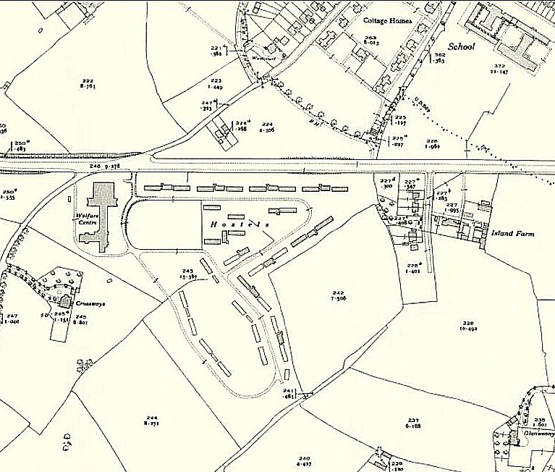
 | Ordnance Survey 1946 – still marked as ‘hostels’
10 March 1945 - 84 pows escaped by a tunnel from Hut 9, the largest mass escape in the UK. There are still questions over some details, such as how many pows escaped.

The Secretary of State for War gave a brief account of the escape with some errors on 15 March 1945, and announced that a court of inquiry was being convened. He was asked about the suitability of the site, and three weeks later the camp was closed. (House of Commons Vol 409). The pows were sent to Carburton, Camp 181.

January 1945 - The camp was re-opened as Special Camp 11 in late 1945, though the first officers arrived January 1946. It would house a much smaller number of very senior German officers, many of whom were awaiting trial – and some other ranks.

Four of the senior officers were sent for trial; von Rundstedt, von Brauchitsch, Manstein and Strauss. They were transferred to the military hospital at Diss before being returned to Germany.

14 November 1947 - Camp number included in an ‘Urgent Memorandum’ (FO 939/270) regarding inspection of food parcels.  May 1948 - The Camp was closed in. The last pows were escorted by the Commandant and a small number of guards all the way back to Germany.  Known Camp Commandants:  1944/5 - ? Lieutenant-Colonel Darling – previously with the Royal Artillery  c.1947 Major D B Topham c 1947 – from the Royal Fusiliers. Previously Commandant at The Hayes Camp 5 and Cockfosters/Trent Park Camp 11.  1947 – 1948 Major C M L Clements of the 4th Queen’s Own Hussars.  For high ranking German pows, see list on website mentioned below.  After the camp: Complaints about the camp being left abandoned were made in 1953, (House of Lords, 24 March, 1953, Vol 181, Col240). Now, only Hut 9 remains – occasionally opened for visits. Housing estate. 2003 / 2016 archaeology investigations.  The site as it is now - https://repatriatedlandscape.org/pow-sites-in-wales/pow-camp-11-island-farm/  Further information: http://www.islandfarm.wales/  National Archives references: FO 939/97 – 11 Officers’ Camp, Island Farm Camp – dated 1946-48  Listed at coflein.gov.uk – 31802 and 31803 | 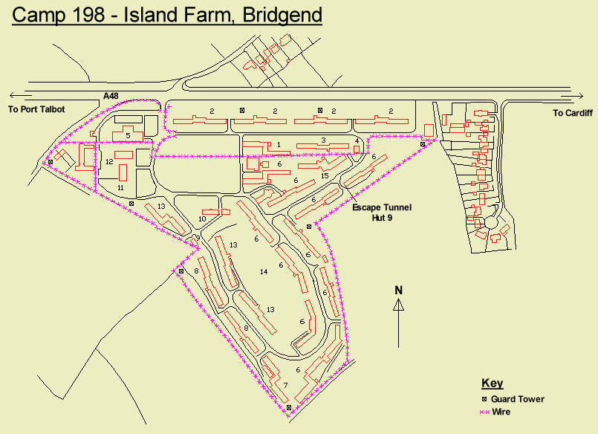
1. British Officers quarters. 2. Other Ranks quarters. 3. Cookhouse & Canteen. 4. Quartermasters Store. 5. Guard room & cells. 6. High ranking German Officers quarters. 7. Officers cookhouse & mess. 8. Officers rest room.
9. Camp Commandant's Office. 10. Sick Room, Dentist & Doctor. 11. Theatre. 12. Other Ranks kitchen. 13. Other Ranks sleeping quarters. 14. Parade ground & playing field. 15. Workshops - Maintenance.
Found on Google images with broken link.
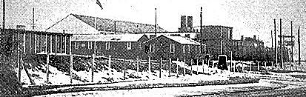

A bleak view of the front of the camp.

National Library of Wales - NLW MS 24094; documents and collected by Captain Ted Lees, Intelligence Officer.

London Metropolitan Archives – LMA/4288/D/004 – correspondence with imprisoned generals – 1946-48.

“Multi-disciplinary investigations at PoW Camp 198, Bridgend, S. Wales: site of a mass escape in March 1945” - Journal of Conflict Archaeology, 2017 – freely available online:
https://doi.org/10.1080/15740773.2017.1357900

Aerial photograph 1947 - Bridgend Island Farm, Prisoner of War camp, 1947 | Peoples Collection Wales

Facebook page for Hut 9, Island Farm P.o.W Camp and ROF Bridgend - https://www.facebook.com/groups/108034282547714/ -

Collection of pictures - https://www.peoplescollection.wales/collections/377332

‘The German Great Escape’ - Peter Phillips – 2008 - ISBN-13: 9781854113832

