Camp 10 (& 11) – Cockfosters / Trent Park Camp, Barnet, London

Prisoner of War Camps (1939 – 1948) - Project report by Roger J.C. Thomas - English Heritage 2003
OS NGR | Sheet | No. | Name & Location | County | Cond’n | Type 1945 | Comments
TQ 290 973 | 166 | 10 | Cockfosters Camp, Barnet, London | Middlesex | 5 |  | May be the same camp as at Trent Park see.below
 |  | 11a | Trent Park Camp, Trent Park, Barnet |  | 2 |  | Large house enclosed by a double wire perimeter, pillboxes & watch towers

There are sufficient books and websites concerning Cockfosters / Trent Park for me just to give an overview.  Location: Cockfosters is a suburb of London. Trent Park is a large park within Cockfosters. Trent Park House is in the London Borough of Barnet.  Previous use: Large country house and estate. There were several owners and many alterations to the house. When the last owner died in 1939, the Park was requisitioned for use as a pow camp.  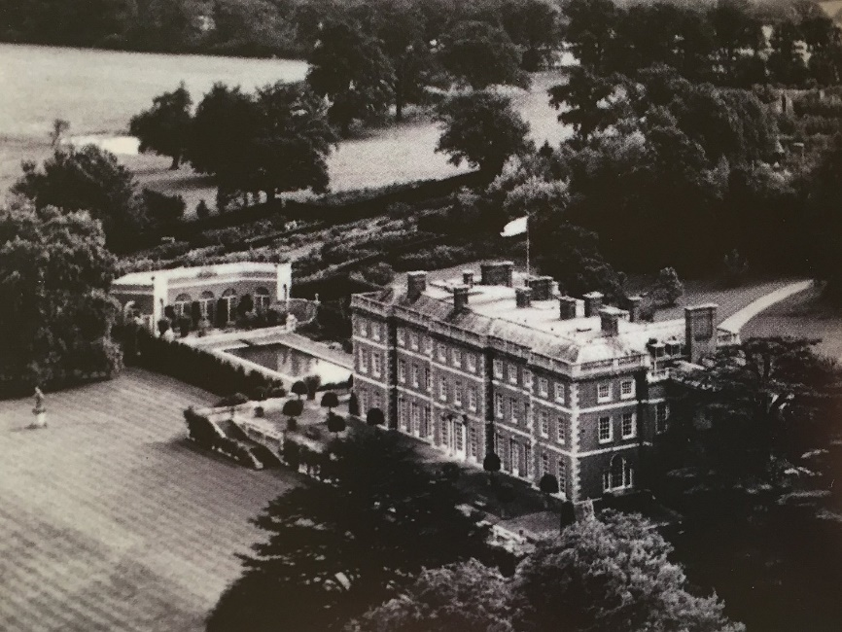  Trent Park Estate late 1930’s | 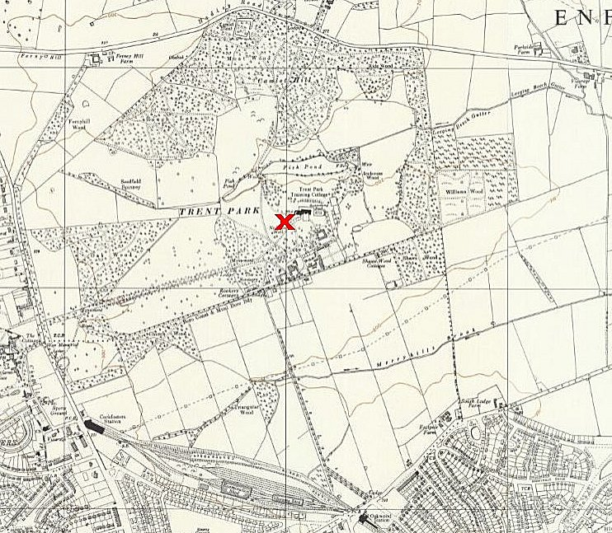
 | Ordnance Survey 1960

POW Camp: The Combined Services Detailed Interrogation Centre (CSDIC) moved from the Tower of London to Trent Park on 12 December 1939. It was called Cockfosters Camp at that time.  The CSDIC was under the control of MI9 and led by Lieutenant Colonel Thomas Joseph Kendrick. The Centre used overt and covert methods to obtain information. Covert methods included hidden microphones in 12 rooms and ‘stool-pigeons’ to initiate discussions, (some of these infiltrators were Germans and Austrians working for the Pioneer Corps).  Some of the first pows were German pilots, including Franz von Werra, (mentioned in “The One That Got Away”). Later German high-ranking officers, including 84 generals, were held at Cockfosters.  Further centres were opened on 15 July 1942 at Latimer House, Buckinghamshire, and on 13 December 1942 at Wilton House, Camp 20. They also had similar secret microphones installed.  Rooms included a common room, hall, reading room, study and a dining room. Facilities included a radio, billiards, table tennis, painting, gramophone, library and a canteen selling many items. The officers’ laundry was cleaned and a tailor ensured clothing was cared for. There was an interpreter who also acted as a ‘welfare officer’ to befriend the officers – he was of course an MI9 officer. | 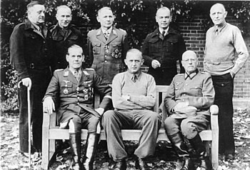
 | Back, l to r: Gen. D von Choltitz, Oberst G Wilck, Gen. H-B Ramcke, Gen.Mr K Eberding, Oberst E Wildermuth. Front, l to r: Gen.lt R von Heyking, Gen.lt K-W von Schlieben, Gen.lt W Daser.

One of the overt ‘techniques’ used was simply to treat the pows well, to put them at their ease, in order to encourage chat. Standards were generally high. Some officers were expected to share a room, and they raised complaints about this. Senior generals however were provided their own room, or even suite of rooms. Gen. Crüwell arrived early September 1942 and reported to a camp inspector at the end of September that he had no complaints. He had been accommodated in a “spacious cottage” in a “well-kept park.” His cottage consisted of a large, well-furnished bedroom, bathroom, living room and dining room. He was allowed to walk within the grounds for two hours each day and given occasional excursions outside the camp. The respect shown to him by the British guards was also noted. [Report of visit with General Crüwell, Camp No. 11, 28 September 1942,” PERS 6/114, BA-MA].

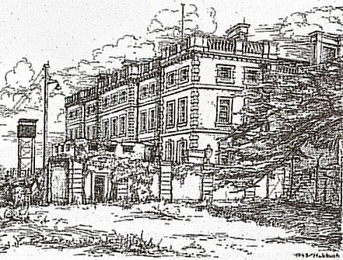 | Photographs of German officers were taken at Trent Park during 1943 / 1944 – example shown – they can be found at: https://www.bild.bundesarchiv.de/  19 October 1945 – the camp closed.  Camp Commandants:  Dates unknown - Major D B Topham, from the Royal Fusiliers. Previously Commandant at The Hayes Camp 5, moved on to be Commandant at Island Farm Camp 11  After the camp: The Park was purchased by Middlesex County Council in 1951. The house was used as a training college.  Further information:  National Archives references: Interrogation reports of pows at CSDIC(UK) May 1942 to October 1945 – WO 208/3582-3620  Tapping Hitler’s Generals – Ed Sönke Neitzel – Frontline Books – 2013 - and others
By Pow ‘Hubbuch’ - 1943

https://www.trentparkhouse.org.uk/

