Camp 7 - South Brent Camp, South Brent, Devonshire

Included in the 1945 ICRC list - 7. South Brent Camp, South Brent, Devon.

Not included in the English Heritage report.

Location: South Brent is a large village on the southern edge of Dartmoor, in the valley of the River Avon. It had a railway station on the South Devon Railway. Camp at NGR SX 704 597, possibly some further huts just to the north at Sanderspool Cross on map. |  | 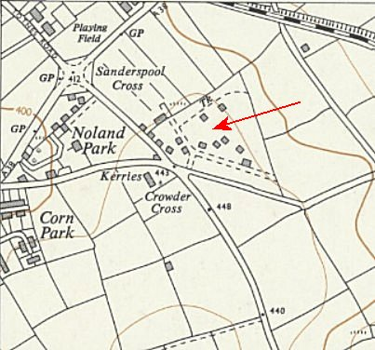
Previous use: Farmland, US troop camp up to D-Day (Sanderspool Camp).
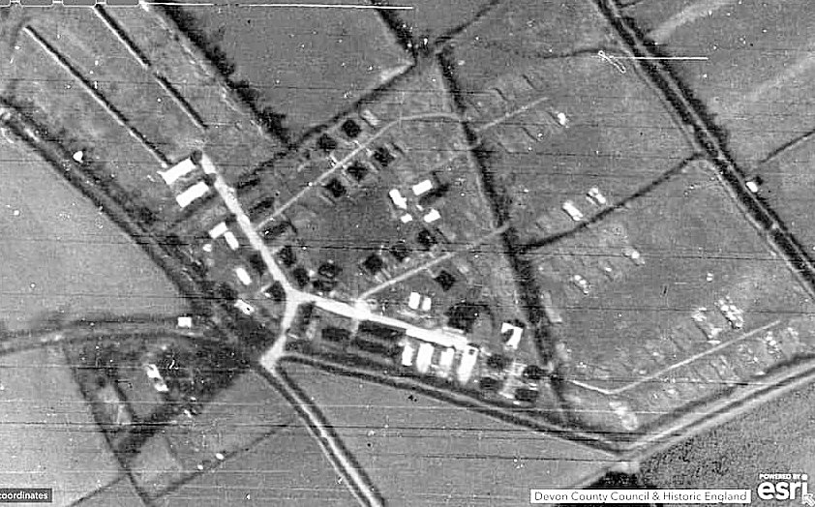
Devon County Council / Historic England |  | Ordnance Survey 1963

POW Camp: A hutted camp. Accommodation was described in one report as ‘not good’ due to being often overcrowded. They did have electric lights.

It was a Holding / Transit camp for the repatriation of pows. There was a permanent German pow staff of about 120. Up to 1500 other pows (capacity) could also be passing through the camp.

1945 – The camp was recorded in a list of pow camps sent to the ICRC – but it was reported as having been opened in March 1946. Possibly Italian pows located here 1945 preparing the camp.

March 1946 – The Commandant, Lt Col P L Grimwood was transferred from Winter Quarters Camp 7 to South Brent Camp 7 - presumably some of the British staff as well.

German pows transferred to this camp as permanent staff: 100 from Bourton Camp 157; 10 pow clerks from Sandbeds Camp 53; 2 MO from Lodge Moor Camp 17.

16-18 May 1946 – Major C H B Readman visited to screen 1500 pows. Most of the pows had been transferred from US Camps in the BAOR. Permanent staff – 110 OR, 2 M.O.

Commandant: Lt Col P L Grimwood MC TD. Camp leader: HFw H Falk (A)
Interpreter: Capt D W MacIntosh Deputy C/L: Fw K Irmscher (A)
German MO’s: St.Arzt Franzen
O/Arzt von Keller.

Morale was regarded as only ‘fair’. Although the permanent staff were working long hours arranging for the repatriation of other pows, they had not been paid as it was not listed as a working camp. Politically the camp was categorized as grey.

The standard list of re-education activities was given. With such a low number of permanent pows there was not much scope for developing these activities:

Wochenpost and Ausblick – 40 / 0 respectively.

Newspapers – 5 British daily papers purchased. A request was made that British Officers donate their papers. Some German papers received.

Library – 0nly 25 books.

Lectures – 2 so far by outside visitors. The pows were recorded as: “Intellectual level – low”.

Discussion groups – some talks had been given by the pows.

Films – every 2/3 weeks from the YMCA. Very popular.

Radio – one set in one of the dining halls.

Camp magazine – none

Press review – Friday evenings with about 40 pows.

English Instruction – 4 classes with 69 pupils.

The Political Intelligence Department, (PID - overseeing pow re-education) were requested to send newspapers, books, films, monthly lecturers and teaching materials.

Other activities –

Religion – Father Benedikt from Buckfast Abbey gave weekly RC services. Rev Karle, an Evangelist pastor from Torquay gave weekly protestant services.

Education – classes for Russian, mathematics, Accountancy and Stenography.

Theatre / Orchestra – none.

4-7 June 1946 – 5 members of a screening team from PID arrived to politically screen 750 Austrian pows at this camp. 9 of the pows had not yet arrived. 62 were officers. The pows were due for repatriation. The German pow staff were not screened.

It was noted that the camp had only recently been opened and that it was not expected to remain open for long.

No change to senior personnel, but the two M.O.’s no longer listed.

The camp was considered to be overall politically ‘grey’. Screening results:

British zone |  | U.S. zone |  | French zone |  | USSR zone |  | Vienna zone |  | ‘C’  category | Hospital | German  nationals
A | B | A | B | A | B | A | B | A | B
8 | 164 | 8 | 134 | 2 | 54 | 7 | 196 | 19 | 130 | 13 | 2 | 4

The four German nationals were unable to prove Austrian citizenship, or had expired Austrian passports.

12 June 1946 – Major T Barry gave an English Inspector’s Report. Strength 122 permanent German pow staff – many others passing through.

There were 5 English classes at various levels with 69 pow pupils. There was a shortage of teaching resources.

29 July 1946 – Mr L P D Cooper conducted the first survey on behalf of the Control Office for Germany and Austria, (COGA (UK)) of pow re-education at this camp. Permanent staff strength 115 O.R.; “appointed by the Commandant. They were well chosen and carried out their duties efficiently. They are keen on re-education.”

Only change to senior staff - new Interpreter Officer: Lt H Grenville.

Political screening: | A+ | A | B+ | B | B- | C
 | 3 | 15 | 36 | 43 | 17 | 1
(From A+ anti-Nazi (‘white’) – to C Nazi (‘black’) – overall the camp was categorised as ‘grey’).

The Interpreter was stated to be; “keen on re-education and carries out his job well.”

Morale was considered to be good, but, as in all other camps, there was despondency over the lack of information about repatriation.

45 of the pows were ‘youth’, (under-25), but they were not considered to be a problem.

The standard list of re-education activities was given. Considering that people were apparently ‘keen’, there was little activity listed, and no outside contacts.

Wochenpost / Ausblkick – 50 / 0 copies received

Newspapers – none regular, owing to shortage of local supplies. As requested, British Officers gave their own papers. A news digest was read out at meal times. Some articles were pinned up on walls.

Library – 248 mixed books. No details given as to how many were in German.

Lectures – 3.

Discussion group – none. Some discussions were held after lectures.

Films – supplied by YMCA fortnightly. COGA newsreels alternate Sundays.

English instruction – 2 classes. Still a shortage of teaching texts.

Wireless – good. Controlled by Camp Leader. The Hamburg station was popular.

There were plans to start a camp magazine if paper could be supplied.

Other activities:

Religion – the RC priest and protestant padre only came once a month.

Education – French and Russian classes of about 10 pupils. Some instruction for mathematics and shorthand.

Theatre – none

Orchestra – 7 members (Violins, saxophone and clarinets).

18 August 1946 – Major T Barry gave a further English Inspector’s Report. Strength 113 German staff.

Late 1946 / early 1947 – the camp closed.

Not included in the 1947 Camp list. Lt Colonel Grimwood (originally from the Royal Artillery) was recorded as retired, September 1947.

After the camp: Used for emergency accommodation up to the mid-1950’s. Reported as being cold, draughty and damp.

Further information:

National Archives reference: FO 939/89 – 7 Holding Camp, South Brent Camp, Tiverton, Devon. Dated 1946. Used above.

