Camp 5 - Monrush Camp, Cookstown, County Tyrone

Prisoner of War Camps (1939 – 1948) - Project report by Roger J.C. Thomas - English Heritage 2003
OS NGR | Sheet | No. | Name & Location | County | Cond’n | Type 1945 | Comments
 |  | 5 | Monrush Camp, Cookstown | County Tyrone |  | Base Camp | Northern Ireland

Location: Information received from Andy Glenfield (Website - The Second World War in Northern Ireland - www.ww2ni.webs.com ); “I eventually found a man who told me that it was off Lissan Road. I met up with him in Cookstown and the site is from the junction of Lissan Road and Lissan Drive.  The Housing estate and Children’s playground has been built on most of the site however, little remains. There is a red coloured shed on Lissan Road immediately past Princess Avenue on the left. This was part of the Camp!” (Confirmed by a local resident).  Previous use:  POW Camp: From the two entries below; Italian, then German pow camp.  Pows worked at local farms including Lissan House, Cookstown. Hazel Dolling, the last of the Staples family to live at Lissan, said that some of the Italian POWs made furniture from the oddly shaped boughs of laurel which pervades the woods at Lissan.  March 1945 - A German pow was killed during an escape attempt, shot by sentries on 20 March 1945. In most articles his name is recorded as Herbert Lisser, but the CWG entry states his surname was Lissen.  Mid Ulster Mail news article, 24 March 1945: “While attempting to escape from the prisoner of war camp near Cookstown on Monday (20th March) night, a German prisoner of war, aged 21, was fired on by the military guard and received five bullet wounds. He was attended to by two German doctors and later taken to Dungannon Hospital, where he was attended to by Dr J G Bell. Subsequently he was removed to a military hospital in Belfast, in a serious condition. It is stated that the German had got clear of the heavy barbed wire entanglements when spotted, and as he refused to halt, the sentry opened fire. He received four bullet wounds in the right arm and a fifth in the chest. The right arm was badly shattered and Dr Bell gave a blood transfusion.”  The hospital in Belfast was Orangefield Military Hospital (Camp 161)  Details of the funeral appeared in the Belfast Telegraph, 24 March 1945: “The Nazi salute was given by more than 100 German soldiers and airmen who stood on the steps of a | 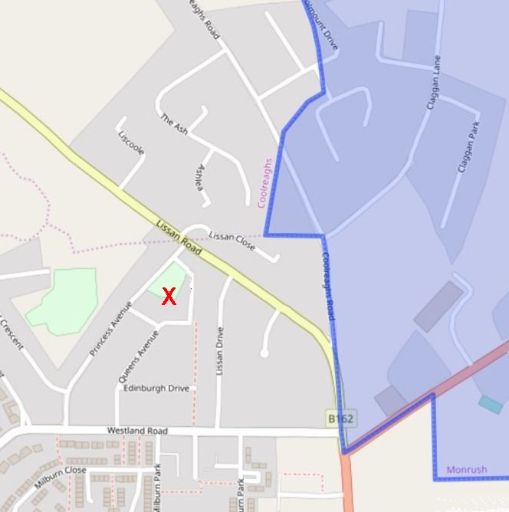
 | Camp east of the townland of Monrush, (in blue). © OpenStreetMap contributors
hospital at a Northern Ireland prisoner of war camp today, and watched the funeral of one of their comrades, an army corporal who was fatally wounded when attempting to escape from a camp.

The coffin, draped with a Swastika flag was carried by six members of the Luftwaffe. Included in the small party who walked behind the coffin were two German nursing sisters who, with a number of others, were taken prisoner in a Brussels hospital. At Belfast City Cemetery, where the internment took place, a brief service was conducted by the German chaplain.” [The pow was an ‘Obergefreiter’ – he was a member of the Luftwaffe, rather than the army].

Herbert was first buried at Belfast City Cemetery. One site records that he was reburied in Germany on 18 July 1962 – however, the CWG entry states that he was interred at the Cannock Chase German Military Cemetery (Plot 4 Row 1 Grave 14).

A plan of the camp (and article) was issued in the ‘Mid Ulster Local History Journal – Vol 7’; [https://www.coaghinww1.co.uk/docs/b017.pdf]. An enhanced image is shown.

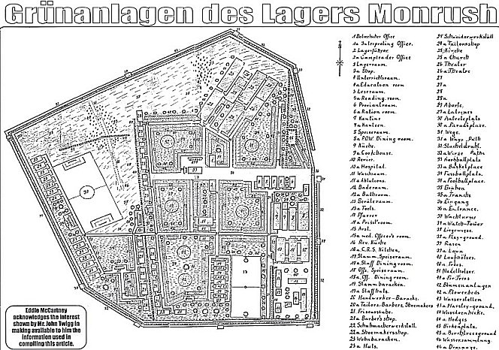 | With a slight rotation of the plan, it can be seen how the current road layout is very similar to the perimeter of the camp.  The plan was drawn by pows with the authorisation of the commandant. It was presented to Stewart Twigg who was the c/o of the local Home Guard.  “On one of his visits to the Camp it was mentioned to Mr Twigg that the prisoners wanted to build a model of a Rhine Castle but that they needed a plan to work from…” Mr Twigg supplied a copy of Grimms’ Fairy Tales with a picture of a fairytale castle and this was used as a design. The castle was built inside the camp entrance on Lissan Road.  The Camp was closed during 1945 (FO939/383).

