Camp 4 - Scraptoft, Thurnby, Leicester, Leicestershire.

1947 Camp List
4(B.C) | Scraptoft Camp, Scraptoft Thurnby, Leicester. | N. | Priswar, Thurnby | Thurnby 437 | Leicester | Lt.Col.E.Howell, M.B.E. M.C. | v/202/4

Prisoner of War Camps (1939 – 1948) - Project report by Roger J.C. Thomas - English Heritage 2003
OS NGR | Sheet | No. | Name & Location | County | Cond’n | Type 1945 | Comments
SK 64 05 | 140 | 4 | Scraptoft, Thurnby, Leicester | Leicestershire | 5 | Base Camp

Location: SK 650 062 (incorrect GR given above). Four miles to the east of Leicester, just north of Scraptoft Hall and west of Beeby Road. The large area included farm land and part of the golf course.  Previous use: Part of the Scraptoft estate and golf course, (the Golf Club was formed 1928). From about February 1944 to June 1944, the 325th Glider Infantry Regiment of the 82nd US Airborne Division was based on the site. Their site was called Camp March Hare.  The FPHS Journal No.309 records that there was a military hospital at Scraptoft in 1941 with Italian pows, and then; “Italian presence after 1941 not proved.”  POW Camp: After the US troops left for D-day, the camp became number 4 pow camp for German pows and then a repatriation camp.  Italian pows were often employed in preparing sites as pow camps. This is possible here as the site was vacant from mid-1944 and it may explain the suspicions that Italians were held at this site. (??).  July 1945 – recorded as being formed in this month as a pow camp in a later report.  7/8 November 1945 – Report made by Mr.Dadley-Potter for an ‘English Educational visit’. Strength: 738 Germans.  Commandant: Lt.Col.Howell.  Education Officer: Capt.Fryers; “does not know German”.  Interpreter…”does not take much part in camp activities”. | 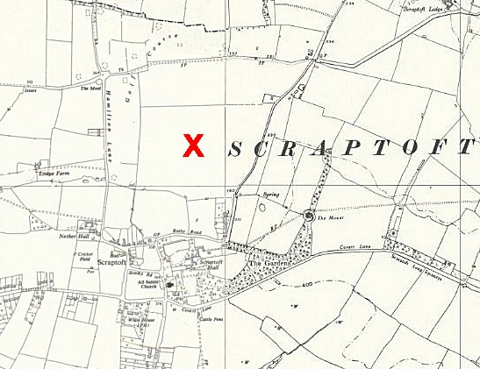
 | Ordnance Survey 1952 – approximate centre of camp shown

The comments about the German Camp Leader were more positive; “BADER. Is the life and soul of the English educational movement here…”

Scraptoft was categorised as politically; ‘Grey’.

The visitor stated that there were 11 English lessons per week of various standards. He also commented that the camp was unfinished and that by the end of the year it may become a repatriation camp.

29 August 1946 – Number 4, Base Camp. General Report made by L P D Cooper. Strength 3100 / Officers: 2 / Other Ranks 3098

The camp was re-categorised as grey / black. Despite this, very few prisoners had been screened: A (white) 4 / B+ (grey) 3 / B 38 / B- 27 / C (black) 2 / unscreened 3020.

Commandant: Lieutenant Colonel E Howell DSO, MC.

There were three interpreters, who; “are extremely keen on re-education, speak good German and untiring in their efforts to further the aims of COGA.” COGA = Control Office for Germany and Austria, with an office in London overseeing ‘re-education’ of German pows.

Camp Leader; O/Faehnrich Gabriel, (Oberfähnrich equivalent to highest non-commissioned officer rank).

Deputy; O/Faehnrich Schochmann.

There were also 2 German medical officers.

The report stated that the camp was formed last July (1945). The pows at that time were; “sick personnel awaiting repatriation, who have come from camps 167, 166, 183” These were the nearby camps 166, Wollaton Park, Nottinghamshire, 167 Shady Lane, Leicestershire and 183 Quorn Camp, Leicestershire. This ties in with the 1941 report that there were military hospital facilities at Scraptoft.

“Morale on the whole is bad, owing to Ps/W having no work to do and being on non-working rations. Their sole interest is to get home as soon as possible. Apathy exists but is being countered by re-education.” Up to this time repatriations for German pows were irregular – a more regular schedule started in September 1946.

“The camp has not yet been segregated. The following estimate is based on information supplied by I.O. and the camp staff: 20% Nazis, 60% no political opinion, just sheep, 20% anti-Nazi.” 1000 of the pows were ‘youth’, aged between 18-25 and it was hoped that they would soon be housed in special huts with their own leaders and instructors.

The facilities were basic. The standard list of re-education activities was given - English newspapers and two German newspapers were received; although there was no library, there was a reading room and about 200 books had been donated; no lecturers had visited the camp; no discussion groups, but one was expected to start the next week; films were shown once a month; one old wireless in bad repair. There was a camp magazine, but it was probably of limited interest as; “Articles are mostly by the editor and contributions from the British staff.”

Other activities included English, French, and mathematics lessons – but lessons were often disrupted as the instructors were repatriated. Likewise, there was a theatre group and a nine-piece orchestra, but they were also due to be repatriated. Religious services were held regularly by a pow lay preacher, with a new church being created in a hut. A Catholic priest also visited from camp 167 once a fortnight.

NOTE – The camp was redesignated as a repatriation camp and the ‘strength’ of the camp given in the reports below only applied to the German pow staff working there - many other pows were passing through every month for repatriation.

24 February 1947 – visited again by L P D Cooper, now reviewing ‘Re-education’. Strength: 204 / Officers: 1 / Other ranks: 203.

Political screening figures; A 11 / B+ 38 / B 100 / B- 26 / C 26 / unscreened 3.

Commandant: Lt.Col Howell Camp Leader: Alfred Wengel Fw.
Interpreter: Capt.Tombala, Polish, but speaks good German Deputy O/Gefr. Georg Demnich
German MO: O/Arzt Zeiss.

Morale was recorded as good as repatriations were well underway and there was sport and recreation in the camp. There were few pows in the camp with strong political views. The number of 18-25 year olds (‘youth’) had decreased to just 80. Re-education activities were similar to the previous report, but pows were staying much shorter times. The old wireless broke down.

27 June 1947 – Mr Cooper returned for another visit. Strength: Officers 2 / Other ranks 188.

Political screening figures; A 4 / B 186. Some pows were appealing against their category because ‘A’ category prisoners were repatriated before others. It was noted that there had been 60 appeals, and all were successful. There had been a further 50 pows repatriated since March.

The commandant and interpreter remained the same as before; the new Camp Leader was Gefr. Demmich, G(eorg) – an ex-SA member and described as, “Has a militaristic outlook; not a good type”.; Deputy Uffz. Heinz, J. There were two new German medical officers.

Morale was still considered to be good, and the camp was regarded overall as politically grey. 75% were ‘youth’. It was noted that recent ‘privileges’ (degrees of greater freedom) had a good effect. Re-education activities were similar to above – they were limited by the nature of the camp with many pows only staying for a few days. They had a new wireless.

6 October 1947 – The Leicester Evening Mail reported on the suicide by hanging of pow Peter Leugner. Peter was born on 17 September 1902 in the Ukraine, he died on 4 October 1947. The article stated that he was due for repatriation. Peter has a memorial stone at Loughborough Cemetery.

1/3 October 1947 – visitor A Reynolds looking at re-education. Strength: Officers 1 / Other ranks 187.

The commandant and camp leaders were the same; there were two new interpreters, one of whom, S/Sgt Landauer was highly rated; and there was a new German medical officer.

Politically regarded as light grey and improving, with 40% under 25. Activities were generally the same, though many were affected by repatriations, English lessons had ended.

13 November 1947 – visitor P Donovan inspected English classes. Strength: 205 permanent Germans/Austrians (working as staff) and 2000 repats per month.

Commandant changed to Lt.Col.H D Chaplin, the Camp Leader was the same as before.

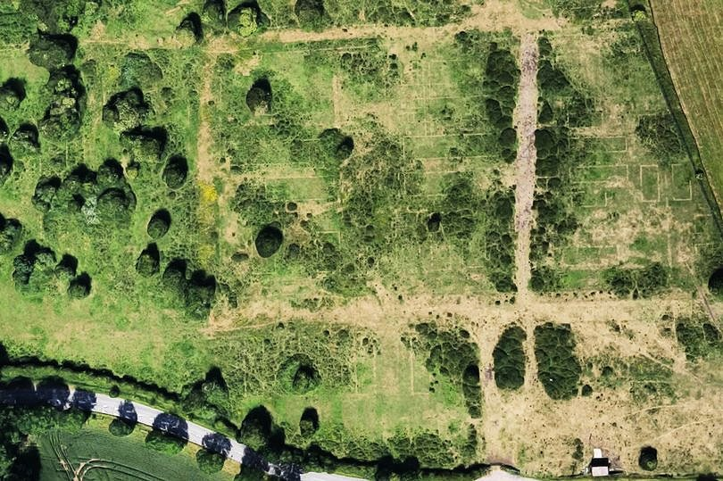 | “Scraptoft is a Repatriation Camp and up till recently has taken in about 2000 repats monthly, releasing them in fortnightly groups of 1000 each. I am told that the system is now to be changed and the intakes will only remain 3-4 days in the Camp; under these circumstances it is impossible to organise any educational activity amongst the ‘repats’”.  28-30 October 1947 – A G George visited to carry out a re-education survey. Strength 1 officer, 217 OR.  Commandant: Lt Col H D Chaplin  Interpreter: Capt. W Spiegler  S/Sgt Landauer  Camp leader: Gefr. Demmech, G (B) “Tackles his job with an indifferent efficiency. He shows little interest in re-education but does not appear to be obstructive.”  Deputy: Uffz Heinz, Joseph (B+) “Unimpressive, but seems to carry out his task satisfactorily.”  German MO: S/Arzt Dr Pfeiffer (B+)  A/Arzt Toenshof (B)  Simplified screening – A 3; B 215.  Morale was considered to be fair. Negative aspects were news from Germany, especially the expectation of ‘démontage’ where redevelopment of German industry would have been limited. Positive factors were good treatment by the British staff and a reasonably friendly local population – pows were able to visit Leicester.
Aerial view with hut outlines clearly visible.

There was a high number of youth pows – with 50% under 26. However, this was not seen as a problem.

The standard list of re-education activities was given. The main problem was a lack of volunteers to produce them;

Newspapers: English papers were adequate, but only 10-15 old German newspapers were being received.

Library: 1800 books, but at least 600 were of no interest.

Films: a 16mm projector had just been received, but no films shown.

Wireless: Adequate with loudspeaker system and microphone.

Lectures: Good number, but no Swiss lecturers. The studientleiter planned to give lectures on PanGermanism, however, the interpreter officer was monitoring the content.

Discussion group: none.

Press review – daily news sheet.

Information room: Well laid out room with items of interest from each of the German zones.

Camp magazine: “Auslese”, monthly.

Other activities –

Religion: The Protestant Padre was depressed due to his own family news, and this was having an effect on his work. The RC Padre was also not very successful + he was also travelling to Camps 94, 106, and 167.

Entertainments: Instruments were available and some concerts had been given by pows in transit. Popular sports and games were football, chess, table tennis and cards.

Education: No classes in camp. 7 or 8 members of the German staff attended courses at Vaughan College, Leicester.

It was recommended that two students from the Training Centre should be sent.

14 November 1947 - Camp number included in an ‘Urgent Memorandum’ of 14 November 1947 (FO 939/270) regarding inspection of food parcels.

1-2 March 1948 – Mr A G George returned for another re-education survey. Strength 2 officers; 230 OR.

Joseph Heinz had become camp leader, previously deputy. Other staff the same as previous October report.

A non-scientific and highly dubious survey of pow attitudes to the British was carried out in camps that were open at this time. These were often carried out in front of British guards; I have not yet seen one that gives actual numbers of pows surveyed. Perhaps, if it had been carried out a year or so earlier, it may have had some purpose. For what it is worth, the results were:

Distrust 30% - Only one particular reason was listed – officers were allowed to take twice as much luggage as OR, this was not just unfair, but considering the responsibility for the war, it was unjust.

Indifference 60%

“Benefit of the doubt” 10%.

There were few re-education activities, thoughts in general for the pows were of going home.

5 April 1948 – brief report by a visiting lecturer who spoke about repatriation to the remaining pows. He raised the criticism that this type of lecture should have been given a long time ago.

20-24 April 1948 – Visit by F C Milner for ‘Re-educational Survey’ and ‘Resettlement Lecture’. Strength 188.

Commandant: Lt Col Chaplin Camp Leader: Uffz Joseph Heinz
Interpreter Officer: Capt. W Spiegler M.O.: Stabs/A Pfeiffer.

Another survey of attitudes towards the British was carried out with a different batch of repatriation pows:

“Liking: 15%
Benefit of Doubt: 25%
Indifference: 50%
Distrust: 10%”

While the category of ‘Liking’ comprised only 15%, most Ps/W professed a liking for the individual Englishman, and appreciated the friendliness of the vast majority of the civilian population with whom they had contact. Small kindnesses on the part of farmers, for instance, have created good feeling. Criticisms are directed against the impersonal ‘officialdom’ . Good treament by military staff was acknowledged.”

Criticisms raised by the pows were listed. How or why this list was created was not explained - it was all too late and no follow-up was expected. It was also probably detrimental to good relationships to allow unfounded, and some ridiculous, comments to be raised without challenge. No figures were given as to how many of the pows held these views:

1. Screening – This was particularly resented by the younger element, who had grown up under the Nazi Regime. It was felt that it was unjust and unreasonable to penalise them for an outlook which they had been forced to accept when they were too young to realise its implication.

2. Pay – the rate of pay and the conversion rate to marks

3. Length of captivity – the pows considered that a year to 18 months would have been reasonable.

4. Privileges – “appreciated as a generous gesture, many considered they should have been granted long before they were, and the comparison was made of the French Ps/W in Germany who, very soon after the capitulation of France, were given a large measure of freedom.” No mention of any challenge to this criticism.

5. Ps/W ex-USA – many pows sent from the USA to the UK had expected to be returned to Germany. They had been given false information in the USA regarding this, even though the US knew where the pows were really being sent. Not surprisingly this created resentment. Pows stated that although standards were better in the US camps, they were generally more hostile places. “One P/W swore that one of the atrocity films [regarding concentration camps] he was forced to see, had been shown in Germany before the war and had then purported to have been filmed in Poland.”

6. Conference on future of Germany – criticism “that no German representatives have been invited to this conference. This sort of thing was said to pave the way for another Nazi-revolution.”

There were few re-education activities: a camp newspaper with a final number was being produced. Some lectures had taken place.
Known Commandants;
Lieutenant Colonel E. Howell, M.B.E., M.C. – This may have been Edward Howell of the Loyal North Lancashires’.
Lieutenant Colonel H. D. Chaplin

After the camp: For a short time, the site housed homeless families. It then reverted to agricultural land, a nature reserve and golf course. A 2017 botanical survey noted some bases of the huts were still visible. The site as it is now: https://repatriatedlandscape.org/england/pow-sites-in-the-east-midlands/pow-camp-4-scraptoft/

Further information:

National Archives Reference: FO 939/87. Description: 4 Repatriation Camp, Scraptoft Camp, Scraptoft, Leicestershire - FO 1120/206 ‘Re-educational survey visit reports for camps 1 to 4’. Both used above.

Aerial photographs - https://britainfromabove.org.uk/image/eaw010431

