Camp 2 (& 780) - Woodhouselee, Milton Bridge, Midlothian (aka Milton Bridge, also hostel 16A(2))

Included in the 1945 ICRC List as: Labour Camp. 780. Woodhouselea Camp, Milton Bridge, Midlothian.

Prisoner of War Camps (1939 – 1948) - Project report by Roger J.C. Thomas - English Heritage 2003
OS NGR | Sheet | No. | Name & Location | County | Cond’n | Type 1945 | Comments
 |  | 2 | Woodhouselee Camp, Milton Bridge | Midlothian |  |  | Scotland

Although Milton Bridge is about 2.5 miles south-east of the site indicated below, it would appear to be the same camp as Camp 780 – see lists above.  Location: NT 2409 6452. The Woodhouselee area is about 6½ miles south of Edinburgh. The road running alongside is the A702.  The last site survey reported that there are no visible remains.  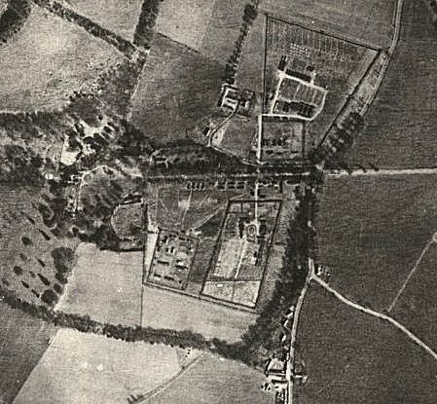 | 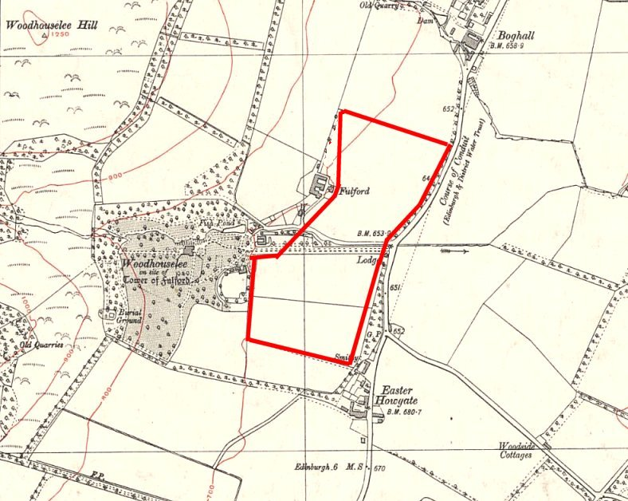
RAF aerial photograph 1946 | Ordnance Survey revised 1938, published c.1944.

Previous use: the Woodhouselee estate was based around a 16th century castle. Recorded as a tented camp for internees in 1940.

POW Camp: Numbering for this camp is not certain. 780 is confirmed, but use of ‘2’ may be a confusion from when it was listed as 16A(2). If it was Camp 2 this was only for a very brief time in 1944/45.

Canmore – “A Prisoner-of-War camp is visible at this location on RAF aerial photographs (106G/Scot/UK 11, frames 5104, 5105, flown 15 April 1946). The camp measured 600m from SW to NE, by 200m transversely and was subdivided into 4 enclosed areas.
Information from RCAHMS (KM) 7 May 2003.
Nothing is visible of this prisoner-of-war camp. It stood in what are now two improved fields, one immediately E of Fulford farm-steading, the other immediately SE of Woodhouselee Stables.” http://canmore.org.uk/site/242803

End 1944 - Modern Italian list recorded Italian pows at Woodhouselee Camp 2.

NOTE - The reports for Gosford Camp 16 included a Woodhouselee hostel for Germans. It seems there was a main Camp, and a hostel with the name Woodhouselee.

20-28 April 1945 – A visit was made by Mr R M Carlisle to Amisfield pow Hostel 16A to review welfare and complete the card index of (German) pows. He was only concerned with German pows and made no reference to the Italians. His report listed ‘Woodhouse Lea’ as being hostel 16A(2), linked to Amisfield 16A, 20 miles away. Amisfield was administered by the main Gosford Camp 16. Strength at Woodhouselee hostel - 146.

Commanding at 16A(2): Lt Jode, M.C.

5 November 1945 - I have seen a letter-sheet for Woodhouselee Camp 780 with this date written in Italian to Italy.

14 – 16 June 1946 – a report about a lecture continues to list a Woodhouselee hostel for Gosford Camp 16. The lecturer reported; “The hostel, on the other side of Edinburgh, called Woodhouselee, though having all the attributes of a hostel, is simply classified as a detachment and I discovered that previous lectures here were separately reported (i.e. the main camp put in a report without however, getting the report direct from the detachment).”

20 June 1946 – English Inspector’s Report by Mr James Grant. ‘Woodhouse Lea’ Hostel - 300 pows.

21/23 June 1946 - Hostel strength as 307. It was noted that the Italian pows had evacuated the camp.

Officer i/c: Lt G H Hood Hostel leader: W/M Frehse (B)

Morale was considered to be good.

Not listed in reports for Camp 16 from August 1946 to February 1948. It may have been regarded as a detachment rather than a hostel as stated in the 14 June report above. (Or it could have been attached to another camp).

13 February 1948 – again listed as a hostel for Gosford Camp 16 with just 10 pows. Hostel leader Uffz Blosinski.

Further information:

