Camp 5 (& 13, 58, 179, 297) - The Hayes, Swanwick Hayes, Swanwick, Derbyshire

Not included as Camp 5 in the English Heritage Report – Entry is for Camp 13:

Prisoner of War Camps (1939 – 1948) - Project report by Roger J.C. Thomas - English Heritage 2003
OS NGR | Sheet | No. | Name & Location | County | Cond’n | Type 1945 | Comments
SK 4075 5234 | 119 /  120 | 13 | The Hayes, Swanwick | Derbyshire | 4 |  | Large complex of huts and tents enclosed by double perimeter fence  and guard towers. See Camp no. 58, 179 and 297

Location: NGR for The Hayes, main building SK 4102 5264.  Previous use: The main building was constructed in the 1860’s for Fitzherbert Wright, partner of the company which built St Pancras Station using iron from the nearby Butterley Iron Works. The estate was sold 50 years later and it became a Christian Conference Centre.  From September 1939 to Spring 1940, correspondence referred to the site as ‘Internment Camp 17’. There were reports that ardent Nazis were placed here. Letters were signed by Captain / Major F R Allison, Commandant, who continued in post when the site became POW Camp 13.  POW Camp: Camp numbers 13, then 5, then 179 (58 / 297?) Large country house used as a ‘hostel’ for officers + tented area, and later huts for other ranks.  1940 – site opened for POWs, (listed in Appendix to WO 199/405).  9 April 1940 – During 1940 the site was used as a camp for both civilian internees and pows. This soon proved to be unsatisfactory and was raised in the House of Commons:  “Mr.Lipson asked the Secretary of State for War whether he will make inquiries into the conditions obtaining at the internment camp at Swanwick, Derby; and is he aware that the leader of the camp is a Nazi party leader, censors all letters, compels the singing of the Horst Wessel song, and that all non-Nazis are beaten up?  Mr.Stanley – I am informed that, on the arrival of a number of men at this camp, there was a demonstration, but that no serious harm was done and that the new arrivals are on good terms with the rest of the camp population. I am also informed that there is no substance in the suggestion that all letters are censored by the camp leader or that there is compulsion to sing Nazi songs.”  Daniel Lipson, MP for Cheltenham, re-asserted his claim, and then asked; “Will my right hon. | 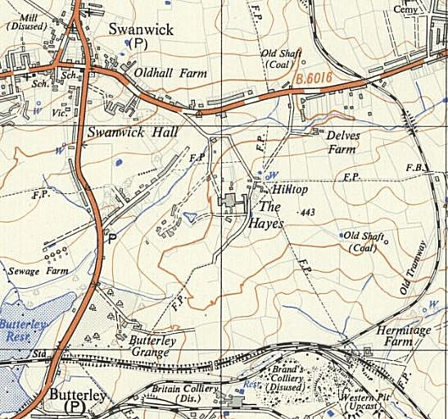
 | Ordnance Survey 1951
friend arrange that prisoners of war are not put in the same camps as residents of this country who have had to be interned?”

Oliver Stanley (S of S for War) agreed to this. (HC Deb 09 April 1940 vol 359 cc457-8457).

2 July 1940 - The SS Arandora Star, sailing from Liverpool to Canada was sunk by the U-47. 478 German internees were aboard the ship – 241/2 of which had previously been held at Swanwick – 36 were believed to have been drowned. (FO 371/25210 Embarkation List for Arandora Star – though inaccuracies were found in the original listing).

3 November 1940 - Franz von Werra was transferred to this camp from Grizedale Camp 1. On the night of 20/21 December 1940, he escaped by tunnel with four other German pows while the choir distracted the guards. The tunnel was dug from a bedroom block and under the perimeter fence, a distance of 30 metres. The team digging the tunnel called themselves “Swanwick Excavations Inc.” (The tunnel entrance can still be viewed). On capture and return to Swanwick, von Werra was punished with 14 days confinement.  By end 1940 – German pows had been transferred to Canada.  January 1941 – letter shows that Major Allison was still commandant, but expected to leave soon.  1 September 1941 to March 1942 – The War Diary entries for POW Camp 13 record Italian pows: | Key  1. Main Building  2. Detention Cells  3. Mess Hall  4. Recreation Hut  5. Chapel  6. Officers' Quarters  7. Double Gates  8. Escape Tunnel  9. Lawn  10. Stone slab covering underground tank | 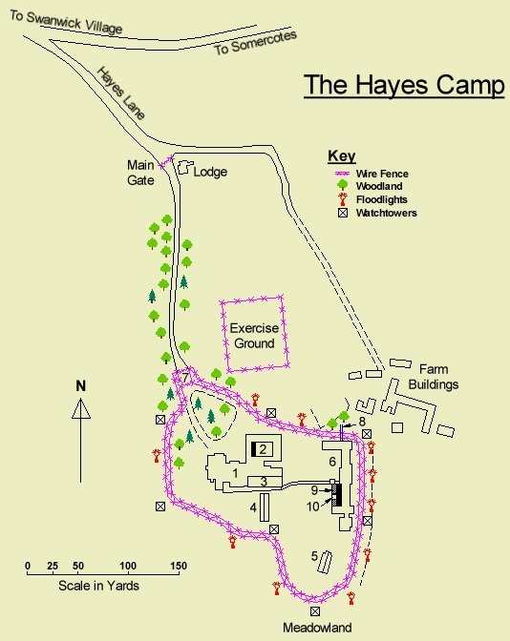
British strength - 7 officers and 144 OR (HQ staff and guards). These numbers only varied slightly ± 1, for six months.

1 officer and 121 ORs attached in training from the Sherwood Foresters [until 2 October]. Attachments from the Sherwood Foresters were made several times.

1 September - 131 Italian pows – 23 officers and 108 OR. This number did vary, see numbers below.

Most of the entries related to small numbers of pows arriving, hospital cases, transfers of personnel, and officers visiting to inspect the camp. Two British privates from other camps were tried here, charges not specified, one sentenced to 1 year’s detention, the other sent to Leicester Prison.

20 November 1941 – M Zimmermann from the International Red Cross Committee (ICRC) visited the camp.

1 December 1941 - POW strength: 32 officers and 11 ORs. Major D B Upton arrived to take over command.
 |  | Plan on several websites – source reference unknown

1 January 1942 – POW strength – 34 officers and 14 ORs.

1 March 1942 - POW strength – 36 officers and 17 ORs.

12 March 1942 – “42 Italian Labour POW taken on the strength of this Camp from No.28 Camp [Garenden Park] and accommodated in Conference Hall.”

16 March 1942 - 108 Italian Labour pows transferred from No 9 camp and accommodated in Conference Hall and Recreation Room. The Labour pows were segregated from the Italian officers

20 March 1942 – Private Edward George Pettit, aged 26, of the Pioneer Corps, was accidentally killed by a gun shot wound to the chest.

Although mainly Italian pows were recorded here from 1942 to 1944, there were also Germans. Most Germans were held prior to shipping to Canada. Part of the site was also used to house about 300 badly wounded German pows prior to exchange in October 1943. These pows, and others from elsewhere, (about 5000 altogether), left Swanwick, to travel to Glasgow and then on to Göteborg.

March 1943 – a letter to the camp stated the Commandant was a Major Clarke.  25 September 1943 – A contract for the hire of furniture for the officer’s mess was made with Commandant Major Ernest George Macdonald Porcelli  American Transit Camp 7.  24 May 1944 – A letter from the secretary, Ernest Beves, for the owners of The Hayes stated:  “The Hayes is now in possession of the United States Army. It will still be used for German prisoners.” The transfer happened just a day or two before this letter. The site’s legal requisition by the UK War Department continued to be in place.  Correspondence for the camp dated June 1944 was addressed to Major William H McGrath who was acting as Executive Officer at American Transit Camp No.7. The Americans only remained here for a couple of months.  Memories – “During 1944 the Americans were responsible for guarding Swanwick Hayes and their Military Police were a common sight in Ripley in their white helmets, belts and spats and armed with a hefty ‘nightstick’. “Got any gum chum” became a regular request by kids when they spotted soldiers in the street. Another ploy to get gum | 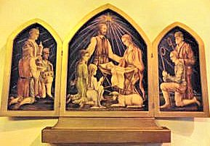
Nativity triptych signed F.P., an Italian POW at The Hayes. “I was told the faces were modelled on fellow prisoners”.
www.northernvicar.co.uk/2021/12/30/swanwick-derbyshire-st-andrew/
was to go down to the outer camp gates. These were situated on the A61 between Hickton Road and the entrance to Butterley Grange. The barbed wire came down almost to the road but the actual prisoner compound was out of sight over the top of the field. When the working parties returned, the guards would open the outer gate to allow the lorries in, then close the gate, before guards on the vehicles handed over their firearms. The vehicles would then carry on up the compound into the main camp
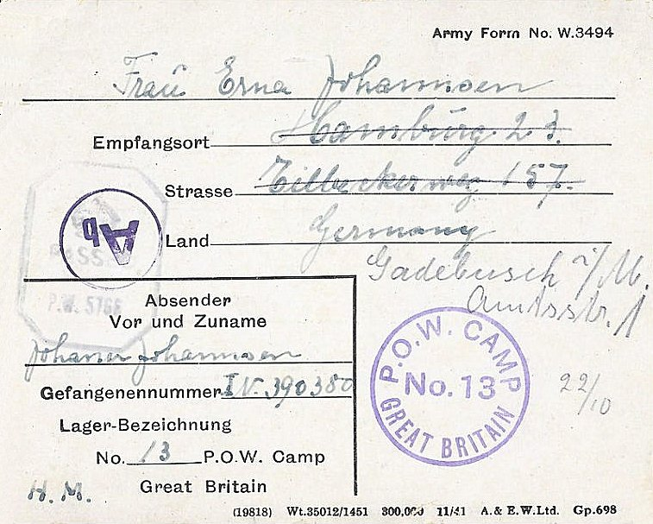 | “…In addition to the One That Got Away (albeit not completely from Swanwick) there were other escapes from time to time. We were always aware of this at school when the guards would come into the school grounds to search the air raid shelters which were situated between the main drive and the Headmaster’s House. Their search also involved prodding with their bayonets between the rows of cabbages and brussel sprouts which the school gardener was growing for school dinners… Digging for Victory of course!!  “…As the war in Europe ended the prisoners were allowed out on parole until they could be repatriated. The Germans were allowed into Ripley but the Italians could not go beyond the Horse & Jockey pub at the top of Hartshay Hill. One day two Germans came into Dad’s shop and asked if he would like to buy some butter. Now the British people had been living on rationed food, which included just 2 ozs of butter each per week, for the past 5 years, and yet prisoners were able to pilfer large tins of butter from the US Army cookhouse supplies…..and NO Dad didn’t buy.  Part of memories recalled by Eric Brown - https://www.rdht.org.uk/prisoners-of-war/  <<< Mail from Camp 13, posted by Johann? Johannsen, in German to Germany. 2 postcards dated 9 / 14 Sept 1943 + letter sheet undated. Cards informed wife? and mother that he was about to move to Canada.

August 1944 – the house was recorded as being not in use while it was re-painted.

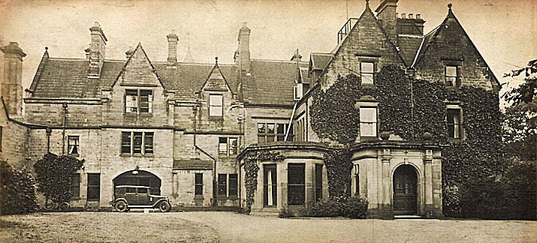 | British POW Camp again.  26 February, 1945 - Extracted details from ICRC Report on Camp 179 by M. F. Bieri.  Capacity: 2,250. Camp strength on day of visit: a). 3 Officers – 2 Medical Officers + 1 Protestant chaplain, b). Other ranks – 289.  Commandant: Lt. Col. R.C.G. Joy.  Camp leader: Hauptfeldwebel TROSKA, Georg, A842722.  Nationalities: 165 German / 110 Dutch / 2 Czechoslovaks / 1* Norwegian / 1* Luxembourg / 13 Jugoslavs. (* were being transferred on 28.2.45).  General description - "Camp 179 when last visited was No.5, and, before that, No.13. On my last visit, together with Mr Haccius the ‘Hostel’, a building with a capacity of 500, was used for the POW officers, and all the rest of the POW lived in tents surrounded by a morass of mud. During the winter, all POW were taken out of the tents and transferred to other camps, with the exception of the present number of POW who were retained for camp
The main building ‘hostel’ – other areas also used with tented / hutted accommodation.
construction, etc., and are accommodated in the ‘Hostel’. There are three POW to a room, palliasses plus two blankets and a head-roll serve as bedding". “During the last months the compounds have been provided with an extensive drainage-system, concrete-slab pathways have been laid out and roads are being built. The mud has disappeared. Ablution huts, kitchens, latrines and other huts have been enlarged or improved, so that everything is now ready for the reception of newcomers (expected at any moment). There are 4 tented compounds with a capacity of 500, each with its own camp leader who, during the winter, supervised work in his compound, and the Hostel, for the use of elderly men or POW whose state of health will not allow them to live in tents. The whole camp is now well laid out and there is no danger of a return to the November conditions.”

FOOD – No complaints. On the day of the visit:
Breakfast: Haferflockensuppe mit Kakao u.Brot. [Oatmeal soup with cocoa and bread].
Dinner: Gemueseeintopf (Kartoffel u.Fleisch). [Vegetable stew (potato and meat)].
Supper: Brot, Margarine, Kaese, Buechsenwurst. [Bread, margarine, cheese, canned sausage].

General state of nutrition " " " " " " " "Sehr gut".

MEDICAL – Officers: Oberarzt Ulrich Reuter and Oberarzt Bruno Tesch. There were 23 protected personnel working in the infirmary. Dental work was carried out by a German Unterarzt. Medical supplies were sufficient.

There were 24 cases in the Camp Infirmary, none were recorded as serious. The infirmary had 79 beds in 7 wards. 1 death was recorded, of Obergefr. Hotzon, E, who was sent to the camp with a serious shell wound to the head. He was transferred to a hospital, but died there.

“General state of health of pow in words of German M.O. "Gut".

CLOTHING - “Everything necessary, including boots, has been issued in sufficient quantity.”

WORK - "According to the Camp leader, 80% of the POW are employed, the rest will get work in the near future, so that no man will be without funds. Rate of pay: 3/- a week. Working hours: 8. Employment: For a time on farms (where the farmers, at first sceptical, were in the end highly satisfied) and later, on camp construction.”

There was a canteen “with sufficient supplies at normal prices”; a football ground; a library with 180 German books, no Dutch books; a radio (broken at the time).

RELIGION – Protestant chaplain, Lt Johann Koldetz. Services were held every Sunday, the chaplain and a local clergyman visited each other weekly. No RC chaplain, but services held by a pow chaplain from another camp.

ACTIVITIES; main sport was football; English courses were held with about 80 pows; a shorthand course had about 10 pows attending.

CORRESPONDENCE – “A few POW receive mail often, but all the rest, particularly the Dutch, are without news. Shortest time for a letter from Germany: 6 weeks; average time: 8 weeks. Parcels:
a) 2 individual parcels from GRC were received on 30.1.45 and 2.2.45 respectively.
b) 8 individual parcels were received on 30.1.45 (4) 8.2.45 (1) and 9.2.45 (3)

GIFTS – 25 parcels of biscuits had been received from the ICRC

GENERAL COMPLAINTS – none.

DISCIPLINE - 2 Dutchmen are in detention for theft. The Camp leader describes discipline as "Ausreichend". [Satisfactory]

REQUESTS. Books of all kinds for educational courses, fiction, religious, medical, Dutch - Ping-pong balls (cannot be obtained locally) - Games

“GENERAL IMPRESSION OF CAMP: Very good."

At the time of this report a further 2000 pows were expected.

20 April 1945 - Hitler’s Birthday and a few weeks after the mass break-out at Bridgend).

Memories - “We were assembling for the usual roll-call when the English sergeant arrived on the parade ground, looked up on the mast between the big marquees and spotted a swastika flag. The alarm was given, the guard strengthened, the machine-guns manned on the watch-towers, and we found ourselves surrounded by soldiers with fixed bayonets. It was demanded that the culprit come forward. When no one emerged, the guards began to shout and rave at us – up till then we’d always got on well with them. They divided us up into groups and began a game with us that lasted nearly all day. One group had to sing, another to stand to attention, another were chased through the camp as if a horde of Indians were after them. After a while, we were paraded again, the same question asked, and again no one came forward. In the second part of the circus we had to dismantle the wooden flooring of the tents and pile them in heaps outside the camps, then the same with the duck-boards which criss-crossed the whole camp. The little flower beds which prisoners had made round their tents were trampled to bits. Next the mess-tents and their tables and benches had to be added to the heap. Then individual groups had to advance across the whole camp picking up every match stick and piece of paper on the ground. Everything had to be done at the double. The camp was on a hill at the bottom of which were heaps of stones and heavy concrete blocks: we had to carry these to the top of the hill and then to the bottom again.

The guards urged us on with shouts and an occasional bayonet prick, for which a few had to have medical attention. We had not even had any tea that morning, and it was now afternoon. As a petty officer of twenty, I was one of the youngest, and quite a sportsman, but there were men ten and twenty years older than me. What infuriated me most was the attitude of the officers, both English and German, who stood watching it all in the top part of the camp and never intervened.”

This event ended when a pow admitted (probably falsely) to the flag. (Account given by Rudolf Bradatsch, Petty officer of the Marines).

5 July 1945 - ICRC Report on Camp 179 by Mr Chavan – extracted details where they differ from the report made barely four months earlier.

There had been a large rise in numbers – strength 2392, all described as German (but see * below): 5 officers; 697 NCOs; 245 medical personnel; 4 medical officers (doctors); 1 chaplain.

The site was described as “very well situated”; though, apart from the hospital, accommodation was in tents. A hostel was recorded at Clay Cross

Medical facilities had been greatly increased and held about 350 sick and invalids.

“Each prisoner has the use of a straw mattress, a sleeping bag and three blankets. The Camp leader has a copy of the Geneva Convention. Fire safety has been improved; new emergency exits were set up; the equipment was completed. In addition, a motor pump is now in service in the Camp and the Camp leader has drawn up an emergency evacuation plan; exercises are carried out regularly…

“Latrines are sufficient (buckets); disinfectant is at disposal. The prisoners have one hot and cold shower per week.

Clothing – Satisfactory. 50 pairs of shoes needed.

Work, money and wages – 900 pows work 1 week in 3 at the moment, expected that soon all will have regular work. Work consists of agriculture and drainage.

Correspondence – All pows were dissatisfied. The ICRC were trying very hard to resolve this problem.

Special cases – 3 pows were captured in German Red Cross uniforms, as they were paid by the Deutsche Rotkreuz they are claiming to be civilians.

3 other pows were also claiming to be medical personnel and the delegate would submit these cases to the relevant authorities. *1 of these cases – S Komisschika – was listed as Russian.

Requests – 50 pairs of shoes, size 42 and 43; Playing cards; Cigarettes for the infirmary.

Summary – This camp is considered to be very good. All issues raised previously have been dealt with satisfactorily. No complaints were raised. Discipline is excellent.

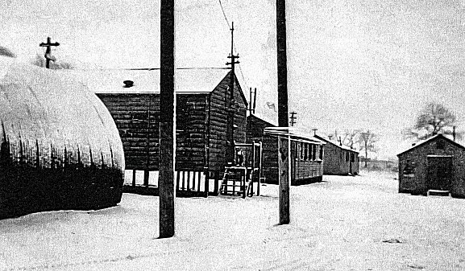 | 1946 – German Pows arrived from the US where they had been mistakenly told they were being returned to Germany. Morale was subsequently low amongst these pows.  Pows were employed on farms, local industries and breaking stones for road building.  24, 25, 27 and 28 October 1946 - Incidental information from a German theatre group visited Swanwick, Camp 58, (journal held by the Deutsches Historisches Museum). The group toured pow camps around England during 1946. Note the use of Camp Number 58 at this time.  1946 – 30-year-old Karl Panwitz hanged himself at Swanwick Camp. Speaking at the inquest, a friend and fellow POW stated that Panwtiz had told him that if he remained in Britain for more than two years he would kill himself.  March 1947 – A letter from the Board of Trade lists furniture and other items which were being replaced or coupons issued.  c.1945 – 1948. Extracts from a letter giving memories of the camp by Kurt Hess. Mr Hess had been shot down in France August 1944 and had been held at Swanwick for 4 years, (September 1944 to January 1948), and was camp
Mixed hut types in part of the camp.
leader for three and a half years. This would have been around the start of 1945 to 1948. From further comments it seems that Mr Hess was one of the camp leaders for a section of the camp – he stated there was a different overall camp leader. He described the time as “the best years of my life”….

“At first on the tent site, later in the huts of the English below the pond… The hostel at the top was in winter the quarters for the administration.

After the end of the war the first labour commandos went to work for farmers, in quarries, roads, Butterley works in Ripley, the sawmill and flax factory. The work was satisfactory. Our people were hardworking and honest. After 1946 the hardness of the guards relaxed. We got into contact with the population. Christmas 1947 we got 5 days holiday from the camp. In 1947 we had one sergeant and one soldier to guard, but 5 German prisoners as man guard…

In the camp we had up to 200 rabbits, 300 fattened chickens. Mr Hull brought us 4 young pigs…

Some of our people removed the whole of the barbed wire, double, for one shilling an hour. With Heinz Schneider I built a motor boat, 4 metres long, from two work troughs and an old lawnmower. With that we were on the river near Belper….”

Mr Hess refers to some families that he was friendly with in Swanwick. He stated that there was a good band.

“The main camp leader was a Sergeant (Feldwebel) Biermann. He suffered from TB… Our Camp Commander, Commander Bricksdale had a daughter. Our camp doctor looked after her (or courted her).”

POWs attended services at St Andrew’s Swanwick. A triptych was on the wall of the church by Fritz Pueschel.

One pow recorded his transfers to various camps and stated that from September 1947 to 22 April 1948 he was located at; “The Hayes Camp Swanwick nr. Derby, Hostel of 248 GPWW Camp”.

Known Camp Commandants:

1940 – early 1941 Major F R Allison. He went on to be commandant at “W.O.8 Command Cage, POW, Stratford on Avon” by July 1941.
1941 – Major J T Upton - Hussars
December 1941 - ? – Major D B Topham from the Royal Fusiliers.
c.1943 – Major Clarke
c.1943 – Major Ernest George Macdonald Porcelli from the Duke of Cornwall’s Light Infantry.
c.1945 - Lt. Col. R.C.G. Joy from the Royal Dragoons.
? Bricksdale? Mentioned in Kurt Hess memories above. Spelling Prixdal in another letter.

Further information:

National Archives: Miscellaneous documents - both entries relate to Swanwick as Camp 13 - WO 166/5978 – 1 September 1941 to 31 December, 1941 - WO166/10295 – 1 January 1942 to 31 March 1942. Used above.

National Archives - FO 1120/231 – ‘Re-educational survey visit reports for camps 177 to 186’. Between 1946 to 1948 inspections were carried out at various camps for German pows regarding the provision of re-education programmes. The quality and detail of the reports vary greatly.

Lambeth Palace Library – Correspondence on postponing an extension of a pow camp at Swanwick, including letters from Tissington Tatlow, Hon.Canon of Canterbury and Sir Percy Grigg, Secretary of State for War. Ref W.Temple 44, ff.109-15

Mentioned in 'The One That Got Away' and 'Thresholds of Peace'.

I believe there is a book by Margaret Byard about the camp, but I have not manged to track down a copy.

The site as it is today - https://repatriatedlandscape.org/england/pow-sites-in-the-east-midlands/pow-camp-13-the-hays/

Hostels

Clay Cross. 13 miles from main camp

July 1945 - First listed in ICRC report. Hutted.

Q - was this previously Camp 248 New Drill Hall, Clay Cross, Derbyshire, then taken over by The Hayes???

Huthwaite Pow hostel –  Location: around SK 4683 5842 - on the B6027 (Common Road). It is about 6 miles NE of Swanwick.  POW Camp: Probably opened 1944/5. Wooden huts (possibly 6, including 1 used for cooking / eating). Area enclosed by barbed wire fencing with an entrance gate almost opposite Pit Road.  Italian, then German pows.  Memories of a guard who arrived in 1946 – “…We had about fifty PoW's, whom we sent out each morning to work on farms in the area. I often took prisoners to a radio shop on the road to Sutton-in-Ashfield, and they would carry back batteries and accumulators for our radios. They were only allowed out under escort, and they were all Germans.  All prisoners were German ex-soldiers, but gave very little trouble to the guards. We only had to threaten them with a return to The Hayes to bring them into line. They wore army battledress, which was dyed brown with a red circle on the back of the tunic and a patch on the trouser knee. Very distinctive indeed.  The camp was enclosed with barbed wire, with a large gate almost opposite the Pit Road. The gate was manned all and every night. The camp huts were all wooden construction, I think six in total. One large one in two sections, one end being the cookhouse and the other end the prisoners dining area. There were nine soldiers to look after them, and our hut was the last one at the bottom of the camp (nearest the gate.) | 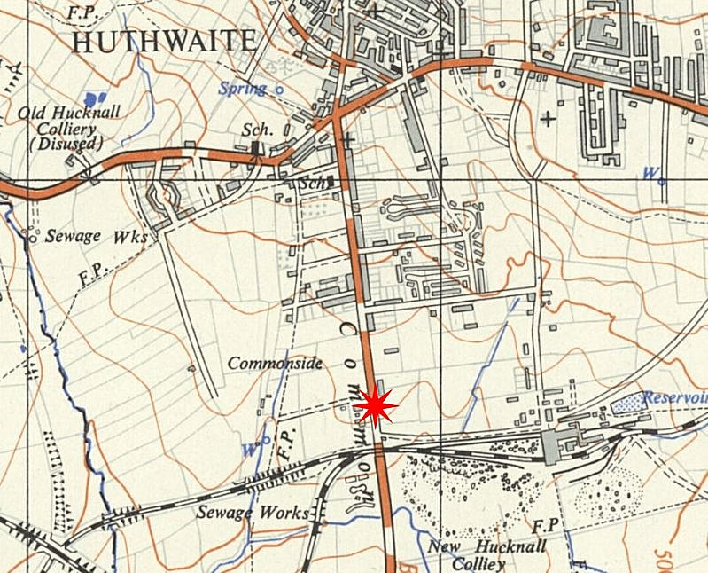
 | Ordnance Survey 1951

We were all well fed, a typical day’s menu would be: porridge for breakfast; very little for lunch as the camp would be empty; plenty of bread and sometimes cake and individual fruit pies. The main evening meal would consist of canned stew or corned beef, of which there was plenty, and all prepared by German cooks. We had no M.O. (medical officer) and in case of sickness the Prisoners of War were taken to the surgery at Huthwaite to be treated. The soldiers reported there also.”

Mr Frederick G Pote on; https://www.huthwaite-online.net/gallery/memorial/pow_camp.php

After the camp: Probably used for a short time by Ukrainian displaced workers. No trace of the camp left. Mainly residential and light industry.

