Camp 188, 16A, 243 Amisfield Camp, Haddington, East Lothian

Prisoner of War Camps (1939 – 1948) - Project report by Roger J.C. Thomas - English Heritage 2003
OS NGR | Sheet | No. | Name & Location | County | Cond’n | Type 1945 | Comments
 |  | 243 | Amisfield Camp, Haddington | East Lothian |  | German Working Camp | Scotland

Camp numbered – 188 > 16A > 243 > 16A.

Location: NGR NT 5260 7400  Before the camp: During the Second World War units including the Sherwood Foresters and the Polish 10th Mounted Rifles were accommodated at the camp.  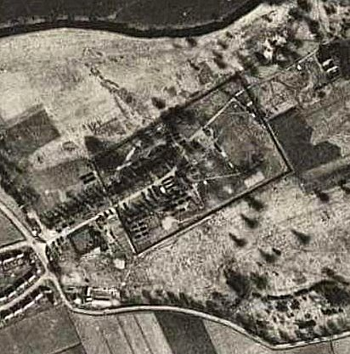  Pow Camp: The OS map shows the camp perimeter fencing for the pow compounds and some of the guard huts at the ‘front’ of the camp.  “A prisoner-of-war camp was situated at the western end of Amisfield Park, the centre being about 250m NE of the West Lodge…. [large rectangle on map shows the perimeter fence]. The accommodation for the guards and staff… was situated between the gate of camp (NT c.5249 7393) and the West Lodge (NT 5233 7387).” [Huts shown along the driveway]. (From Canmore)  1944 – As Camp 188; recorded as holding mixed co-operator and non-co-operator Italian pows.  Late 1944 / early 1945 – As Hostel 16A administered by the main Camp 16 at Gosford.  About 800 men, non-Germans, including many Austrians, were moved from Gosford to Amisfield. The Austrians were transferred to other camps in 1946. | 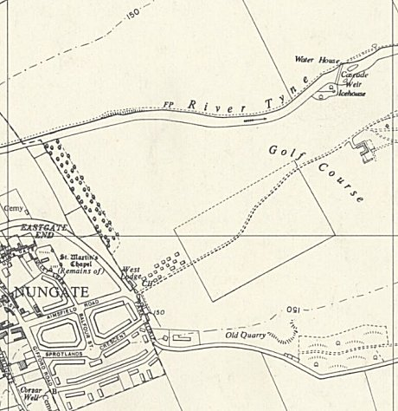
 | Ordnance Survey 1957
Commentary by pow Harry Dittrich who arrived in Gosford in 1944: “After a few weeks [at Gosford PoW camp] all the ‘foreigners’ were assembled and transported to PoW camp No 16A in Haddington, all eight hundred of us. I spent two years there. We had to work on farms but it was a nice camp, very tidy and run by ourselves. We had a theatre and a good band, plays were written and concerts laid on frequently. Many of the Austrians came from Vienna. Music and song were in their blood and what they had to offer was really outstanding. I had a lot of friends among them”. (*1 below)

20-28 April 1945 – a visit and report by Mr R M Carlisle to Amisfield Hostel 16A to review welfare and complete the card index of pows. Strength approximately 620 at 16A and 16A(2) – [16A(2) was a hostel at Woodhouselee].
Commandant: Major Binden-Blood at Camp 16a Camp leader: Sychrowski.
Interpreter Officer: Captain Svar (Czech Army)
The Camp leader was from Austria – “an agreeable fellow, well-liked by the Commanding Officer. Scottish Command are not so keen on him, and Major Rudolf considers him too slack.”

Mr Carlisle judged the camp to be politically ‘white’ (Category A). Most pows were Social Democrats and Christian Socialists with a few communists. There were five Nazis who were being removed. Many of the pows were from Austria and Czechoslovakia.

At Amisfield, 340 pows were constructing further barracks at the camp - 142 pows worked on the land – 10 worked in the hospital – 36 were administrative staff – 67 protected personnel – 20 worked in the kitchen and Officers and Sergeants’ mess – 5 were unfit for work due to wounds, (recommended they be removed to a hospital). Some pows were being allowed out of the camp to work unescorted.

Overall health was good.

A list of standard re-education activities was given:

Wochenpost / Ausblick – good / excellent reception of these magazines.

Newspapers – 1 copy of The Times, Daily Herald, Daily Mirror, and the German language publication from London; Die Zeitung - 2 copies of Daily Express

English Teaching – 2 excellent pow teachers.

Lectures – regular, provided by the pows themselves, not yet with visiting speakers.

Library – 250 to 300 books.

Films – none

Radio – none, (a handwritten note points out that the commandant only has to ask for one).

Other activities –

Religion – 496 RC and 24 protestants. About 50-60% of these attended weekly services held with alternating English and German pastors.

Classes – building, engineering, Czech questions of the day, Austrian questions of the day, algebra, maths, German history.

Theatre – “There is a theatre, and at the kind invitation of the Commandant, I saw a most excellent representation, with music composed by the prisoners themselves. The libretto came from the same source. Three performances are given every second week.”

23 August 1945 – Visit and report by Mr Grant. Described as a satellite camp for Gosford, rather than a hostel.

Commandant: Major Woodnott Camp leader (Lagerfűhrer): O Hussermann, recently arrived from a camp in Ireland.

1062 pows – including “436 rejected Czechs, 227 Austrians, 3 other rejected nationals, and only 396 Germans.”

Little re-education activity had taken place due to the mix of nationalities, 500 Austrians having recently departed, and there were new arrivals from camps in Ireland.

September 1945 – Mr Grant returned to review English Instruction.

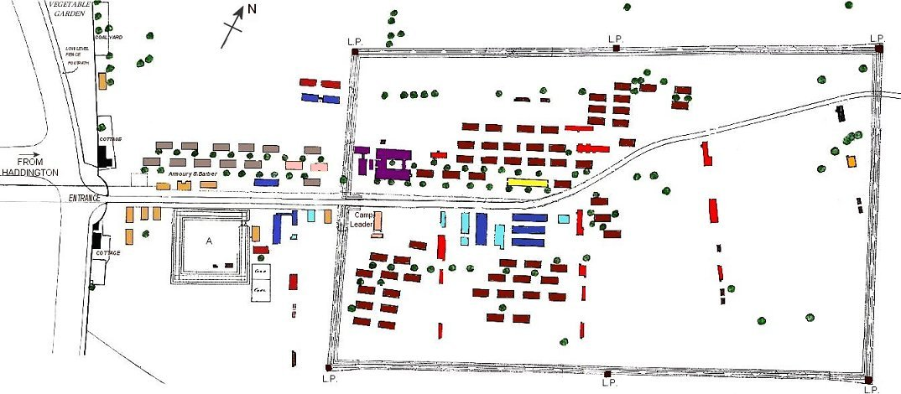
A simplified plan of Amisfield Camp adapted from the original dated 30th November 1945. The original is much more detailed and includes features such as drains and manholes – it is held by the John Gray Centre in Haddington - https://www.johngraycentre.org/

A = Turbulent Prisoners  Compound  L.P. = Lookout Post  There is a note that officers were accommodated in a requisitioned property in Haddington. | Guards’ and Administration Area |  | POW Compound
 | 16 Sergeants in 2 Nissens 75 F.S. per sergeant |  | Camp leader
 | 234 O.R.’s in 13 Nissens 30 F.S. per man |  | 1026 pow accommodated in 57 Nissens 30 F.S. per pow
 | Camp administration |  | Theatre
 |  |  | Sick Quarters
 | Both areas
 | Messes and cookhouses
 | Latrines and Ablutions
 | Ancillary Buildings

September 1945 – “Roll calls were a necessary if trying feature of camp life, but despite them, two twenty-four-year-olds, SS Sergeant Gotfried Lachmann and Corporal Paul Schmucker, escaped from Gosford in September 1944. Both were later recaptured. A further German PoW, Karl Lasar, aged forty-four, escaped from a working party in Haddington in 1945. PC Erskine related the details in his report: “On Sunday, 18th April 1948, about 4.20pm, the skeleton of a human being was found on the west banking of the disused quarry situated about 200 yards east from the Birk Hedges Road, in the parish of Haddington, and the remains are suspected to be those of No A989611 Karl Lasar, (44), PoW, who was an inmate of No 16A Prisoner of War Camp, Amisfield Park, Haddington, who went missing from a working party employed at Dovecot Farm, Haddington, on 7th September, 1945. The cause of death is not certified.”

The cause of death for Karl Lasar was left open and only recorded as; “Found dead about 4.20 pm on 18th April 1948 within Birk Hedges Quarry, Birk Hedges Road, in the Parish of Haddington, having been missing since 7th September 1945.” (Statutory Registers and Corrected Entries).
“It’s more than likely that Karl took his own life as Willie Downey, one of the three young boys who made the unpleasant discovery, described in 1998. He described how the boys were looking for frog spawn in the Spring of 1948 when one of them kicked what he thought was a sheep’s head in the water. A closer look led to the realisation that it was a human skull with the remains of boots and a uniform with patches nearby. Willie noticed a length of hemp rope hanging from a nearby tree which overhung the quarry and remembered that identity discs were discovered along with a watch.” (*1 below)

8 February 1946 – As Camp 243; recorded as a camp in its own right. It was inspected by the ICRC led by M Bieri (Monsieur Frédérick Bieri).

There were 792 other rank pows and 1 officer - 610 came from the Army, 52 from the Navy, 123 from the Luftwaffe, 4 were ‘OT’ (Organisation Todt) and 3 were protected personnel. Of these 381 were German, 409 Czech and Sudeten, and 2 were Austrian. The commandant was Major P. Woodnott. (Woodnutt?) The pows were classified as mainly Category A ‘white’, low risk, not Nazis. Some of the pows were housed in billets. The camp was described by the ICRC delegate as, ‘Very good’.

Facilities at the camp included a theatre in a converted hut, an orchestra, a football pitch, and library. Classes were held for English, German, French, mathematics and stenography. Films were shown in the camp. Later, a Ukrainian chapel was built in one converted hut. Religious services were held by visiting chaplains / priests and some in Haddington. There was a camp newspaper, called ‘Der Spatz’ (The Sparrow). One of the Czechoslovakian pows was Karl Gilg, a chess master, held from 29 October 1945 to 5 July 1946, when he was transferred to Gosford until 30 September 1947.

Mid-1946 - Many of the pows from Amisfield were transferred to Gosford Camp 16 when it became a German labour camp. Amisfield was then returned to the administration of Gosford and was once more designated as a hostel.

11 August 1946 – Listed as hostel 16A attached to Gosford Camp 16. K W Rothschild gave a lecture at the main camp and at hostel 16A. Strength approximately 120. The lecturer had found poor relationships with many pows at the main Gosford camp – however he had a very good reception at Amisfield.

November 1946 – Strength 961 + 331 billetees.

January 1947 – Camp leader same as in August 1945 – “a regular soldier with 24 years service, hiving very sound ideas as to the re-education of POW in general and the younger men in particular.”

22 January 1947 – Strength 1050.

24/27 March 1947 – Strength 459. Camp leader: Uffz. Pienker (B)

May 1947 – no longer listed as being administered by Camp 16 in further reports, probably as it held Ukrainian pows.

The Ukrainian pows were ex-members of the Waffen-SS Division Galizien. The division was accused of major war crimes against civilians. It is claimed that from the 8,000+ Ukrainians that were transferred from a camp in Italy, that about 965 were sent to Amisfield. While there, some were recruited by MI6 to be sent back as spies to Ukraine where they were immediately arrested having been betrayed to the Russians by Kim Philby. (Stories in The Scotsman + 2 books below).

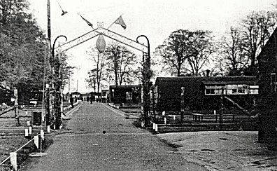 | 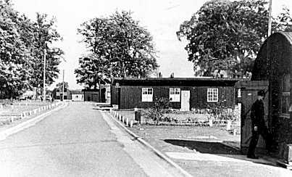
The camp c.1947

27-30 October 1947 – just 10 German pows at the camp (administrative staff) – the rest were Ukrainian.

4/5 November 1947 – 294 Ukrainians.

February 1948 - a report for Camp 16 stated – “Amisfield is Ukrainian with a small German office staff.”

27 – 29 April 1948 – in a note for Deer Park pow Camp (which became Camp 16 after Gosford); “There is a Ukrainian hostel at Amisfield.”

After the camp: Used for a while to house Ukrainians and displaced persons, (EVW – European Voluntary Workers). 2020 Golf course

The camp as it is now - https://repatriatedlandscape.org/pow-sites-in-scotland/pow-camp-243-amisfield/

Further Information:

*1 - http://eastlothianatwar.co.uk/page-8/PoW%20Camps.html - includes memories, pictures and a plan of the camp.
National Archives FO 1120/235 – Re-educational survey visit reports for camps 240 to 246. Dated 1 Jan 1946 – 31 Dec 1948

http://canmore.org.uk/site/222940

Vertical air photographs RAF 106G/UK 1319, 5196-7, flown 28 March 1946.

Ukrainian agent story - ‘Morningside Mata Haris’ by Douglas MacLeod, 2005; and ‘Secret Edinburgh’ by Hannah Robinson, 2016.

